Glimmora ONE — User Manual
Hi! This is a friendly guide to Glimmora ONE — a small, calm place to slow down and notice your inner weather. We made this guide so anyone, even a 10-year-old, can use the app on their own. Read through once, then keep it nearby for the first few days.
App version: 0.2.1 · Last updated: 2026-05-12

1. What Glimmora ONE is
Glimmora ONE is four small rooms inside one app:
- Companion — a kind AI you can talk to like a journal.
- Stories — short, calm video lessons on stillness and feelings.
- Reflect — a private journal that quietly draws a map of how you feel.
- Circles — a slow, anonymous place to share with others.
You also get a Dashboard called 'Today' with three small things to do each day.
2. Making an account
On the landing page, click 'Begin gently'. Fill in a name (anything you like), a username, a password, and your email (optional). Click Create account.
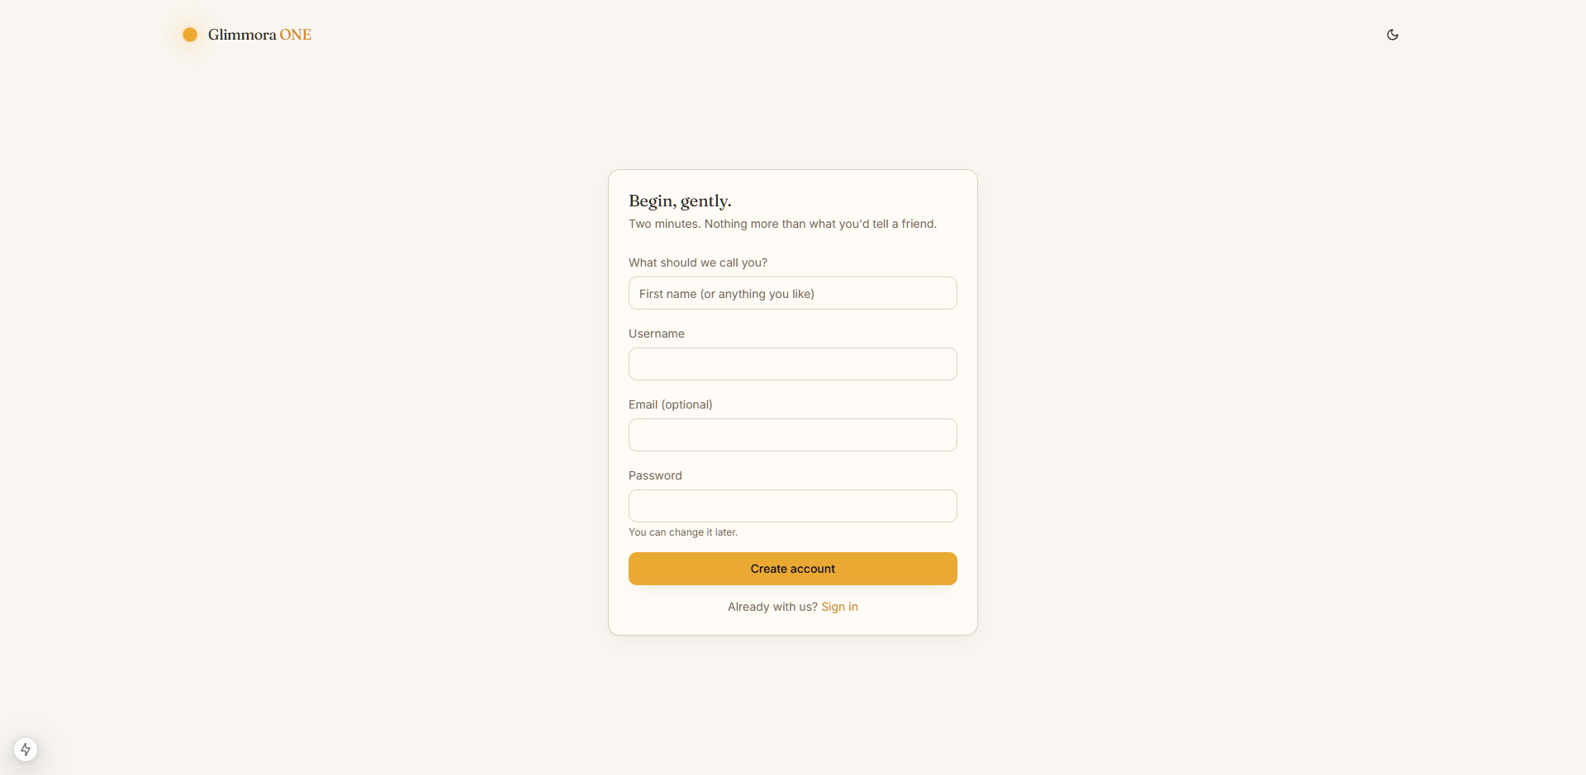
The sign-up page.
Tip: you can use a one-letter username and a one-letter password while testing — Glimmora won't yell at you.
3. The welcome — four small steps
After you sign up, the app asks you four gentle questions. You can skip any of them.
- What should we call you?
- What's your one-sentence intention?
- Pick up to four focus areas (Stillness, Becoming, Feeling, Grief, Joy, Relationships, Work, Sleep, Creativity).
- A 'Ready when you are' page that quotes your intention.
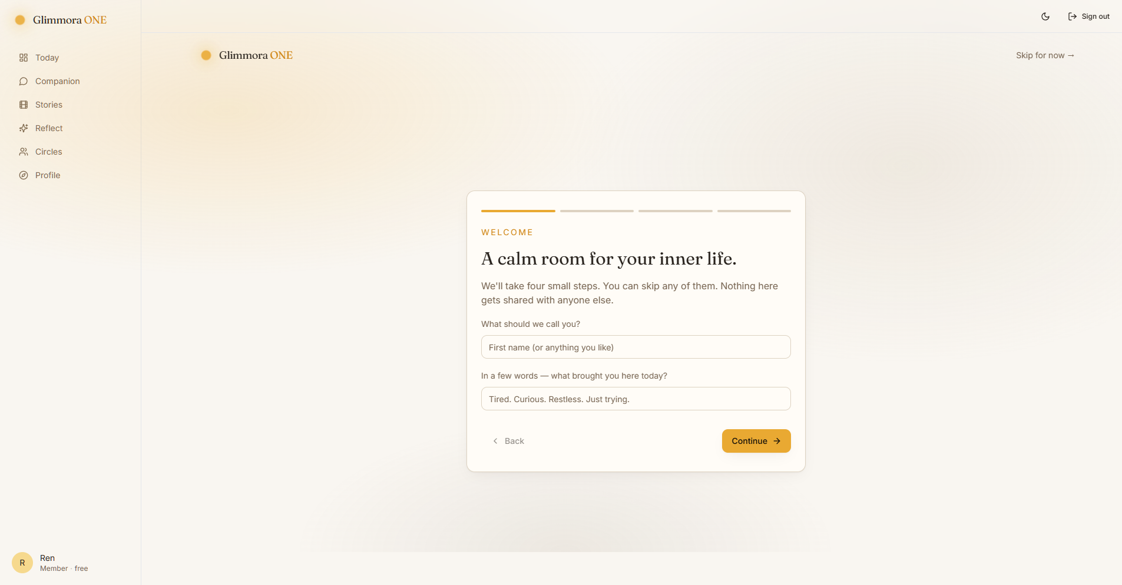
Step 1 of the welcome.
4. Today's three small steps
Every day the dashboard shows three small invitations. They are never required — they're just gentle nudges.
- Step 1 — Arrive: say hello to the Companion.
- Step 2 — Notice: watch one short episode.
- Step 3 — Reflect: write a sentence in the journal.
Each step you finish gets a soft check. There's a small 'streak' counter for days you did all three — but missing days is fine.
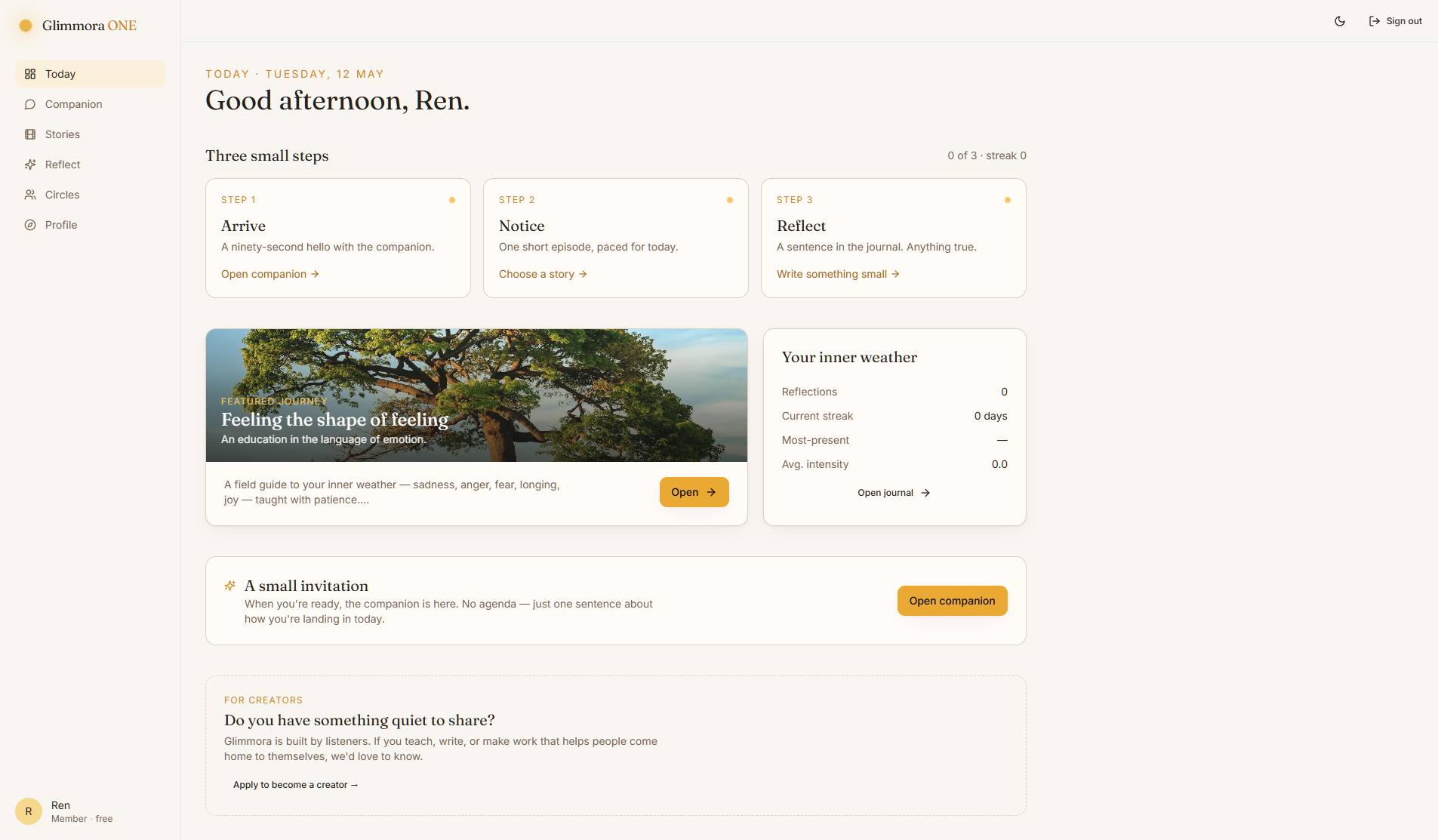
The dashboard.
5. Talking to the Companion
Click 'Companion' in the sidebar. You'll see four starter sentences you can tap, or you can type your own. The Companion will answer, guess at an emotion, and suggest a single question to sit with.
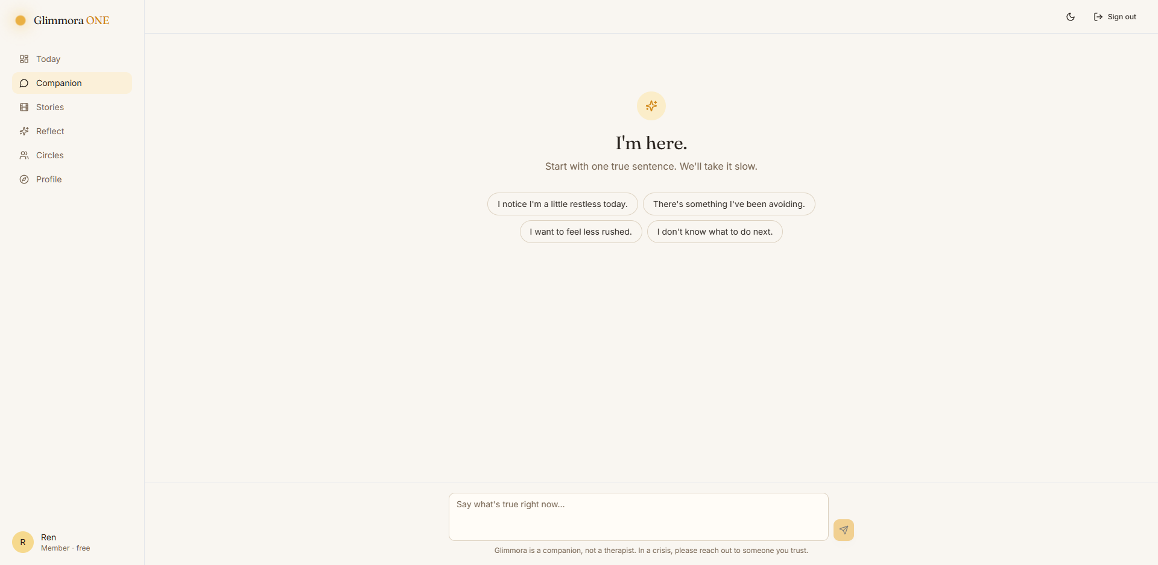
The empty Companion screen.
Glimmora is NOT a therapist. If you ever say something serious like 'I want to die', a rose-colored card pops up with phone numbers for crisis lines around the world. Please use them.
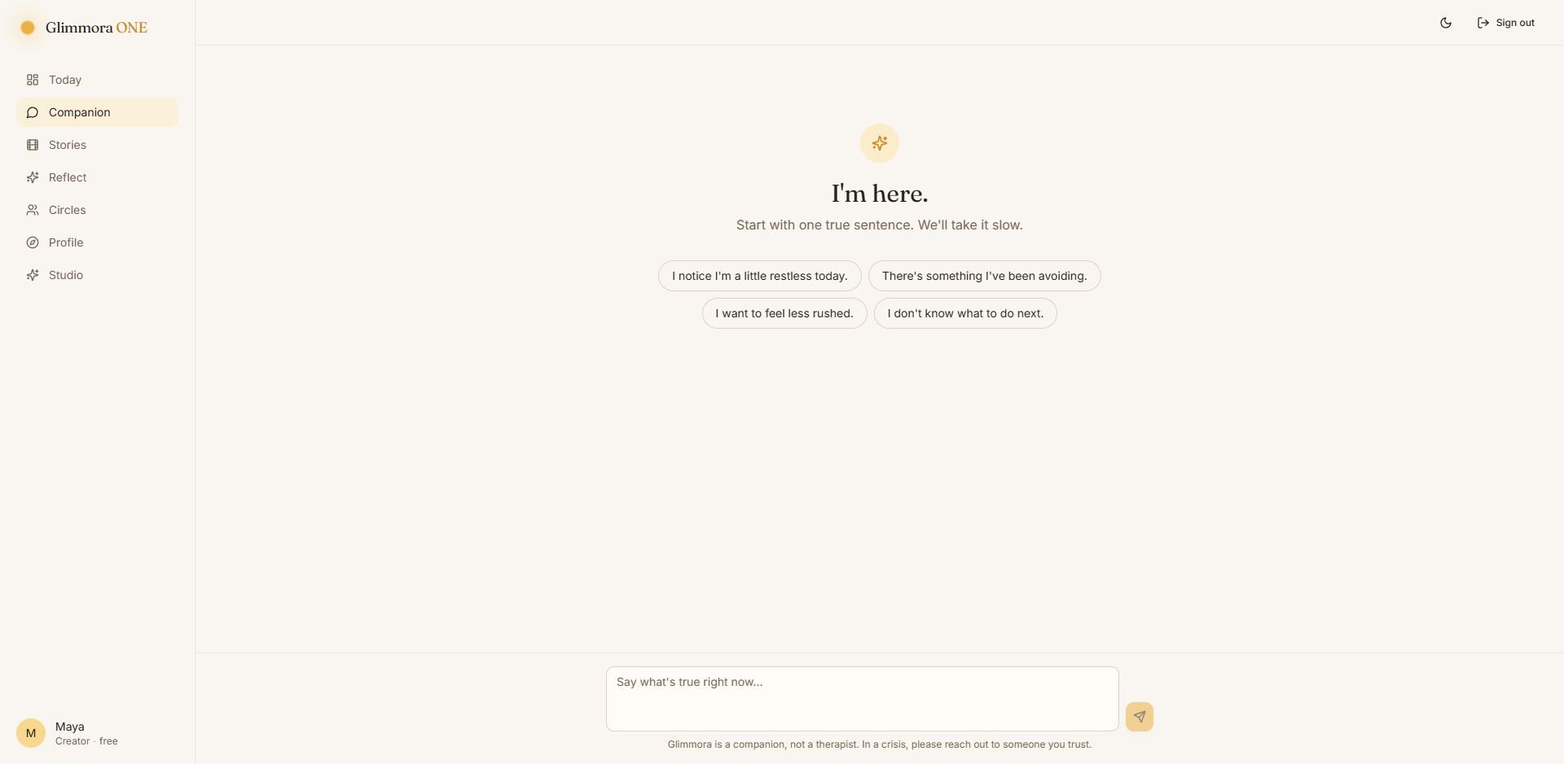
The safety card.
6. Stories — the calm library
Click 'Stories'. Pick a series (like Still Mind). Pick an episode. Each episode ends with a single, kind question — you can click the link below the video to write a reflection on that question.
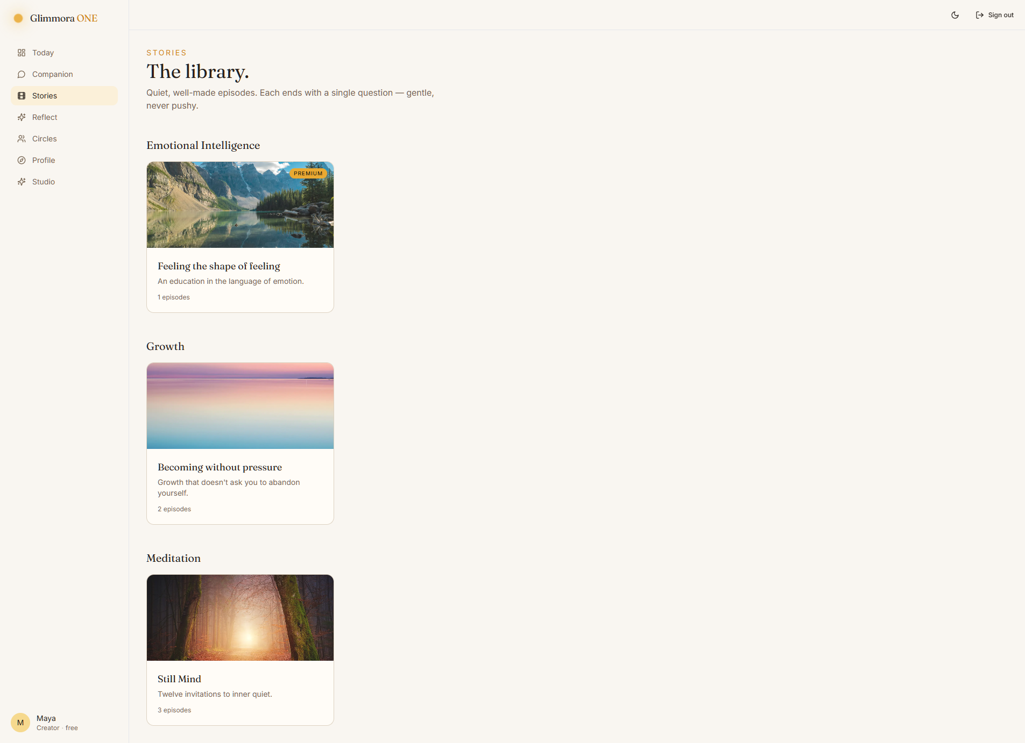
The library page.
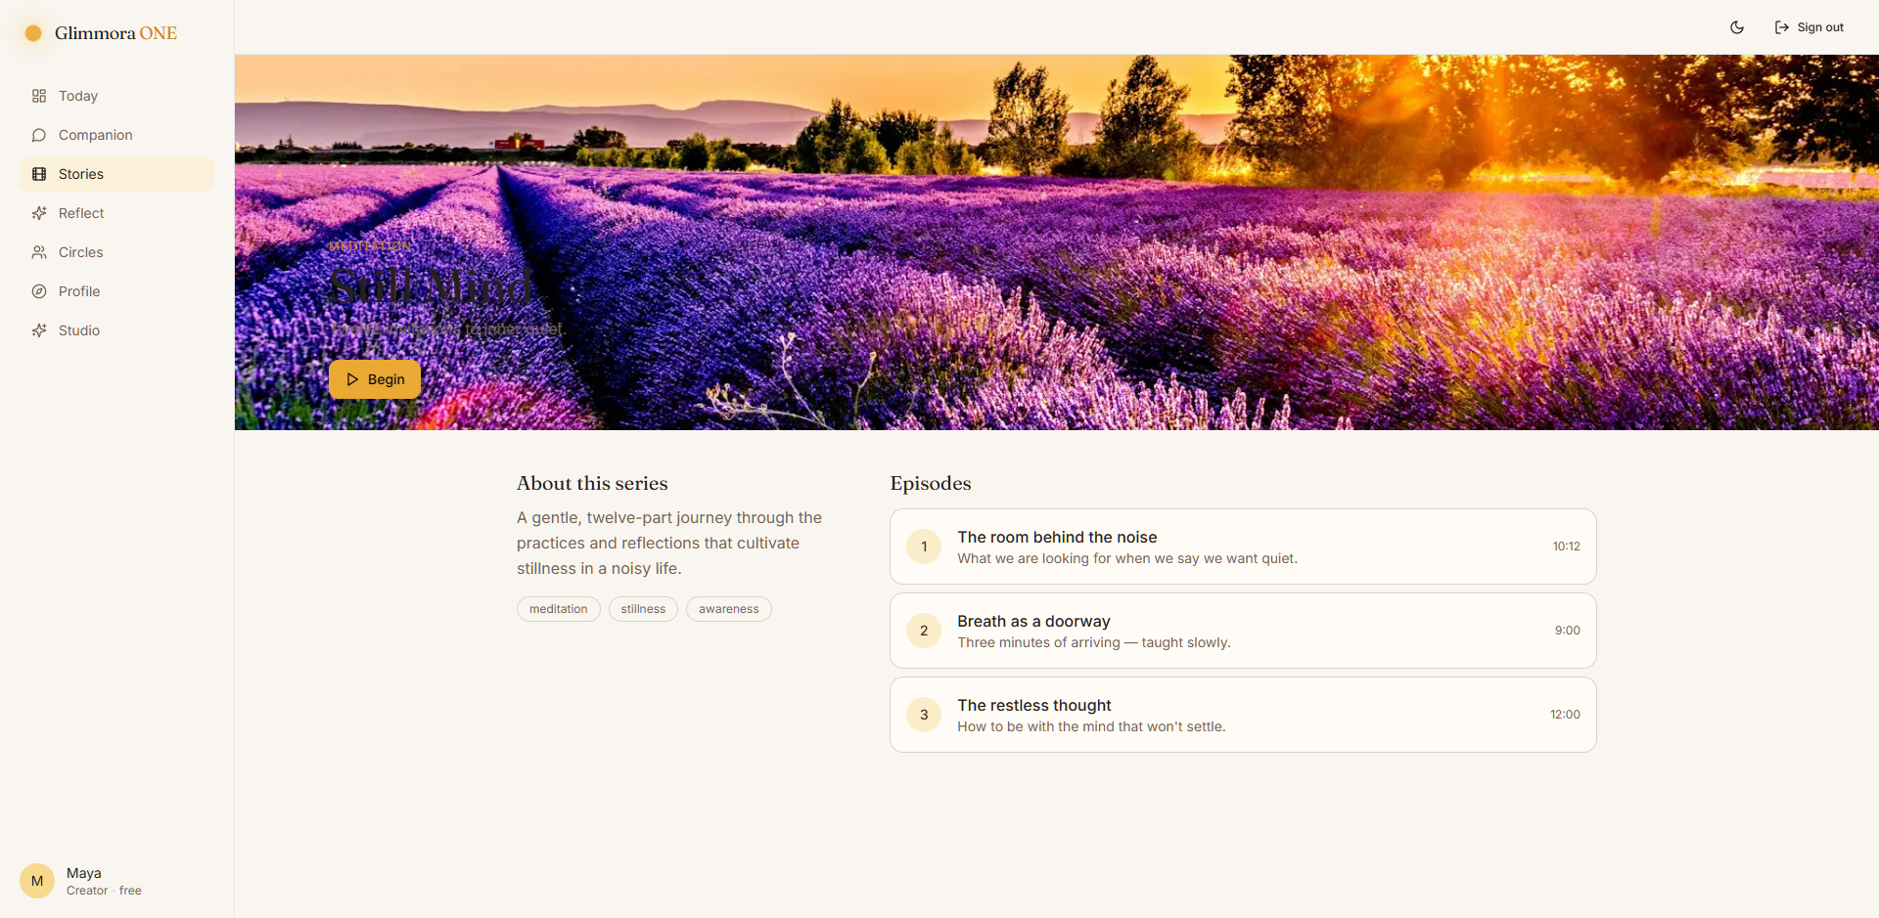
Inside a series.
7. The journal (Reflect)
Click 'Reflect' → 'New reflection'. Write a sentence. Pick a mood. Set the intensity slider. Save. The Reflect home page builds a small map of how you've been — your 'inner weather'.
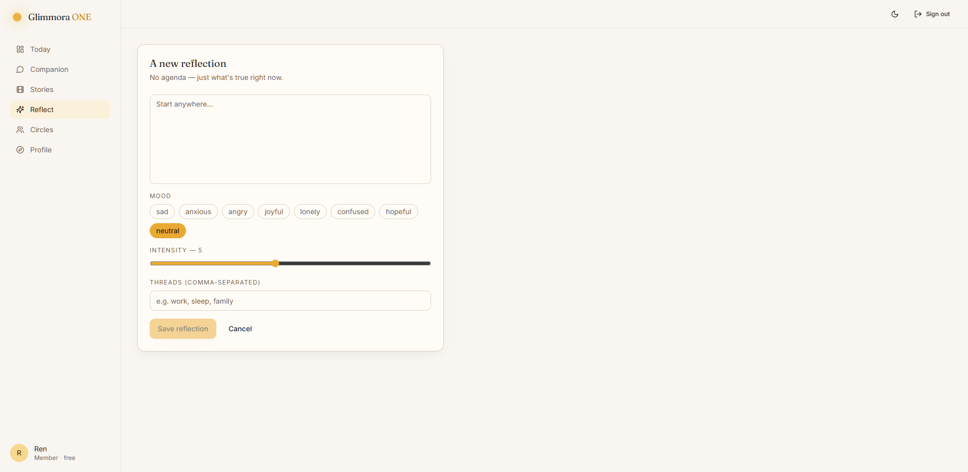
Writing in the journal.
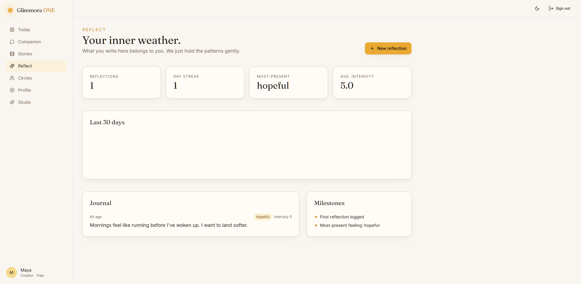
Your inner weather map.
8. Circles — quiet community
Click 'Circles'. Pick one. You can write a short message. Other people see your message under a made-up handle — never your username — and no one can DM you. The space stays slow.
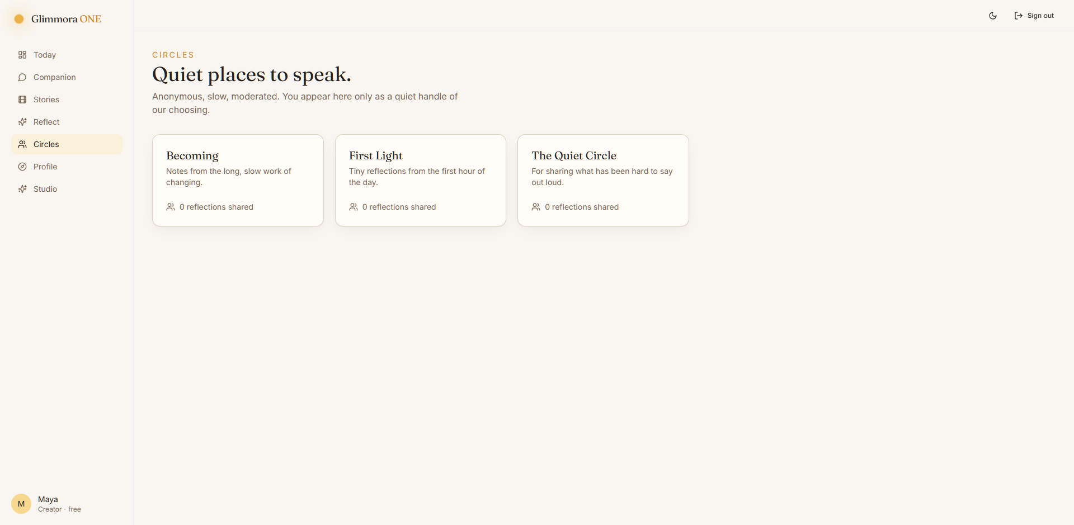
The Circles list.
9. Profile — see who you are
Click 'Profile'. You'll see:
- You — edit your name, avatar, and bio.
- Your role — tells you if you're a Member, Creator, or Admin, and what each can do.
- Membership — shows whether you're on the Free or Premium plan.
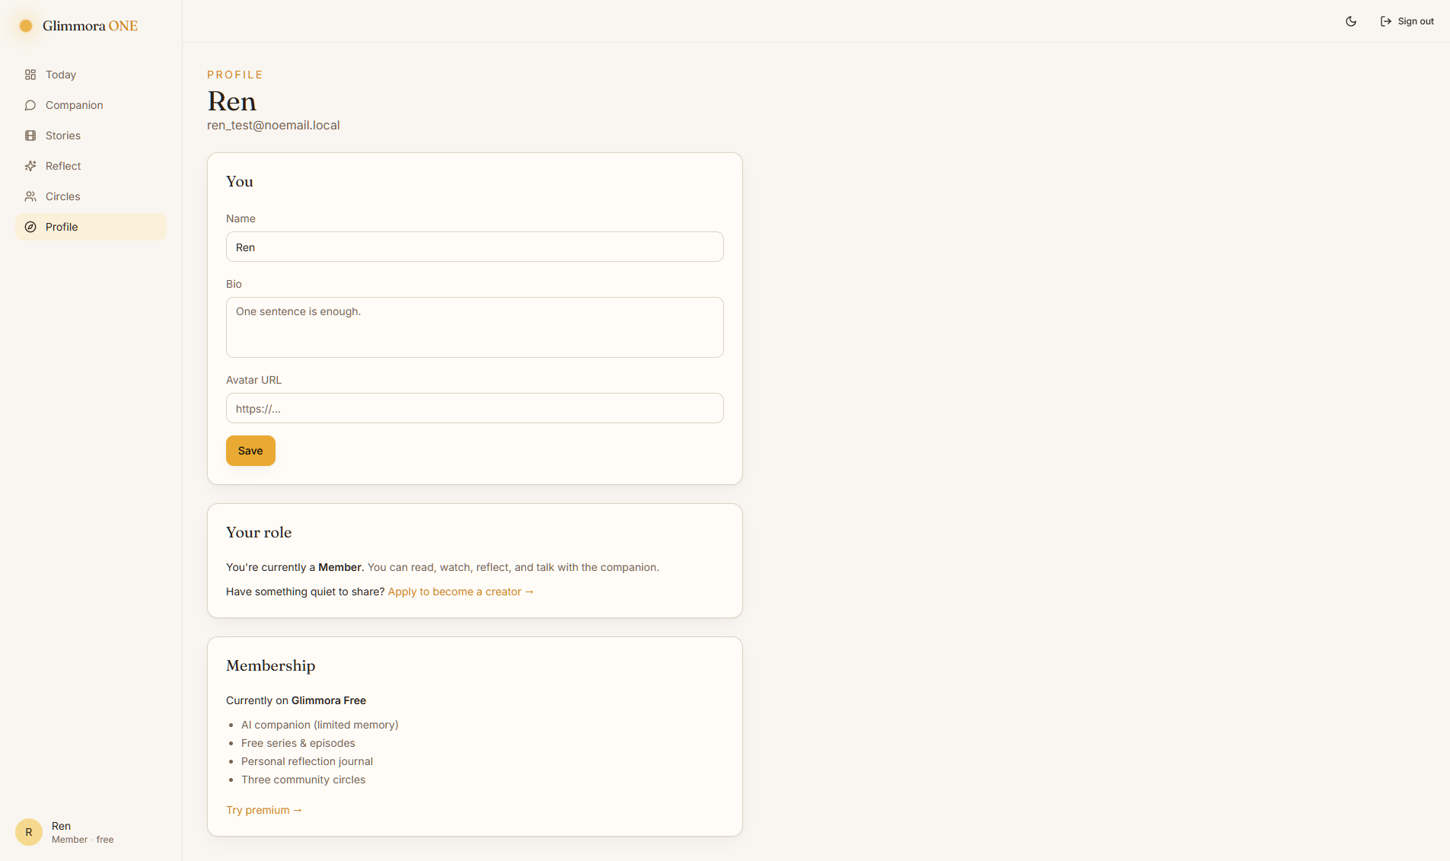
Profile as a Member.
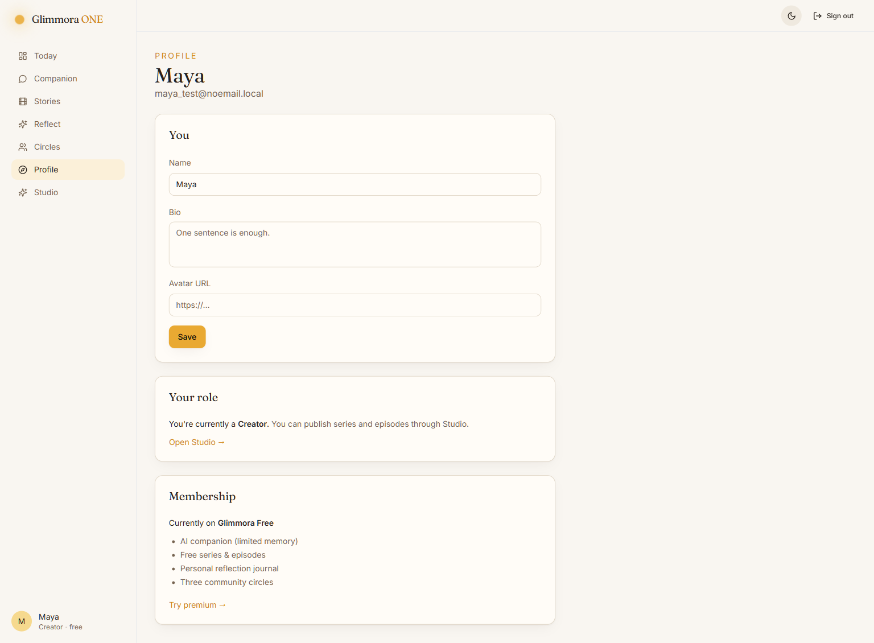
Profile as a Creator.
10. Roles — who can do what
There are four roles. The sidebar tells you which one you are.
- Member — read, talk, watch, reflect, post in circles. (Default.)
- Creator — Member + publish their own series and episodes in Studio.
- Admin — Member + review creator applications + moderate.
- Superadmin — Admin + can also manage other admins.
Want to become a Creator? See the next section.
11. Becoming a Creator
On the Dashboard you'll see a soft 'Do you have something quiet to share?' callout. Click 'Apply to become a creator →'. Write 1–3 sentences about what you'd like to share. Click Send.
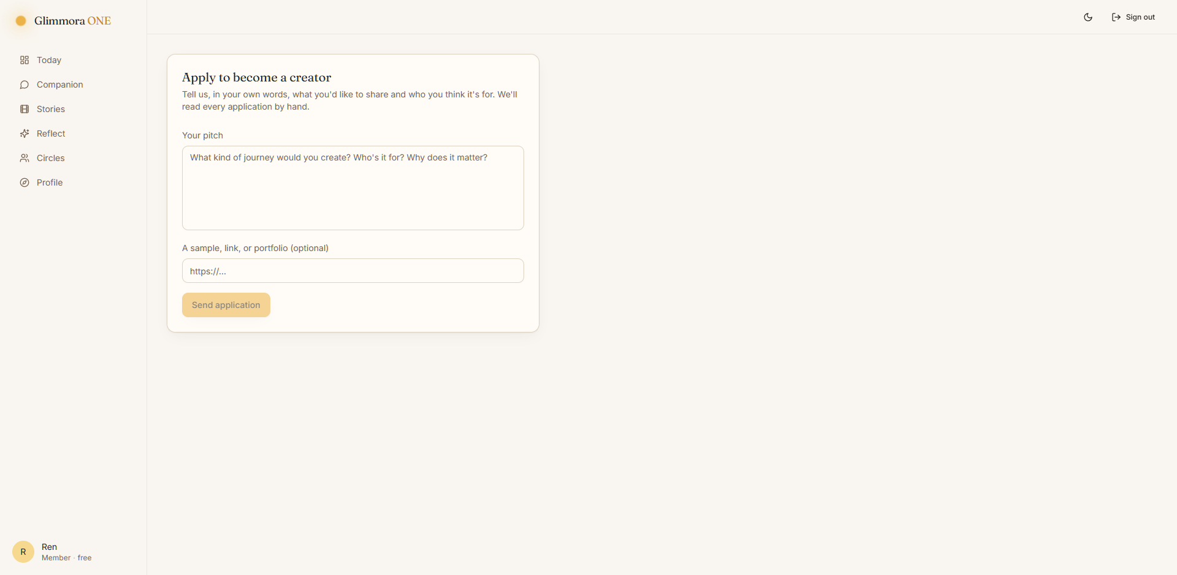
The apply page.
After you apply, the page shows 'YOUR APPLICATION — PENDING'. An admin reads it. If they approve you, your role becomes Creator the next time you visit. A new 'Studio' link will appear in your sidebar.
12. Studio — for Creators
When you're a Creator, click 'Studio'. You can:
- Create a new series (title, tagline, cover image).
- Add episodes to a series.
- See small analytics about how your series are doing.
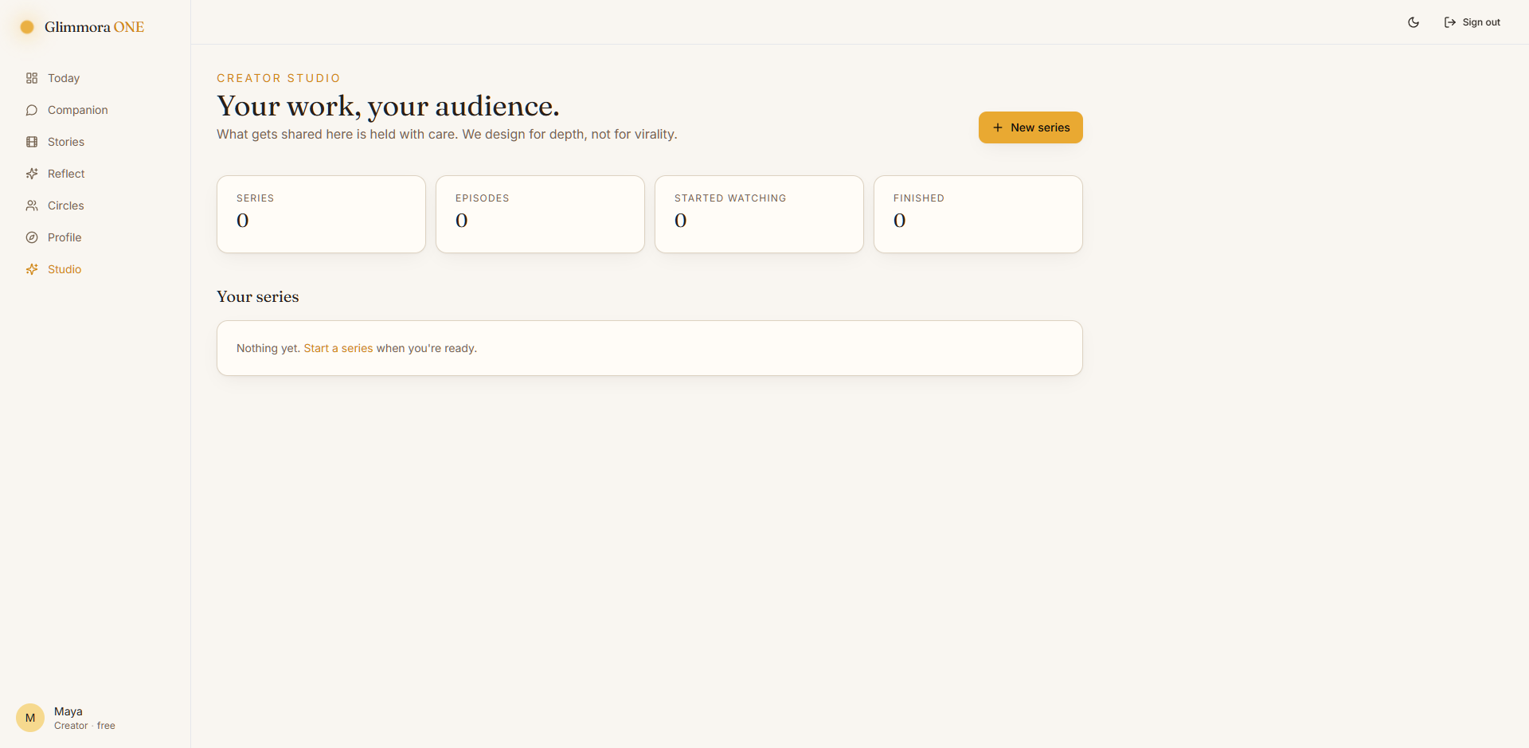
The Creator Studio.
13. Admin tools (only for Admins)
Admins see one extra link in the sidebar: 'Admin'. The Admin page shows:
- Numbers — users, series, episodes, reflections, conversations, posts.
- Creator applications — Approve or Deny.
- Users — a list of everyone on the platform.
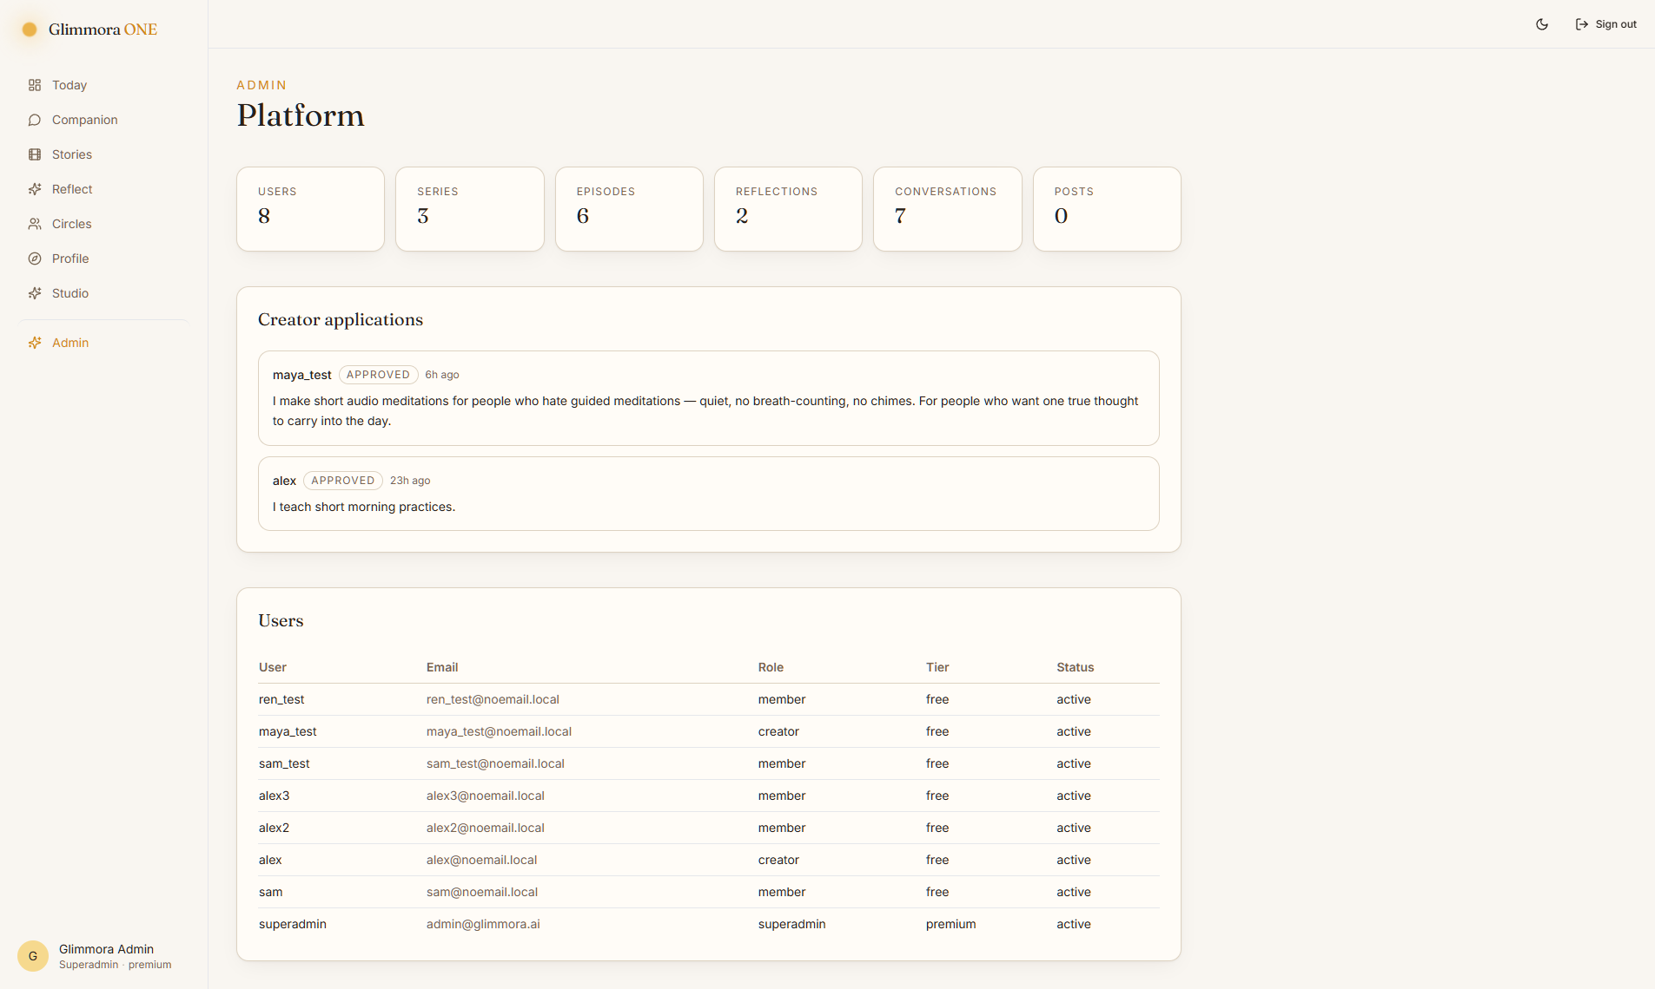
The Admin page.
14. Dark and light mode
Click the moon or sun in the top-right of any page. The app switches. It remembers your choice for next time.
15. If something goes wrong
- Can't log in? Check the username and password. They are case-sensitive.
- Page is blank? Refresh once. If still blank, restart the dev server.
- Companion says 'companion is resting'? Wait a few seconds and try again.
- If you need help, contact your admin or the person who set up Glimmora.
16. Safety
Glimmora ONE is not a doctor or a therapist. It's a calm space for reflection. If you're in danger, please contact a real person — a trusted adult, or a local crisis line. The Companion will show you the closest crisis numbers on the safety card.

