Лаб 5

1. Татвар

*НДШ => NDSH = 11%,  
Татвар ногдуулах орлого => TNO,  
Ногдуулсан албан татвар => NAT,  
Чөлөөлөгдөх татвар =>CHT,  
Төлбөл зохих татвар =>TZT,  
Гарт авах цалин=>GATS*

Кодны бүтэц:

**Tatvar2020**

**<<class>>**

* Salary: Long
* NDHSProcent:float
* NATProcent:float
* CHTProcent:float

**Tatvar2021**

**<<class>>**

* Salary: Long
* NDHSProcent:float
* NATProcent:float
* CHTProcent:float

**iTatvar**

**<<Interface>>**

+ show(): void

**Abstract**

**<<class>>**

* Salary: long
* GATS: long
* NDSH: float
* TNO: float
* NAT:float
* CHT: float
* TZT: float

+ show(): void

**Main**

Create object

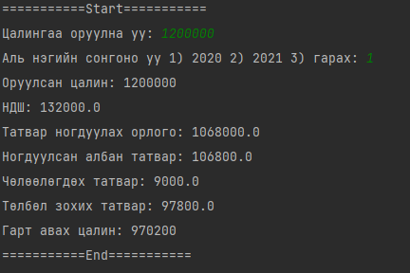

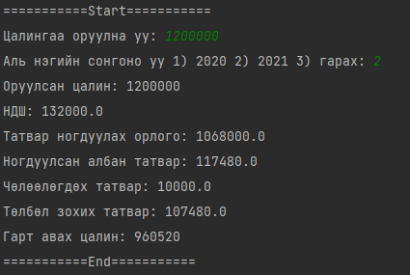

Main.java

public class Main {  
 public static void main(String[] args) {  
 int Salary,type;  
 Scanner sc = new Scanner(System.*in*);  
 while(1==1) {  
 System.*out*.println("===========Start===========");  
 System.*out*.print("Цалингаа оруулна уу: ");  
 Salary = sc.nextInt();  
 System.*out*.print("Аль нэгийн сонгоно уу 1) 2020 2) 2021 3) гарах: ");  
 type = sc.nextInt();  
 switch (type){  
 case 1: {  
 AbsTatvar Tatvar2020 = new Tatvar2020(Salary);  
 Tatvar2020.show();  
 }break;  
 case 2: {  
 AbsTatvar Tatvar2021 = new Tatvar2021(Salary);  
 Tatvar2021.show();  
 }break;  
 default: System.*exit*(0);  
 }  
 }  
 }  
}

iTatvar(interface)

public interface iTatvar {  
 void show();  
}

Tatvar2021.java(class)

public class Tatvar2021 extends AbsTatvar implements iTatvar{  
 Tatvar2021(int Salary){  
 super(Salary, (float) 0.11, (float) 0.11

, 10000);  
 }  
}

Tatvar2020.java(class)

public class Tatvar2020 extends AbsTatvar implements iTatvar{  
 Tatvar2020(int Salary){  
 super(Salary, (float) 0.11, (float) 0.1, 9000);  
 }  
}

AbsTatvar.java(abstract)

import java.util.Scanner;  
  
public abstract class AbsTatvar{  
 */**НДШ => NDSH = 11%,  
 * Татвар ногдуулах орлого => TNO,  
 * Ногдуулсан албан татвар => NAT,  
 * Чөлөөлөгдөх татвар =>CHT,  
 * Төлбөл зохих татвар =>TZT,  
 * Гарт авах цалин=>GATS* */* long Salary,GATS;  
 float NDSH,TNO, NAT, CHT,TZT;  
 AbsTatvar(int salary,float ndsh,float nat,float cht){   
 this.Salary = salary;  
 this.NDSH = salary*(ndsh);//0.11  
 this.TNO = salary - NDSH;  
 this.NAT = TNO*(nat);//0.1  
 this.CHT = cht;//0.1  
 this.TZT = NAT-CHT;//0.9  
 this.GATS = (long) (TNO - NAT+CHT);  
 }  
 public void show() {  
 System.*out*.println("Оруулсан цалин: "+Salary);  
 System.*out*.println("НДШ: "+NDSH);  
 System.*out*.println("Татвар ногдуулах орлого: "+TNO);  
 System.*out*.println("Ногдуулсан албан татвар: "+NAT);  
 System.*out*.println("Чөлөөлөгдөх татвар: "+CHT);  
 System.*out*.println("Төлбөл зохих татвар: "+TZT);  
 System.*out*.println("Гарт авах цалин: "+GATS);  
 System.*out*.println("===========End===========");  
 }  
  
}