Лаб 5

2. Natural, Social

**ALesson**

**<<abstract class>>**

* **Name : string**
* **Credit: float**
* **Payment : long**

**+ setCredit(); void**

**+ setName(); void**

**+ setPayment; void**

**+ getCredit(); void**

**+ getName(); void**

**+ getPayment; void**

**Natural**

**<<class>>**

* **Name : string**
* **Credit: float**
* **Payment : long**

**Social**

**<<class>>**

* **Name : string**
* **Credit: float**
* **Payment : long**

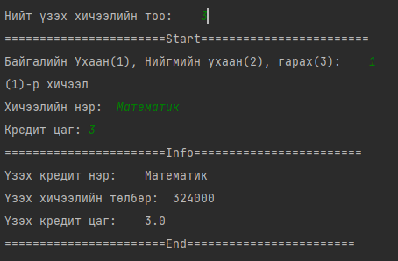

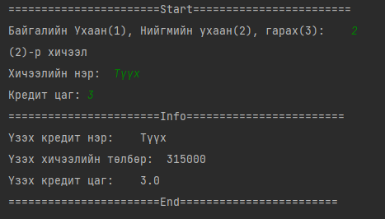

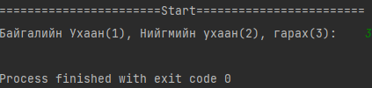

Main.java

public static void main(String[] args) {  
 ALesson natural,socail;  
 Scanner sc = new Scanner(System.*in*);  
 String name;  
 long payment;  
 float Credit;  
 int Lesson_Count,lessonType = 0;  
 System.*out*.println("=======================(Start)========================");  
 System.*out*.print("Нийт үзэх хичээлийн тоо:\t");  
 Lesson_Count = sc.nextInt();  
  
 for (int i = 0;i < Lesson_Count;i++){  
 System.*out*.println("=======================Start========================");  
 System.*out*.print("Байгалийн Ухаан(1), Нийгмийн ухаан(2), гарах(3):\t");  
 lessonType = sc.nextInt();  
 switch (lessonType) {  
 case 1: {  
 System.*out*.println("("+(i+1)+")-р хичээл");  
 System.*out*.print("Хичээлийн нэр:\t");  
 name = sc.next();  
 System.*out*.print("Кредит цаг:\t");  
 Credit = sc.nextFloat();  
  
 natural = new Natural(name, Credit, (long) (108000 * Credit));  
 System.*out*.println("=======================Info========================");  
 natural.getName();  
 natural.getPayment();  
 natural.getCredit();  
 break;  
 }  
 case 2: {  
 System.*out*.println("("+(i+1)+")-р хичээл");  
 System.*out*.print("Хичээлийн нэр:\t");  
 name = sc.next();  
 System.*out*.print("Кредит цаг:\t");  
 Credit = sc.nextFloat();  
  
 socail = new Social(name, Credit, (long) (105000 * Credit));  
 System.*out*.println("=======================Info========================");  
 socail.getName();  
 socail.getPayment();  
 socail.getCredit();  
 break;  
 }  
 case 3: {  
 System.*exit*(0);  
 break;  
 }  
 }  
 System.*out*.println("=======================End========================");  
 }  
  
 System.*out*.println("=======================(End)========================");  
}

**Social.java**

public class Social extends ALesson{  
 Social(String name, float credit, long payment) {  
 super(name, credit, payment);  
 }  
}

**Natural.java**

public class Natural extends ALesson{  
 Natural(String name, float credit, long payment) {  
 super(name, credit, payment);  
 }  
}

**ALesson.java-abstract class**

public abstract class ALesson {  
 */**  
 * Name, Credit, Payment  
 * */* String Name="";  
 float Credit = 0;  
 long Payment = 0;  
  
 ALesson(String name, float credit,long payment){  
 this.Name = name;  
 this.Credit = credit;  
 this.Payment = payment;  
 }  
  
 public void setCredit(float credit) {  
 Credit = credit;  
 }  
  
 public void setPayment(long payment) {  
 Payment = payment;  
 }  
  
 public void setName(String name) {  
 Name = name;  
 }  
  
 public float getCredit() {  
 System.*out*.println("Үзэх кредит цаг:\t"+Credit);  
 return Credit;  
 }  
  
 public long getPayment() {  
 System.*out*.println("Үзэх хичээлийн төлбөр:\t"+Payment);  
 return Payment;  
 }  
  
 public String getName() {  
 System.*out*.println("Үзэх кредит нэр:\t"+Name);  
 return Name;  
 }  
}