**8** [**Tally is frequently turning to educational mode.**](http://greetbss.greettech.com/cgi-bin/greettech/Licening-1.php?flag=tally_educational_mood_frequently&empl_no=81002)

Dear Sir/Mam, we understand that your Tally license frequently turning to educational mode. In this regard we would like to inform you that, if the Tally gateway services is not running, then Tally will turn to educational mode. Hence to ensure that the Tally gateway services are always in running status, we suggest you to:

1.      Press   **Windows+R**  > type   **services.msc**  and press   **Enter** . The service management window opens.

2.      Check the status of   **Tally Gateway Server** . If it has stopped, right-click and   **Start**  the service.

**Further we suggest you to configure the recovery options at the Service level to avoid the gateway services to stop automatically.**

1.      Go to   **Start**   >   **Run**   > type   **Services.msc** .

2.      Click   **OK** .

3.      In the Service management screen, search for   **Tally Gateway Service**   > right-click and select   **Properties** .

4.      Click the   **Recovery**   tab, and make the below changes. (Need to set the option “Restart the service” for first, second and subsequent failure”) As shown below:

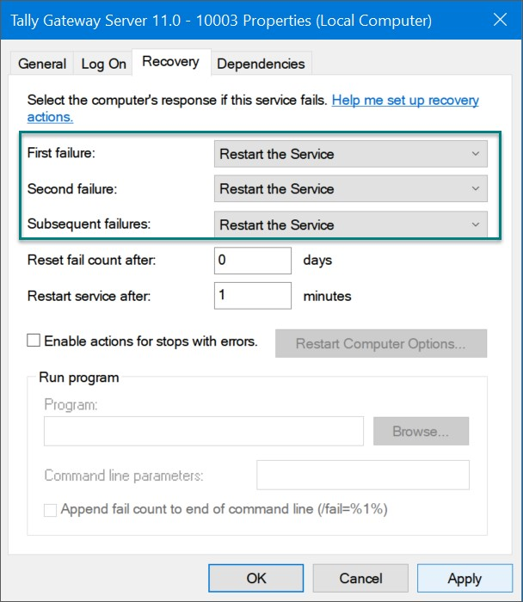

2. 5.      Click   **Apply**   to restart the service.

In case there are multiple gateway services, uninstall the unused gateway services.

**To Uninstall Tally Gateway**  **Server**

1.      Open the   **Command Prompt**   in administrator mode.

2.      In the Command Prompt, navigate to the folder where   **Tally Gateway Server**   is installed.

3.      Type   **tallygatewayserver.exe – u**   and press   **Enter**   to uninstall the   **Tally**  **Gateway Server** .  
You will get a confirmation as shown below.

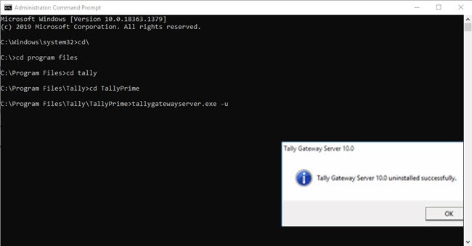

Now we suggest you to please check whether the license is still turning to educational mode or not.

If Not,

**Hope I have resolved your query?**

If License is in educational mode,

Sir/Ma’am, we are escalating your case to Xperts and our team will get back to you on the same within 2 bhrs” (escalate the case by selecting the escalation reason as ' Solution not known ').

1. [Unable to reactivate the license; it shows error code 404 and displays the message: 'Activation/Reactivation Failed due to Gateway Server Installation Failure.](http://greetbss.greettech.com/cgi-bin/greettech/Licening-1.php?flag=Unable_to_reactivate&empl_no=81002)

Dear Sir/Mam, we understand that while activating or reactivating the license, you are getting a message as “Activation/reactivation failed due to Gateway Server installation failure”.   For the same we would like to suggest you to:

1. Delete all the Tally.dmp files and Gatewayserver.dmp files from the TallyPrime application/installation folder. (Note: To open the Application/installation Folder: Press F1 (Help) > About, and click Application Path under the Product Information section).

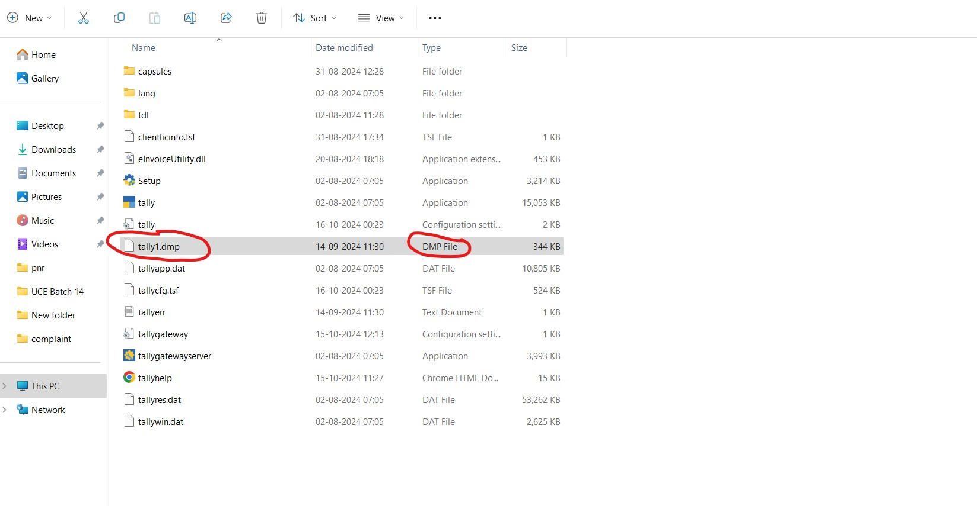

1. Later set the permission of Tally Gateway Server to full control: Right click Tallygatewayserver.exe > Properties > Security Control.   (Note: in case the full control has not been given for all the users, then need to create a new user “Everyone” and allow full control to it).

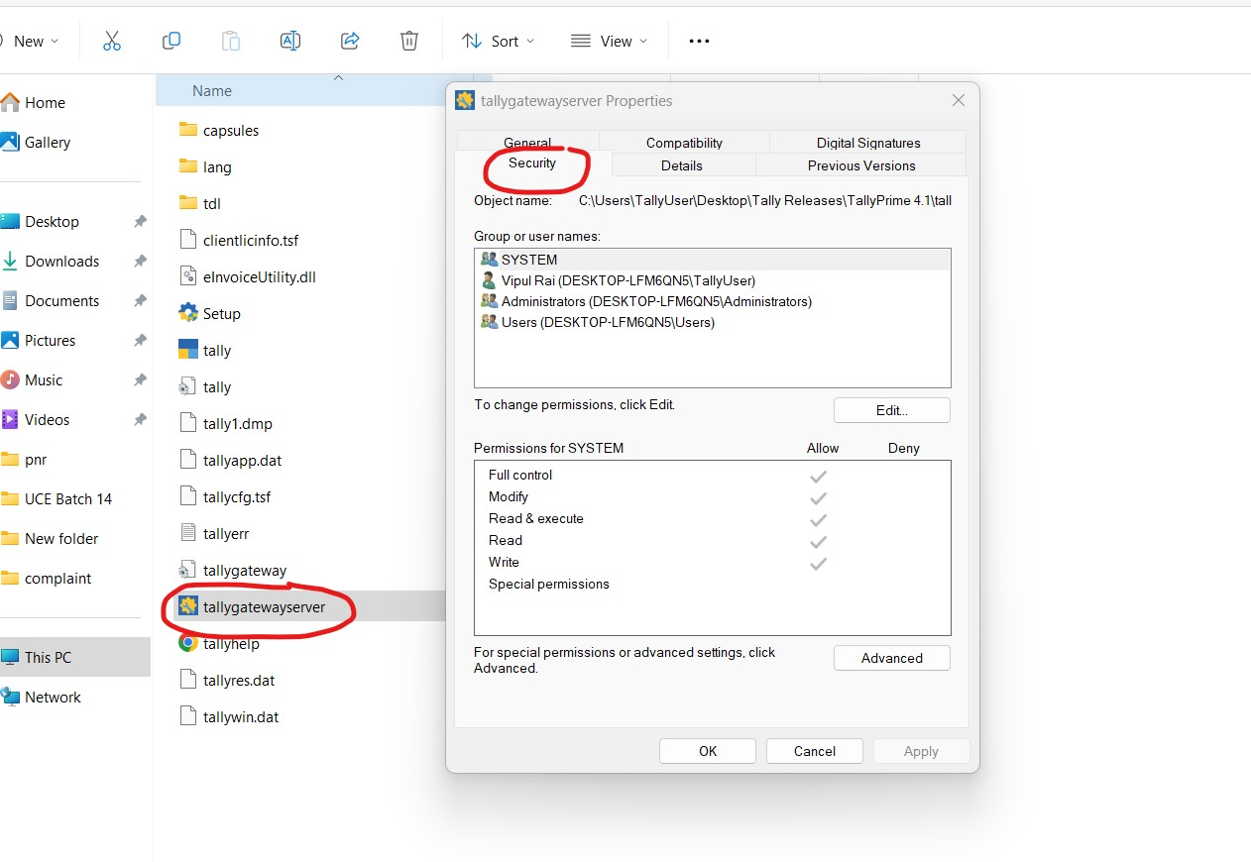

*To allow full control, Click on Edit option.

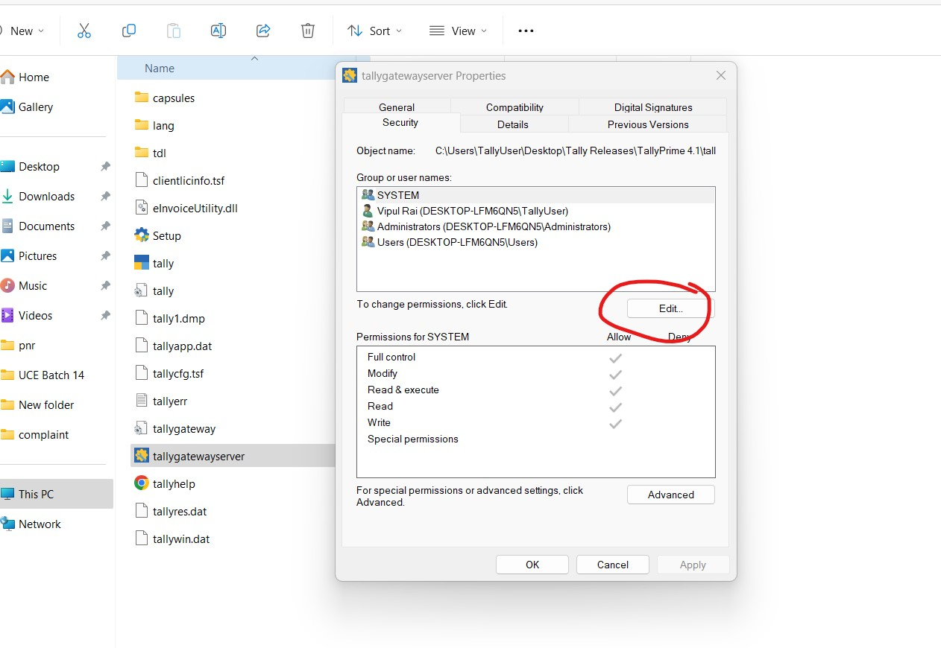

1. Click Add in the Permissions for tallygatewayserver.exe screen.



*To allow full control, Click on Edit option.



1. Click Add in the Permissions for tallygatewayserver.exe screen.