ASIC Design and Modeling

ECE – 581

Project – 1

Engineers: 1] Yadnesh Samant (ysamant@pdx.edu)

2] Hiral Barot (bhiral@pdx.edu)

Task 2: For the following problems, implement them in SV with testbench and simulate  
the design using an HDL simulator.

**2.1)** A full adder has the truth table for its sum (S) and carry (Co) outputs, in terms of its inputs, A,  
B and carry in (Ci).

1] Derive expressions for S and Co using only AND and OR operators. Hence write a SystemVerilog description of a full adder as a netlist of AND and OR gates and inverters. Do not include any gate delays in your models.

**Answer]** Module Name: hw_sum_tb …. (Please refer to the code with module name)

Code Snippet:

always_comb

begin

Co = (A & B) | (B & C) | (A & C);

S = (~A & ~B & C) | (~A & B & ~C) | (A & ~B & ~C) | (A & B & C);

end

2] Write a SystemVerilog testbench to test all combinations of inputs to the full adder of 1). Verify the correctness of your full adder and of the testbench using a SystemVerilog simulator.

**Answer]** Module Name: hw_sum_tb …. (Please refer to the code with module name)

**Description:** This is a self-checking test bench which will shell out the error if mis-match is found. A function is created which will generate the “expected sum” which is used to compare with the actual sum and carry generated by the Design under test. If the mismatch is found, error will be displayed in the console.

**Console output:**

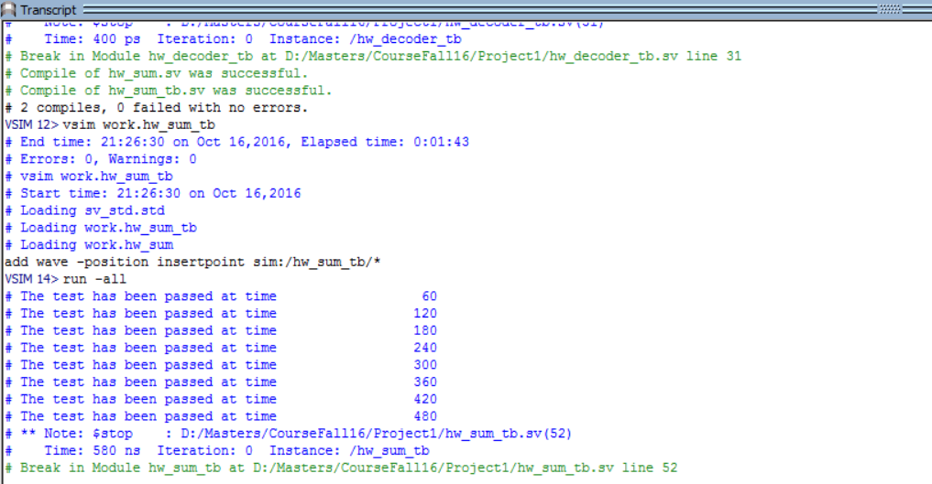

**Waveforms:**

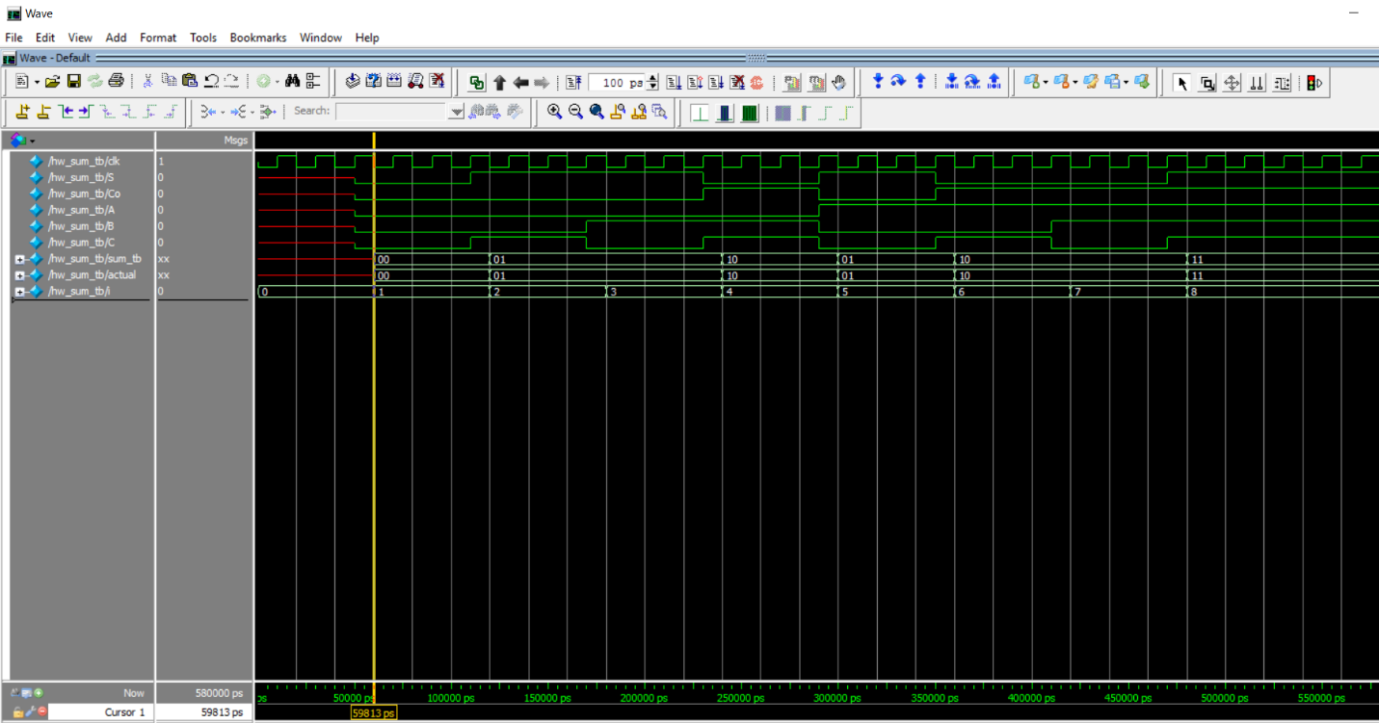

**2.2)** Write SystemVerilog models of a 3 to 8 decoder using (a) Boolean operators, (b) a conditional operator and (c) a shift operator. Write a testbench to compare the three versions.

**A] Boolean Operator**

Module name: hw_3_8_decoder …. (Please refer to the code with module name)

Description: Boolean operators are also called as Logical operators.

|  |  |  |  |  |  |  |  |  |  |  |
| --- | --- | --- | --- | --- | --- | --- | --- | --- | --- | --- |
| **INPUT** | | | **OUTPUT** | | | | | | | |
| **s2** | **s1** | **s0** | **q0** | **q1** | **q2** | **q3** | **q4** | **q5** | **q6** | **q7** |
| 0 | 0 | 0 | 1 | 0 | 0 | 0 | 0 | 0 | 0 | 0 |
| 0 | 0 | 1 | 0 | 1 | 0 | 0 | 0 | 0 | 0 | 0 |
| 0 | 1 | 0 | 0 | 0 | 1 | 0 | 0 | 0 | 0 | 0 |
| 0 | 1 | 1 | 0 | 0 | 0 | 1 | 0 | 0 | 0 | 0 |
| 1 | 0 | 0 | 0 | 0 | 0 | 0 | 1 | 0 | 0 | 0 |
| 1 | 0 | 1 | 0 | 0 | 0 | 0 | 0 | 1 | 0 | 0 |
| 1 | 1 | 0 | 0 | 0 | 0 | 0 | 0 | 0 | 1 | 0 |
| 1 | 1 | 1 | 0 | 0 | 0 | 0 | 0 | 0 | 0 | 1 |

Boolean Equations: (~ : NOT)

Q0 = ~s2~s1~s0 Q4 = s2~s1~s0

Q1 = ~s2~s1 s0 Q5 = s2~s1 s0

Q2 = ~s2 s1~s0 Q6 = s2 s1~s0

Q3 = ~s2 s1 s0 Q7 = s2 s1 s0

Code snippet:

always_comb

begin

if(EN == 1)begin

q[0] = (~s[2] && ~s[1] && ~s[0]);

q[1] = (~s[2] && ~s[1] && s[0]);

q[2] = (~s[2] && s[1] && ~s[0]);

q[3] = (~s[2] && s[1] && s[0]);

q[4] = ( s[2] && ~s[1] && ~s[0]);

q[5] = ( s[2] && ~s[1] && s[0]);

q[6] = ( s[2] && s[1] && ~s[0]);

q[7] = ( s[2] && s[1] && s[0]);

end

else

q=8'b0;

end

**B] Conditional Operator**

**Answer]** Module Name: hw_3_8_decoder_cond …. (Please refer to the code with module name)

Description: Conditional operators are also called as Ternary operators, which when synthesized form a MUX structure.

Code Snippet:

always_comb

begin

if(EN == 1)begin

q[0] = (s == 3'd0) ? 1'b1 : 1'b0;

q[1] = (s == 3'd1) ? 1'b1 : 1'b0;

q[2] = (s == 3'd2) ? 1'b1 : 1'b0;

q[3] = (s == 3'd3) ? 1'b1 : 1'b0;

q[4] = (s == 3'd4) ? 1'b1 : 1'b0;

q[5] = (s == 3'd5) ? 1'b1 : 1'b0;

q[6] = (s == 3'd6) ? 1'b1 : 1'b0;

q[7] = (s == 3'd7) ? 1'b1 : 1'b0;

end

else

q=8'b0;

end

**C] Shift Operator:**

Answer] Module Name: hw_3_8_decoder_shift …. (Please refer to the code with module name)

Description: Q0 bit s loaded with 1 and is Left-shifted based on the input given to the module.

Code Snippet:

//Temporary value to hold q[0]

logic [7:0] q_temp = 8'b1;

always_comb

begin

if(EN == 1) begin

q = q_temp << s;

end

else

q=8'b0;

end

**Test Bench:**

**Module Name:** hw_decoder_tb

**Waveform:**

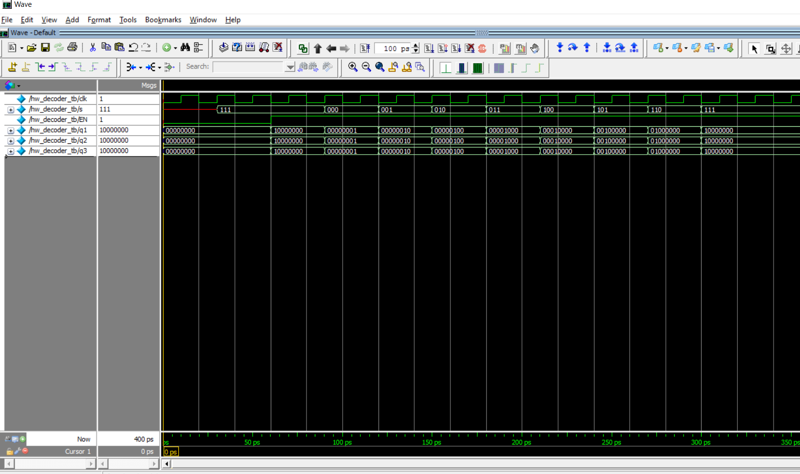

**2.3]** Write a SystemVerilog model of a 2n to n priority encoder.

Module name: hw_priority_encoder …. (Please refer to the code with module name)

Description: The priority encoder is designed such that if MSB bit has a SET value of 1, all the bits below i.e LSBs will be ignored. A parameter is created, which takes a value from the instantiation. For eg. If n=3, the from 2^(3)=8 inputs, bit 7 will have higher priority over bit 0.

Eg. If input =>enc_in[7:0] = 8’b01100000, as bit 6 i.e enc_in[6]=1, it will be given higher priority over bit 5. Thus the output => enc_op = 3’b110

**Code Snippet:**

always_comb

begin

if(enc_in == 0)

enc_op= 'x;

else

for(i=0;i<2**n;i=i+1) begin

if(enc_in[i] == 1'b1)

enc_op = i;

end

end

**TestBench:**

Module name: hw_priority_encoder_tb … (Please refer to the code with module name)

Description: Various 8 bits inputs were given to the design under test, and the behavior was validated using the waveform.

**WaveForm:**

