 | Univerzitet u Novom Sadu  Tehnički fakultet »MihajloPupin«  Zrenjanin | 

Seminarski rad:
Predmet: Distributivni softverski sistemi

Tema: Common Object Request Broker Architecture (CORBA)

Profesor : Dr. Željnko Stojanov Student: Babic Bojan SI 12/17
Nemanja Svilarov SI 28/17
Prokin David SI 17/17

Zrenjanin, 2020. godina

Sadrzaj:
1.UVOD 2
2.Specifikacija zahteva korisnika 3
3.Faze razvoja softvera 4
a.Projektne ideje 4
b.Dizajn softvera i arhitektura 4
4. Prikaz softvera 6
5. Prikaz realizacija i implementacije 7
Prikaz izvornog koda 7
Rad sa Gih/Github sistemom 25
6. Korišteni alati i softveri 28
7. Literatura 29

1.UVOD

Seminarski rad iz predmeta Razvoj softvera otvorenog koda obuhvata izradu desktop aplikacije za laksu organizaciju u internet kaficima pod rukovodstvom administratora.Softver obuhvata: prijavu administrator; administrator moze da prijavljuje ili pravi nove korisnike; odjavljuje korisnike koji su u nekoj sesiji; sesije se mogu brisati ; dodavanja racunara .

2.Specifikacija zahteva korisnika

Zahtev 1 : Logovanje administratora radi kotrole sesija i prijavljenih korisnika,prioritet 1.
Zahtev 2: Prijavljivanje korisnika u neku sesiju, prioritet 3
Zahtev 3: Dodavanje novih korisnika, prioritet 2
Zahtev 4: Odjavljivanje korisnika iz neke sesije, prioritet 4.
Zahtev 5: Dodavanje novih racunara, prioritet 5.
Zahtev 6: Brisanje sesije, prioritet 6.
Zahtev 7: Odredjena zarada u zavisnosti od izabranog datuma, prioritet 7.

3.Faze razvoja softvera

a.Projektne ideje

Softver: desktop aplikacija , relaciona baza podataka (PHPMyAdmin za rukovanje bazama podataka), troslojna arhitektura softvera(Baza podataka , “backend”,”frontend”-interfejs).
Alat za razvoj: Sybase/SAP Power Designer CASE alat za projektovanje softvera ,PHPMyAdmin web aplikaciju za administraciju baze podataka,Visual Studio 2017 za pisanje desktop aplikacije u C# programskom jezik. Dokumentovanje u MS Word.
Izvrsavanje softvera: hostovanje baze podataka na lokalnom server (MS Windows OS, XAMP)

b.Dizajn softvera i arhitektura

Faza razvoja softvera:
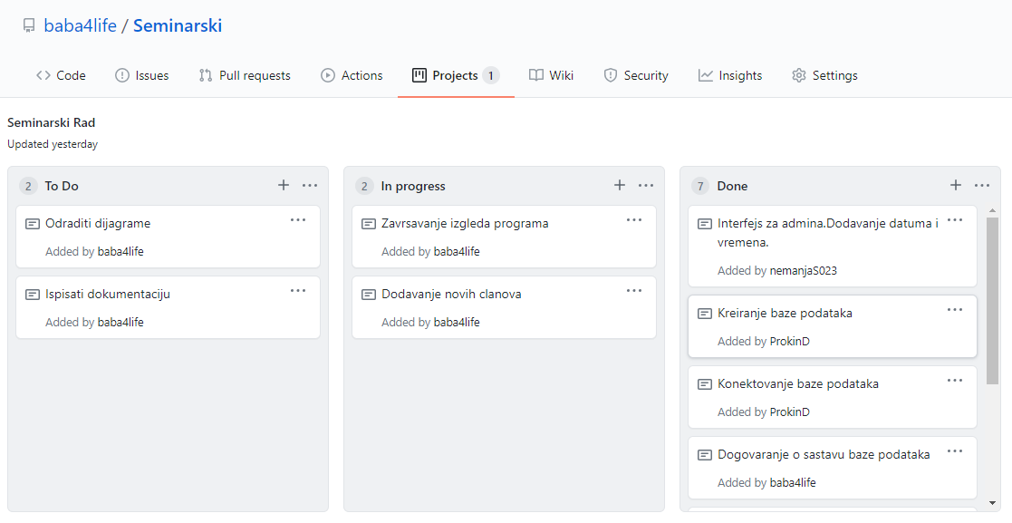

Sloj baze podataka: Konceptualni model baze podataka (BP, DB)
EER dijagram:
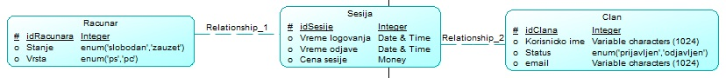
Rečnik podataka:
//recnik
Sloj baze podataka: Fizički model baze podataka (BP, DB)
Dijagram relacionog modela:

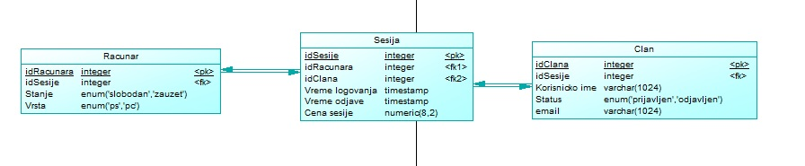

Srednji aplikacioni sloj: Objektni model srednjeg aplikacionog sloja (dijagram klasa objektnog modela):

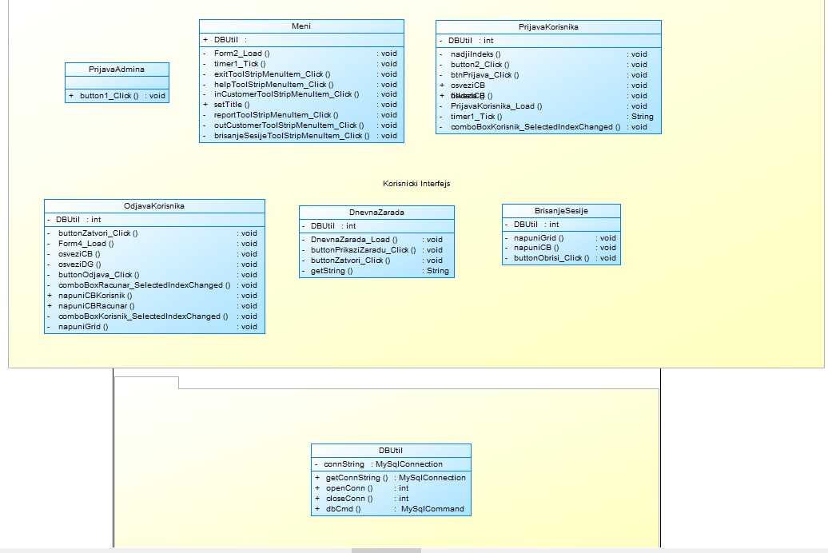

Sloj KI: Softverske funkcije i korisnici (dijagram slučajeva korišćenja):

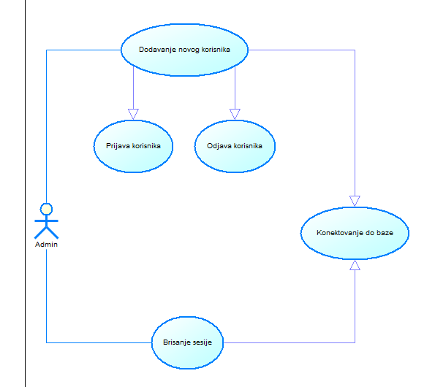

Sloj KI: Logika i aktivnosti slučajeva korišćenja

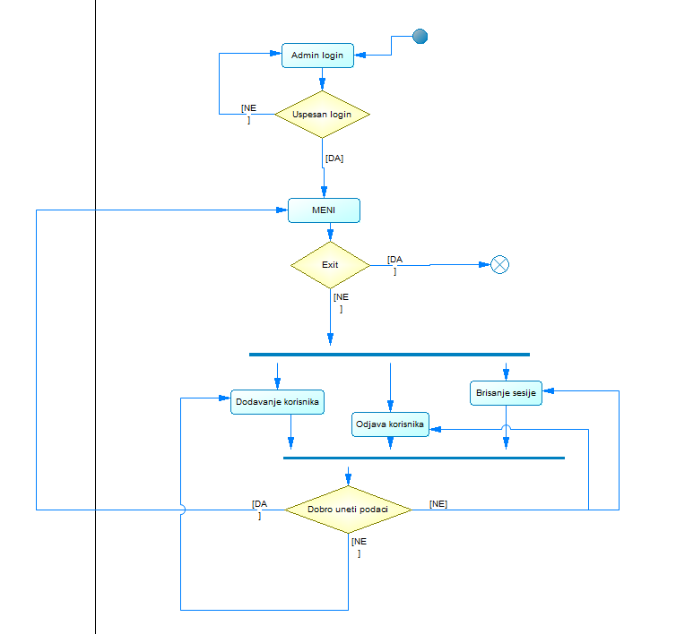

4. Prikaz softvera

Nakon instaliranja XAMP softverskog paketa, aplikacija se kopira u folder C:\Xamp\htdocs\internet_caffee
U PHPMyAdmin softveru se kreira baza podataka sa nazivom: internet_caffee
Zatim se u izvšri SQL DDL skript za kreiranje objekata baze podataka.
Pokretanje aplikacije je iz Visual Studia
Početni prozor:
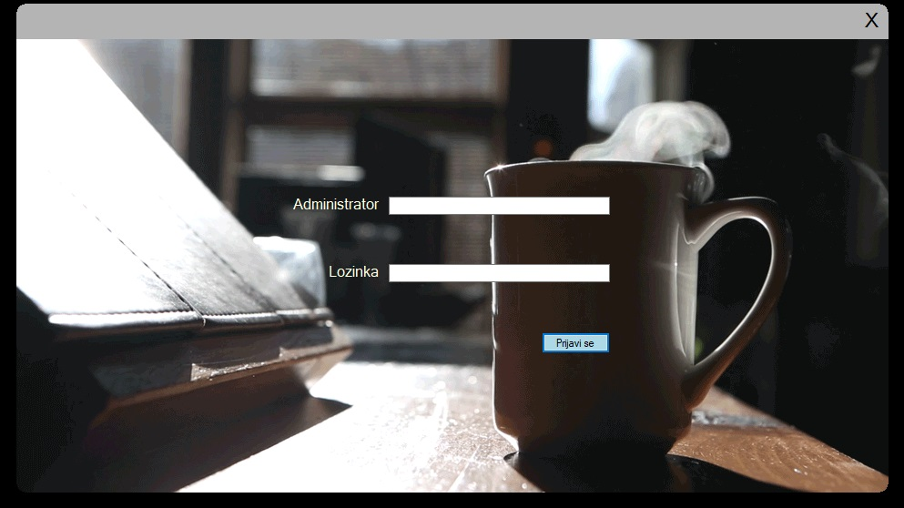

Prozor glavnog menia:
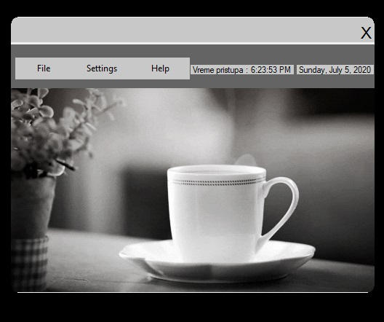

Prozor za dodavanje i prijavu korisnika:
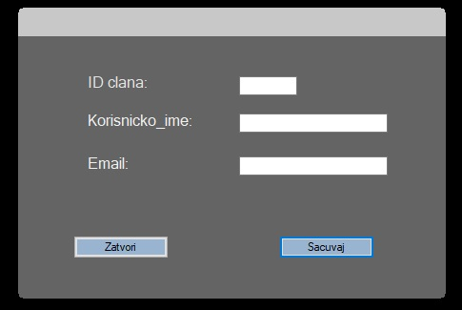

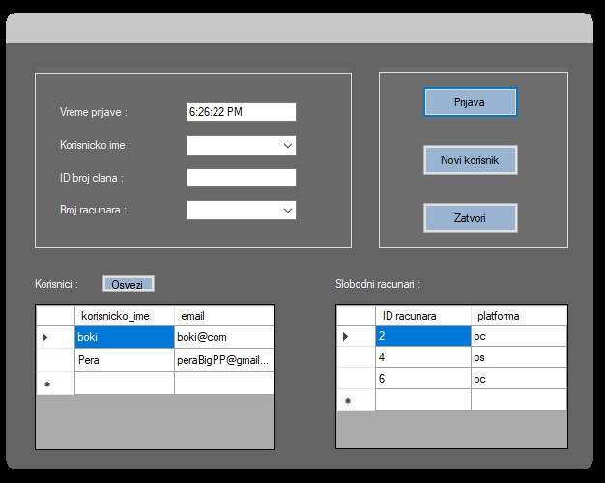

Prozor za odjavljivanje korisnika iz sesije:

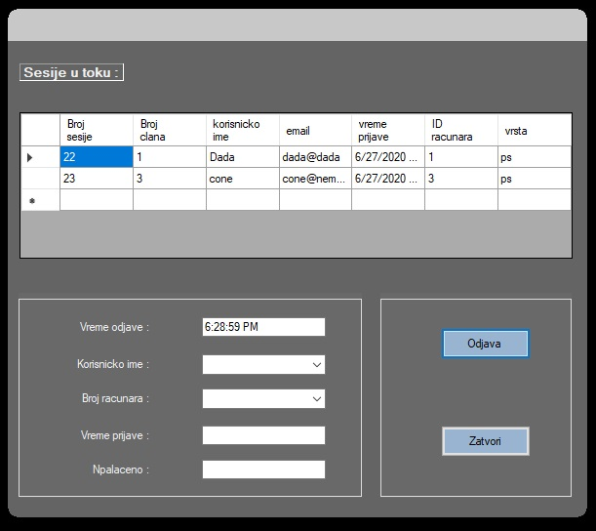

Prozor za izracunatu zaradu nekog datuma
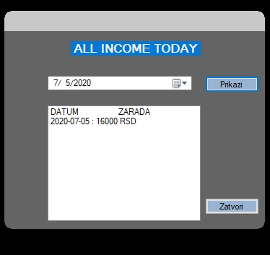

Prozor za dodavanje novih racunara

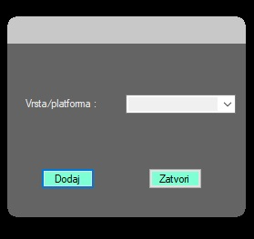

Prozor za brisanje sesije:
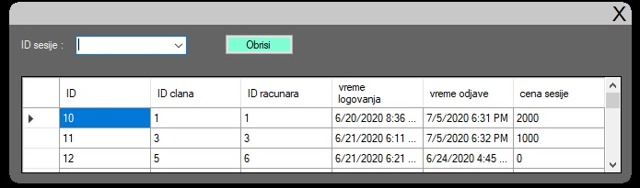
Poruka prilikom pritiskanja ‘Help’

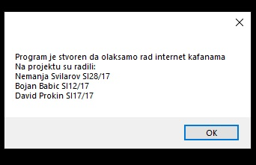

5. Prikaz realizacija i implementacije

SQL DDL skripta za kreiranje baze podataka:
-- phpMyAdmin SQL Dump
-- version 4.9.1
-- https://www.phpmyadmin.net/
--
-- Host: 127.0.0.1
-- Generation Time: Jul 05, 2020 at 06:44 PM
-- Server version: 10.4.8-MariaDB
-- PHP Version: 7.3.10

SET SQL_MODE = "NO_AUTO_VALUE_ON_ZERO";
SET AUTOCOMMIT = 0;
START TRANSACTION;
SET time_zone = "+00:00";

/*!40101 SET @OLD_CHARACTER_SET_CLIENT=@@CHARACTER_SET_CLIENT */;
/*!40101 SET @OLD_CHARACTER_SET_RESULTS=@@CHARACTER_SET_RESULTS */;
/*!40101 SET @OLD_COLLATION_CONNECTION=@@COLLATION_CONNECTION */;
/*!40101 SET NAMES utf8mb4 */;

--
-- Database: `internet_cafe`
--

-- --------------------------------------------------------

--
-- Table structure for table `clan`
--

CREATE TABLE `clan` (
`ID clana` int(11) UNSIGNED NOT NULL,
`korisnicko_ime` varchar(40) NOT NULL,
`email` varchar(40) DEFAULT NULL,
`status` enum('prijavljen','odjavljen') DEFAULT NULL
) ENGINE=InnoDB DEFAULT CHARSET=utf8mb4;

--
-- Dumping data for table `clan`
--
-- --------------------------------------------------------

--
-- Stand-in structure for view `clanovizaprijavu`
-- (See below for the actual view)
--
CREATE TABLE `clanovizaprijavu` (
`korisnicko_ime` varchar(40)
,`email` varchar(40)
);

-- --------------------------------------------------------

--
-- Table structure for table `racunar`
--

CREATE TABLE `racunar` (
`ID racunara` int(10) UNSIGNED NOT NULL,
`stanje` enum('slobodan','zauzet') NOT NULL,
`vrsta` enum('pc','ps') NOT NULL
) ENGINE=InnoDB DEFAULT CHARSET=utf8mb4;

--
-- Dumping data for table `racunar`
--

-- --------------------------------------------------------

--
-- Table structure for table `sesija`
--

CREATE TABLE `sesija` (
`ID` int(10) UNSIGNED NOT NULL,
`ID clana` int(10) UNSIGNED NOT NULL,
`ID racunara` int(10) UNSIGNED NOT NULL,
`vreme logovanja` datetime NOT NULL,
`vreme odjave` datetime DEFAULT NULL,
`cena sesije` double UNSIGNED DEFAULT NULL
) ENGINE=InnoDB DEFAULT CHARSET=utf8mb4;

--
-- Dumping data for table `sesija`
--

-- --------------------------------------------------------

--
-- Stand-in structure for view `sesija_info`
-- (See below for the actual view)
--
CREATE TABLE `sesija_info` (
`ID clana` int(11) unsigned
,`korisnicko_ime` varchar(40)
,`email` varchar(40)
,`ID` int(10) unsigned
,`vreme logovanja` datetime
,`vreme odjave` datetime
,`cena sesije` double unsigned
,`ID racunara` int(10) unsigned
,`stanje` enum('slobodan','zauzet')
,`vrsta` enum('pc','ps')
);

-- --------------------------------------------------------

--
-- Stand-in structure for view `sesijeutoku`
-- (See below for the actual view)
--
CREATE TABLE `sesijeutoku` (
`ID` int(10) unsigned
,`ID clana` int(10) unsigned
,`ID racunara` int(10) unsigned
,`vreme logovanja` datetime
);

-- --------------------------------------------------------

--
-- Stand-in structure for view `sesije_u_toku_info`
-- (See below for the actual view)
--
CREATE TABLE `sesije_u_toku_info` (
`Broj clana` int(11) unsigned
,`korisnicko ime` varchar(40)
,`email` varchar(40)
,`Broj sesije` int(10) unsigned
,`vreme prijave` datetime
,`vreme odjave` datetime
,`cena sesije` double unsigned
,`ID racunara` int(10) unsigned
,`stanje` enum('slobodan','zauzet')
,`vrsta` enum('pc','ps')
);

-- --------------------------------------------------------

--
-- Stand-in structure for view `slobodni_racunari`
-- (See below for the actual view)
--
CREATE TABLE `slobodni_racunari` (
`ID racunara` int(10) unsigned
,`stanje` enum('slobodan','zauzet')
,`platforma` enum('pc','ps')
);

-- --------------------------------------------------------

--
-- Structure for view `clanovizaprijavu`
--
DROP TABLE IF EXISTS `clanovizaprijavu`;

CREATE ALGORITHM=UNDEFINED DEFINER=`root`@`localhost` SQL SECURITY DEFINER VIEW `clanovizaprijavu` AS select `clan`.`korisnicko_ime` AS `korisnicko_ime`,`clan`.`email` AS `email` from `clan` ;

-- --------------------------------------------------------

--
-- Structure for view `sesija_info`
--
DROP TABLE IF EXISTS `sesija_info`;

CREATE ALGORITHM=UNDEFINED DEFINER=`root`@`localhost` SQL SECURITY DEFINER VIEW `sesija_info` AS select `a`.`ID clana` AS `ID clana`,`a`.`korisnicko_ime` AS `korisnicko_ime`,`a`.`email` AS `email`,`b`.`ID` AS `ID`,`b`.`vreme logovanja` AS `vreme logovanja`,`b`.`vreme odjave` AS `vreme odjave`,`b`.`cena sesije` AS `cena sesije`,`c`.`ID racunara` AS `ID racunara`,`c`.`stanje` AS `stanje`,`c`.`vrsta` AS `vrsta` from ((`clan` `a` join `sesija` `b`) join `racunar` `c` on(`a`.`ID clana` = `b`.`ID clana` and `b`.`ID racunara` = `c`.`ID racunara`)) ;

-- --------------------------------------------------------

--
-- Structure for view `sesijeutoku`
--
DROP TABLE IF EXISTS `sesijeutoku`;

CREATE ALGORITHM=UNDEFINED DEFINER=`root`@`localhost` SQL SECURITY DEFINER VIEW `sesijeutoku` AS select `sesija`.`ID` AS `ID`,`sesija`.`ID clana` AS `ID clana`,`sesija`.`ID racunara` AS `ID racunara`,`sesija`.`vreme logovanja` AS `vreme logovanja` from `sesija` where `sesija`.`vreme odjave` = NULL ;

-- --------------------------------------------------------

--
-- Structure for view `sesije_u_toku_info`
--
DROP TABLE IF EXISTS `sesije_u_toku_info`;

CREATE ALGORITHM=UNDEFINED DEFINER=`root`@`localhost` SQL SECURITY DEFINER VIEW `sesije_u_toku_info` AS select `a`.`ID clana` AS `Broj clana`,`a`.`korisnicko_ime` AS `korisnicko ime`,`a`.`email` AS `email`,`b`.`ID` AS `Broj sesije`,`b`.`vreme logovanja` AS `vreme prijave`,`b`.`vreme odjave` AS `vreme odjave`,`b`.`cena sesije` AS `cena sesije`,`c`.`ID racunara` AS `ID racunara`,`c`.`stanje` AS `stanje`,`c`.`vrsta` AS `vrsta` from ((`clan` `a` join `sesija` `b`) join `racunar` `c` on(`a`.`ID clana` = `b`.`ID clana` and `b`.`ID racunara` = `c`.`ID racunara` and `b`.`cena sesije` is null)) ;

-- --------------------------------------------------------

--
-- Structure for view `slobodni_racunari`
--
DROP TABLE IF EXISTS `slobodni_racunari`;

CREATE ALGORITHM=UNDEFINED DEFINER=`root`@`localhost` SQL SECURITY DEFINER VIEW `slobodni_racunari` AS select `racunar`.`ID racunara` AS `ID racunara`,`racunar`.`stanje` AS `stanje`,`racunar`.`vrsta` AS `platforma` from `racunar` where `racunar`.`stanje` = 'slobodan' ;

--
-- Indexes for dumped tables
--

--
-- Indexes for table `clan`
--
ALTER TABLE `clan`
ADD PRIMARY KEY (`ID clana`);

--
-- Indexes for table `racunar`
--
ALTER TABLE `racunar`
ADD PRIMARY KEY (`ID racunara`);

--
-- Indexes for table `sesija`
--
ALTER TABLE `sesija`
ADD PRIMARY KEY (`ID`),
ADD KEY `sesijaclan` (`ID clana`),
ADD KEY `sesijaracunar` (`ID racunara`);

--
-- AUTO_INCREMENT for dumped tables
--

--
-- AUTO_INCREMENT for table `clan`
--
ALTER TABLE `clan`
MODIFY `ID clana` int(11) UNSIGNED NOT NULL AUTO_INCREMENT, AUTO_INCREMENT=22;

--
-- AUTO_INCREMENT for table `racunar`
--
ALTER TABLE `racunar`
MODIFY `ID racunara` int(10) UNSIGNED NOT NULL AUTO_INCREMENT, AUTO_INCREMENT=7;

--
-- AUTO_INCREMENT for table `sesija`
--
ALTER TABLE `sesija`
MODIFY `ID` int(10) UNSIGNED NOT NULL AUTO_INCREMENT, AUTO_INCREMENT=24;
COMMIT;

/*!40101 SET CHARACTER_SET_CLIENT=@OLD_CHARACTER_SET_CLIENT */;
/*!40101 SET CHARACTER_SET_RESULTS=@OLD_CHARACTER_SET_RESULTS */;
/*!40101 SET COLLATION_CONNECTION=@OLD_COLLATION_CONNECTION */;Kreiranje baze podataka, izvršavanjem SQL DDL skripta, u okviru PHPMyAdmin web aplikacije:
//slika
Naziv baze podataka: internet_caffee

Prikaz šeme baza podataka:

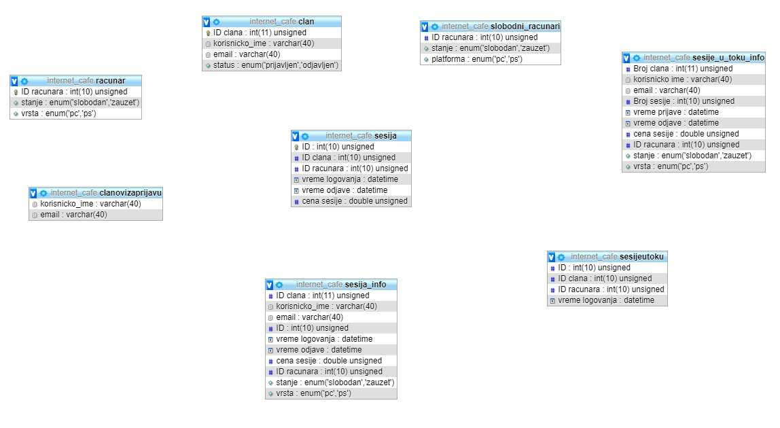

Prikaz izvornog koda
Pocetni prozor je za logovanje administrator . Za logovanje administrator postavljena je sifra ‘123’ a korisnicko ime ‘Admin’ kao sto je prikazano u sledecem kodu.
using System;
using System.Collections.Generic;
using System.ComponentModel;
using System.Data;
using System.Drawing;
using System.Linq;
using System.Text;
using System.Threading.Tasks;
using System.Windows.Forms;
using System.Runtime.InteropServices;

namespace WindowsFormsApp1
{
public partial class PrijavaAdmina : Form
{
[DllImport("Gdi32.dll", EntryPoint = "CreateRoundRectRgn")]
private static extern IntPtr CreateRoundRectRgn
(
int nLeftRect, // x-coordinate of upper-left corner
int nTopRect, // y-coordinate of upper-left corner
int nRightRect, // x-coordinate of lower-right corner
int nBottomRect, // y-coordinate of lower-right corner
int nWidthEllipse, // height of ellipse
int nHeightEllipse // width of ellipse
);

public PrijavaAdmina()
{
InitializeComponent();
//this.BackgroundImage = Properties.Resources.image2;
this.FormBorderStyle = FormBorderStyle.None;
Region = System.Drawing.Region.FromHrgn(CreateRoundRectRgn(0, 0, Width, Height, 20, 20));

}

private void button1_Click(object sender, EventArgs e)
{

if (textAdmin.Text == "Admin" && textPass.Text == "123")
{
this.Hide();
MessageBox.Show("Uspesno logovanje. Dobrodosli admine");
Forma2 form2 = new Forma2();
form2.ShowDialog();
this.Close();
}
else
{
MessageBox.Show("Ne uspesno logovanje");
}

}

int mouseX = 0,mouseY = 0;
bool mouseDown;

private void panel1_MouseMove(object sender, MouseEventArgs e)
{
if (mouseDown) {
mouseX = MousePosition.X - 200;
mouseY = MousePosition.Y - 40;

this.SetDesktopLocation(mouseX, mouseY);
}
}

private void label3_Click(object sender, EventArgs e)
{
this.Close();
}

private void panel1_MouseUp(object sender, MouseEventArgs e)
{
mouseDown = false;
}

private void panel1_MouseDown(object sender, MouseEventArgs e)
{
mouseDown = true;
}
}
}}

Kod prozora za dodavanje korisnika u bazu podataka kako bi mogli koristeni u naredne sesije
using MySql.Data.MySqlClient;
using System;
using System.Collections.Generic;
using System.ComponentModel;
using System.Data;
using System.Drawing;
using System.Linq;
using System.Linq.Expressions;
using System.Text;
using System.Threading.Tasks;
using System.Windows.Forms;
using System.Runtime.InteropServices;

namespace WindowsFormsApp1
{
public partial class NoviKorisnik : Form
{

[DllImport("Gdi32.dll", EntryPoint = "CreateRoundRectRgn")]
private static extern IntPtr CreateRoundRectRgn
(
int nLeftRect, // x-coordinate of upper-left corner
int nTopRect, // y-coordinate of upper-left corner
int nRightRect, // x-coordinate of lower-right corner
int nBottomRect, // y-coordinate of lower-right corner
int nWidthEllipse, // height of ellipse
int nHeightEllipse // width of ellipse
);

DBUtil dbu = new DBUtil();
public NoviKorisnik()
{
InitializeComponent();
this.FormBorderStyle = FormBorderStyle.None;
Region = System.Drawing.Region.FromHrgn(CreateRoundRectRgn(0, 0, Width, Height, 10, 10));
}

private void button1_Click(object sender, EventArgs e)
{
if (textBox1.Text.Equals(""))
{
MessageBox.Show("Unesite ID clana");
}
else if (textBox2.Text.Equals(""))
{
MessageBox.Show("Unesite korisnicko ime.");
}
else if (textBox3.Text.Equals(""))
{
MessageBox.Show("Unesite email.");

}
else
{
MySqlDataReader dr;
try
{
dbu.openConn();
MySqlCommand com1 = dbu.dbCmd("INSERT INTO `clan` (`ID clana`,`korisnicko_ime`,`email`,`status`)Values('"+textBox1.Text+"','"+textBox2.Text+"','"+textBox3.Text+"','odjevljen')");
com1.ExecuteNonQuery();

MessageBox.Show("Dodan novi korisnik!");
}
catch (Exception ex)
{
MessageBox.Show("SQL GRESKA " + ex.Message);
}

this.Close();
}
}

private void button2_Click(object sender, EventArgs e)
{
this.Close();
}

int mouseX = 0, mouseY = 0;
bool mouseDown;

private void panel1_MouseMove(object sender, MouseEventArgs e)
{
if (mouseDown)
{
mouseX = MousePosition.X - 200;
mouseY = MousePosition.Y - 40;

this.SetDesktopLocation(mouseX, mouseY);
}
}

private void panel1_MouseDown(object sender, MouseEventArgs e)
{
mouseDown = true;
}

private void panel1_MouseUp(object sender, MouseEventArgs e)
{
mouseDown = false;
}
}

}
Prozor za odjavu korisnika koji je zavrsio sa sfojom upotrebom nekog racunara
using System;
using System.Collections.Generic;
using System.ComponentModel;
using System.Data;
using System.Drawing;
using System.Drawing.Text;
using System.Linq;
using System.Text;
using System.Threading.Tasks;
using System.Windows.Forms;
using MySql.Data.MySqlClient;
using System.Runtime.InteropServices;

namespace WindowsFormsApp1
{
public partial class OdjavaKorisnika : Form
{
[DllImport("Gdi32.dll", EntryPoint = "CreateRoundRectRgn")]
private static extern IntPtr CreateRoundRectRgn
(
int nLeftRect, // x-coordinate of upper-left corner
int nTopRect, // y-coordinate of upper-left corner
int nRightRect, // x-coordinate of lower-right corner
int nBottomRect, // y-coordinate of lower-right corner
int nWidthEllipse, // height of ellipse
int nHeightEllipse // width of ellipse
);

public OdjavaKorisnika()
{
InitializeComponent();
this.FormBorderStyle = FormBorderStyle.None;
Region = System.Drawing.Region.FromHrgn(CreateRoundRectRgn(0, 0, Width, Height, 20, 20));

}

private void buttonZatvori_Click(object sender, EventArgs e)
{
this.Close();
}
DBUtil dbu = new DBUtil();
private void Form4_Load(object sender, EventArgs e)
{
timer1.Start();
textBoxVremeOdjave.Text = DateTime.Now.ToLongTimeString();
osveziCB();
osveziDG();

}
private void osveziCB()
{

MySqlDataReader dr1;
MySqlDataReader dr2;
comboBoxKorisnik.Items.Clear();
comboBoxRacunar.Items.Clear();
try
{
dbu.openConn();

MySqlCommand com1 = dbu.dbCmd("SELECT `ID racunara` FROM racunar WHERE stanje ='zauzet'");
dr1 = com1.ExecuteReader();
while (dr1.Read())
{
comboBoxRacunar.Items.Add(dr1.GetString("ID racunara"));
}
com1.Dispose();
dr1.Dispose();

MySqlCommand com2 = dbu.dbCmd("SELECT `korisnicko_ime` FROM clan WHERE status='prijavljen'");
dr2 = com2.ExecuteReader();
while (dr2.Read())
{
comboBoxKorisnik.Items.Add(dr2.GetString("korisnicko_ime"));
}
dr2.Dispose();
com2.Dispose();
dbu.closeConn();

}
catch (Exception ex)
{
MessageBox.Show("SQL GRESKA u LOAD " + ex.Message);
}
}

private void osveziDG()
{
napuniGrid();
}

private void timer1_Tick(object sender, EventArgs e)
{

textBoxVremeOdjave.Text = DateTime.Now.ToLongTimeString();
timer1.Start();
}

private void buttonOdjava_Click(object sender, EventArgs e)
{

MySqlDataReader dr;
try
{
dbu.openConn();

MySqlCommand com1 = dbu.dbCmd("UPDATE sesija SET `vreme odjave`='" + DateTime.Now.ToString("yyyy-MM-dd HH:mm:ss") + "',`cena sesije`='" +textBoxNaplaceno.Text+"' WHERE `ID racunara`='" +comboBoxRacunar.Text+"'");
com1.ExecuteNonQuery();

MySqlCommand com2 = dbu.dbCmd("UPDATE racunar SET stanje = 'slobodan' WHERE `ID racunara`='" + comboBoxRacunar.Text + "'");
com2.ExecuteNonQuery();

MySqlCommand com3 = dbu.dbCmd("UPDATE clan SET status = 'odjavljen' WHERE korisnicko_ime='" + comboBoxKorisnik.Text + "'");
com3.ExecuteNonQuery();
dbu.closeConn();
MessageBox.Show("Sesija okoncana!");

}
catch(Exception ex)
{
MessageBox.Show("SQL GRESKA " + ex.Message);
}
osveziDG();
this.Close();
}

private void comboBoxRacunar_SelectedIndexChanged(object sender, EventArgs e)
{
napuniCBRacunar();
}

public void napuniCBKorisnik()
{
MySqlDataReader dr;
try
{
dbu.openConn();

MySqlCommand com = dbu.dbCmd("SELECT `ID racunara`, `vreme prijave` FROM sesije_u_toku_info WHERE `korisnicko ime`='" + comboBoxKorisnik.Text + "'");
dr = com.ExecuteReader();
while (dr.Read())
{
textBoxVremePrijave.Text = dr["vreme prijave"].ToString();
comboBoxRacunar.Text = dr["ID racunara"].ToString();
}
dbu.closeConn();
}
catch (Exception ex)
{
// MessageBox.Show("SQL GRESKA " + ex.Message);
}
}
public void napuniCBRacunar()
{
MySqlDataReader dr;
try
{
dbu.openConn();

MySqlCommand com = dbu.dbCmd("SELECT `korisnicko ime`, `vreme prijave` FROM sesije_u_toku_info WHERE `ID racunara`='"+comboBoxRacunar.Text+"'");
dr = com.ExecuteReader();
while (dr.Read())
{
textBoxVremePrijave.Text = dr["vreme prijave"].ToString();
comboBoxKorisnik.Text = dr["korisnicko ime"].ToString();
}
dbu.closeConn();
}
catch(Exception ex)
{
// MessageBox.Show("SQL GRESKA " + ex.Message);
}

}

private void comboBoxKorisnik_SelectedIndexChanged(object sender, EventArgs e)
{
napuniCBKorisnik();
}
private void napuniGrid()
{
MySqlDataAdapter da = new MySqlDataAdapter();
dbu.openConn();
MySqlCommand cmd = dbu.dbCmd("select `Broj sesije`, `Broj clana`, `korisnicko ime`, `email`, `vreme prijave`, `ID racunara`, `vrsta` from sesije_u_toku_info");
da.SelectCommand = cmd;
DataTable table = new DataTable();
da.Fill(table);
dataGridViewSesijeUToku.DataSource = table;
dbu.closeConn();
}

int mouseX = 0, mouseY = 0;
bool mouseDown;

private void panel1_MouseMove(object sender, MouseEventArgs e)
{
if (mouseDown)
{
mouseX = MousePosition.X - 200;
mouseY = MousePosition.Y - 40;

this.SetDesktopLocation(mouseX, mouseY);
}
}

private void panel1_MouseDown(object sender, MouseEventArgs e)
{
mouseDown = true;
}

private void panel1_MouseUp(object sender, MouseEventArgs e)
{
mouseDown = false;
}
}

}

Prozor za prihod nekog datuma
using MySql.Data.MySqlClient;
using System;
using System.Collections.Generic;
using System.ComponentModel;
using System.Data;
using System.Drawing;
using System.Linq;
using System.Text;
using System.Threading.Tasks;
using System.Windows.Forms;
using System.Runtime.InteropServices;

namespace WindowsFormsApp1
{
public partial class DnevnaZarada : Form
{
[DllImport("Gdi32.dll", EntryPoint = "CreateRoundRectRgn")]
private static extern IntPtr CreateRoundRectRgn
(
int nLeftRect, // x-coordinate of upper-left corner
int nTopRect, // y-coordinate of upper-left corner
int nRightRect, // x-coordinate of lower-right corner
int nBottomRect, // y-coordinate of lower-right corner
int nWidthEllipse, // height of ellipse
int nHeightEllipse // width of ellipse
);

public DnevnaZarada()
{
InitializeComponent();
this.FormBorderStyle = FormBorderStyle.None;
Region = System.Drawing.Region.FromHrgn(CreateRoundRectRgn(0, 0, Width, Height, 20, 20));
}

DBUtil dbu = new DBUtil();

private void DnevnaZarada_Load(object sender, EventArgs e)
{
listBoxZarada.Items.Add("DATUM\t\tZARADA");
}

private void buttonPrikaziZaradu_Click(object sender, EventArgs e)
{
String datum = dateTimePicker.Value.ToString("yyyy-MM-dd");
String cena = getString(datum) ;
if (cena.Equals(""))
{
listBoxZarada.Items.Add(datum + " : " + " Nema zabelezene zarade!");
return;
}
listBoxZarada.Items.Add(datum + " : " + cena + " RSD");
}
// promenljiva double koja je 0 za brojenje ukumnog dobitka u toku dana
// Treba da se otvori konekcija i da se u bazi podatake tebele za CustomerLogout uzme suma koju je kupac uplatio na kraju zajebavanja
// i da se kao sto smo radili samo dodaje na promenljivu double i da se ispise u TextBox.
private string getString(string datum)
{
MySqlDataReader dr;
double cena;
String konac = "nedefinisano";
try
{
dbu.openConn();

MySqlCommand com = dbu.dbCmd("SELECT SUM(`cena sesije`) FROM `sesija` WHERE `vreme odjave` >= '" + datum + " 00:00:00' AND `vreme odjave` <= '" + datum + " 23:59:59'");
dr = com.ExecuteReader();
while (dr.Read())
{
konac = dr[0].ToString();
}

dbu.closeConn();
}
catch (Exception ex)
{
MessageBox.Show("SQL GRESKA : " + ex.Message);
}
MessageBox.Show(konac);
return konac;
}

private void buttonZatvori_Click(object sender, EventArgs e)
{
listBoxZarada.Items.Clear();
this.Close();
}
int mouseX = 0, mouseY = 0;
bool mouseDown;

private void panel1_MouseMove(object sender, MouseEventArgs e)
{
if (mouseDown)
{
mouseX = MousePosition.X - 200;
mouseY = MousePosition.Y - 40;

this.SetDesktopLocation(mouseX, mouseY);
}
}

private void panel1_MouseDown(object sender, MouseEventArgs e)
{
mouseDown = true;
}

private void panel1_MouseUp(object sender, MouseEventArgs e)
{
mouseDown = false;
}
}
}
Kod za brisanje sesije iz baze podataka
using MySql.Data.MySqlClient;
using System;
using System.Collections.Generic;
using System.ComponentModel;
using System.Data;
using System.Drawing;
using System.Linq;
using System.Text;
using System.Threading.Tasks;
using System.Windows.Forms;
using System.Runtime.InteropServices;

namespace WindowsFormsApp1
{
public partial class BrisanjeSesije : Form
{

[DllImport("Gdi32.dll", EntryPoint = "CreateRoundRectRgn")]
private static extern IntPtr CreateRoundRectRgn
(
int nLeftRect, // x-coordinate of upper-left corner
int nTopRect, // y-coordinate of upper-left corner
int nRightRect, // x-coordinate of lower-right corner
int nBottomRect, // y-coordinate of lower-right corner
int nWidthEllipse, // height of ellipse
int nHeightEllipse // width of ellipse
);

public BrisanjeSesije()
{
InitializeComponent();
this.FormBorderStyle = FormBorderStyle.None;
Region = System.Drawing.Region.FromHrgn(CreateRoundRectRgn(0, 0, Width, Height, 20, 20));
}
DBUtil dbu = new DBUtil();
private void BrisanjeSesije_Load(object sender, EventArgs e)
{
napuniGrid();
napuniCB();
}

private void napuniGrid()
{
MySqlDataAdapter da = new MySqlDataAdapter();
DataTable table = new DataTable();
try
{
dbu.openConn();
MySqlCommand cmd = dbu.dbCmd("SELECT * FROM sesija");
da.SelectCommand = cmd;
da.Fill(table);
dataGridViewZaBrisanje.DataSource = table;
dbu.closeConn();
}
catch (Exception ex)
{
MessageBox.Show("SQL greska " + ex.Message);
}
}
private void napuniCB()
{
MySqlDataReader dr;
comboBoxIDSesije.Items.Clear();

try
{
dbu.openConn();

MySqlCommand com1 = dbu.dbCmd("SELECT `ID` FROM sesija");
dr = com1.ExecuteReader();
while (dr.Read())
{
comboBoxIDSesije.Items.Add(dr.GetString("ID"));
}
dbu.closeConn();
}
catch (Exception ex)
{
MessageBox.Show("SQL GRESKA : " + ex.Message);
}
}

private void buttonObrisi_Click(object sender, EventArgs e)
{
MySqlDataReader dr;

try
{
dbu.openConn();
MySqlCommand com1 = dbu.dbCmd("DELETE FROM sesija where ID='" + comboBoxIDSesije.Text + " '");
com1.ExecuteNonQuery();

dbu.closeConn();
MessageBox.Show("Sesija obrisana!");

}
catch (Exception ex)
{
MessageBox.Show("Greska u brusanju iz baze! " + ex.Message);
}
napuniGrid();
napuniCB();
}

int mouseX = 0, mouseY = 0;
bool mouseDown;

private void panel1_MouseMove(object sender, MouseEventArgs e)
{
if (mouseDown)
{
mouseX = MousePosition.X - 200;
mouseY = MousePosition.Y - 40;

this.SetDesktopLocation(mouseX, mouseY);
}
}

private void panel1_MouseDown(object sender, MouseEventArgs e)
{
mouseDown = true;
}

private void panel1_MouseUp(object sender, MouseEventArgs e)
{
mouseDown = false;
}

private void label1_Click(object sender, EventArgs e)
{
this.Close();
}
}
}Kod za dodavanje novih racunara u bazu podataka igraonice
using MySql.Data.MySqlClient;
using System;
using System.Collections.Generic;
using System.ComponentModel;
using System.Data;
using System.Drawing;
using System.Linq;
using System.Text;
using System.Threading.Tasks;
using System.Windows.Forms;
using System.Runtime.InteropServices;

namespace WindowsFormsApp1
{
public partial class DodavanjeRacunara : Form
{
[DllImport("Gdi32.dll", EntryPoint = "CreateRoundRectRgn")]
private static extern IntPtr CreateRoundRectRgn
(
int nLeftRect, // x-coordinate of upper-left corner
int nTopRect, // y-coordinate of upper-left corner
int nRightRect, // x-coordinate of lower-right corner
int nBottomRect, // y-coordinate of lower-right corner
int nWidthEllipse, // height of ellipse
int nHeightEllipse // width of ellipse
);

public DodavanjeRacunara()
{
InitializeComponent();
this.FormBorderStyle = FormBorderStyle.None;
Region = System.Drawing.Region.FromHrgn(CreateRoundRectRgn(0, 0, Width, Height, 20, 20));

}

private void button2_Click(object sender, EventArgs e)
{
this.Close();
}

private void button1_Click(object sender, EventArgs e)
{
if (comboBoxVrsta.Text.Equals(""))
{
MessageBox.Show("Izaberite platformu da bi dodali!");
return;
}
DBUtil dbu = new DBUtil();
MySqlDataReader dr;
try {
dbu.openConn();
MySqlCommand cmd = dbu.dbCmd("INSERT INTO `racunar`(`ID racunara`, `stanje`, `vrsta`) VALUES (NULL,'slobodan','"+ comboBoxVrsta.Text +"')");
cmd.ExecuteNonQuery();
dbu.closeConn();
}
catch(Exception ex)
{
MessageBox.Show("Greska u unosu racunara u bazu! " + ex.Message);
}
this.Close();
MessageBox.Show("Racunar dodat!");
}
int mouseX = 0, mouseY = 0;
bool mouseDown;

private void panel1_MouseMove(object sender, MouseEventArgs e)
{
if (mouseDown)
{
mouseX = MousePosition.X - 200;
mouseY = MousePosition.Y - 40;

this.SetDesktopLocation(mouseX, mouseY);
}
}

private void panel1_MouseDown(object sender, MouseEventArgs e)
{
mouseDown = true;
}

private void panel1_MouseUp(object sender, MouseEventArgs e)
{
mouseDown = false;
}
}

Rad sa Gih/Github sistemom

Kreirani repozitorijum – https://github.com/baba4life/Seminarski
Ucesnici projekta:
1. Bojan Babic SI 12/17;
2.David Prokin SI 17/17;
3.Nemanja Svilarov SI 28/17

Plan projekta – Faze razvoja: 1. Specifikacija zahteva 2. Idejno rešenje 3. Dizajn aplikacije: Baze podataka, srednjeg aplikacionog sloja I baze podataka 4. Implementacija 5. Dokumentovanje, realizacija i licenca.
Kreirane grane: 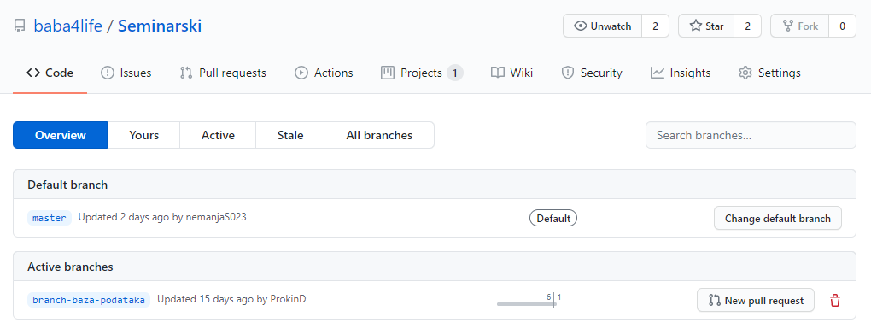
Postavljanje datoteka - urađeno upload tehnikom za sve datoteke, na svim granama.
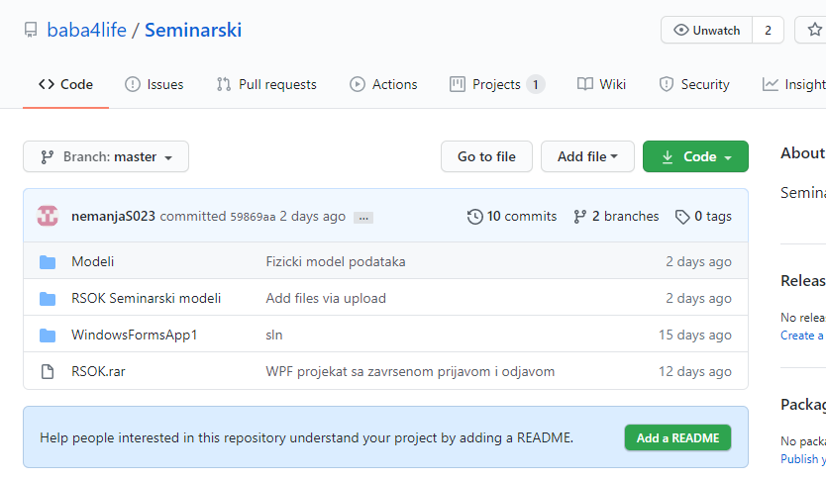
Preuzimanje datoteka - izvršeno opcijom “Download ZIP” čime se kompletna apliakcija preuzima kao zapakovana arhiva
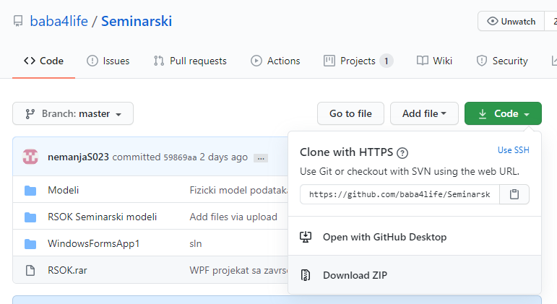
Spajanje grana – Izvršeno nakon završetka postavljanja (“Push”) svih datoteka na granama opcijom “Pull”

6. Korišteni alati i softveri

- PHPMyAdmin web aplikacija za administraciju baze podataka
- Visual Studio 2017 radi pisanja koda za desktop aplikaciju . Pisano u C# programsom jeziku.
- Sybase/SAP Power Designer CASE za prikaz razlicitih dijagrama naseg projekta

7. Literatura

- Github repozitorijum, 2020., https://github.com/

- phpMyAdmin,https://www.phpmyadmin.net/

- PowerDesigner,https://www.powerdesigner.biz/EN/powerdesigner/try-powerdesigner-source_adwPD.html?gclid=Cj0KCQjw9IX4BRCcARIsAOD2OB0SGL_zAwydKhc_wMtMlHGbgCrMq8bSmwDjwp8MAyxmG8yU6RQsAnoaAreSEALw_wcB

