The initial database table :

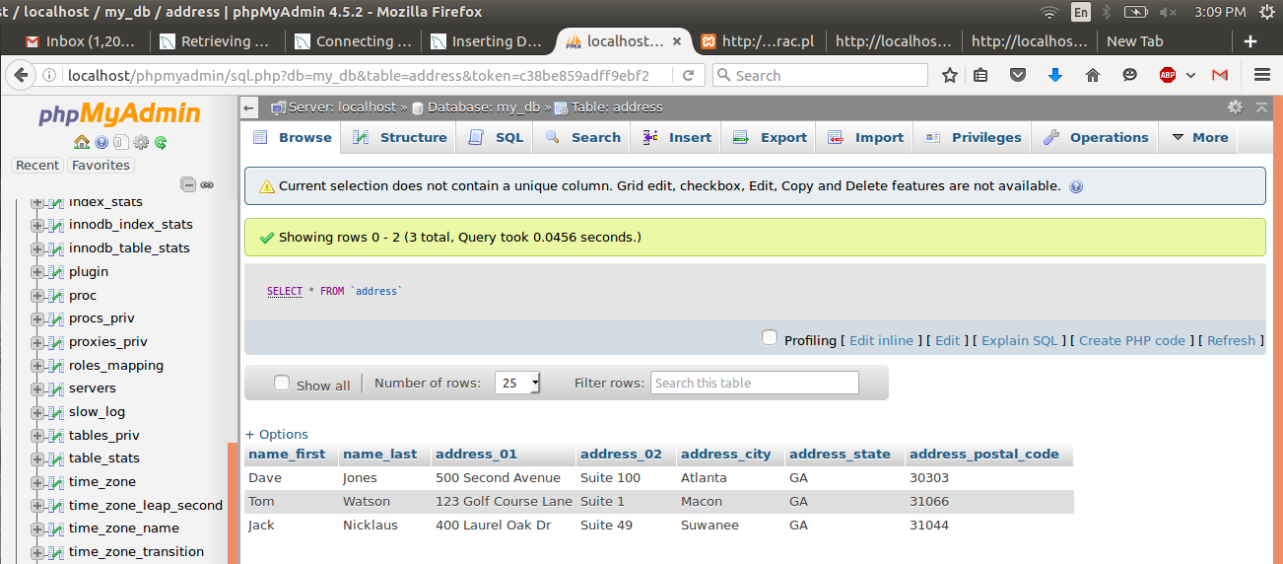
Initial html page displayed:

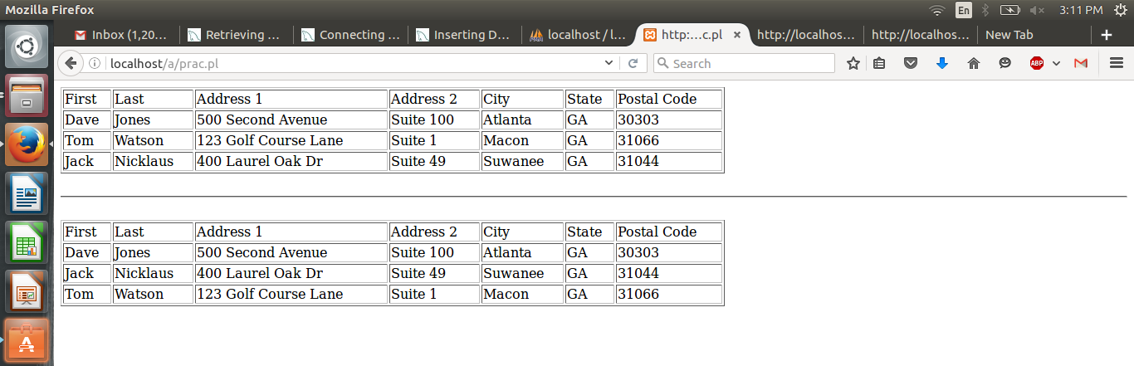

Insert query :

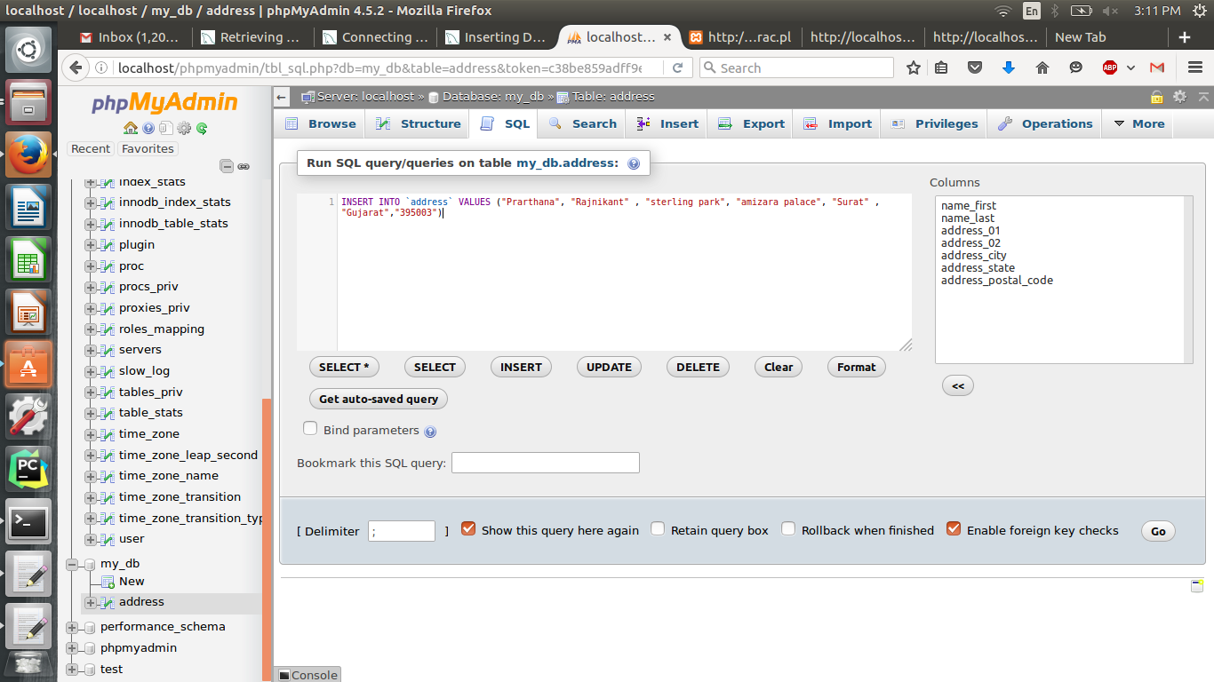

Values inserted successfully :

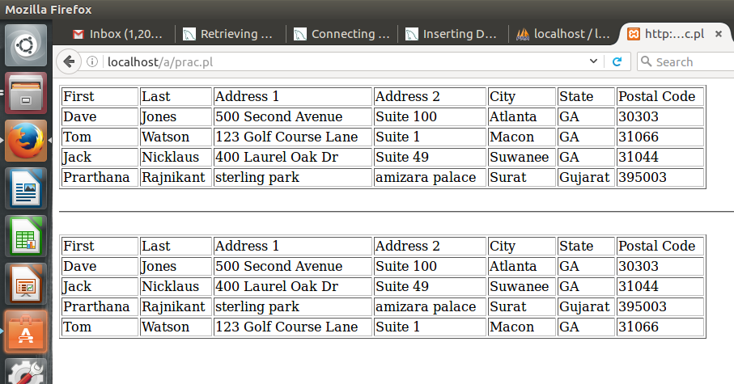

$connection = ConnectToMySql($database);

$query = "select name_first, name_last, address_01, address_02, address_city, address_state, address_postal_code from address order by name_first";

$statement = $connection->prepare($query);
$statement->execute();

while (@data = $statement->fetchrow_array()) {
$name_first = $data[0];
$name_last = $data[1];
$address_01 = $data[2];
$address_02 = $data[3];
$address_city = $data[4];
$address_state = $data[5];
$address_postal_code = $data[6];

print "<tr><td>$name_first</td><td>$name_last</td><td>$address_01</td><td>$address_02</td><td>$address_city</td><td>$address_state</td><td>$address_postal_code</td></tr>\n";

}

print "</table>\n";

The above code fires a SQL query to retrieve data from the table “ADDRESS” in sorted order of first name.
Perl Script:

#!/usr/bin/perl -w

# DBI is the standard database interface for Perl
# DBD is the Perl module that we use to connect to the <a href="http://mysql.com/" />MySQL</a> database
use DBI;
use DBD::mysql;

# we use CGI since this will be executed in a browser
use CGI qw(:standard);

use warnings;

#----------------------------------------------------------------------
# open the accessDB file to retrieve the database name, host name, user name and password
open(ACCESS_INFO, "<..\/accessDB") || die "Can't access login credentials";

# assign the values in the accessDB file to the variables
my $database = <ACCESS_INFO>;
my $host = <ACCESS_INFO>;
my $userid = <ACCESS_INFO>;
my $passwd = <ACCESS_INFO>;

# the chomp() function will remove any newline character from the end of a string
chomp ($database, $host, $userid, $passwd);

# close the accessDB file
close(ACCESS_INFO);
#----------------------------------------------------------------------

# print the header
print header;

# HTML for the beginning of the table
# we are putting a border around the table for effect
print "<table border=\"1\" width=\"800\"> \n";

# print your table column headers
print "<tr><td>First</td><td>Last</td><td>Address 1</td><td>Address 2</td><td>City</td><td>State</td><td>Postal Code</td></tr>\n";

# invoke the ConnectToMySQL sub-routine to make the database connection
$connection = ConnectToMySql($database);

# set the value of your SQL query
$query = "select name_first, name_last, address_01, address_02, address_city, address_state, address_postal_code from address";

# prepare your statement for connecting to the database
$statement = $connection->prepare($query);
# execute your SQL statement
$statement->execute();

# retrieve the values returned from executing your SQL statement
while (@data = $statement->fetchrow_array()) {
$name_first = $data[0];
$name_last = $data[1];
$address_01 = $data[2];
$address_02 = $data[3];
$address_city = $data[4];
$address_state = $data[5];
$address_postal_code = $data[6];

# print your table rows
print "<tr><td>$name_first</td><td>$name_last</td><td>$address_01</td><td>$address_02</td><td>$address_city</td><td>$address_state</td><td>$address_postal_code</td></tr>\n";

}

# close your table
print "</table>\n";

# exit the script
exit;

#--- start sub-routine ------------------------------------------------
sub ConnectToMySql {
#----------------------------------------------------------------------

my ($db) = @_;

# assign the values to your connection variable
my $connectionInfo="dbi:mysql:$db;$host";
# make connection to database
my $l_connection = DBI->connect($connectionInfo,$userid,$passwd);

# the value of this connection is returned by the sub-routine
return $l_connection;

}

#--- end sub-routine --------------------------------------------------

