
Report: Systematic Design of a High-Performance Neural Network for Fashion-MNIST
FullName : Mohammadmahdi Bababeyk
Student ID: 4041419005
Introduction: The Mission to Optimize
This report documents the systematic process of designing and optimizing a high-performance, fully connected neural network for the Fashion-MNIST dataset. The primary objective was to move beyond ad-hoc model creation and adopt a principled approach to architecture design, isolating the impact of individual components to build a final model based on empirical evidence.
The methodology employed a three-phase strategy: an initial exploration phase consisting of a systematic ablation study, a combination phase where effective components were strategically integrated, and a final optimization phase to fine-tune the resulting "champion" model. Through this process, we investigated key architectural and regularization components, including network depth and size, various activation functions (e.g., ReLU, Leaky ReLU), Batch Normalization, Dropout, and Data Augmentation.
This report will detail the experimental framework that ensured reproducibility, present the findings from each phase of the investigation, and culminate in the configuration and performance analysis of the winning model.
1. Experimental Framework and Methodology
Establishing a robust, configurable, and reproducible experimental framework is the cornerstone of any systematic study. This foundation is crucial for generating reliable and comparable results across a wide range of model configurations, ensuring that observed performance differences are attributable to the specific components being tested and not to random variation. Our framework was designed to support this rigor from data loading to final evaluation.
1.1 Core Architecture and Dataset
The core of our investigation is the FCNet, a highly configurable fully connected neural network. This model was designed to allow for dynamic adjustments to its hidden layer sizes, the choice of activation function, and the inclusion of regularization techniques like Batch Normalization and Dropout.
The experiments were conducted on the Fashion-MNIST dataset. All images were preprocessed using a standardized pipeline:
- Train-Validation Split: The training data was split into a 90% training set and a 10% validation set.
- Normalization: Input data was normalized using the dataset-specific mean (0.2860) and standard deviation (0.3530) to stabilize training.
- Data Augmentation: For specific experiments, the training data was augmented using Random Affine transformations, including rotations (up to 10 degrees), translations (up to 10%), and scaling (90-110%). The validation set was never augmented to ensure an unbiased performance evaluation.
1.2 Training and Evaluation Protocol
To ensure fair comparisons, a standardized training protocol was applied across all experiments in the initial ablation study:
- Loss Function: Cross-Entropy Loss, the standard for multi-class classification tasks.
- Optimizer: The Adam optimizer was used with an initial learning rate of 1e-3 and a weight decay (L2 regularization) of 1e-4.
- Learning Rate Scheduler: A ReduceLROnPlateau scheduler was employed, which automatically reduces the learning rate by a factor of 0.5 (factor=0.5) after 3 consecutive epochs (patience=3) with no improvement in validation loss.
- Epochs: Models in the initial study were trained for 20 epochs.
- Reproducibility: A fixed random seed (42) was used for all experiments, including data splitting and model initialization, to ensure consistency and comparability of results.
This structured setup provides the necessary controls to isolate variables and confidently attribute performance changes to specific architectural choices.
2. Phase 1: Exploration via Systematic Ablation Study
The purpose of the ablation study was to conduct a scientific investigation into the individual and combined effects of key neural network components. By systematically adding, removing, or altering one element at a time, we could isolate and quantify its specific impact on model performance. This process provided the foundational insights required for the subsequent design of a high-performance model.
2.1 The Critical Role of Non-Linearity
The first investigation quantified the performance gap between a simple linear model and a model incorporating a non-linear activation function. The linear_baseline model, which performs only linear transformations, achieved a validation accuracy of 84.82%. In stark contrast, the baseline_relu model, identical in architecture but with the addition of the ReLU activation function, reached 89.88%.
Across all experiments, the introduction of non-linearity provided an average performance gain of 4.16 percentage points, with the average accuracy of linear models at 84.73% compared to 88.89% for non-linear models. This confirms that non-linearity is the single most critical component for capturing the complex patterns present in the Fashion-MNIST dataset.
2.2 Evaluating Activation Functions
With non-linearity established as essential, we conducted a head-to-head comparison of six different activation functions, with all other parameters held constant. The results clearly identified a top performer.
Activation Function | Final Validation Accuracy (%)
Leaky ReLU | 90.30%
ReLU | 89.88%
Sigmoid | 89.03%
Tanh | 88.90%
Maxout | 86.23%
ELU | 84.82%
Leaky ReLU emerged as the clear winner, delivering the highest accuracy in this initial comparison and establishing itself as the prime candidate for our champion model. Notably, ELU's performance was identical to the linear baseline, suggesting that for this specific architecture and dataset, its theoretical advantages did not translate into practical gains and may have even hindered the learning of non-linear features.
2.3 Quantifying the Impact of Regularization
Next, we evaluated the individual contribution of each regularization technique when applied to the baseline_relu model (89.88% accuracy).
- Batch Normalization (bn_relu): Adding Batch Normalization provided a clear benefit, increasing validation accuracy to 90.03%.
- Data Augmentation (aug_relu): Applying data augmentation alone maintained the baseline accuracy at 89.88%, suggesting its benefits may be more pronounced in deeper or more complex models prone to overfitting.
- Dropout (dropout_relu): Introducing a dropout rate of 0.3 resulted in a slight performance decrease, with accuracy dropping to 89.28%.
The best_combo model, which combined all three techniques, achieved an accuracy of 89.58%. This result is lower than what Batch Normalization achieved alone, indicating that a naive combination of regularizers can be counterproductive. The heavy-handed dropout rate of 0.3 likely induced underfitting, negating the benefits provided by Batch Normalization and demonstrating that regularization techniques must be balanced against model capacity.
2.4 Performance Visualization of Key Models
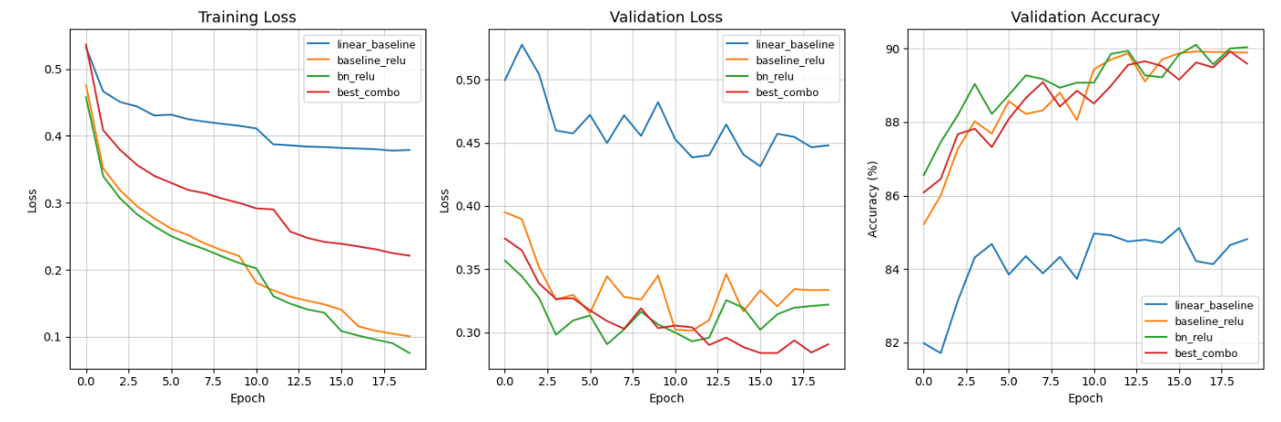
Figure1- Training Loss, Validation Loss, Validation Accuracy
2.5 Analysis of Network Depth
The final ablation experiment investigated the effect of increasing network depth. We compared the standard two-layer baseline_relu model (hidden layers: [256, 128], accuracy: 89.88%) with a deeper three-layer deeper_relu model (hidden layers: [512, 256, 128], accuracy: 89.87%). The results showed that simply increasing network depth without corresponding adjustments to regularization provided no performance benefit for this configuration.
The key learnings from this phase were clear: Leaky ReLU and Batch Normalization are powerful components, while depth and other regularizers require careful integration to be effective. These insights directly informed the design of our champion models.
3. Phase 2 & 3: Champion Model Design and Optimization
This phase leverages the insights gained from the ablation study to strategically construct and refine a high-performance model. By combining the most effective components and fine-tuning their interactions, we aimed to push the performance limits of the fully connected architecture on the Fashion-MNIST dataset.
3.1 First Champion: The "ULTIMATE_CHAMPION"
The ULTIMATE_CHAMPION model was designed by integrating the best-performing elements identified in Phase 1 and scaling up the model's capacity.
- Activation: Leaky ReLU was selected, as it was the top-performing activation function from our tests.
- Hidden Layers: The architecture was deepened to [512, 256, 128] to increase model capacity, building on the deeper_relu experiment.
- Regularization: Batch Normalization was included due to its proven effectiveness. Data Augmentation was added to improve generalization, and a moderate Dropout Rate of 0.2 was introduced to balance the increased model capacity.
- Training Parameters: Training was extended to 30 epochs with a larger batch size of 128 to allow for more stable convergence.
This configuration achieved a final validation accuracy of 90.78%, successfully surpassing the performance of all models from the initial ablation study.
3.2 The Winning Model: "GOD_MODE"
The GOD_MODE model represents a final round of optimization on the ULTIMATE_CHAMPION. The goal was to further enhance performance by carefully balancing an even larger model with more finely tuned regularization.
- Hidden Layers: Model capacity was increased further to [768, 384, 192] to enable the learning of more complex feature representations.
- Regularization: To support the larger model's capacity and prevent overfitting, regularization was meticulously re-calibrated. The Dropout Rate was lowered to 0.1 to retain more information, while weight_decay was fine-tuned to 5e-5, striking a more delicate balance between complexity and generalization.
- Training Parameters: The training duration was extended to 35 epochs to give the larger, more complex model sufficient time to converge on a superior solution.
This carefully tuned architecture achieved a final, winning validation accuracy of 90.83%.
3.3 Head-to-Head Performance Comparison
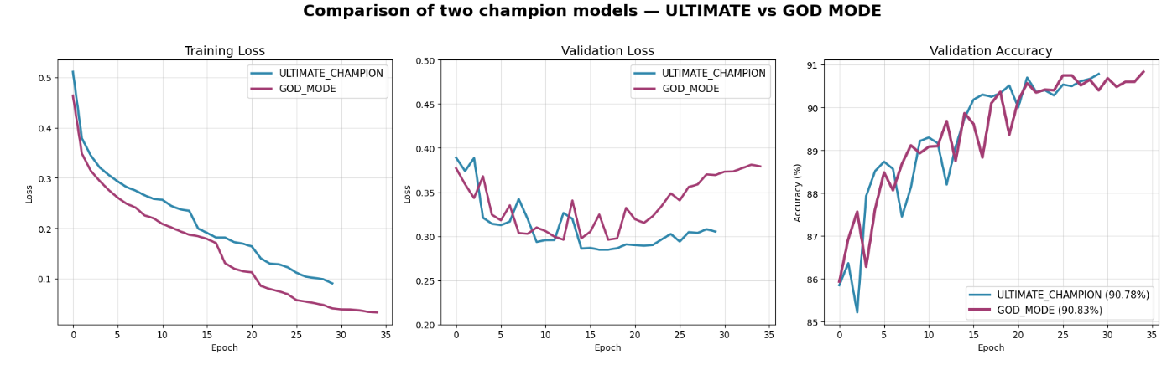
Figure2- Comparison of two champion models – ULTIMATE vs GOD MODE
As illustrated in Figure 2, the GOD_MODE configuration's superiority is most evident in the validation loss plot. While both models achieve similar training loss, GOD_MODE's validation loss curve not only reaches a lower absolute value but also maintains a flatter, more stable trajectory during the final 10 epochs. This indicates it has learned more generalizable features, whereas the ULTIMATE_CHAMPION shows early signs of plateauing, explaining its slightly lower final accuracy.
4. Final Results and Conclusion
This section consolidates the findings from all experiments, presenting a comprehensive summary of the results and formally declaring the winning model configuration.
4.1 Final Results Summary
The table below summarizes the final validation accuracy for all 17 experiments conducted, sorted from highest to lowest performance. It provides a clear overview of how different architectural and regularization choices influenced the final outcome.
Run ID | Activation | Hidden Layers | Batch Norm | Dropout | Augmentation | Final Validation Accuracy (%)
GOD_MODE | leaky_relu | [768, 384, 192] | True | 0.1 | True | 90.83%
ULTIMATE_CHAMPION | leaky_relu | [512, 256, 128] | True | 0.2 | True | 90.78%
act_leaky_relu | leaky_relu | [256, 128] | False | 0.0 | False | 90.30%
bn_relu | relu | [256, 128] | True | 0.0 | False | 90.03%
baseline_relu | relu | [256, 128] | False | 0.0 | False | 89.88%
aug_relu | relu | [256, 128] | False | 0.0 | True | 89.88%
deeper_relu | relu | [512, 256, 128] | False | 0.0 | False | 89.87%
best_combo | relu | [256, 128] | True | 0.3 | True | 89.58%
dropout_relu | relu | [256, 128] | False | 0.3 | False | 89.28%
act_sigmoid | sigmoid | [256, 128] | False | 0.0 | False | 89.03%
act_tanh | tanh | [256, 128] | False | 0.0 | False | 88.90%
act_maxout | maxout | [256, 128] | False | 0.0 | False | 86.23%
linear_baseline | linear | [256, 128] | False | 0.0 | False | 84.82%
linear_dropout | linear | [256, 128] | False | 0.3 | False | 84.82%
act_elu | elu | [256, 128] | False | 0.0 | False | 84.82%
linear_full_reg | linear | [256, 128] | True | 0.3 | True | 84.65%
linear_bn | linear | [256, 128] | True | 0.0 | False | 84.65%
4.2 Winning Configuration and Submission
The GOD_MODE configuration is declared the winning architecture based on this systematic study. Its combination of a large, deep network with Leaky ReLU activation, Batch Normalization, and carefully tuned Dropout and weight decay regularization achieved the highest performance.
Final Winning Validation Accuracy: 90.83%
4.3 Conclusion and Future Work
This report demonstrates the value of a systematic, evidence-based approach to neural network design. The study reveals a core principle for iterative model improvement: performance is unlocked not by any single component, but by a strategic cycle of increasing model capacity (deeper and wider layers) followed by a corresponding recalibration of regularization (finer-grained dropout and weight decay) to harness that new capacity without overfitting.
For future work, further performance gains could likely be achieved by exploring more advanced optimizers or, more significantly, by transitioning to architectures better suited for image data. Experimenting with Convolutional Neural Networks (CNNs) would be a logical next step, as their inherent ability to capture spatial hierarchies is ideally matched to image classification tasks like Fashion-MNIST.
4.4 References
Fashion-MNIST Dataset: Xiao, H., Rasul, K., & Waibel, T. (2017). Fashion-MNIST: A novel image dataset for benchmarking machine learning algorithms. arXiv preprint arXiv:1708.07747.
General Deep Learning Principles (Fully Connected Networks, Weight Decay, ReLU): Goodfellow, I., Bengio, Y., & Courville, A. (2016). Deep learning. MIT press.
Batch Normalization (BN): Ioffe, S., & Szegedy, C. (2015). Batch normalization: Accelerating deep network training by reducing internal covariate shift. Proceedings of the 32nd International Conference on Machine Learning (ICML), 448-456.
Adam Optimizer: Kingma, D. P., & Ba, J. (2014). Adam: A method for stochastic optimization. arXiv preprint arXiv:1412.6980.
Dropout Regularization: Srivastava, N., Hinton, G., Krizhevsky, A., Sutskever, I., Salakhutdinov, R. (2014). Dropout: A simple way to prevent neural networks from overfitting. The Journal of Machine Learning Research, 15(1), 1929-1958.
Leaky ReLU Activation Function: Maas, A. L., Hannun, A. Y., & Ng, A. Y. (2013). Rectifier nonlinearities improve neural network acoustic models. Proceedings of the 30th International Conference on Machine Learning (ICML).
Data Augmentation (General Image Processing Context): Ciresan, D., Meier, U., Masci, J., Gambardella, L. M., & Schmidhuber, J. (2011). Flexible, high performance convolutional neural networks for image classification. Proceedings of the 22nd International Joint Conference on Artificial Intelligence (IJCAI), 1237-1243. (Note: This type of paper is suitable for referencing a standard technique like Data Augmentation within image tasks).
CheckPoint_Stage3 - Google Drive

