CHILD GAME PROJECT

Project Initiation Document

|  |  |  |
| --- | --- | --- |
| **Customer Name** | TEAM 1 (University of Essex) | |
| **Original Issue Date** | 01/03/2020 | |
| **Author** | Ian Wolloff | |
| **Filename** | PID.docx | |
| **Document Distribution** | Team 2 | |
| **Document History** | | |
| **Date of Revision** | **Brief description of change** | **Version** |
| July 2022 | First draft | V0.1 |
|  |  |  |
|  |  |  |
|  |  |  |
|  |  |  |

Contents

1. PURPOSE OF THIS DOCUMENT 3

2. PROJECT DEFINITION 3

3. PROJECT APPROACH 4

4. BUSINESS CASE 5

5. QUALITY MANGEMENT STRATEGY 6

6. CONFIGURATION MANAGEMENT STRATEGY 7

7. RISK MANAGEMENT STRATEGY 8

8. RISK MANAGEMENT STRATEGY 8

# PURPOSE OF THIS DOCUMENT

The purpose of this document is to define the project, to form the basis for its management and the assessment of overall success.

There are four primary uses of the document:

* To ensure that the project has a sound basis before asking the Project Board to make any major commitment to the project.
* To act as a base document against which the Project Board and Project Manager can assess progress, change management issues and ongoing viability questions.
* To act as a contract between the Project Executive and the Project Manager
* To provide a single source of reference about the project so that people joining the project can quickly and easily find out what the project is about, and how it is being managed.

# PROJECT DEFINITION

* **Background:**

TEAM 2 have been contracted to provide a solution in the form of a game that can be used by a child a number of requirements have been provided to be included in the solution these are listed below

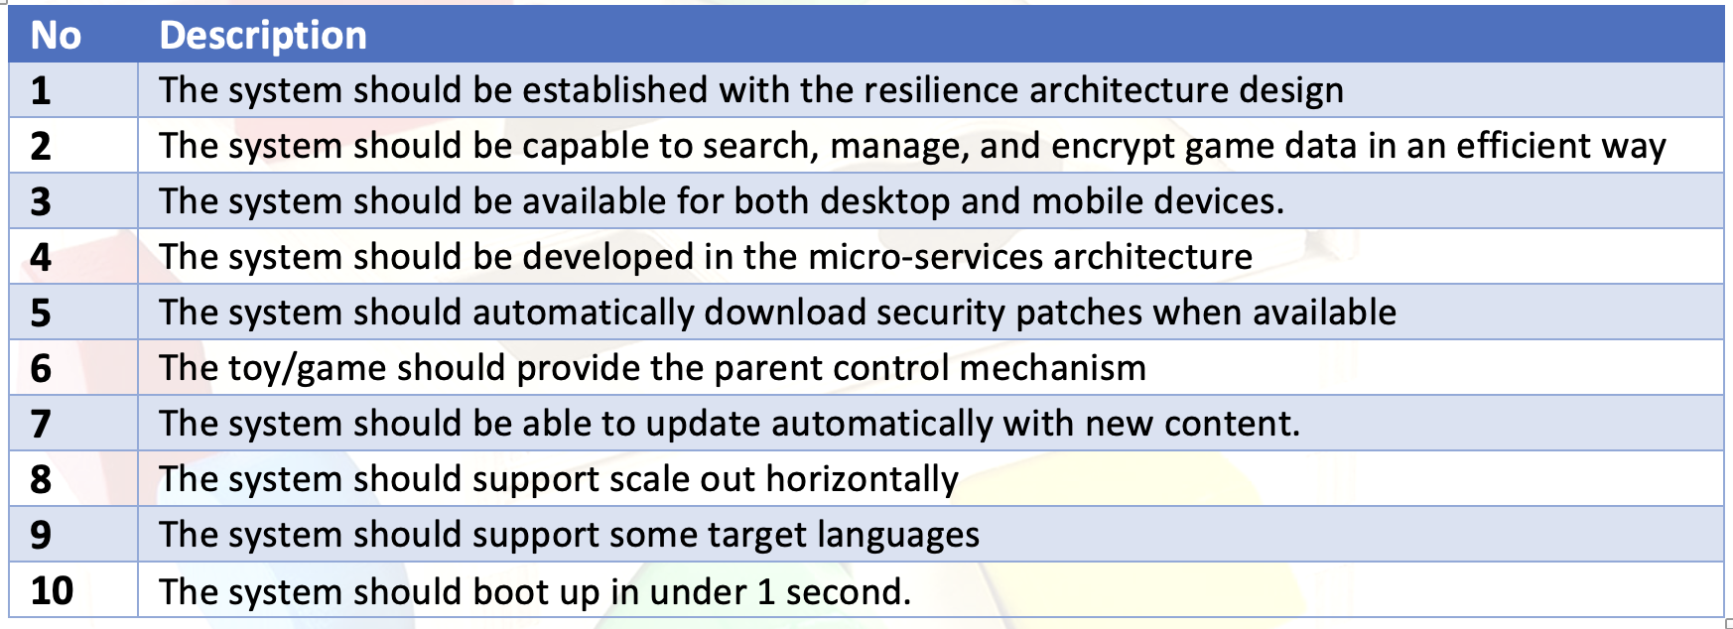

The solution should meet these requirements while being a fun experience for the user of the game / service.

* **Project Objectives:**
  + To provide a system in the form of a game that is fun to use
  + Enable the game to be delivered via the form of a web application
  + Solution to be delivered in a modular fashion to allow for future expandability
* **Desired outputs/Deliverables:**
  + Core Game
  + SME tender assessment input
  + Solution Architecture Document
  + Low level design documents, detailing the IT system and the technical interfaces
  + Testing of the changes to the Game IT system.
  + Creating of IT Support and BAU Instructions, processes and documents
* **Scope exclusions:**

Being this project addresses the IT elements of the Game project only, its scope will exclude the following:

* + Contract management of 3rd party suppliers
  + Discussion or negotiation of Hosting or backend Infrastructure
* **Constraints:**

The project will be constrained by:

* An August 2022 deadline for delivery
* Physical Location of Development Team
* Physical Location of Project Sponsors
* Time Zone Differences
* **Assumptions:**

Project assumptions are:

* + The Capital funding for the programme covers the IT resources required.
  + The selected solution integrates with existing Team 1 solutions
  + Team 1 do not make any changes to the delivery timeline
  + IT resources will be available to deliver the solution
  + System testing and user acceptance testing of the overall Child Game solution will be the responsibility of the Child Game programme
* **The users and other known interested parties (Stakeholders):**

The interested parties and users are:

* + Team 1
  + University of Essex
* **Interfaces**

There will be internal interfaces to:

* API
* DBMS

# PROJECT APPROACH

The high level project approach is based around two phases:

* The first is the Design Phase, which will deliver a Solution Architecture Design to the Child Game Program
* Once a decision is made and approval is given then the Build & Implement phase of the Child Game project can commence and deliver the IT solution.

**Design Phase**

* Deliver an approved Solution Architecture Document (SAD), detailing the high level design of the Child Game Solution
* Work with the Delivery team to develop Low Level Design documents, detailing the technical aspects of the Child Game Solution
* Review the estimates and costs to deliver the Build & Implement Phase of the project
* Assist the Child Game programme in the development and presentation of the detailed design

**Build & Implement Phase**

* Deliver the elements of the Game solution, including:
  + Building and developing of the child game
  + Develop instructions for the developed game
  + Develop technical documentation
* Undertake internal IT testing
* Assist the Child Game programme with:
  + The solution end-to-end testing
  + The solution acceptance testing
  + The solution operational acceptance testing

# BUSINESS CASE

The business case and project benefits are not within the scope of this IT Delivery Team we assume that the business case for the development of the solution has been assessed before Team2 as the delivery partner were engaged.

# 

# QUALITY MANGEMENT STRATEGY

Quality Controls:

* Products delivered by the Project will be subject to quality expectations and acceptance criteria that will be defined within the Product Description.
* Product descriptions will be produced for each major product and these will define the quality controls to be applied.

Quality Methods:

The following quality methods will be used:-

* Business Analysis
* Requirements Gathering
* Requirements review
* Unit testing/System testing
* User Acceptance testing
* Integration testing
* End to End testing
* Security assessment
* Data Migration load rehearsals

Quality Register - - minutes and reports from all meetings and testing sessions produced and circulated

# CONFIGURATION MANAGEMENT STRATEGY

**Issues and change control procedures:**

**Tools and techniques:**

Changes will be handled as Project Issues. The Project Manager will control and advise of any change to the standard tooling

**Records:**

All Issues in Issue Log; all Risks in Risk Register; raising of either to be recorded in Meeting Minutes; all records within project folders.

**Reporting:**

Change control / Exception reporting to Project Board as per Communications plan

# RISK MANAGEMENT STRATEGY

**Issues and change control procedures:**

**Tools and techniques:** Changes will be handled as Project Issues. The Project Manager has the authority to approve changes for the stage in hand to agreed tolerance levels.

**Records:** All Issues in Issue Log; all Risks in Risk Register; raising of either to be recorded in Meeting Minutes; all records within project folders.

**Reporting:** Change control / Exception reporting to Project Board as per Communications plan NB: asap, do not wait for the Board meeting

**Scale for Priority and severity:** Any Issue which extends the project beyond the agreed tolerances to be subject to a Change Control / Exception report. Issue added to Risk Register and reported to Project Board. *Ad hoc* direction requested from Board.

# RISK MANAGEMENT STRATEGY

Risk management procedures:

Team Twos standard risk management approach will be used.

**Risk management Controls:**

Initial Key risks will be recorded within the Risk Register

A full risk assessment will be held and recorded in the risk register

The Risk register will be constantly reviewed during the life of the project by the Project Manager

Tool and techniques:

The risk register will be formed as an Excel spread sheet and reviewed/updated a minimum of weekly

**Records:**

The risk register will be located within the project folder and reviewed/updated a minimum of weekly.

Current Risks Identified are:

Lack of Python experience in the development team

Limited Project management Experience

Small Time Scale

Distributed Development Team

**Reporting:**

The Project Manager will make the Project team aware of new risks added to the risk register for approval of, or suggestion for, the mitigation method of that risk. Open risks will also be recorded on a highlight report.