*Ponzo Effect*

Projective Geometry and the Ponzo Effect

Objects in the physical world project onto the retina i.e. the light bouncing off the surface of the object falls onto a projection surface, retina. This setting follows the principles of projective geometry as illustrated in the figure below:

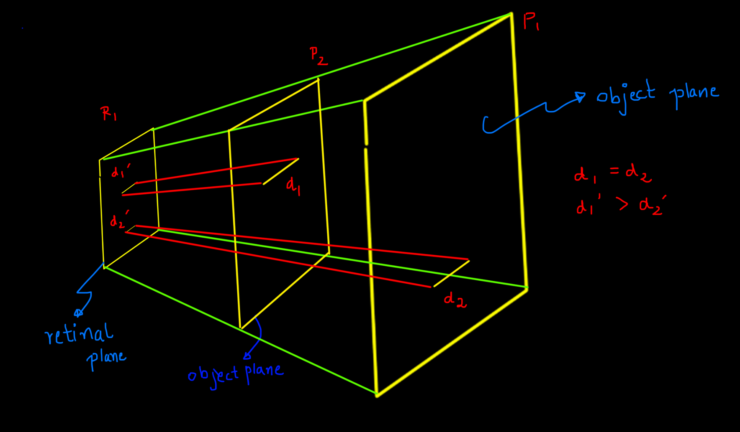

Consider two object planes - P1 and P2, where P1 is closer to the retinal plane than P2. A line on P1 and an equal length line on P2 project on the retinal plane as two different lengths. The line that lies on the object plane (P2) closer to the retinal plane is projected longer than the line that comes from the object plane P2 that is further from the retinal plane.

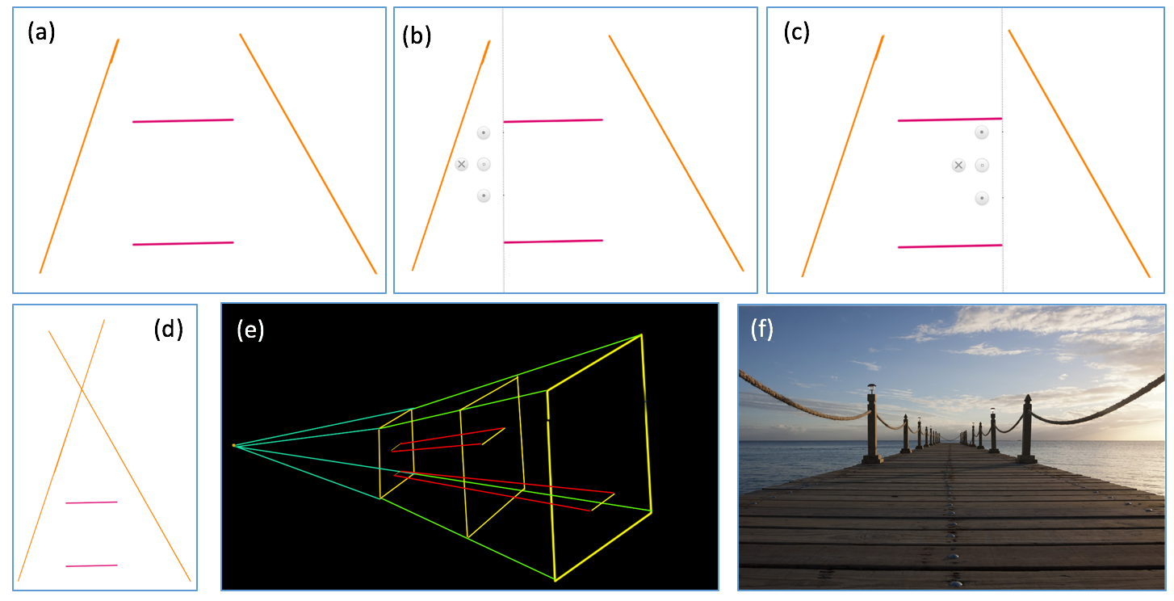

A similar “illusion” in perception is created by the setting of the Ponzo effect. Figure (a) shows the ponzo effect. The figures (b) and (c) shows that the two lines are actually the same length. Figure (d), (e) and (f) shows the concept of an extended vanishing point in case of the Ponzo effect, the example of projective geometry discussed before and, an example of vanishing point in the real world.

Ponzo effect creates the illusion that the two slanting lines are converging at a point (illustrated in figure (d)). The upper horizontal line appears to be further than the lower horizontal line. But on the other hand, a misapplied size constancy mechanism in the visual system makes the upper red line appear longer.

Taking over the illusion

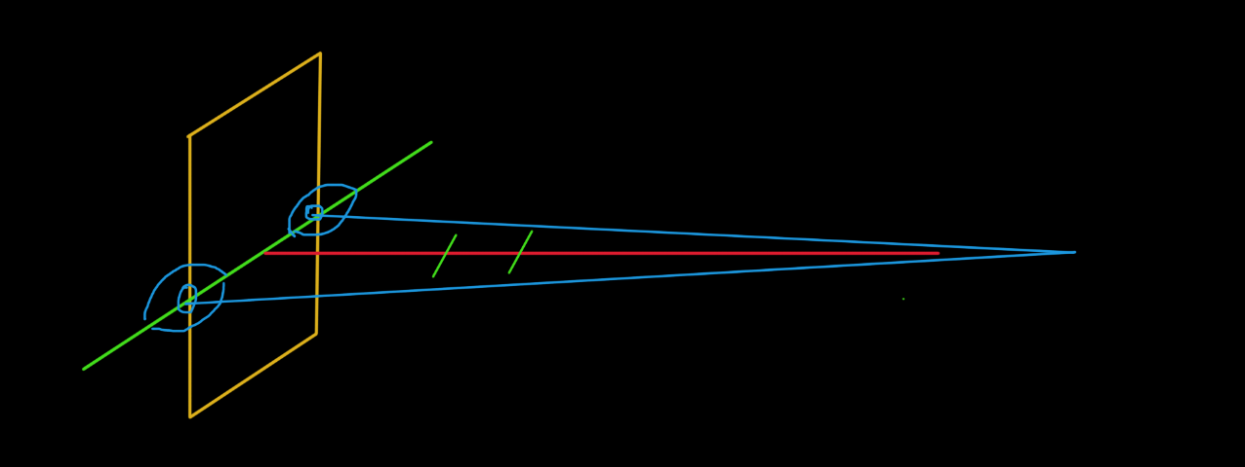

Aligning the retinal plane perpendicular to the vanishing point will make disappear the illusion as explained in the figure above. That is because the projective geometry scene on that particular plane converts to a Euclidean geometry scene where converging lines intersect at infinity. Same can be observed with other versions of the Ponzo effect (Refer: <http://mesosyn.com/mental8-3.html> )

Explaining the Ponzo Effect:

Note: The factor that makes the Ponzo Effect happen is the background (i.e. the converging lines).

**Hypothesis:** Ponzo effect is observed due to the mismatch of the planes. The ‘mismatch of plane’ is that the object creating the illusion (L1 and L2 in figure 4) to be coming from one plane while the background is set on another plane. These two planes interest at the median line of one of the objects (L2 in the figure below). The other (L1) seems to be coming from the slant plane (P2) while it actually exists over the plane orthogonal plane (P1). Since an object with a same length seems to be coming from a farther distance, it appears to be longer than the other. This is what creates the Ponzo effect.

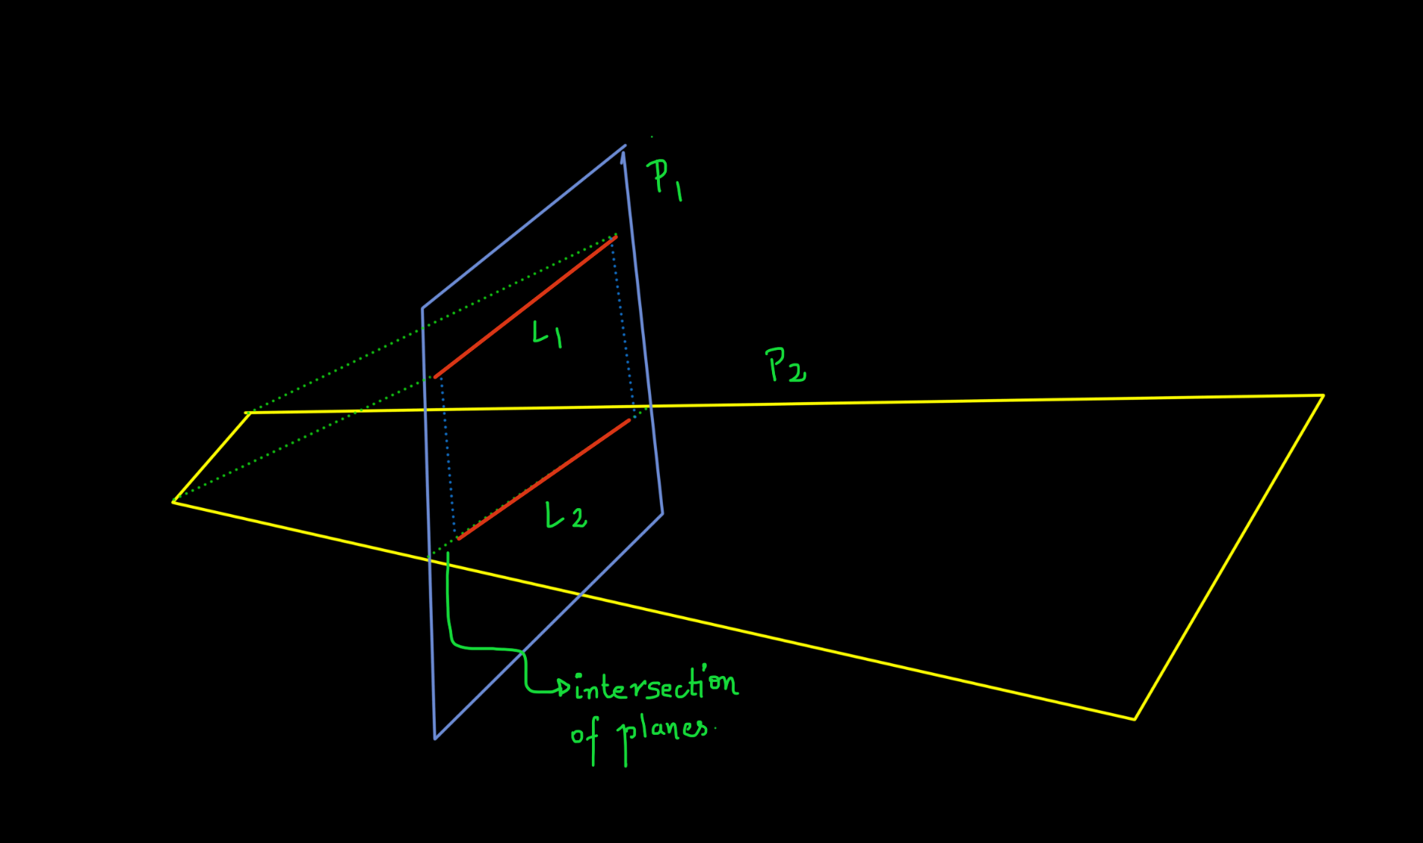

**Experiment:** Plane Frequency in a visual system and nature of experience

We consider a visual system wherein planes are occurring in all different orientations. Consider patches of 1x1 sq. units in different orientations. Each orientation has an equal probability of occurring. Each of these planes project onto the retinal plane. The planes which are parallel to the retinal plane cover the maximum area over a projection. Any plane inclined from the retinal plane projects a smaller area than a parallel plane.

**Conclusion:** The occurrence of a parallel object plane over the surface of the retina excites more neurons than the inclined planes, as the parallel planes are more extant in area. This gives a relative preference of observance to the parallel plane over the inclined ones.

The proposed argument takes the course’s core idea of perception through frequency of experience to show the preferential perception towards a parallel object plane. If the experiment is in line with the hypothesis, it shows that the Ponzo effect is caused by relative preference to a parallel plane than an inclined plane.