Static constructor - where we have used it in our application and why?
Python does not have the concept of a static constructor like C#.

For our Travel Expense AI project
If an interviewer asks, "Where did you use a static constructor in your Python project?", the accurate answer is:
"We didn't use a static constructor because Python doesn't support that language feature. Instead, we performed one-time initialization at the module level, such as creating the Azure OpenAI client and embedding client once so they could be reused across requests, avoiding repeated expensive initialization."

In fraud_service.py we import:
“from app.infrastructure.azure_openai import llm”
So, here are we importing entire module?
No, you are not importing the entire module into your namespace. You are importing only the variable llm.
However, Python does execute the entire module once before giving you the llm object.

“from app.infrastructure.azure_openai import llm” --
This line is imported in multiple files like in fraud_service.py, parser_service.py
So, llm object is created every time?
The answer is “No”

Think of It Like a Factory
Imagine azure_openai.py is a factory.
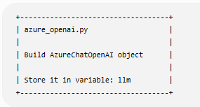
Now another file says: from app.infrastructure.azure_openai import llm
Python goes to the factory.
If the factory hasn't run yet:
- Build the object.
- Store it.
- Hand back llm.
If the factory has already run:
- Don't build again.
- Just hand back the existing llm.

Does It Create a New Object Every Time?
No.
This is one of Python's important behaviors.
The first import: “from app.infrastructure.azure_openai import llm” creates:
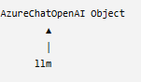
Later another file does the same import: “from app.infrastructure.azure_openai import llm”
Python does not execute azure_openai.py again.
Instead it returns the same object.
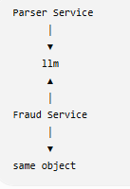

How Does Python Know?
Python keeps imported modules in a cache called sys.modules.
The first time: “import app.infrastructure.azure_openai”
Python:
- executes the file
- creates llm
- stores the module in sys.modules
The second time: from app.infrastructure.azure_openai import llm
Python checks:
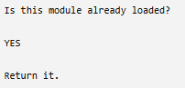
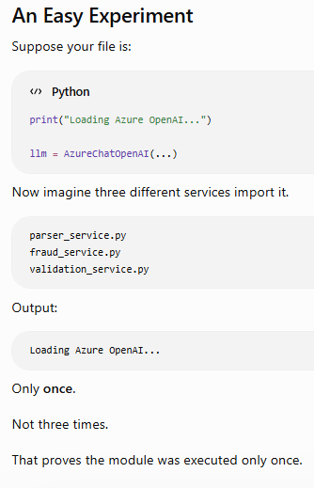
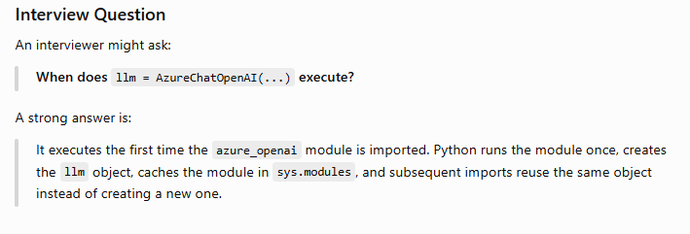
Suppose your azure_openai.py looks like this:
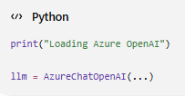
Now, during development, you edit azure_openai.py while your FastAPI server is running.
Question: Will Python automatically create a new llm object because the file changed, or will it continue using the existing one?
Answer: No.
Why?
Because the application is already running.
Python is using the module already loaded in memory, not continuously reading the file from disk.

Step 3: What Happens If Another File Imports It?
Suppose later another service executes:
from app.infrastructure.azure_openai import llm
Python checks:
Is module already in sys.modules?

YES
So it simply returns:
Existing llm
It does not read the updated file.

So When Does the New Code Take Effect?
Usually, one of these happens:

Option 1: Restart the Application
This is the most common.
You stop FastAPI:
CTRL + C
Then run:
uvicorn main:app
Now Python starts fresh.
It imports the module again.
Output:
Loading Azure OpenAI
A new llm object is created with:
temperature=0.5

Option 2: Development Auto-Reload
When you run FastAPI like this:
uvicorn main:app --reload
(or the equivalent VS Code launch configuration)
Uvicorn watches your files.
If you change:
azure_openai.py
it notices:
File changed!
Then it automatically:
- Stops the running process.
- Starts a new Python process.
- Imports all modules again.
So you see something like:
Loading Azure OpenAI
again.
This isn't Python reusing the existing module—it is an entirely new process starting.

What About importlib.reload()?
Python also provides:
import importlib

importlib.reload(module)
This forces Python to execute the module again.
Example:
import app.infrastructure.azure_openai as azure_openai

import importlib

importlib.reload(azure_openai)
Now:
llm = AzureChatOpenAI(...)
runs again, creating a new object.
This is useful in some advanced scenarios, but it's uncommon in typical FastAPI applications.
Does Python automatically make objects singletons?
A good answer is:
No. Every time you instantiate a class, Python creates a new object by default. In my project, the AzureChatOpenAI client is shared because it is created once at the module level. Python caches imported modules in sys.modules, so subsequent imports reuse the same module and therefore the same llm object. That behavior comes from module caching, not from the Singleton design pattern.
In your project:
llm = AzureChatOpenAI(...)
There is no Singleton class.
Instead:
- Python executes the module once.
- The module creates one object.
- All imports reference that object.
Many developers call this a module-level singleton.

Does Python have private variables?
Python doesn't have true access modifiers. By convention, members without an underscore are public, a single leading underscore indicates internal use, and a double leading underscore triggers name mangling to reduce accidental access. Python relies more on conventions than strict enforcement
Feature | C# | Python
Public | public | Default
Protected | protected | _member (convention)
Private | private | __member (name mangling)
Internal | internal | No direct equivalent
Enforcement | Strict compiler/runtime | Mostly conventions
• No underscore → Public
• One underscore (_) → Internal/protected by convention
• Two underscores (__) → Name mangling to reduce accidental access
Example
class Employee:
def __init__(self):
self.name = "John"
self._salary = 50000 # Protected attribute
self.__bonus = 5000 # Private attribute

Using the class
emp = Employee()
print(emp.name)
print(emp._salary)
print(emp._Employee__bonus) # Accessing the private attribute using name mangling
print(emp.__bonus) # This will raise an AttributeError
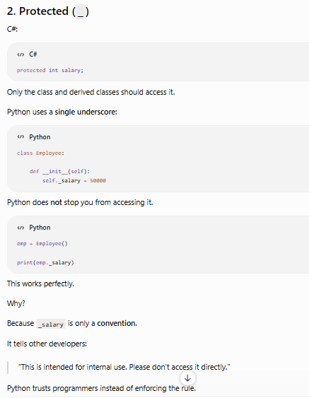
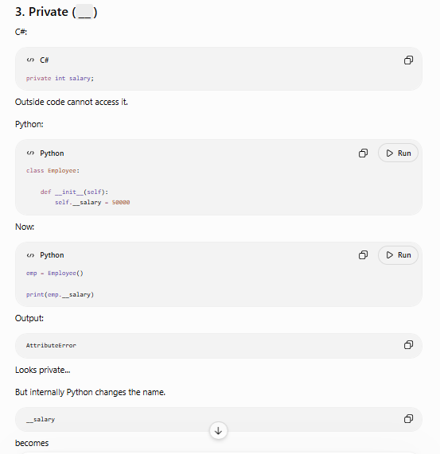
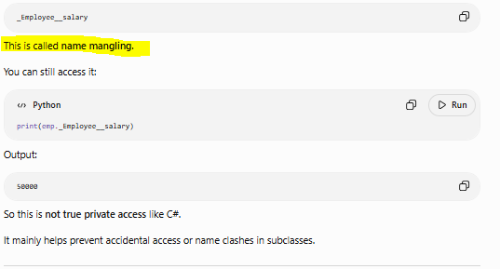
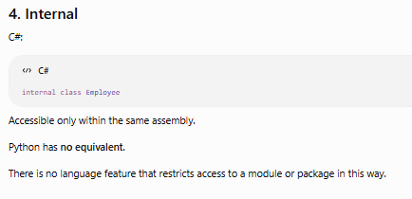
Three Types of Methods in Python
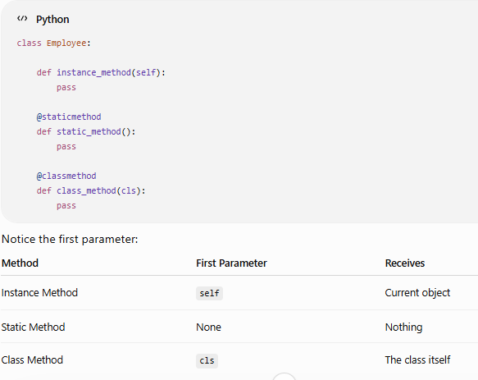

Why we use @staticmethod?
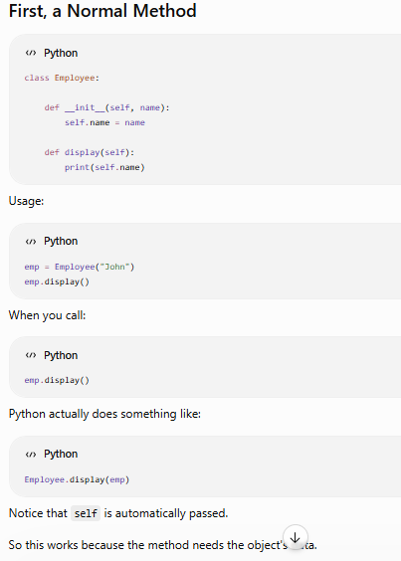
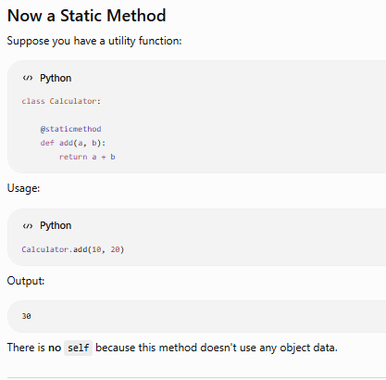
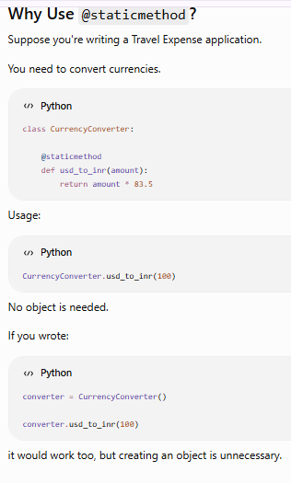
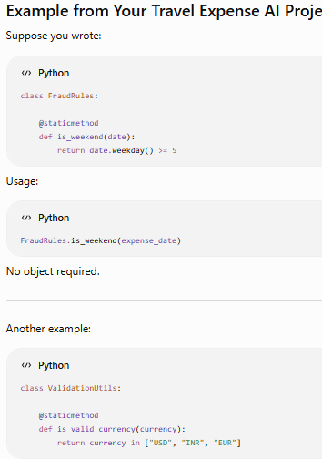
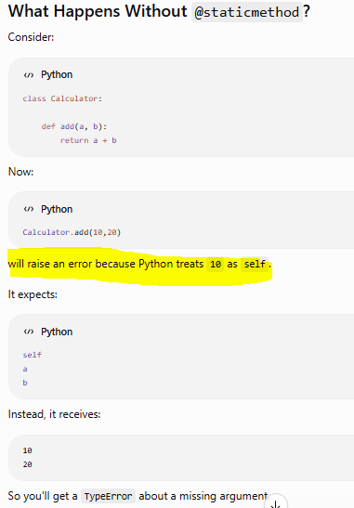
Adding @staticmethod tells Python:
"Don't pass self automatically."
Why do we use @staticmethod?
A good answer is:
We use @staticmethod when a method logically belongs to a class but doesn't need access to instance data (self) or class data (cls). It allows the method to be called directly on the class without creating an object and is commonly used for utility or helper functions.
This is actually one of the best examples of the difference between @staticmethod and @classmethod.
- @staticmethod has no knowledge of the class that called it.
- @classmethod receives cls, so it works correctly with inheritance.
That's why @classmethod is preferred when the method needs to access class variables or behave differently for subclasses.
Predict the output without running the code.
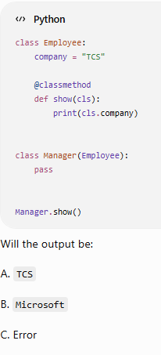
Answer
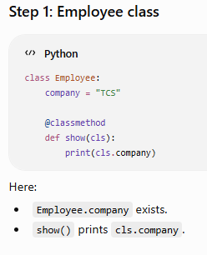
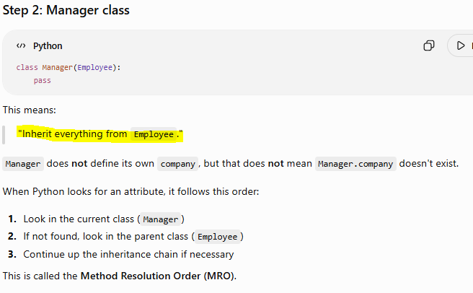
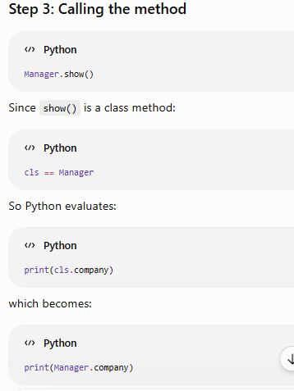
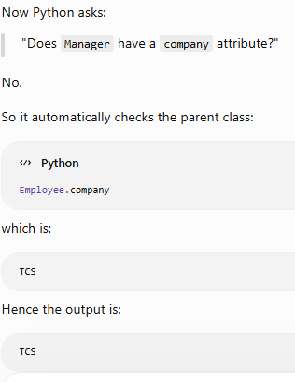
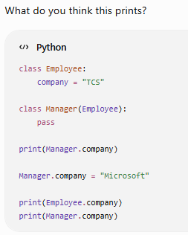

This is called "Shadowing"
When a subclass defines an attribute with the same name as one in its parent class, it shadows or overrides the inherited attribute for that subclass.
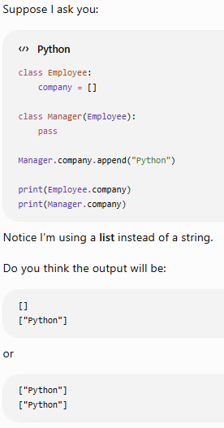
Answer
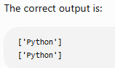
Explanation:
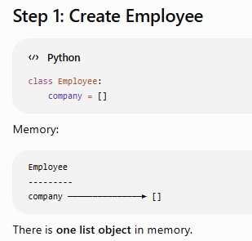
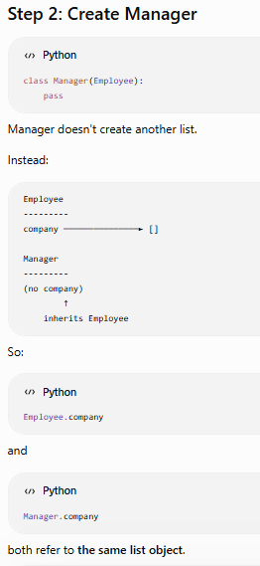
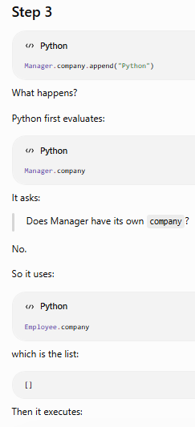
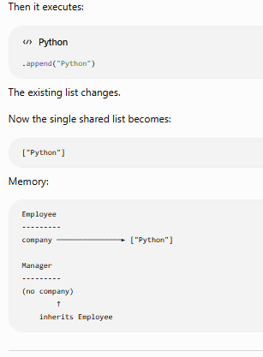
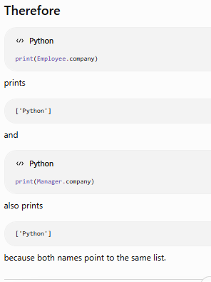
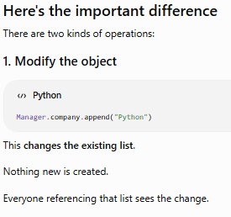

This is a very common interview concept
A good way to think about it is:
- Attribute lookup (Manager.company) follows the inheritance chain until it finds the attribute.
- Assignment (Manager.company = ...) never searches for a parent attribute to modify. It creates or updates the attribute directly on Manager.
- Mutation (Manager.company.append(...)) first performs attribute lookup, then modifies the object that was found.
