Does python support multiple inheritance?
Yes, Python fully supports multiple inheritance.
This is actually one of the biggest differences between Python and C#.
Feature | C# | Python
Multiple class inheritance | ❌ No | ✅ Yes
Multiple interface inheritance | ✅ Yes | ✅ Yes

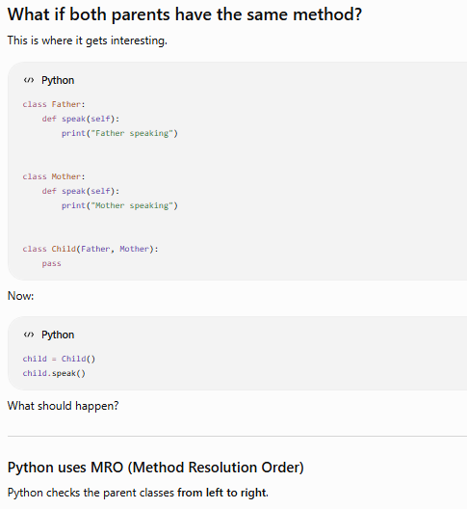
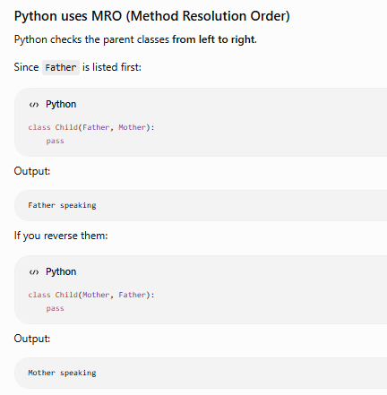
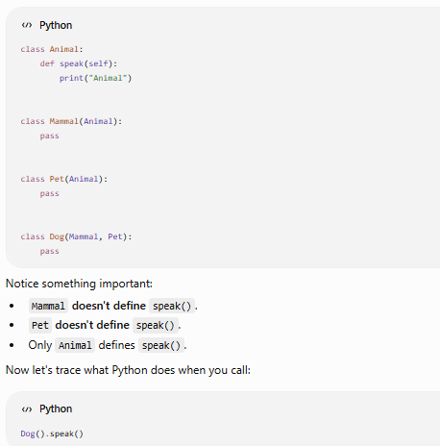
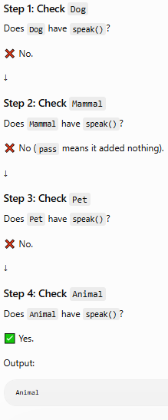
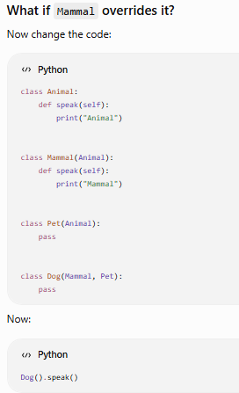
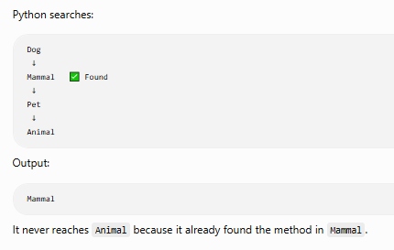
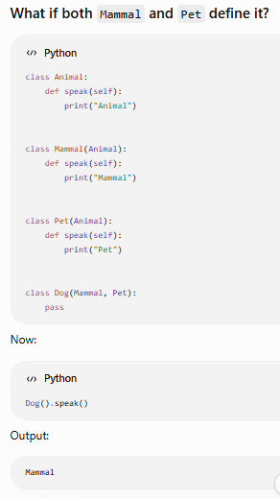
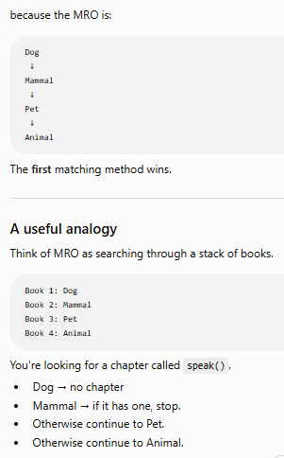
Python doesn't stop because a class exists. It stops because it finds the requested attribute or method.
super() in Single Inheritance
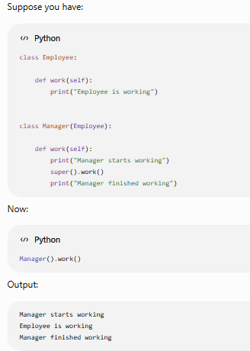
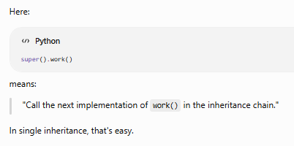
Step 2: What happens in Multiple Inheritance?
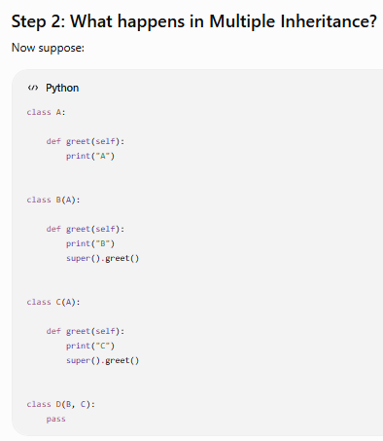
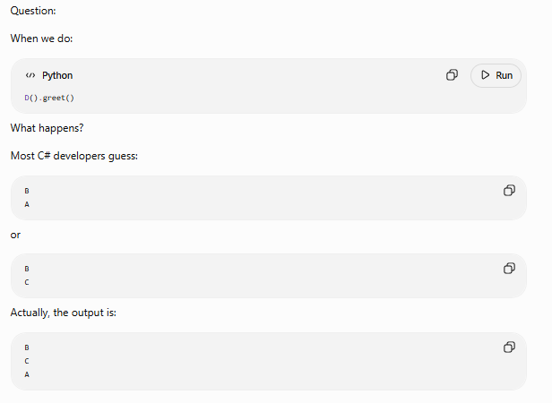
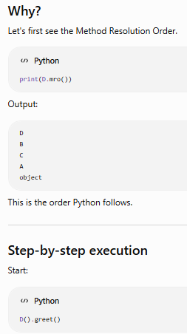
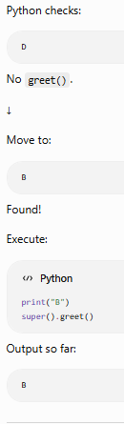
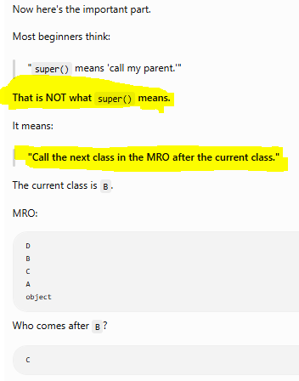
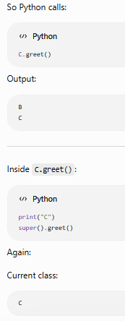
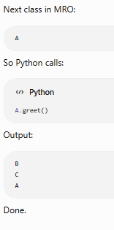

• When the class of the object has multiple inheritance, Python uses the Method Resolution Order (MRO) to decide what super() means. Each super() call moves to the next class in the MRO, not just the immediate parent. That’s why in D(B, C), the chain goes B → C → A.
• When the class inherits from a single parent, the MRO is simple:
Child → Parent → object
So in that case, super() effectively calls the parent’s method or property directly, because there’s no other class in between.

Does python have interfaces
Yes, but not in the same way as C#.
This is another major difference between Python and C#.
Feature | C# | Python
Interface keyword | ✅ interface | ❌ No interface keyword
Multiple interface implementation | ✅ Yes | ✅ Yes (using Abstract Base Classes or Protocols)
Enforced implementation | ✅ Compiler | ✅ Runtime (with Abstract Base Classes)
There are two common ways to achieve interface-like behavior in Python:
- Abstract Base Classes (ABC) ← Most common and interview favorite
- Protocols (introduced in Python 3.8+, used for static type checking)
Let's start with ABCs because they're closest to C# interfaces.

Python Equivalent (ABC)
Python has a module called abc.
