Does python support multiple inheritance?
Yes, Python fully supports multiple inheritance.
This is actually one of the biggest differences between Python and C#.
Feature | C# | Python
Multiple class inheritance | ❌ No | ✅ Yes
Multiple interface inheritance | ✅ Yes | ✅ Yes

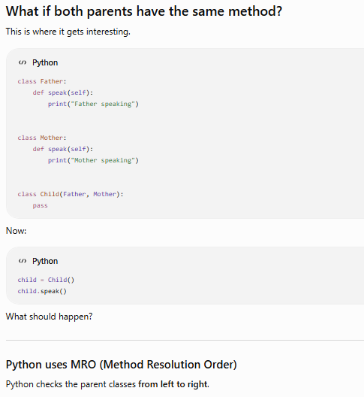
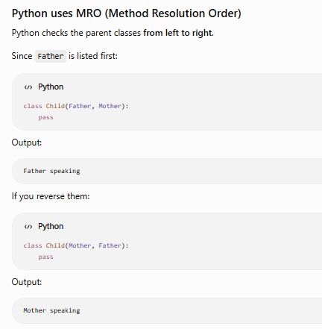
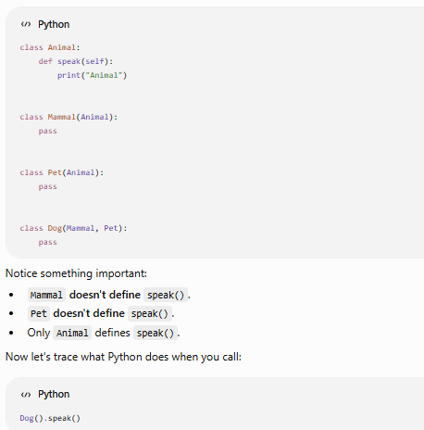
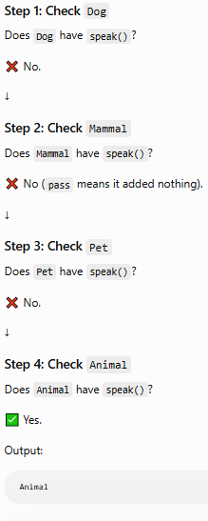
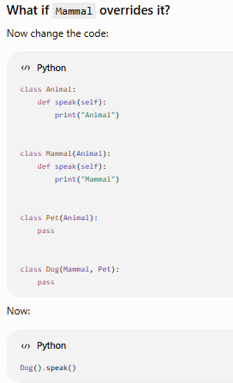
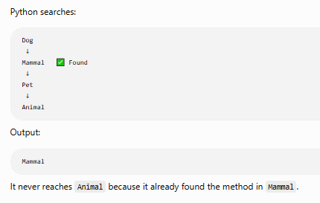
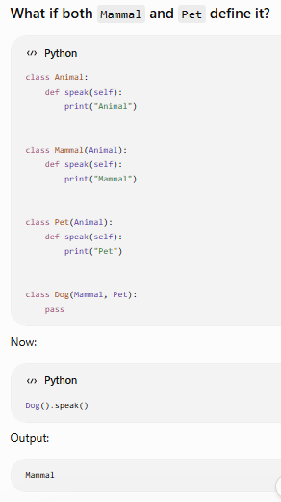
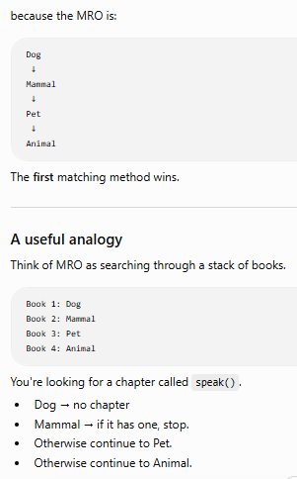
Python doesn't stop because a class exists. It stops because it finds the requested attribute or method.
super() in Single Inheritance
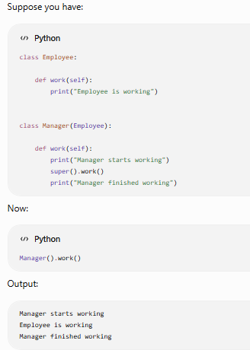
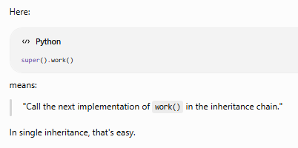
Step 2: What happens in Multiple Inheritance?
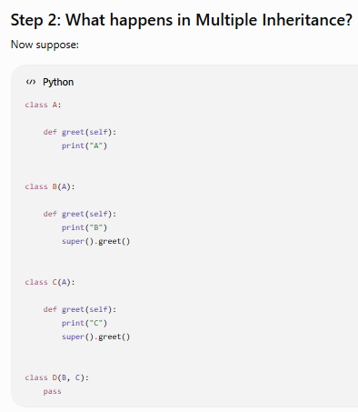
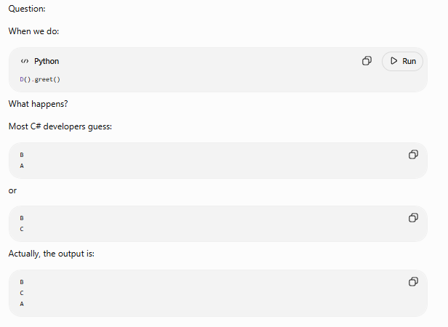
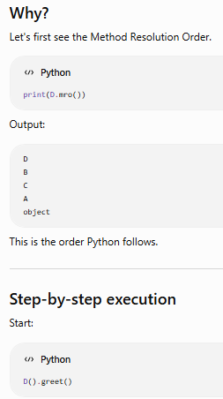
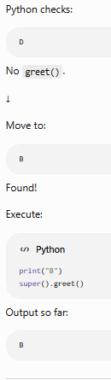
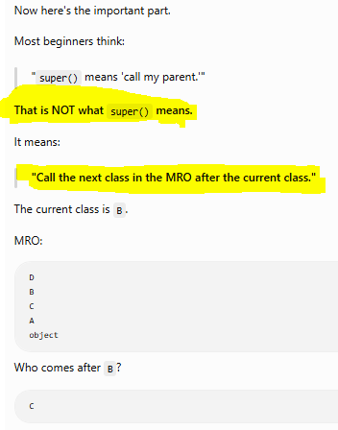
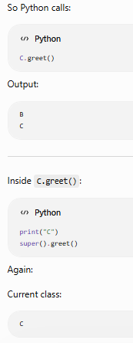
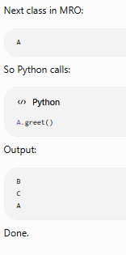

Does python have interfaces
Yes, but not in the same way as C#.
This is another major difference between Python and C#.
Feature | C# | Python
Interface keyword | ✅ interface | ❌ No interface keyword
Multiple interface implementation | ✅ Yes | ✅ Yes (using Abstract Base Classes or Protocols)
Enforced implementation | ✅ Compiler | ✅ Runtime (with Abstract Base Classes)
There are two common ways to achieve interface-like behavior in Python:
- Abstract Base Classes (ABC) ← Most common and interview favorite
- Protocols (introduced in Python 3.8+, used for static type checking)
Let's start with ABCs because they're closest to C# interfaces.

Python Equivalent (ABC)
Python has a module called abc.
