Manual – SSPlot : A Plotter and Numerical Solver for Dynamical Systems

Subhraman Sarkar
Version 1.5, 09/05/21

Copyright

Copyright (C) 2021 Subhraman Sarkar
Permission is granted to copy, distribute and/or modify this document under the terms of the GNU Free Documentation License, Version 1.3 or any later version published by the Free Software Foundation; with no Invariant Sections, no Front-Cover Texts, and no Back-Cover Texts. A copy of the license is included in the section entitled "GNU Free Documentation License".

1. Introduction
To help with visualization of dynamical systems in 2d and 3d, a simple plotting utility and dynamical system simulator software has been written by me (Subhraman Sarkar). It was written in the Java programming language. Java has been choosen for the following reasons :
- Java is highly object-oriented. So it is possible to break down large programs into small modules (class) where each module does a small portion of the total job.
- Java standard library has very good graphics libraries as well as libraries for writing complex graphical user interfaces (gui) which is a must for any kind of simulation. In Java we do not need any external libraries for graphics or gui building. Also libraries are easy to use after learning some basics.
- Java is cross-platform. Once a Java program has been compiled, it can run on any OS for which a Java Runtime environment is available. (With some more effort it can be ported to Android as well, since Android uses Java for its applications development language.)

2. Installation and Running
Homepage : SSPlot Repository
It is an open source software and is available under the terms of LGPL 2.1 license. It works on any platform with a Java JRE installed, though the exact steps required for installation might vary depending on the OS.
General Instructions :
- Install Java JRE or JDK. Version 14 preferred as it includes a parsing engine which is used for parsing the equations in the System parameters window. Versions > 14 require some additional work.
- Install the Apache Commons Math library, version 3 in your CLASSPATH.
- If you are using Java versions > 14, an external script engine such as Jython is required. (To use Jython, install its jar file in your CLASSPATH. Then setup the SSPLOT_ENGINE environment variable with the value python.)
- Download and install the SSPlot.jar file in your CLASSPATH from the homepage of the SSPlot project given above.
- Run using the command java math.plot.PlotterFrame.
Much more detailed and updated information about installing, running and compilation of the software is given in its homepage given above.

3. The Main Window
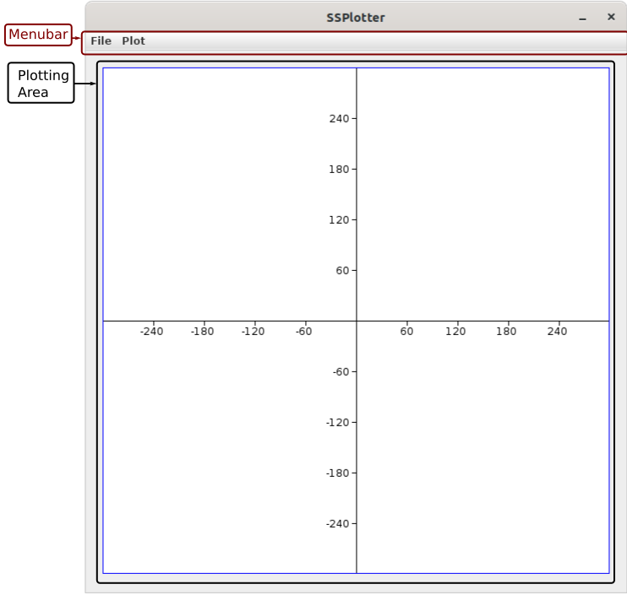Figure 1: Main Window
The main window consists of two parts,
- The Menubar
It contains two menus,
  - The File Menu
  - The Plot Menu
- The Plotting Canvas
This is the area where the Plot and the Axes are shown.

4. The Menus
- The File Menu
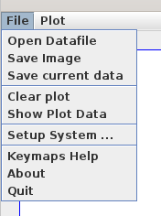Figure 2: File Menu
The File Menu is show in Figure 2. It is the most import menu as it contains most of the tools we need.
  - Open Datafile
This launches a file selection window, from which you can select a datafile with your data, which then gets plotted in the Plotting Area. A datafile is a plain-text file with numbers separated by spaces, like this :
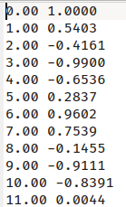
Each row is one of the data points. There is no restriction on the number of rows. However, the number of columns is restricted by the current Plot Type. It is explained in section 5.1 on different plot types.
If you open multiple datafiles, each file will be plotted over the previous plot.
  - Save Image
This saves the current plot as a png graphic file. (Please enter the filename with the extension. (ie. like plot1.png))
  - Save current data
Saves the datapoints associated with the current plot (usually the last) to a datafile.
  - Clear plot
Clears all plots from the Plotting Area as well as their data from memory, and resets the axes (and any zoom level changes).
  - Show plot data
Shows the datapoints of the current plot in a separate data viewer window. Explained in section 5.2.
  - Setup System…
Opens the System Parameters window, which allows you to solve systems of ODEs or systems of Difference equations and plot them. How to use this window to solve systems and plot them is explained in detail later in section 7
  - Keymaps Help
There are some keys on the keyboard which are mapped to special functions inside the plotting area. For example, the J and B keys are mapped to Zoom in and Zoom out functions, so you can use them to zoom in and out the plot. The various keybindings are explained in detail in section 6.
  - About
Shows information about the software.
  - Quit
Stops and exits the application.

- The Plot Menu
Shown in Figure 3. This menu changes the properties of the current plot.
  - Show/hide axes
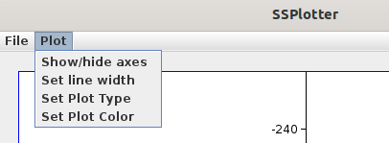Figure 3: Plot Menu
Toggles the axis visibility.
  - Set line width
Sets the thickness of the line or size of points. (both are same)
  - Set Plot Type
This is an extremely important menu item. It sets the type of the plot, which changes the interpretation of the datafile. For example, a two column datafile is valid in Lines or Points modes, but is illegal in 3d Lines, 3d Points or Vector Field modes, which require a datafile with at least 3 columns, 3 columns or 4 columns respectively. (The program will show an error message if run from command line.)
Various plot types are explained in section 5.1.
  - Set Plot Color
Opens a color chooser dialog, from which you can change the color of the current plot.

5. Working with Data

5.1 Plot Types
For now, there are five plot modes,
- Lines
This mode requires a datafile with at least two columns. Each row of the datafile contains two values separated by whitespace. The first value specifies the x coordinate, while the second value specifies the y coordinate of one data point. Each row thus represents one single datum. The software then draws a plot by joining each point (specified by a row) with the next point in the datafile by a line segment.
For a datafile with more than two columns, you can select which column to plot along the x axis and which column to plot along the y axis from the Data Viewer window. See the next sub-section (§5.2).
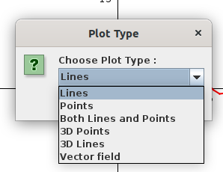Figure 4: Plot Type Dialog
- Points
Similar to the lines mode, except that it just draws a point on the plot corresponding to each datum. Changing the line color from the plot menu changes the color of the points.
- Lines and Points
A combination of the previous two modes. Both the datapoints and the line segments joining them are drawn. Changing line color does not changes the color of the point only in this mode. The defaut point color is black.
- 3d Points
This mode requires a datafile with at least three columns. Everything is the same as the Points mode. The first three columns are used as the x, y and z data and the rest of the columns are ignored. You can use the 3d rotation keys on the keyboard to rotate the view. (See §6) The default view shows the XY plane.
- 3d Lines
Same as 3d points, except this mode joins each point on the plot with the point following it by a straight line segment. (just like Lines mode, but in 3d) You can use the 3d rotation keys similarly.
- Vector field
Requires a datafile with at least 4 columns (all columns except the first four are ignored). The first two values in a row indicate a point (say A) and the last two values indicate another point (say B). The program then draws an arrow from the first point to the second point.

5.2 Data Viewer window
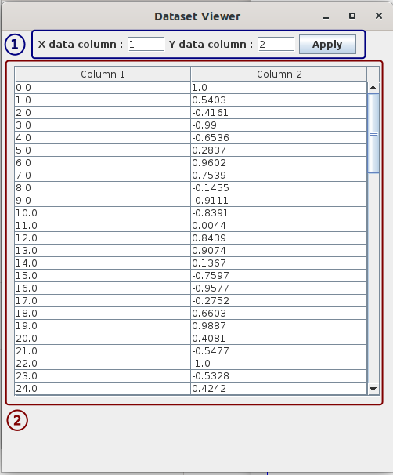Figure 5: The Data Viewer Window
This window is accessed by clicking the Show Plot Data in the File menu. (shown in the Figure on the side)
The area marked by 1 allows you to set the columns which will be used as the X data and Y data respectively. Just enter the column number in the respective boxes and click Apply.
The area marked by 2 shows the data in your datafile.

6. Keybindings
As mentioned earlier, various keys in the keyboard have been mapped to various plot related functions. These keys are given the table below.
Key | Function
J | Big Zoom. Double the Zoom level (i.e., if the zoom was 2x, then after pressing it will be 4x)
F | Big Zoom. Halve the Zoom level (i.e., if the zoom was 2x, then after pressing it will be 1x)
H | Small Zoom. Increase the zoom by 1x. (i.e., if the zoom was 3x, then after pressing it will be 4x)
G | Small Zoom. Decrease the zoom by 1x. (i.e., if the zoom was 3x, then after pressing it will be 2x)
Arrow keys | Shift the plot in the direction of the arrow key pressed.
Q | Rotate the view by 10° counterclockwise about the x axis.
A | Rotate the view by 10° clockwise about the x axis.
W | Rotate the view by 10° counterclockwise about the y axis.
S | Rotate the view by 10° clockwise about the y axis.
E | Rotate the view by 10° counterclockwise about the z axis.
D | Rotate the view by 10° clockwise about the z axis.

Whenever these keys are pressed, the current position, zoom or viewing angle in printed to the standard output stream (the terminal if you are running it from the terminal).
Also, if you Right Click on a point on the plotting area with the mouse, a message will appear showing the coordinates of the point. _{[v1.3]}
You can now big zoom (zoom */ 2) using the mouse wheel and set the zoom center using middle click.[v1.4] [Disabled in v1.5 due to a bug]

7. The System Parameters Window
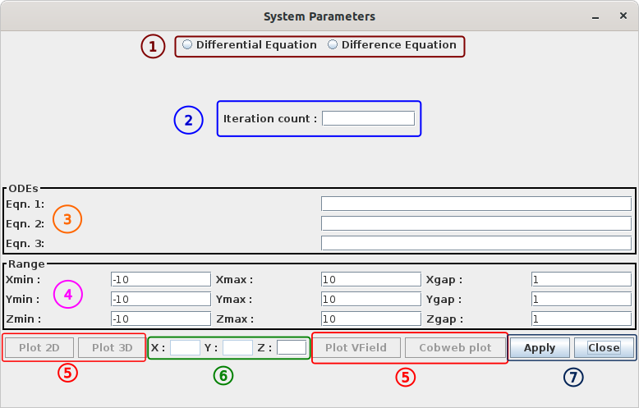Figure 6: The System Parameters Window

This window can be accessed by clicking the System Parameters… item from the File menu. It allows you to numerically solve and plot systems of ordinary differential equations (in 2 and 3 dimensions) as well as systems of difference equations or iterated maps (in 1, 2 and 3 dimensions). Let’s divide this window into some sections to better explain how it works.
From the top,
- The area marked by ① allows you to choose whether you want to solve a system of differential equations or difference equations.
- In the area marked by ②, you have to put how many times the system is going to be iterated. (Values like 5000 or 10000 are good for ODEs, while 100 is pretty high for some cobwebs plot, because it makes the plot a blob of black lines!)
- Next is the area called ODEs, marked ③. You will enter the system of equations, either differential equations or difference equations here. The first, second and third textboxes are for the x, y and z equations respectively. Note that you must use x, y, z as the variables. The program cannot recognize any other variables. Also, you need to enter the right hand side of the equations only. The left hand side will be automatically added. Also note that you will have to enter the equations in the notation of whatever script engine the program is using. For Java 14, this engine is a JavaScript parser, so you have to enter the equations in JavaScript notation for that case, i.e., becomes Math.pow(x,3) + Math.sin(x). Latest version uses an internal math parser based on JavaCC, which supports mathematical notation, so this becomes just x^3 + sin(x).
- You can enter the range as well as the spacing between arrows for vector field plot in area ④.
- After you have entered the equations, setup the system by pressing the Apply button in area ⑦. Or, you can close the window by pressing Close if you don’t need it.
- As soon as you have setup the system, you can plot it by using the buttons Plot 2D, Plot 3D, Plot Vfield or Cobweb Plot in area (5). Except for the Plot Vfield button, you must enter the appropriate initial conditions in area (6) before pressing the buttons. This will now solve the system and plot the solution or vector field in the Plotting Area in the main window. As soon as the plot appears, you will be able to view the solutions in the Data Viewer window (File → Show Plot Data) and save it as a datafile using Save Current Data item in the File menu.
- The various plotting buttons in the area (5) are :
  - Plot 2D : Computes the numerical solution for the 2D system entered in the area (6). You need not enter the initial condition for N. You also don’t need to enter the z equation in area (3). Uses RK 4th order method for ODEs for the numerical solution. For difference equations it just iterates the system.
  - Plot 3D : Same as Plot 2D button, except it needs all three initial conditions as well as all three equations. Initially the xy view is shown. You can rotate the view using the 3d rotation keys described in section 6.
  - Plot Vfield : Plots a 2D vector field. You need to enter the x and y equations only.
  - Cobweb plot : Requires only the x equation as well as the x initial condition. If you need to solve a 1D difference equation, don’t use this. Use the Plot 2D button with 0 for the y equation and the y initial conditon instead. Use this button only to visualize the Cobweb plot of a 1D map.

8. Tutorial

1. Plotting a 2D system given by a system of ODEs
As an example, let us plot the Simple Harmonic Oscillator system, given by :
This is a 2nd order ordinary differential equation (ODE). To plot this, we first need to convert it to a system of equations. Since this is a 2nd order equation, this can be converted to a system of two first order ODEs. Let’s introduce . Then this equation becomes a system of two equations :
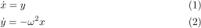
Now launch SSPlot and open the System Parameters window by clicking File menu → System Parameters…
Since this is a system of differential equations, we choose the differential equations option. We want to iterate the system 5000 times, so we enter 5000 in the iteration count box. Next, we enter the right hand sides in the ODEs section in the System Parameters window. Enter the RHS of equation (1), i.e. the RHS of the equation in the Eqn. 1 field, which is . Similary, enter the RHS of the equation in the Eqn. 2 window. You can choose any value of . For simplicity, we will set here. So let’s set Eqn. 2 field to . Leave the Range parameters to their default values. The window should look like this :
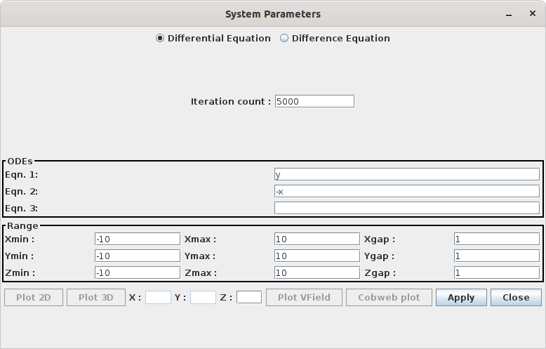Figure 7: System Parameters for Example 1
Now click the Apply button. The Plot VField, Plot 2D, Plot 3D button, and the X, Y, Z textboxes on the bottom of the window will become active. Click on the Plot VField button, and you will see the main window like Figure 8.
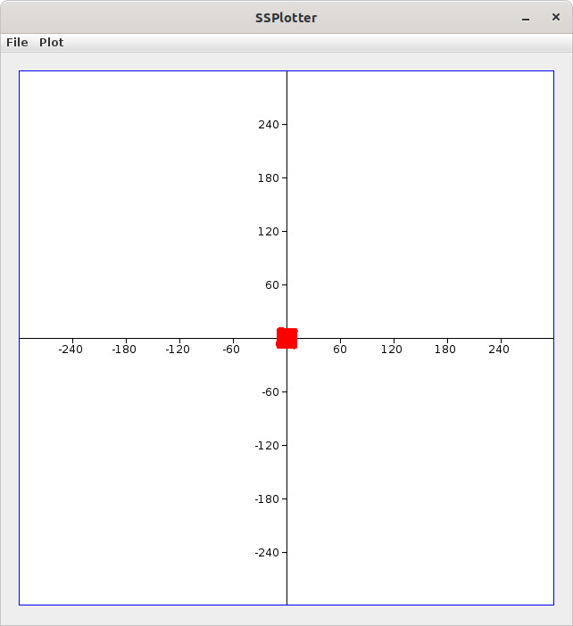Figure 8: Main Window, not zoomed in
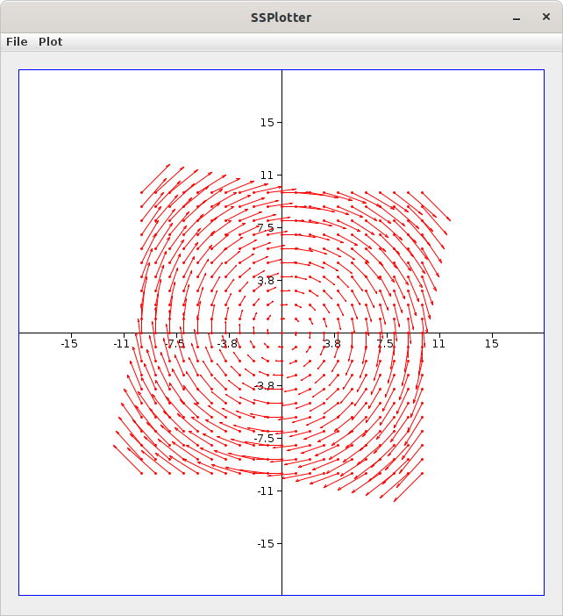Figure 9: Main Window, zoomed in
The problem is that the default scale is way too big for our choice of , so we have to zoom in to see the system. Click on the Main Window, and press the J key on the keyboard a couple of times to zoom in, and you will get a vector field like Figure 9.
Now suppose you want to see what happens for large amplitude oscillations. In this case the equation are :
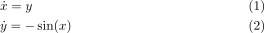
Just change the value of the Eqn. 2 field to -sin(x). (Change the notation to match whatever parsing engine you are using.). In this case we will also need to tweak the Range parameters to increase the resolution of the Vector Field plot and plotting area in order to see the features of this system. Put Ymin = -5, Ymax = 5 and Xgap = Ygap = 0.5, then press the Apply button once more to update the system. Then clear the previous plot using File menu → Clear Plot, and plot the new system by clicking the Plot VField button on the System Parameters window. Zoom in a couple of times, and you will end up with something like Figure 11.
Now suppose you want to plot the solution over this direction field, say for initial conditions . You can easily do so by entering the initial conditions in the X
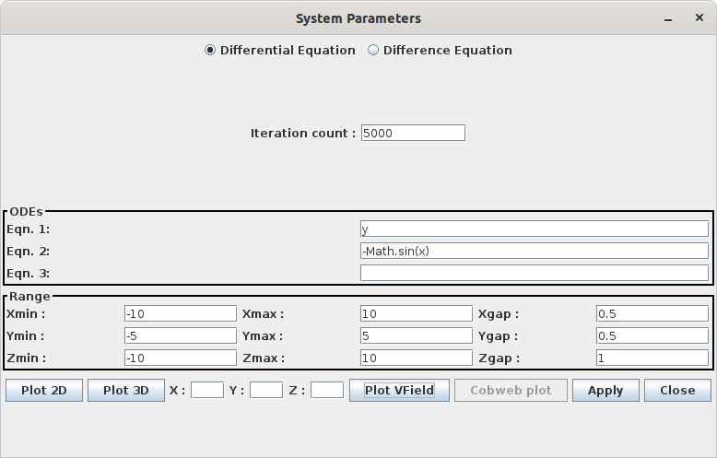Figure 10: System Parameters for nonlinear SHO
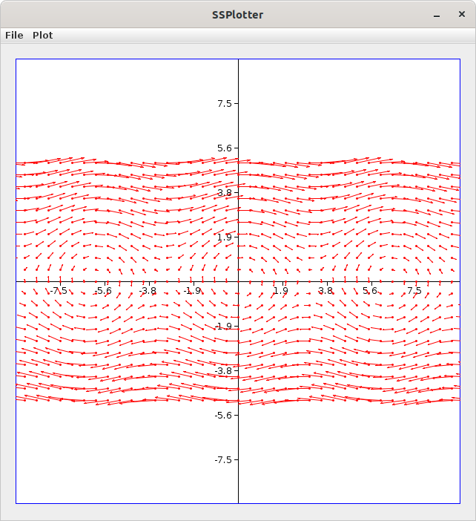Figure 11: Direction Field for nonlinear SHO
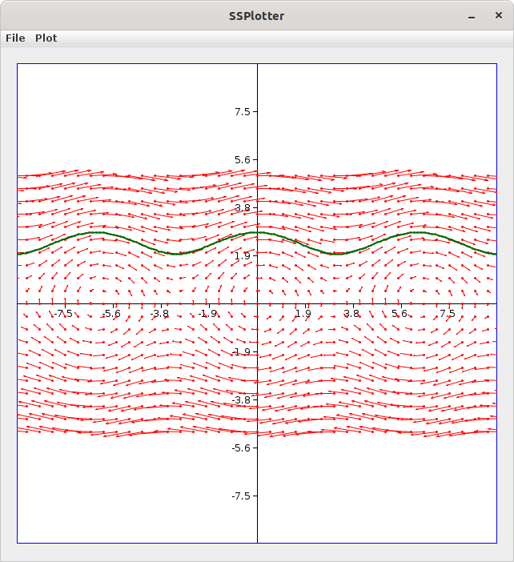Figure 12: Trajectory for (-10,2)
and Y boxes at the bottom of the System parameters window and clicking Plot 2D. The result is something like Figure 12. The color of the trajectory is changed by using the Set Plot Color item in the Plot menu in the Main Window.

9. Gallery
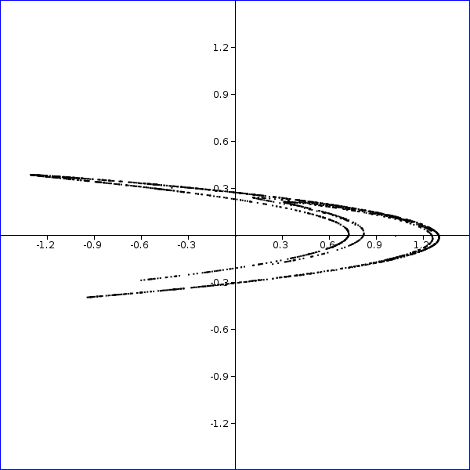Figure 13: Henon map for parameter values a=1.4, b=0.3, initial condition (0,0)
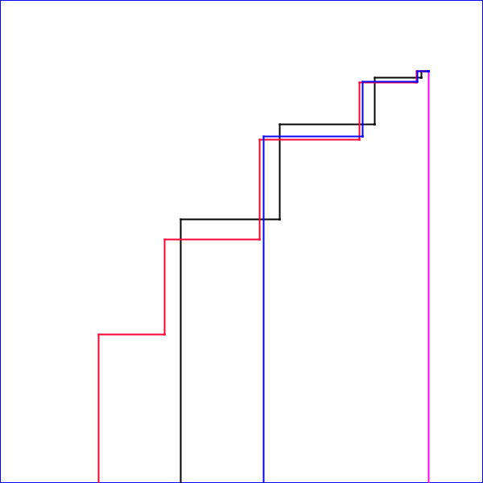Figure 14: logistic map cobweb plot for parameter value a = 2 and several initial conditions in different colors. All trajectories converge to x = 0.5.
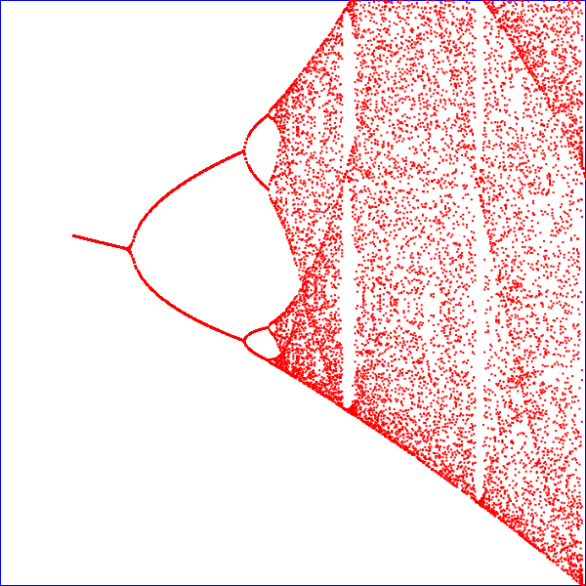Figure 15: orbit diagram of logistic map, 1213x zoomed, showing self similarity. Plotted from a datafile created by a Fortran90 program
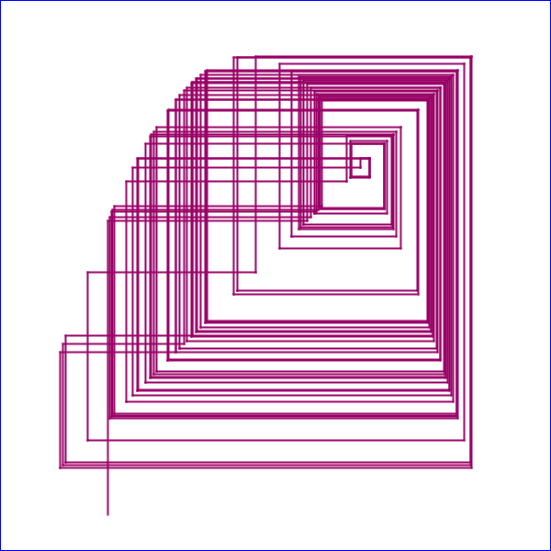Figure 16: logistic map cobweb plot showing a single chaotic trajectory for parameter value a = 3.9, initial condition x = 0.2.
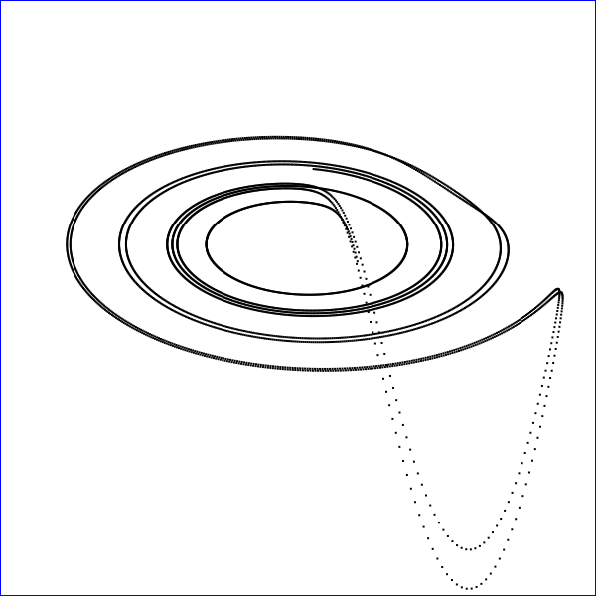Figure 17: Rossler system, a=0.1, b=0.1, c=14, initial condition (5,5,5), rotated 60º counterclockwise, about x axis.
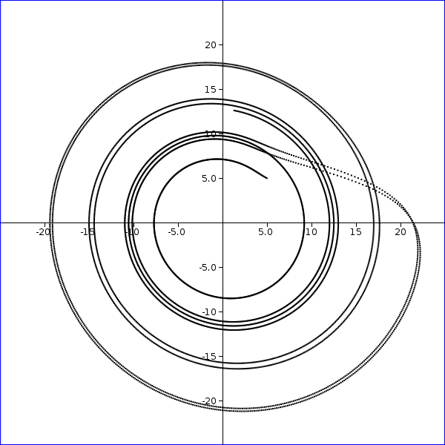Figure 18: Rossler system, parameters a = 0.1, b= 0.1, c = 14, initial condition (5,5,5), XY view

GNU Free Documentation License
Version 1.3, 3 November 2008
Copyright (C) 2000, 2001, 2002, 2007, 2008 Free Software Foundation, Inc. https://fsf.org/
Everyone is permitted to copy and distribute verbatim copies of this license document, but changing it is not allowed.

0. PREAMBLE
The purpose of this License is to make a manual, textbook, or other functional and useful document "free" in the sense of freedom: to assure everyone the effective freedom to copy and redistribute it, with or without modifying it, either commercially or noncommercially. Secondarily, this License preserves for the author and publisher a way to get credit for their work, while not being considered responsible for modifications made by others.
This License is a kind of "copyleft", which means that derivative works of the document must themselves be free in the same sense. It complements the GNU General Public License, which is a copyleft license designed for free software.
We have designed this License in order to use it for manuals for free software, because free software needs free documentation: a free program should come with manuals providing the same freedoms that the software does. But this License is not limited to software manuals; it can be used for any textual work, regardless of subject matter or whether it is published as a printed book. We recommend this License principally for works whose purpose is instruction or reference.

1. APPLICABILITY AND DEFINITIONS
This License applies to any manual or other work, in any medium, that contains a notice placed by the copyright holder saying it can be distributed under the terms of this License. Such a notice grants a world-wide, royalty-free license, unlimited in duration, to use that work under the conditions stated herein. The "Document", below, refers to any such manual or work. Any member of the public is a licensee, and is addressed as "you". You accept the license if you copy, modify or distribute the work in a way requiring permission under copyright law.
A "Modified Version" of the Document means any work containing the Document or a portion of it, either copied verbatim, or with modifications and/or translated into another language.
A "Secondary Section" is a named appendix or a front-matter section of the Document that deals exclusively with the relationship of the publishers or authors of the Document to the Document's overall subject (or to related matters) and contains nothing that could fall directly within that overall subject. (Thus, if the Document is in part a textbook of mathematics, a Secondary Section may not explain any mathematics.) The relationship could be a matter of historical connection with the subject or with related matters, or of legal, commercial, philosophical, ethical or political position regarding them.
The "Invariant Sections" are certain Secondary Sections whose titles are designated, as being those of Invariant Sections, in the notice that says that the Document is released under this License. If a section does not fit the above definition of Secondary then it is not allowed to be designated as Invariant. The Document may contain zero Invariant Sections. If the Document does not identify any Invariant Sections then there are none.
The "Cover Texts" are certain short passages of text that are listed, as Front-Cover Texts or Back-Cover Texts, in the notice that says that the Document is released under this License. A Front-Cover Text may be at most 5 words, and a Back-Cover Text may be at most 25 words.
A "Transparent" copy of the Document means a machine-readable copy, represented in a format whose specification is available to the general public, that is suitable for revising the document straightforwardly with generic text editors or (for images composed of pixels) generic paint programs or (for drawings) some widely available drawing editor, and that is suitable for input to text formatters or for automatic translation to a variety of formats suitable for input to text formatters. A copy made in an otherwise Transparent file format whose markup, or absence of markup, has been arranged to thwart or discourage subsequent modification by readers is not Transparent. An image format is not Transparent if used for any substantial amount of text. A copy that is not "Transparent" is called "Opaque".
Examples of suitable formats for Transparent copies include plain ASCII without markup, Texinfo input format, LaTeX input format, SGML or XML using a publicly available DTD, and standard-conforming simple HTML, PostScript or PDF designed for human modification. Examples of transparent image formats include PNG, XCF and JPG. Opaque formats include proprietary formats that can be read and edited only by proprietary word processors, SGML or XML for which the DTD and/or processing tools are not generally available, and the machine-generated HTML, PostScript or PDF produced by some word processors for output purposes only.
The "Title Page" means, for a printed book, the title page itself, plus such following pages as are needed to hold, legibly, the material this License requires to appear in the title page. For works in formats which do not have any title page as such, "Title Page" means the text near the most prominent appearance of the work's title, preceding the beginning of the body of the text.
The "publisher" means any person or entity that distributes copies of the Document to the public.
A section "Entitled XYZ" means a named subunit of the Document whose title either is precisely XYZ or contains XYZ in parentheses following text that translates XYZ in another language. (Here XYZ stands for a specific section name mentioned below, such as "Acknowledgements", "Dedications", "Endorsements", or "History".) To "Preserve the Title" of such a section when you modify the Document means that it remains a section "Entitled XYZ" according to this definition.
The Document may include Warranty Disclaimers next to the notice which states that this License applies to the Document. These Warranty Disclaimers are considered to be included by reference in this License, but only as regards disclaiming warranties: any other implication that these Warranty Disclaimers may have is void and has no effect on the meaning of this License.

2. VERBATIM COPYING
You may copy and distribute the Document in any medium, either commercially or noncommercially, provided that this License, the copyright notices, and the license notice saying this License applies to the Document are reproduced in all copies, and that you add no other conditions whatsoever to those of this License. You may not use technical measures to obstruct or control the reading or further copying of the copies you make or distribute. However, you may accept compensation in exchange for copies. If you distribute a large enough number of copies you must also follow the conditions in section 3.
You may also lend copies, under the same conditions stated above, and you may publicly display copies.

3. COPYING IN QUANTITY
If you publish printed copies (or copies in media that commonly have printed covers) of the Document, numbering more than 100, and the Document's license notice requires Cover Texts, you must enclose the copies in covers that carry, clearly and legibly, all these Cover Texts: Front-Cover Texts on the front cover, and Back-Cover Texts on the back cover. Both covers must also clearly and legibly identify you as the publisher of these copies. The front cover must present the full title with all words of the title equally prominent and visible. You may add other material on the covers in addition. Copying with changes limited to the covers, as long as they preserve the title of the Document and satisfy these conditions, can be treated as verbatim copying in other respects.
If the required texts for either cover are too voluminous to fit legibly, you should put the first ones listed (as many as fit reasonably) on the actual cover, and continue the rest onto adjacent pages.
If you publish or distribute Opaque copies of the Document numbering more than 100, you must either include a machine-readable Transparent copy along with each Opaque copy, or state in or with each Opaque copy a computer-network location from which the general network-using public has access to download using public-standard network protocols a complete Transparent copy of the Document, free of added material. If you use the latter option, you must take reasonably prudent steps, when you begin distribution of Opaque copies in quantity, to ensure that this Transparent copy will remain thus accessible at the stated location until at least one year after the last time you distribute an Opaque copy (directly or through your agents or retailers) of that edition to the public.
It is requested, but not required, that you contact the authors of the Document well before redistributing any large number of copies, to give them a chance to provide you with an updated version of the Document.

4. MODIFICATIONS
You may copy and distribute a Modified Version of the Document under the conditions of sections 2 and 3 above, provided that you release the Modified Version under precisely this License, with the Modified Version filling the role of the Document, thus licensing distribution and modification of the Modified Version to whoever possesses a copy of it. In addition, you must do these things in the Modified Version:
- A. Use in the Title Page (and on the covers, if any) a title distinct from that of the Document, and from those of previous versions (which should, if there were any, be listed in the History section of the Document). You may use the same title as a previous version if the original publisher of that version gives permission.
- B. List on the Title Page, as authors, one or more persons or entities responsible for authorship of the modifications in the Modified Version, together with at least five of the principal authors of the Document (all of its principal authors, if it has fewer than five), unless they release you from this requirement.
- C. State on the Title page the name of the publisher of the Modified Version, as the publisher.
- D. Preserve all the copyright notices of the Document.
- E. Add an appropriate copyright notice for your modifications adjacent to the other copyright notices.
- F. Include, immediately after the copyright notices, a license notice giving the public permission to use the Modified Version under the terms of this License, in the form shown in the Addendum below.
- G. Preserve in that license notice the full lists of Invariant Sections and required Cover Texts given in the Document's license notice.
- H. Include an unaltered copy of this License.
- I. Preserve the section Entitled "History", Preserve its Title, and add to it an item stating at least the title, year, new authors, and publisher of the Modified Version as given on the Title Page. If there is no section Entitled "History" in the Document, create one stating the title, year, authors, and publisher of the Document as given on its Title Page, then add an item describing the Modified Version as stated in the previous sentence.
- J. Preserve the network location, if any, given in the Document for public access to a Transparent copy of the Document, and likewise the network locations given in the Document for previous versions it was based on. These may be placed in the "History" section. You may omit a network location for a work that was published at least four years before the Document itself, or if the original publisher of the version it refers to gives permission.
- K. For any section Entitled "Acknowledgements" or "Dedications", Preserve the Title of the section, and preserve in the section all the substance and tone of each of the contributor acknowledgements and/or dedications given therein.
- L. Preserve all the Invariant Sections of the Document, unaltered in their text and in their titles. Section numbers or the equivalent are not considered part of the section titles.
- M. Delete any section Entitled "Endorsements". Such a section may not be included in the Modified Version.
- N. Do not retitle any existing section to be Entitled "Endorsements" or to conflict in title with any Invariant Section.
- O. Preserve any Warranty Disclaimers.
If the Modified Version includes new front-matter sections or appendices that qualify as Secondary Sections and contain no material copied from the Document, you may at your option designate some or all of these sections as invariant. To do this, add their titles to the list of Invariant Sections in the Modified Version's license notice. These titles must be distinct from any other section titles.
You may add a section Entitled "Endorsements", provided it contains nothing but endorsements of your Modified Version by various parties—for example, statements of peer review or that the text has been approved by an organization as the authoritative definition of a standard.
You may add a passage of up to five words as a Front-Cover Text, and a passage of up to 25 words as a Back-Cover Text, to the end of the list of Cover Texts in the Modified Version. Only one passage of Front-Cover Text and one of Back-Cover Text may be added by (or through arrangements made by) any one entity. If the Document already includes a cover text for the same cover, previously added by you or by arrangement made by the same entity you are acting on behalf of, you may not add another; but you may replace the old one, on explicit permission from the previous publisher that added the old one.
The author(s) and publisher(s) of the Document do not by this License give permission to use their names for publicity for or to assert or imply endorsement of any Modified Version.

5. COMBINING DOCUMENTS
You may combine the Document with other documents released under this License, under the terms defined in section 4 above for modified versions, provided that you include in the combination all of the Invariant Sections of all of the original documents, unmodified, and list them all as Invariant Sections of your combined work in its license notice, and that you preserve all their Warranty Disclaimers.
The combined work need only contain one copy of this License, and multiple identical Invariant Sections may be replaced with a single copy. If there are multiple Invariant Sections with the same name but different contents, make the title of each such section unique by adding at the end of it, in parentheses, the name of the original author or publisher of that section if known, or else a unique number. Make the same adjustment to the section titles in the list of Invariant Sections in the license notice of the combined work.
In the combination, you must combine any sections Entitled "History" in the various original documents, forming one section Entitled "History"; likewise combine any sections Entitled "Acknowledgements", and any sections Entitled "Dedications". You must delete all sections Entitled "Endorsements".

6. COLLECTIONS OF DOCUMENTS
You may make a collection consisting of the Document and other documents released under this License, and replace the individual copies of this License in the various documents with a single copy that is included in the collection, provided that you follow the rules of this License for verbatim copying of each of the documents in all other respects.
You may extract a single document from such a collection, and distribute it individually under this License, provided you insert a copy of this License into the extracted document, and follow this License in all other respects regarding verbatim copying of that document.

7. AGGREGATION WITH INDEPENDENT WORKS
A compilation of the Document or its derivatives with other separate and independent documents or works, in or on a volume of a storage or distribution medium, is called an "aggregate" if the copyright resulting from the compilation is not used to limit the legal rights of the compilation's users beyond what the individual works permit. When the Document is included in an aggregate, this License does not apply to the other works in the aggregate which are not themselves derivative works of the Document.
If the Cover Text requirement of section 3 is applicable to these copies of the Document, then if the Document is less than one half of the entire aggregate, the Document's Cover Texts may be placed on covers that bracket the Document within the aggregate, or the electronic equivalent of covers if the Document is in electronic form. Otherwise they must appear on printed covers that bracket the whole aggregate.

8. TRANSLATION
Translation is considered a kind of modification, so you may distribute translations of the Document under the terms of section 4. Replacing Invariant Sections with translations requires special permission from their copyright holders, but you may include translations of some or all Invariant Sections in addition to the original versions of these Invariant Sections. You may include a translation of this License, and all the license notices in the Document, and any Warranty Disclaimers, provided that you also include the original English version of this License and the original versions of those notices and disclaimers. In case of a disagreement between the translation and the original version of this License or a notice or disclaimer, the original version will prevail.
If a section in the Document is Entitled "Acknowledgements", "Dedications", or "History", the requirement (section 4) to Preserve its Title (section 1) will typically require changing the actual title.

9. TERMINATION
You may not copy, modify, sublicense, or distribute the Document except as expressly provided under this License. Any attempt otherwise to copy, modify, sublicense, or distribute it is void, and will automatically terminate your rights under this License.
However, if you cease all violation of this License, then your license from a particular copyright holder is reinstated (a) provisionally, unless and until the copyright holder explicitly and finally terminates your license, and (b) permanently, if the copyright holder fails to notify you of the violation by some reasonable means prior to 60 days after the cessation.
Moreover, your license from a particular copyright holder is reinstated permanently if the copyright holder notifies you of the violation by some reasonable means, this is the first time you have received notice of violation of this License (for any work) from that copyright holder, and you cure the violation prior to 30 days after your receipt of the notice.
Termination of your rights under this section does not terminate the licenses of parties who have received copies or rights from you under this License. If your rights have been terminated and not permanently reinstated, receipt of a copy of some or all of the same material does not give you any rights to use it.

10. FUTURE REVISIONS OF THIS LICENSE
The Free Software Foundation may publish new, revised versions of the GNU Free Documentation License from time to time. Such new versions will be similar in spirit to the present version, but may differ in detail to address new problems or concerns. See https://www.gnu.org/licenses/.
Each version of the License is given a distinguishing version number. If the Document specifies that a particular numbered version of this License "or any later version" applies to it, you have the option of following the terms and conditions either of that specified version or of any later version that has been published (not as a draft) by the Free Software Foundation. If the Document does not specify a version number of this License, you may choose any version ever published (not as a draft) by the Free Software Foundation. If the Document specifies that a proxy can decide which future versions of this License can be used, that proxy's public statement of acceptance of a version permanently authorizes you to choose that version for the Document.

11. RELICENSING
"Massive Multiauthor Collaboration Site" (or "MMC Site") means any World Wide Web server that publishes copyrightable works and also provides prominent facilities for anybody to edit those works. A public wiki that anybody can edit is an example of such a server. A "Massive Multiauthor Collaboration" (or "MMC") contained in the site means any set of copyrightable works thus published on the MMC site.
"CC-BY-SA" means the Creative Commons Attribution-Share Alike 3.0 license published by Creative Commons Corporation, a not-for-profit corporation with a principal place of business in San Francisco, California, as well as future copyleft versions of that license published by that same organization.
"Incorporate" means to publish or republish a Document, in whole or in part, as part of another Document.
An MMC is "eligible for relicensing" if it is licensed under this License, and if all works that were first published under this License somewhere other than this MMC, and subsequently incorporated in whole or in part into the MMC, (1) had no cover texts or invariant sections, and (2) were thus incorporated prior to November 1, 2008.
The operator of an MMC Site may republish an MMC contained in the site under CC-BY-SA on the same site at any time before August 1, 2009, provided the MMC is eligible for relicensing.

ADDENDUM: How to use this License for your documents
To use this License in a document you have written, include a copy of the License in the document and put the following copyright and license notices just after the title page:
Copyright (C) YEAR YOUR NAME.
Permission is granted to copy, distribute and/or modify this document
under the terms of the GNU Free Documentation License, Version 1.3
or any later version published by the Free Software Foundation;
with no Invariant Sections, no Front-Cover Texts, and no Back-Cover Texts.
A copy of the license is included in the section entitled "GNU
Free Documentation License".
If you have Invariant Sections, Front-Cover Texts and Back-Cover Texts, replace the "with … Texts." line with this:
with the Invariant Sections being LIST THEIR TITLES, with the
Front-Cover Texts being LIST, and with the Back-Cover Texts being LIST.
If you have Invariant Sections without Cover Texts, or some other combination of the three, merge those two alternatives to suit the situation.
If your document contains nontrivial examples of program code, we recommend releasing these examples in parallel under your choice of free software license, such as the GNU General Public License, to permit their use in free software.

