***Incremental vs iterative***

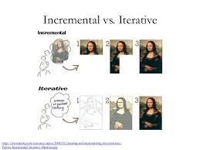

Source:

* https://scrumallianceprofessional.wordpress.com/scrum-is-iterative-and-incremental/