Getting Started with r4c
r4c package
2026-06-30

Overview
r4c supports two operational rangeland tasks:
- Classifying range condition from six-factor field sheets.
- Estimating dry fodder production and livestock units from cutting and weighing (CW), comparative yield (CY), and double sampling (DS) data.
The package accepts Excel workbooks and plain R data frames. The included example workbook is available after installation:
path <- system.file("extdata", "r4c_data.xlsx", package = "r4c")
basename(path)
#> [1] "r4c_data.xlsx"

Installation
Install from GitHub:
install.packages("remotes")
remotes::install_github("babaknaimi/r4c")
For a local checkout, run:
install.packages("devtools")
devtools::install(".")
Then load the package:
library(r4c)

Excel Workbook Structure
The example workbook uses these sheets:
readxl::excel_sheets(path)
#> [1] "sfd1" "sfd2" "cyd" "dsd" "re_cwd"
The range-condition sheets use the field-template structure:
- SP: species or special row label.
- PC: palatability class for species rows.
- C1, C2, …: canopy or cover measurements.
- S1, S2, …: seedling or supplementary observations.
- Special rows: LFP, SGP, TCP, and BSP.
The production sheets are:
- cyd: comparative-yield calibration data with Xri, Ygi, and Ydi.
- dsd: double-sampling calibration data with Xej, Ygj, and Ydj.
- re_cwd: field data with CW observations and CY/DS predictor columns.

Range Condition
In the example workbook, sfd1 and sfd2 are treated as two consecutive years. The helper below reads the field-template layout, separates PC from the cover columns, and classifies each year.
condition <- classify_sf_template_years(
path,
sheets = c("sfd1", "sfd2"),
year_names = c("Year 1", "Year 2"),
score_profile = "template_rank"
)
condition$summary
#> year total_score condition_class
#> 1 Year 1 53 Fair
#> 2 Year 2 56 Fair
The template-rank profile is intentionally explicit. The attached materials did not include the official six-factor scoring table, so r4c exposes the default profile through score_max, count_reference, and rank_fun. Replace those arguments if your agency uses a different official rubric.
condition$details[["Year 1"]]$factor_scores
#> factor value_pct max_score score
#> 1 composition 67.26519 50 33.6326
#> 2 production 34.80000 15 5.2200
#> 3 canopy 34.80000 15 5.2200
#> 4 litter 1.55000 10 3.1000
#> 5 vigour 0.90000 5 0.9000
#> 6 soil_protection 37.25000 15 5.5875
ggplot(condition$summary, aes(year, total_score, group = 1)) +
geom_line(linewidth = 0.8, color = "#2E74B5") +
geom_point(size = 3, color = "#1F4D78") +
geom_hline(yintercept = 50, linetype = 2, color = "gray50") +
labs(
x = NULL,
y = "Total rank",
title = "Range condition trend"
) +
theme_minimal()
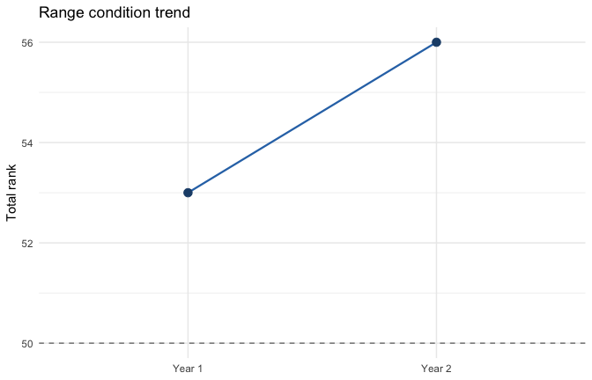

Fodder Production and Livestock Units
Use estimate_fodder_production() when you want CW, CY, and DS summarized from the re_cwd sheet. The default livestock-unit calculation uses:
- allowable use: 0.60
- range area: 700 ha
- animal-unit weight: 60 kg
- daily intake: 2% of body weight
- grazing period: 6 months
- days per month: 30
production <- estimate_fodder_production(path)
production_summary <- production$summary
production_summary$dry_fodder_kg_ha <- round(production_summary$dry_fodder_kg_ha, 1)
production_summary$total_available_fodder_kg <- round(production_summary$total_available_fodder_kg, 1)
production_summary$livestock_units <- round(production_summary$livestock_units)
production_summary
#> method dry_fodder_kg_ha total_available_fodder_kg livestock_units
#> 1 CW 779.6 327413.3 1516
#> 2 CY 772.5 324441.9 1502
#> 3 DS 811.1 340673.0 1577
For this workbook, the livestock-unit checks round to 1516, 1502, and 1577 for CW, CY, and DS. The continuous CY regression gives 772.5 kg/ha. A legacy spreadsheet that rounds intermediate CY predictions can display about 773.1 kg/ha, so confirm which convention your organization wants before locking a reporting template.
ggplot(production_summary, aes(method, dry_fodder_kg_ha, fill = method)) +
geom_col(width = 0.65, alpha = 0.85) +
geom_text(aes(label = dry_fodder_kg_ha), vjust = -0.4) +
labs(
x = NULL,
y = "Dry fodder production (kg/ha)",
title = "CW, CY, and DS dry fodder production"
) +
theme_minimal() +
theme(legend.position = "none")
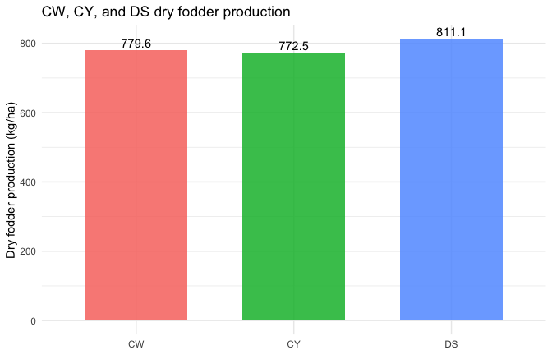

Optional Validation
CW is not required for routine CY or DS estimation, but it is useful for method comparison. Use validate_methods() to build a statistical comparison and plot_validation() for diagnostic plots.
cyd <- read_cyd_excel(path)
dsd <- read_dsd_excel(path)
cwd <- read_cwd_excel(path)
cc <- carrying_capacity(cyd, dsd)
validation <- validate_methods(cwd, cc, test = "kruskal")
validation
#> <r4c_validation_result>
#>
#> Kruskal-Wallis rank sum test
#>
#> data: Yd by Method
#> Kruskal-Wallis chi-squared = 2.1861, df = 2, p-value = 0.3352
plot_validation(validation, type = "boxplot")
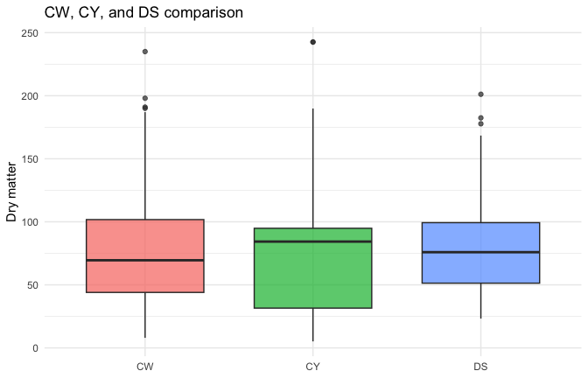
plot_validation(validation, type = "agreement")
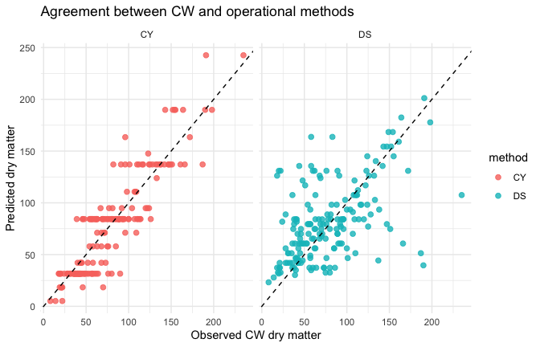

Working with Your Own Data
Use a workbook with the same sheet names:
my_path <- "path/to/my_r4c_workbook.xlsx"
classify_sf_template_years(
my_path,
sheets = c("sfd1", "sfd2"),
year_names = c("Year 1", "Year 2"),
score_profile = "template_rank"
)
estimate_fodder_production(
my_path,
allowable_use = 0.60,
range_area_ha = 700,
au_weight_kg = 60,
grazing_months = 6
)
For data already loaded into R, pass data frames directly:
cyd <- read_cyd_excel(my_path)
dsd <- read_dsd_excel(my_path)
cwd <- read_cwd_excel(my_path)
estimate_fodder_production(cyd, dsd, cwd)

Reporting Checklist
Before reporting results, check:
- The SF sheets represent the intended unit: replicated sheets for one year should be merged; sheets from different years should be classified separately.
- The PC palatability classes match the local field guide.
- The six-factor scoring profile matches your official rubric.
- The production parameters match the management question: area, allowable use, animal-unit weight, grazing months, and daily intake.
- CY/DS validation is only interpreted when the CW comparison data are relevant and collected under the same field conditions.

