First 5 rows:
PassengerId Survived Pclass \
0 1 0 3
1 2 1 1
2 3 1 3
3 4 1 1
4 5 0 3

Name Sex Age SibSp \
0 Braund, Mr. Owen Harris male 22.0 1
1 Cumings, Mrs. John Bradley (Florence Briggs Th... female 38.0 1
2 Heikkinen, Miss. Laina female 26.0 0
3 Futrelle, Mrs. Jacques Heath (Lily May Peel) female 35.0 1
4 Allen, Mr. William Henry male 35.0 0

Parch Ticket Fare Cabin Embarked
0 0 A/5 21171 7.2500 NaN S
1 0 PC 17599 71.2833 C85 C
2 0 STON/O2. 3101282 7.9250 NaN S
3 0 113803 53.1000 C123 S
4 0 373450 8.0500 NaN S

Dataset Info:
<class 'pandas.core.frame.DataFrame'>
RangeIndex: 891 entries, 0 to 890
Data columns (total 12 columns):
# Column Non-Null Count Dtype
--- ------ -------------- -----
0 PassengerId 891 non-null int64
1 Survived 891 non-null int64
2 Pclass 891 non-null int64
3 Name 891 non-null object
4 Sex 891 non-null object
5 Age 714 non-null float64
6 SibSp 891 non-null int64
7 Parch 891 non-null int64
8 Ticket 891 non-null object
9 Fare 891 non-null float64
10 Cabin 204 non-null object
11 Embarked 889 non-null object
dtypes: float64(2), int64(5), object(5)
memory usage: 83.7+ KB
None

Missing Values:
PassengerId 0
Survived 0
Pclass 0
Name 0
Sex 0
Age 177
SibSp 0
Parch 0
Ticket 0
Fare 0
Cabin 687
Embarked 2
dtype: int64

Missing Values After Cleaning:
PassengerId 0
Survived 0
Pclass 0
Name 0
Sex 0
Age 0
SibSp 0
Parch 0
Ticket 0
Fare 0
Embarked 0
dtype: int64
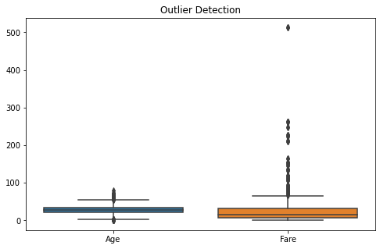

Preprocessed Dataset:
Survived Pclass Sex Age SibSp Parch Fare Embarked
0 0 3 1 -0.607611 1 0 -0.751265 2
2 1 3 0 -0.207827 0 0 -0.700265 2
3 1 1 0 0.691688 1 0 2.712961 2
4 0 3 1 0.691688 0 0 -0.690821 2
5 0 3 1 -0.007934 0 0 -0.659971 1

Final Shape: (718, 8)

Data preprocessing completed successfully!

