Portfolio 1 Database Design and Modelling
Michael Olayemi Babalola
MIT 8103 Advanced Database Systems
2026/2027 Academic Session | First Semester

Case study and scope
CampusMart is a simulated Nigerian online retail business serving university students and staff. It sells electronics, books, clothing and accessories. Customers place orders, sales staff inspect order records, stock staff maintain product information, and administrators manage reference data. All records are fictional and prices are in Nigerian naira (NGN).
The database supports customer registration, product management, order recording and historical order-value reporting. The implementation contains five related tables. Payment processing, shipping, authentication and refunds are outside this scope.

Relational schema
Table | Primary key | Principal attributes
customers | customer_id | full_name; unique email
categories | category_id | unique category_name
products | product_id | category_id FK; unique sku; product_name; price; stock_quantity
orders | order_id | customer_id FK; unique order_reference; order_date; status
order_items | (order_id, product_id) | Both identifiers are FKs; quantity; unit_price

Integrity rules
Each order references one customer and each product references one category. Each order item references an order and a product. Foreign keys restrict deletion of referenced records. Primary and unique keys prevent duplicate identifiers, customer emails, SKUs, category names and order references. NOT NULL and CHECK constraints require valid names, statuses, quantities, stock and monetary values.

Implementation and environment
I executed the schema, fictional seed data, verification queries and constraint checks in pgAdmin 4. The server query reports PostgreSQL 18.6 and database campusmart_portfolio. The submitted SQL files document that sequence, and seven screenshots record the desktop results.

Entity relationship model
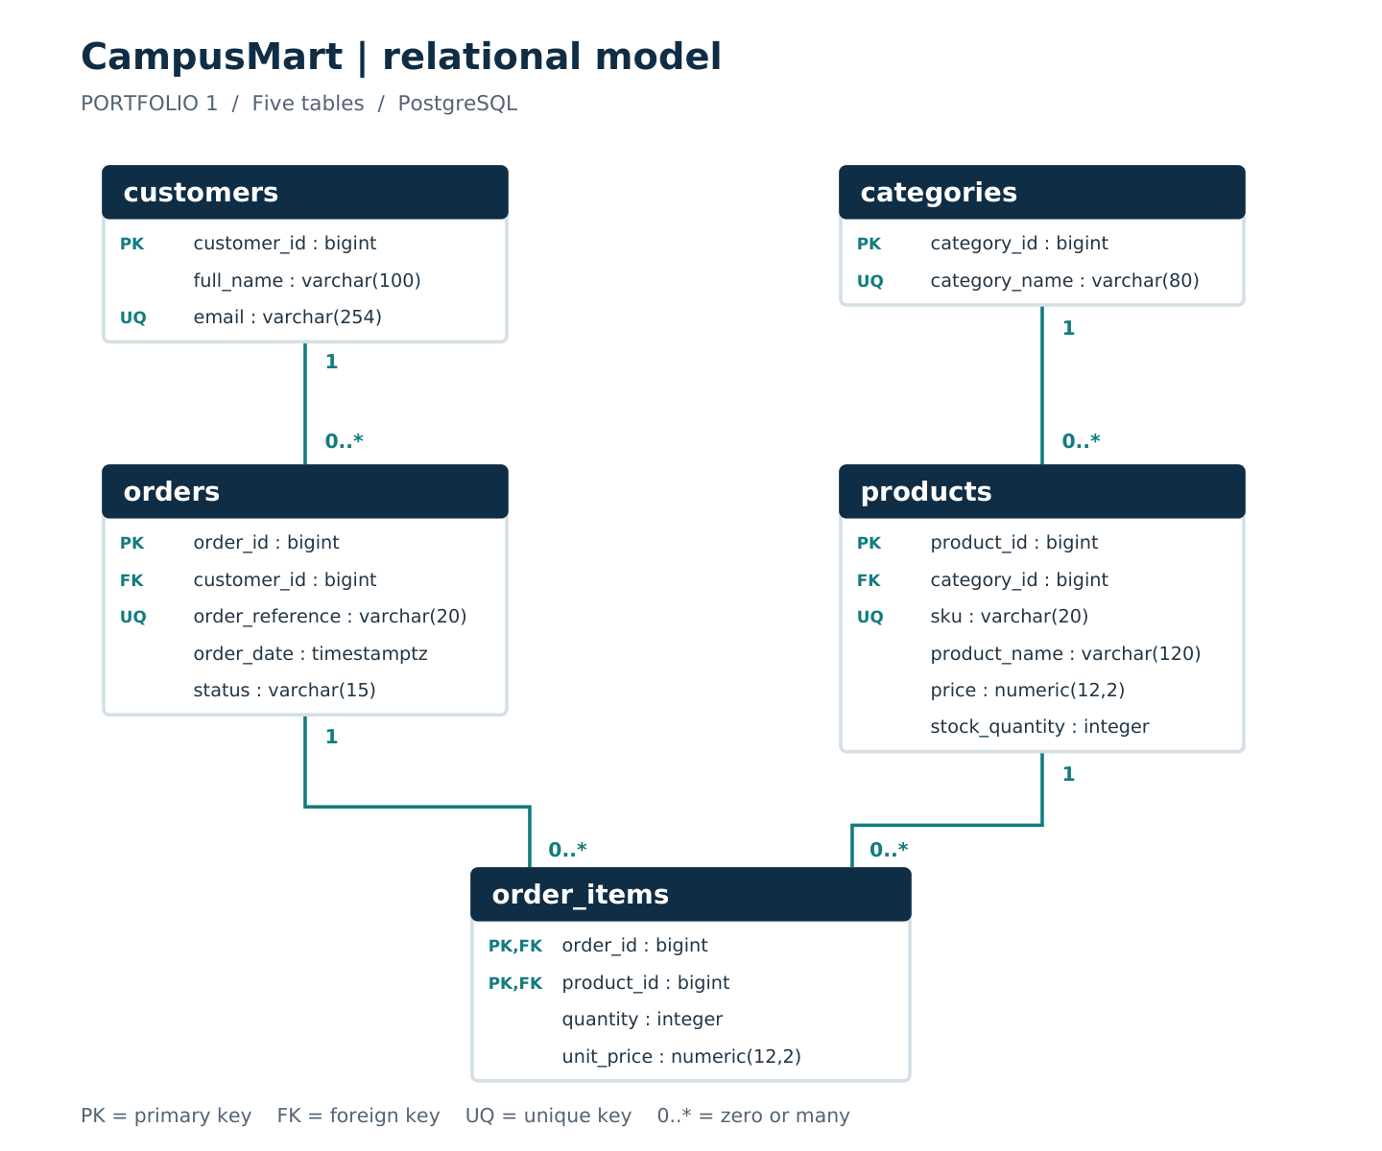
Figure 1. CampusMart physical ER diagram. Each parent can have zero or many children; each foreign-key reference has exactly one parent. ORDER_ITEMS resolves the order/product many-to-many relationship.

Normalisation

First normal form
Each column holds one value for its domain. Multiple products in an order are represented by separate order_items rows, without repeated product columns or comma-separated lists.

Second normal form
The four parent tables have single-column candidate keys. In order_items, quantity and charged unit_price depend on the complete (order_id, product_id) key. Product names depend on product_id alone and remain in products.

Third normal form
Customer names and emails remain in customers; category names remain in categories. This avoids storing the transitive dependencies order_id -> customer_id -> customer details and product_id -> category_id -> category_name in one relation. The full dependencies appear in normalisation.md.
Current product price and historical charged price represent different business facts. The composite order-item key permits a product to appear once in each order. Order totals are derived from quantity multiplied by charged price, avoiding redundant stored totals.

Verification results
Table | Initial rows | Rows after checks
categories | 4 | 4
customers | 6 | 6
products | 10 | 10
orders | 8 | 8
order_items | 16 | 16
Screenshots 02 and 07 show five PASS comparisons. All 12 invalid-operation checks in screenshot 03 also show PASS. The test code compares the expected SQLSTATE and, where specified, the constraint name, so an unrelated error is not accepted as a passing result.
No. | Invalid operation | Result
1 | Duplicate customer email | PASS
2 | Unknown customer on an order | PASS
3 | Negative product stock | PASS
4 | Zero order-item quantity | PASS
5 | Negative current price | PASS
6 | Missing customer name | PASS
7 | Duplicate product line in one order | PASS
8 | Unknown product category | PASS
9 | Delete customer with historical orders | PASS
10 | Invalid order status | PASS
11 | Negative charged price | PASS
12 | Blank product name | PASS

Evidence index
01-database-tables.png - Five public tables. The object browser lists categories, customers, order_items, orders and products.
02-row-counts.png - Initial row counts. All five actual counts match the expected seed counts.
03-constraint-results.png - Constraint checks. All 12 tests show PASS, with expected and actual SQLSTATE values.
04-server-version.png - Database and server. campusmart_portfolio; server_version 18.6; pgAdmin 4 interface.
05-order-values.png - Order values. Eight order values are displayed with customer names and order statuses.
06-historical-price.png - Historical price. CM-1005 / BK001: current price NGN 18,000; charged price NGN 16,000.
07-counts-after-checks.png - Counts after testing. The same five counts remain after the constraint checks.
The seven screenshots are included in evidence/portfolio-1/screenshots/.

Order values and historical price
Order | Status | Value in NGN
CM-1001 | completed | 467,000.00
CM-1002 | completed | 24,000.00
CM-1003 | completed | 27,000.00
CM-1004 | completed | 28,500.00
CM-1005 | completed | 34,000.00
CM-1006 | placed | 19,500.00
CM-1007 | draft | 24,000.00
CM-1008 | cancelled | 15,000.00
The displayed values include all statuses and are not a total of sales revenue. For CM-1005, BK001 was charged at NGN 16,000 while its current price is NGN 18,000. The order value of NGN 34,000 uses the charged price, preserving the historical purchase amount.

Technical reflection and limitations
The historical-price result explains the need to separate catalogue prices from purchase records. The composite order-item key also makes the meaning of each row explicit. During evidence capture, the successful execution message did not display the constraint table; the result grid from the temporary results table is the evidence that records the 12 PASS outcomes.
The constraints validate existing rows but do not force an order to contain an item before placement. A detection query is included; minimum-item enforcement and atomic stock deduction require transaction logic. The unchanged row counts demonstrate the count checks, not full equality of every stored value. The full reflection is in documentation/Technical-Reflection.md.

AI use declaration
I used ChatGPT/Codex to assist with interpreting the assessment and preparing the CampusMart schema, fictional sample data, ER diagram, SQL and documentation. I verified the Portfolio 1 work by running the scripts in PostgreSQL 18.6 using pgAdmin 4. My seven screenshots record the tables, row counts, 12 passing constraint checks, server version, order values, historical price and unchanged counts after testing.

References
1. Miva Open University. (2026). MIT 8103 Advanced Database Systems: First Semester Continuous Assessment, 2026/2027 Academic Session.
2. PostgreSQL Global Development Group. Constraints. PostgreSQL 18 documentation. https://www.postgresql.org/docs/18/ddl-constraints.html
3. pgAdmin Development Team. Query Tool. https://www.pgadmin.org/docs/pgadmin4/latest/query_tool.html

