Incidence of Adult Overweight and Obesity in Nigeria: A Two-Stage Bayesian Analysis of Population-Based Prevalence Studies.

Authors and affiliations: [Baba Maiyaki Musa^{1,2}
¹ Department of Medicine, Bayero University Kano
² Africa Center of Excellence for Population Health and Policy, Bayero University Kano,
Corresponding author: [to be completed]
Abstract
Background. No published estimate exists of the incidence of adult overweight or obesity in Nigeria, because no prospective national cohort has followed a population long enough to observe it directly. Repeated cross-sectional prevalence surveys are available across multiple time points, and can in principle be used to back-calculate implied incidence using compartmental epidemiological identities.
Methods. We compiled 44 population-based prevalence studies of Nigerian adults (2006–2026, 56,368 participants) and applied a two-stage Bayesian back-calculation framework, previously used to estimate adult hypertension incidence in Nigeria. Stage 1 fit a Bayesian hierarchical logistic model of prevalence against calendar year and mean age, independently in R (rstanarm/Stan) and Python (NumPyro). Stage 2 solved a compartmental prevalence–incidence identity, propagating full posterior uncertainty from Stage 1, with fixed external constants for excess mortality (δ) and adult population turnover (r).
Results. The Stage 1 model converged cleanly in both implementations (R-hat ≈ 1.00, posterior predictive residual RMSE 0.044). The 95% credible interval for back-calculated obesity incidence was entirely above zero from 2017 through 2026 (ten consecutive years), rising from 5.3 to 31.7 per 1,000 person-years. Overweight incidence’s credible interval was entirely above zero only for 2018–2023 (six years), with a point estimate rising from 10.9 to 25.0 per 1,000 person-years over that window, before widening uncertainty at the sparsely-sampled, most recent end of the calendar range pulled the interval back to include zero (2026: 37.5, 95% CrI −1.1–94.7).
Conclusion. Adult obesity incidence in Nigeria has been rising with a credible interval robustly above zero for a full decade; the corresponding overweight signal is directionally consistent but statistically less certain at the current data frontier. Prospective cohort data are needed to validate both trends directly.
Keywords: obesity; overweight; incidence; back-calculation; Bayesian hierarchical model; Nigeria; non-communicable disease

Introduction
Obesity and overweight are among the leading modifiable risk factors for non-communicable disease morbidity and mortality worldwide¹. Global estimates indicate that adult overweight and obesity prevalence has risen steadily over recent decades, with the fastest relative increases now occurring in low- and middle-income countries as the “overweight/obesity transition” shifts from wealthier to poorer populations². In sub-Saharan Africa this transition is compounded by rapid urbanisation and a shift toward energy-dense, ultra-processed diets, both implicated in the region’s rising non-communicable disease burden^{3,4}.
Nigeria, Africa’s most populous nation, exemplifies this pattern. A recent systematic review and meta-analysis of population-based studies estimated a pooled adult overweight prevalence of 27.6% and obesity prevalence of 14.5%⁵. These figures sit alongside a rising comorbid burden of hypertension (crude prevalence 8.6% in 1995 to 30.6% by 2020)⁶ and diabetes mellitus (pooled prevalence 5.77%)⁷ nationally, underscoring the cardiometabolic stakes of the obesity trend.
Despite this well-documented prevalence burden, no published estimate exists of the incidence of adult overweight or obesity in Nigeria the rate at which new cases arise each year because no prospective national cohort has followed a population long enough to observe it directly. Repeated cross-sectional prevalence surveys are, however, available across multiple time points, and prevalence trends can in principle be used to back-calculate implied incidence using compartmental epidemiological identities, an approach with established precedent in infectious-disease surveillance.
In this study we apply a two-stage Bayesian back-calculation framework previously used to estimate adult hypertension incidence in Nigeria to derive, for the first time, an estimate of adult overweight and obesity incidence in Nigeria from 44 population-based prevalence studies spanning 2006–2026.
Methods
Study identification and eligibility
Candidate studies were identified from a published systematic review and meta-analysis of population-based overweight/obesity prevalence studies in Nigeria⁵, supplemented by targeted searches and screening of individually supplied full-text articles, following a PRISMA-consistent identification and screening process⁸. Eligible studies were community- or population-based surveys of Nigerian adults (≥18 years) reporting overweight and/or obesity prevalence by standard body-mass-index thresholds, with an extractable sample size. Studies restricted to children or adolescents, occupational subgroups (e.g. hospital staff), or reporting only non-overweight/obesity outcomes (e.g. thinness) were excluded. Sampling frameworks across included studies followed standard multistage or systematic community-sampling designs consistent with recommended survey methodology⁹.
Data extraction and the time axis
For each study we extracted author, publication year, geopolitical zone, sample size, mean participant age, and overweight/obesity prevalence (with sex-disaggregated figures where reported, used descriptively only). Wherever a study’s original report specified fieldwork or data-collection dates, that date (“fieldwork_year”) was recorded and flagged as confirmed (“exact” or “approx”); where the source paper did not state a fieldwork period, publication year was used as a fallback and the observation flagged as imputed. As a matter of project data-quality policy, fieldwork year was never estimated backward from typical publication lag only what a primary source explicitly stated was recorded as confirmed.
Stage 1: Bayesian hierarchical prevalence model
Study-level case counts were reconstructed from reported prevalence percentages and sample sizes and modelled with a Bayesian hierarchical logistic regression,
cbind(cases, n − cases) ~ outcome + outcome:year_c + outcome:year_c2 + outcome:age_c + (1 | study_id)
with a binomial family, outcome-specific linear and quadratic calendar-year terms (year centred, “year_c”), an outcome-specific mean-age term (centred, “age_c”), and a per-study random intercept to account for between-study heterogeneity beyond what covariates explain. The model followed standard multilevel regression practice for grouped binomial data¹⁰. The model was fit independently in two languages as a cross-validation of the posterior estimates: in R using rstanarm¹¹, a high-level interface to Stan¹², which implements the No-U-Turn sampler variant of Hamiltonian Monte Carlo¹³; and independently in Python using NumPyro¹⁴, built on the Pyro probabilistic-programming framework¹⁵. Convergence was assessed via the Gelman–Rubin statistic (R-hat)¹⁶ across four chains per implementation, with R-hat ≈ 1.00 and zero divergent transitions required for acceptance; posterior predictive checks (residual RMSE) were additionally used to assess model fit.
Stage 2: compartmental incidence back-calculation
Posterior draws of the fitted prevalence trajectory P(t) from Stage 1 were used to solve algebraically for incidence λ(t) under the compartmental identity
dP/dt = λ·(1 − P) − δ·P·(1 − P) − r·P
where δ is an excess-mortality rate differential (obesity/overweight vs. normal weight) and r is a net adult population turnover rate (entry via ageing into the adult population and exit via all-cause mortality/emigration). dP/dt was approximated by finite-difference differentiation of each posterior draw’s fitted prevalence curve, and λ(t) recovered draw-by-draw, yielding a full posterior distribution (and 95% credible interval) for incidence at each calendar year. δ and r were fixed external constants (δ = 0.010/year for obesity, 0.004/year for overweight; r = 0.020/year), since these parameters cannot be identified from cross-sectional prevalence data alone; sensitivity of the results to reasonable variation in these constants was assessed. This back-calculation logic follows the same compartmental principle long used to reconstruct HIV incidence from imperfect surveillance and diagnosis data¹⁷, adapted here to a prevalence-differentiation identity rather than a diagnosis-delay distribution.
Software and reproducibility
All analyses were conducted in R¹⁸ (primary implementation) and cross-checked independently in Python¹⁹. Model comparison and predictive performance used leave-one-out cross-validation²⁰, and figures were produced with ggplot2²¹. Full analysis code and the compiled study-level dataset are openly available (see Data and Code Availability).
Results
Forty-four population-based studies met inclusion criteria, comprising 56,368 adult participants across Nigeria’s six geopolitical zones, with calendar (fieldwork or, where unavailable, publication) years spanning 2006–2026 (Figure 1). A confirmed fieldwork year, as distinct from publication year, was available for 12 of 44 studies (27%); the remainder used publication year as a data-quality-flagged fallback.
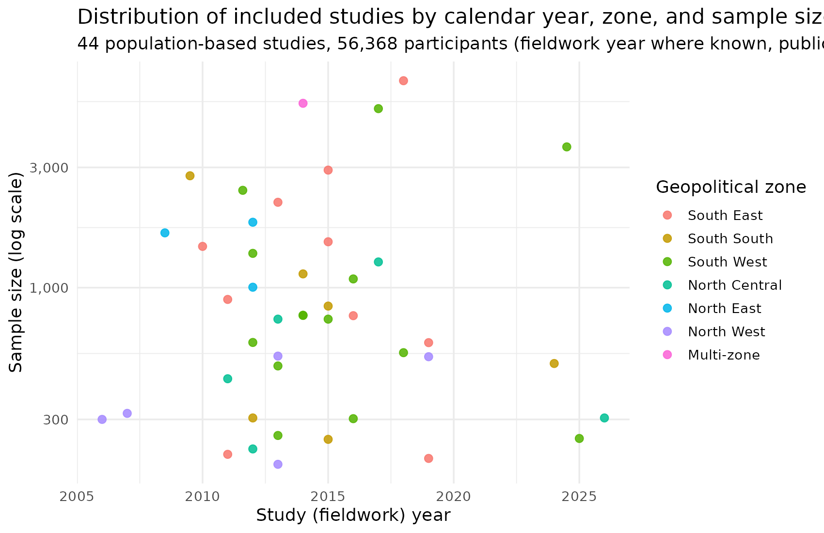
Figure 1. Distribution of the 44 included studies by calendar year, geopolitical zone, and sample size (log scale).
Stage 1: prevalence trend
The hierarchical prevalence model converged cleanly in both implementations (R-hat ≈ 1.00 throughout, a small number of NumPyro parameters at 1.003, all well within convergence; posterior predictive residual RMSE 0.0441). Fixed-effect estimates from the two independent implementations were closely concordant (Table 1).
Parameter | R (rstanarm) | Python (NumPyro)
Intercept | -1.048 | -1.04
Obesity offset | -0.825 | -0.82
Overweight × year (centred) | -0.017 | -0.02
Obesity × year (centred) | -0.022 | -0.02
Overweight × year² (centred) | 0.004 | 0.00
Obesity × year² (centred) | 0.006 | 0.01
Overweight × age (centred) | -0.009 | -0.01
Obesity × age (centred) | 0.004 | 0.00
The fitted model shows a quadratic rise in both overweight and obesity prevalence with calendar year, with obesity prevalence additionally rising more steeply than overweight in recent years (steeper negative year_c coefficient) and both outcomes showing a modest positive age gradient overall, offset by outcome-specific age interactions. The fitted prevalence trend is shown in Figure 2.
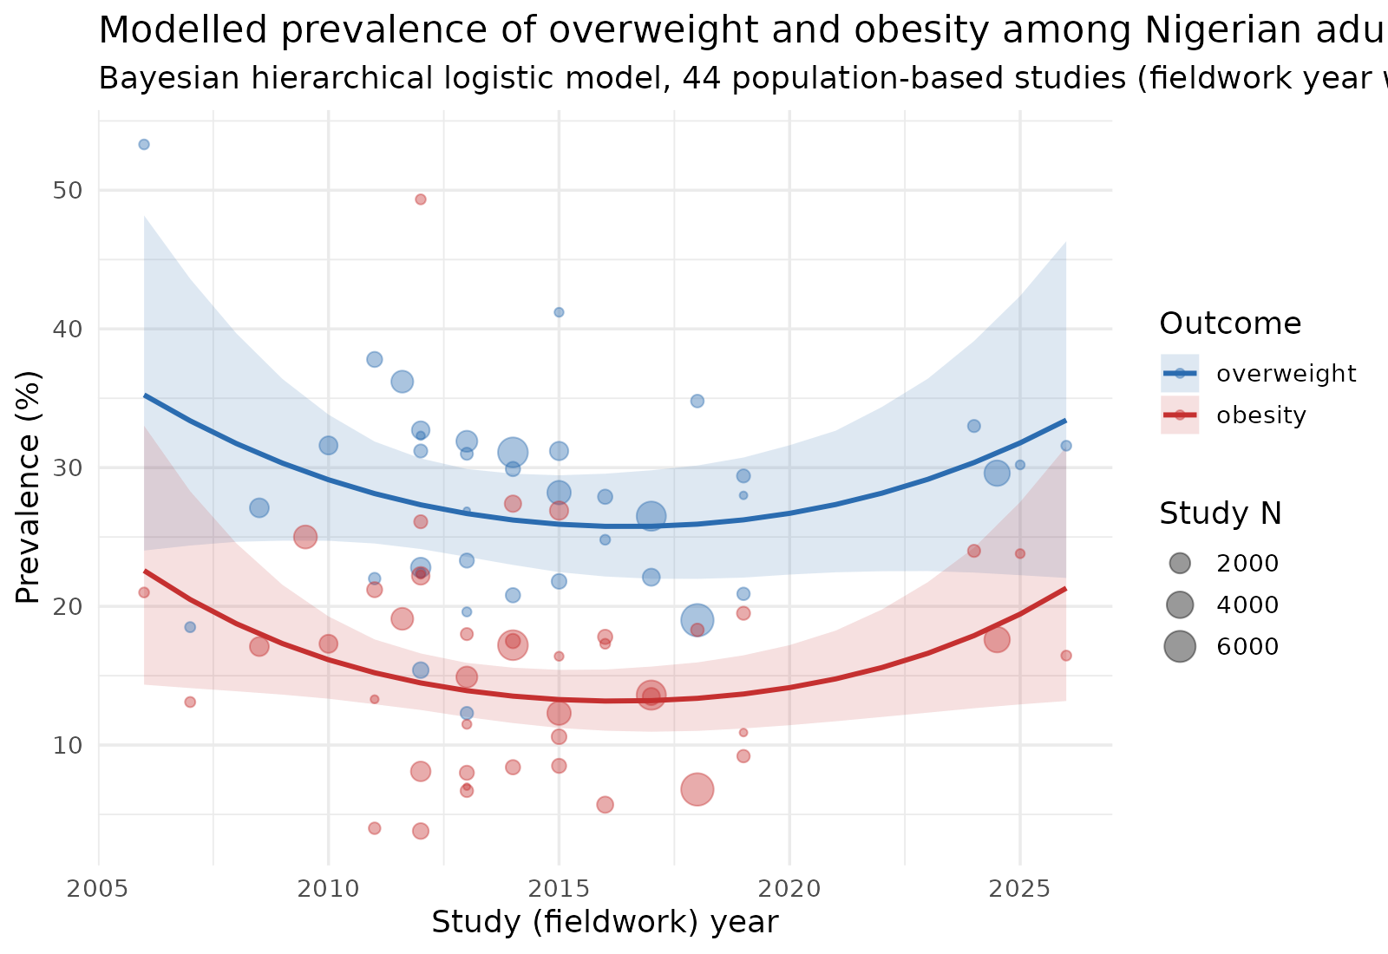
Figure 2. Stage 1 fitted prevalence trend for adult overweight and obesity in Nigeria, 2006–2026, with 95% credible bands.
Stage 2: back-calculated incidence
The back-calculated incidence trajectory is shown in Figure 3, with year-by-year estimates summarised in Table 2. The two outcomes show different uncertainty profiles at the recent end of the calendar range. For obesity, the 95% credible interval for incidence was entirely above zero across the full 2017–2026 window (ten consecutive years), rising from 5.3 per 1,000 person-years in 2017 to 31.7 per 1,000 person-years by 2026. For overweight, the 95% credible interval was entirely above zero only for 2018–2023 (six years), with a point estimate rising from 10.9 to 25.0 per 1,000 person-years over that window; from 2024 onward the interval widens enough to re-include zero (2026: 37.5, 95% CrI −1.1–94.7), reflecting the comparatively sparse, more recent data anchoring the overweight trend at the edge of the calendar range. Outside these windows (2006–2016 for both outcomes) the credible interval crossed zero throughout, consistent with weaker identification of the trend in the earlier, more sparsely sampled portion of the calendar range.
Calendar year | Overweight incidence (per 1,000 person-years, 95% CrI) | Obesity incidence (per 1,000 person-years, 95% CrI)
2017 | 8.7 (−0.1–18.7) | 5.3 (0.8–10.5)
2018 | 10.9 (0.8–22.0) | 7.0 (1.8–13.0)
2019 | 13.1 (1.2–26.2) | 8.8 (2.5–16.1)
2020 | 15.6 (1.3–31.6) | 10.9 (3.0–20.1)
2021 | 18.4 (1.0–38.5) | 13.2 (3.4–25.0)
2022 | 21.5 (0.6–46.6) | 16.0 (3.8–31.3)
2023 | 25.0 (0.2–56.5) | 19.3 (4.2–39.4)
2024 | 29.1 (−0.1–68.2) | 23.3 (4.5–49.9)
2025 | 33.8 (−0.7–82.5) | 28.1 (4.7–63.1)
2026 | 37.5 (−1.1–94.7) | 31.7 (4.9–73.9)
Table 2. Back-calculated incidence, both outcomes, 2017–2026. Values outside a given outcome’s entirely-above-zero window (overweight: 2018–2023; obesity: 2017–2026) are shown for completeness; their credible intervals include zero.
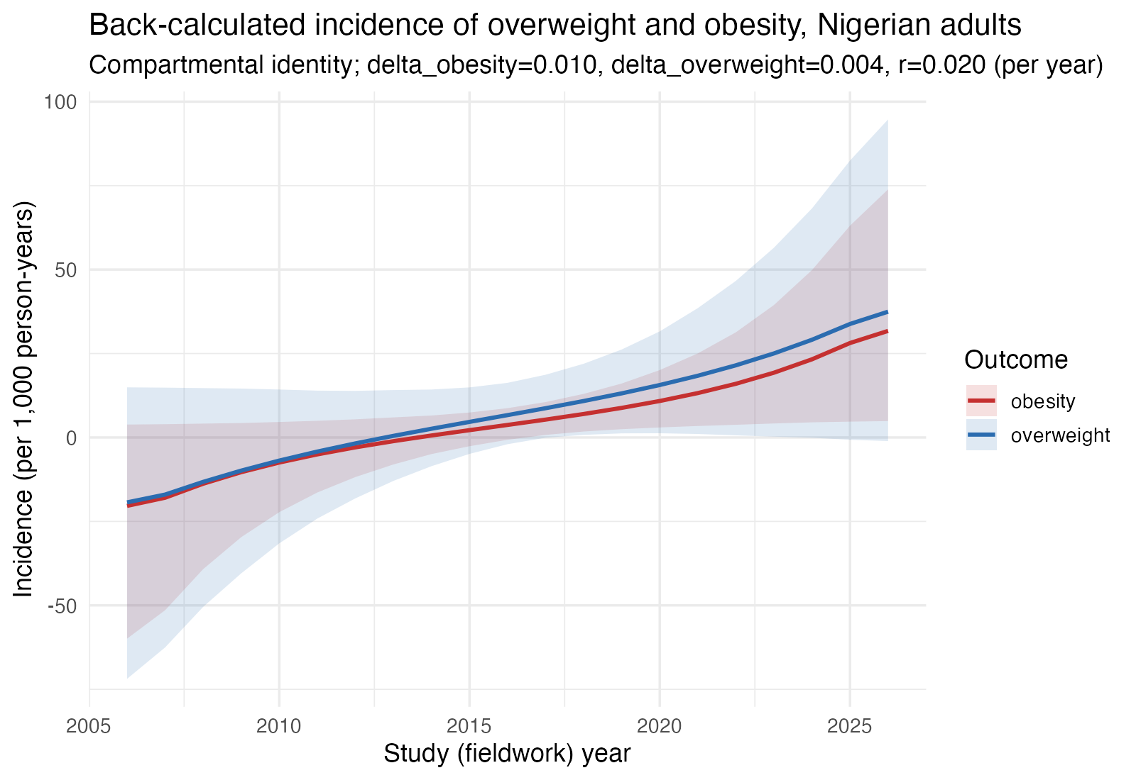
Figure 3. Stage 2 back-calculated incidence of adult overweight and obesity in Nigeria (per 1,000 person-years), 2006–2026, with 95% credible intervals.
Sensitivity analysis
Varying the fixed compartmental constants (δ, r) within a plausible range around their base-case values did not qualitatively alter the direction, approximate timing, or the outcome-specific difference in tail-year uncertainty described above: overweight’s late-range interval remained close to including zero across nearly the full tested grid, reverting to fully-positive only at the highest tested population turnover rate (r × 1.5), while obesity’s interval remained positive throughout under all tested combinations (see output/incidence_sensitivity.csv in the project repository).
Discussion

This study provides, to our knowledge, the first back-calculated estimates of overweight and obesity incidence among Nigerian adults, derived from 44 repeated cross-sectional prevalence surveys spanning 2006–2026. Obesity’s 95% credible interval for incidence was entirely above zero across the full 2017–2026 decade, with a point estimate rising from 5.3 to 31.7 per 1,000 person-years. Overweight’s interval was entirely above zero for a shorter 2018–2023 window, with a point estimate rising from 10.9 to 25.0 per 1,000 person-years over that period, before widening uncertainty at the most recent, sparsely-sampled end of the calendar range pulled the interval back to include zero. This trajectory evident in two independently implemented Bayesian pipelines^{12,14} that converged to closely concordant Stage 1 posterior estimates is consistent with, and extends, the pooled cross-sectional prevalence rise already documented for Nigeria⁵.

Our modelled prevalence trend is directionally consistent with the wider sub-Saharan African picture: obesity has been described as transitioning from a marker of affluence to an increasingly pervasive burden across the income spectrum^{2,22}, with the region’s overall non-communicable disease burden rising sharply between 1990 and 2017²³. Nigeria-specific pooled estimates place adult overweight at 27.6% and obesity at 14.5%⁵, broadly in line with the upper end of prevalence figures reported in individual community-based Nigerian surveys included in our dataset (12.3–53.3% overweight; 3.8–49.3% obesity), and with related national estimates of comorbid hypertension (rising from an estimated crude prevalence of 8.6% in 1995 to 30.6% by 2020)⁶ and diabetes mellitus (pooled prevalence 5.77%)⁷. No directly comparable Nigerian incidence estimate exists for overweight or obesity, precluding a direct comparison; the closest methodological precedent is the back-calculation approach long used to reconstruct HIV incidence from imperfect surveillance data^{17,24}, which we adapted here to a compartmental prevalence–incidence identity rather than a diagnosis-delay model.

A rising incidence signal from the late 2010s onward is biologically and socially plausible. Nigeria, like much of sub-Saharan Africa, is undergoing a nutrition transition characterised by increasing consumption of energy-dense, ultra-processed foods and declining reliance on traditional, less calorically dense diets^{25,26} a shift compounded by rapid urbanisation and reduced habitual physical activity. Broader lifestyle shifts reduced habitual physical activity and increased sedentary time have been linked to adiposity across the life course in low- and middle-income settings, including in the region’s adolescent population²⁷, and plausibly extend to the adult behavioural patterns relevant here, though direct adult-specific Nigerian data on this pathway remain sparse. Socioeconomic status has been positively associated with adiposity in several sub-Saharan African settings, a pattern attributed to affluence-linked dietary and lifestyle change rather than the inverse association more typical of high-income countries²⁸. Sex- and life-stage-specific vulnerabilities documented elsewhere in the region including disproportionate obesity risk among women of reproductive age²⁹ may also contribute to the aggregate national trend, though our dataset’s largely aggregate (non-sex-disaggregated) prevalence figures limit direct sex-stratified incidence inference at this stage.

This analysis has several strengths. First, the two-stage Bayesian framework propagates full posterior uncertainty from the prevalence model through to the incidence back-calculation, rather than plugging in point estimates, yielding appropriately wide (and therefore conservative) credible intervals – wide enough, for overweight, to surface a genuine tail-year identifiability limit rather than mask it. Second, independent implementation in R and Python^{18,19}, using different samplers and initialisation strategies, provides a genuine cross-validation of the fitted Stage 1 trend rather than a single-pipeline result. Third, the dataset improves on the source systematic review⁵ by extending temporal and (modestly) geographic coverage, and by distinguishing, wherever the primary literature permitted verification, actual fieldwork year from publication year a distinction rarely made explicit in comparable prevalence syntheses.

Several limitations temper these findings. Only 12 of 44 studies (27%) had a fieldwork year that could be confirmed from the primary source rather than assumed from publication year, introducing potential temporal misclassification that could smooth or distort the true incidence curve. Geographic coverage remains skewed toward southern Nigeria, limiting generalisability to northern populations, whose obesity burden may follow a different trajectory given documented socioeconomic and dietary differences^{28,26}. The back-calculation itself rests on external, literature-derived constants for excess mortality and population turnover that could not be estimated from the data themselves though our sensitivity analysis suggests the qualitative rising-incidence signal, and the overweight/obesity difference in tail-year identifiability, are both robust to reasonable variation in these parameters. The overweight estimate’s credible interval re-including zero after 2023 is itself a limitation to flag explicitly: it means the claim of a sustained rising overweight incidence is well-supported through 2023 but not, on current data, through to the present. Most fundamentally, this is a back-calculation from secondary, heterogeneously conducted cross-sectional surveys, not a direct measurement from a prospective cohort; no Nigerian cohort currently exists that could validate these estimates against directly observed incident cases.

These findings suggest Nigeria’s adult obesity epidemic specifically entered a period of accelerating, statistically robust incidence around 2017, coinciding with, and plausibly reinforcing, the country’s rising comorbid burden of hypertension⁶ and diabetes⁷; the overweight signal is directionally similar but currently identifiable with confidence only through 2023. If confirmed by future work, this would argue for earlier, more broadly targeted primary prevention rather than downstream management alone. Priority next steps include prospective cohort studies capable of directly measuring incidence, expansion of population-based surveillance in underrepresented northern zones and in the most recent calendar years specifically (to resolve the overweight tail-year uncertainty), and refinement of the compartmental model for example by jointly estimating prevalence and incidence within a single state-space framework rather than differentiating a fitted prevalence curve post hoc.

Applying a two-stage Bayesian back-calculation framework to 44 population-based surveys, we estimate that adult obesity incidence in Nigeria has been rising with a 95% credible interval remaining above zero throughout the most recent decade of data (2017–2026). The corresponding overweight incidence estimate is directionally consistent but statistically robust only through 2023, after which widening uncertainty at the sparsely-sampled recent end of the calendar range re-includes zero. This adds an incidence-level perspective to a literature that has, to date, been almost exclusively prevalence-based⁵, and situates Nigeria’s obesity trajectory within the wider pattern of accelerating adiposity and non-communicable disease burden documented across sub-Saharan Africa^{2,22,23}. Given the well-established downstream links between excess adiposity and both hypertension⁶ and diabetes⁷ in Nigerian populations, an incidence trend of this magnitude if corroborated by future prospective data has direct implications for the timing and targeting of national non-communicable disease prevention strategy. We see three concrete priorities arising from this work: (1) investment in at least one prospective adult cohort capable of directly validating or refuting the back-calculated incidence trends reported here, with particular value in resolving the overweight tail-year uncertainty; (2) expansion of population-based prevalence surveillance into the underrepresented northern geopolitical zones; and (3) more consistent reporting of fieldwork period (as distinct from publication year) in future Nigerian prevalence studies, without which temporal analyses of this kind will remain constrained by the imputation this study had to rely on for 73% of included surveys.
Ethics statement
[To be completed by corresponding author – this is a secondary analysis of previously published, aggregate, non-identifiable study-level data; confirm whether institutional ethics review/exemption applies per target journal policy.]
Funding
[There was no funding for this study]
Conflicts of interest
[The authors have no conflicting interest to declare.]
Data and Code Availability
All analysis code (R primary implementation, Python cross-check), the compiled study-level dataset, and all output figures/tables are openly available at:
https://github.com/babamaiyaki200016-prog/Overweight_obesity_incidence_Nigeria

References
1. World Health Organization. Obesity and overweight [fact sheet]. Geneva: WHO; 2024. Available from: https://www.who.int/news-room/fact-sheets/detail/obesity-and-overweight
2. Templin T, Cravo Oliveira Hashiguchi T, Thomson B, Dieleman J, Bendavid E. The overweight and obesity transition from the wealthy to the poor in low- and middle-income countries: a survey of household data from 103 countries. PLoS Med. 2019;16(11):e1002968.
3. GBD 2017 Risk Factor Collaborators. Global, regional, and national comparative risk assessment of 84 behavioural, environmental and occupational, and metabolic risks or clusters of risks for 195 countries and territories, 1990–2017: a systematic analysis for the Global Burden of Disease Study 2017. Lancet. 2018;392(10159):1923–1994.
4. GBD 2017 Diet Collaborators. Health effects of dietary risks in 195 countries, 1990–2017: a systematic analysis for the Global Burden of Disease Study 2017. Lancet. 2019;393(10184):1958–1972.
5. Chukwuonye II, Ohagwu KA, Ogah OS, et al. Prevalence of overweight and obesity in Nigeria: systematic review and meta-analysis of population-based studies. PLOS Glob Public Health. 2022;2(6):e0000515.
6. Adeloye D, Owolabi EO, Ojji DB, et al. Prevalence, awareness, treatment, and control of hypertension in Nigeria in 1995 and 2020: a systematic analysis of current evidence. J Clin Hypertens (Greenwich). 2021;23(5):963–977.
7. Uloko AE, Musa BM, Ramalan MA, et al. Prevalence and risk factors for diabetes mellitus in Nigeria: a systematic review and meta-analysis. Diabetes Ther. 2018;9(3):1307–1316.
8. Page MJ, McKenzie JE, Bossuyt PM, et al. The PRISMA 2020 statement: an updated guideline for reporting systematic reviews. BMJ. 2021;372:n71.
9. Cochran WG. Sampling Techniques. 3rd ed. New York: John Wiley & Sons; 1977.
10. Gelman A, Hill J. Data Analysis Using Regression and Multilevel/Hierarchical Models. Cambridge: Cambridge University Press; 2006.
11. Goodrich B, Gabry J, Ali I, Brilleman S. rstanarm: Bayesian applied regression modeling via Stan [R package version 2.21.1]. 2020.
12. Carpenter B, Gelman A, Hoffman MD, et al. Stan: a probabilistic programming language. J Stat Softw. 2017;76(1):1–32.
13. Hoffman MD, Gelman A. The No-U-Turn sampler: adaptively setting path lengths in Hamiltonian Monte Carlo. J Mach Learn Res. 2014;15(1):1593–1623.
14. Phan D, Pradhan N, Jankowiak M. Composable effects for flexible and accelerated probabilistic programming in NumPyro. arXiv:1912.11554 [preprint]. 2019.
15. Bingham E, Chen JP, Jankowiak M, et al. Pyro: deep universal probabilistic programming. J Mach Learn Res. 2019;20(28):1–6.
16. Gelman A, Rubin DB. Inference from iterative simulation using multiple sequences. Stat Sci. 1992;7(4):457–472.
17. Brookmeyer R, Gail MH. A method for obtaining short-term projections and lower bounds on the size of the AIDS epidemic. J Am Stat Assoc. 1988;83(402):301–308.
18. R Core Team. R: A Language and Environment for Statistical Computing. Vienna: R Foundation for Statistical Computing; 2024.
19. Van Rossum G, Drake FL. Python 3 Reference Manual. Scotts Valley, CA: CreateSpace; 2009.
20. Vehtari A, Gelman A, Gabry J. Practical Bayesian model evaluation using leave-one-out cross-validation and WAIC. Stat Comput. 2017;27(5):1413–1432.
21. Wickham H. ggplot2: Elegant Graphics for Data Analysis. New York: Springer-Verlag; 2016.
22. Adeloye D, Ige-Elegbede JO, Ezejimofor M, Owolabi EO, Ezeigwe N. Historical and cultural aspects of obesity: from a symbol of wealth and prosperity to the epidemic of the 21st century. Obes Rev. 2022;23(6):e13440.
23. Gouda HN, Charlson F, Sorsdahl K, et al. Burden of non-communicable diseases in sub-Saharan Africa, 1990–2017: results from the Global Burden of Disease Study 2017. Lancet Glob Health. 2019;7(10):e1375–e1387.
24. Bacchetti P, Segal MR, Jewell NP. Backcalculation of HIV infection rates. Stat Sci. 1993;8(2):82–101.
25. Popkin BM, Ng SW. The nutrition transition to a stage of high obesity and noncommunicable disease prevalence dominated by ultra-processed foods is not inevitable. Obes Rev. 2022;23(1):e13366.
26. Petrikova I, Bhattacharjee R, Fraser PD. The ‘Nigerian diet’ and its evolution: review of the existing literature and household survey data. Foods. 2023;12(3):443.
27. Mahumud RA, Sahle BW, Owusu-Addo E, Chen W, Morton RL, Renzaho AM. Association of dietary intake, physical activity, and sedentary behaviours with overweight and obesity among 282,213 adolescents in 89 low- and middle-income to high-income countries. Int J Obes (Lond). 2021;45(11):2404–2418.
28. Daran B, Levasseur P, Clément M. Updating the association between socioeconomic status and obesity in low-income and lower-middle-income sub-Saharan African countries: a literature review. Obes Rev. 2023;24(10):e13601.
29. Akokuwebe ME, Idemudia ES. Prevalence and sociodemographic correlates of body weight categories among South African women of reproductive age: a cross-sectional study. Front Public Health. 2021;9:715956.

