EKS-Task
- Setup eks cluster using eksctl
  - Install AWS CLI
curl "https://awscli.amazonaws.com/awscli-exe-linux-x86_64.zip" -o "awscliv2.zip"
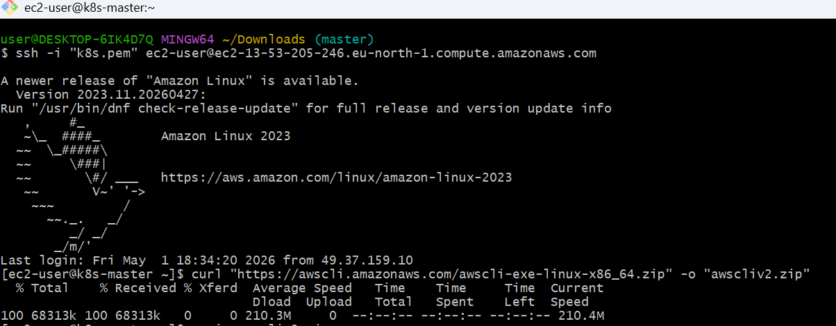

  - unzip awscliv2.zip
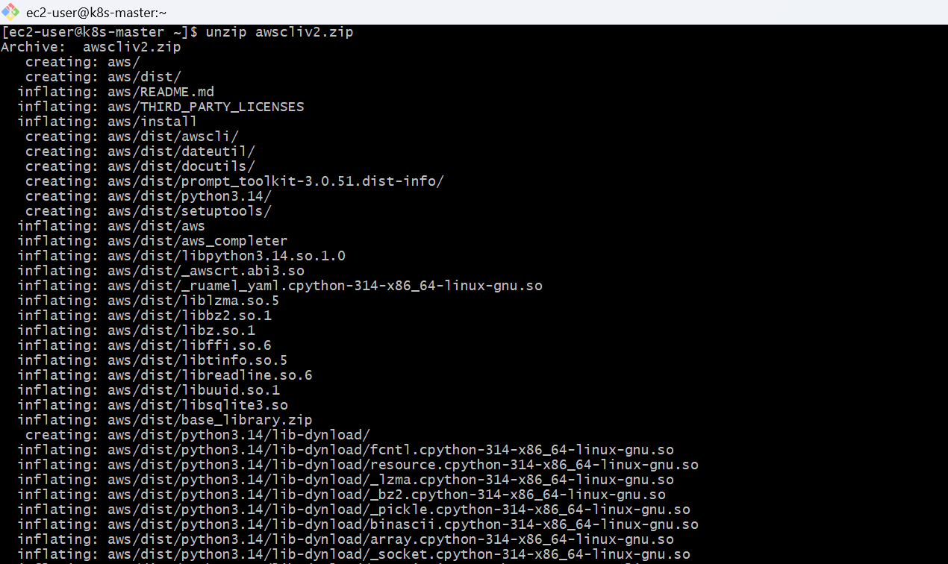

  - sudo ./aws/install
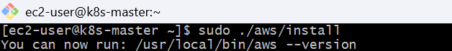
  - Check:
aws –version
  - Configure AWS CLI
aws configure
Enter:
- Access Key
- Secret Key
- Region (e.g., ap-south-1)
- Output format (json)
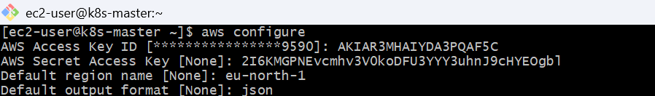
  - Install kubectl
Remove wrong file
sudo rm -f /usr/local/bin/kubectl
  - Download correct kubectl
Use this official working command:
curl -LO "https://dl.k8s.io/release/$(curl -s https://dl.k8s.io/release/stable.txt)/bin/linux/amd64/kubectl"
  - Make it executable
chmod +x kubectl
  - Move to PATH
sudo mv kubectl /usr/local/bin/
  - Verify
kubectl version --client
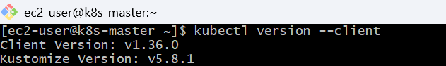
  - Install eksctl
curl --location "https://github.com/weaveworks/eksctl/releases/latest/download/eksctl_$(uname -s)_amd64.tar.gz" | tar xz -C /tmp
sudo mv /tmp/eksctl /usr/local/bin
  - Check:
eksctl version
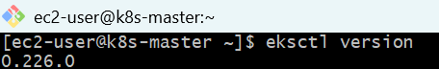
  - Create EKS Cluster
🔹 Basic Command

eksctl create cluster \
--name my-cluster \
--region eu-north-1 \
--nodegroup-name my-nodes \
--node-type t3.micro \
--nodes 2
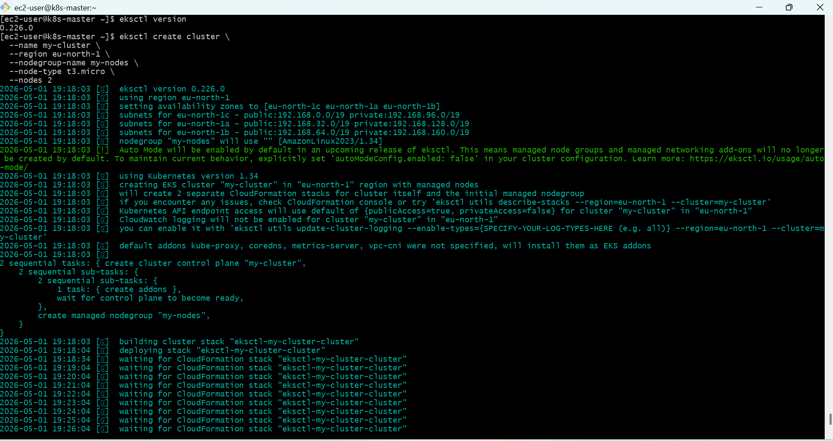
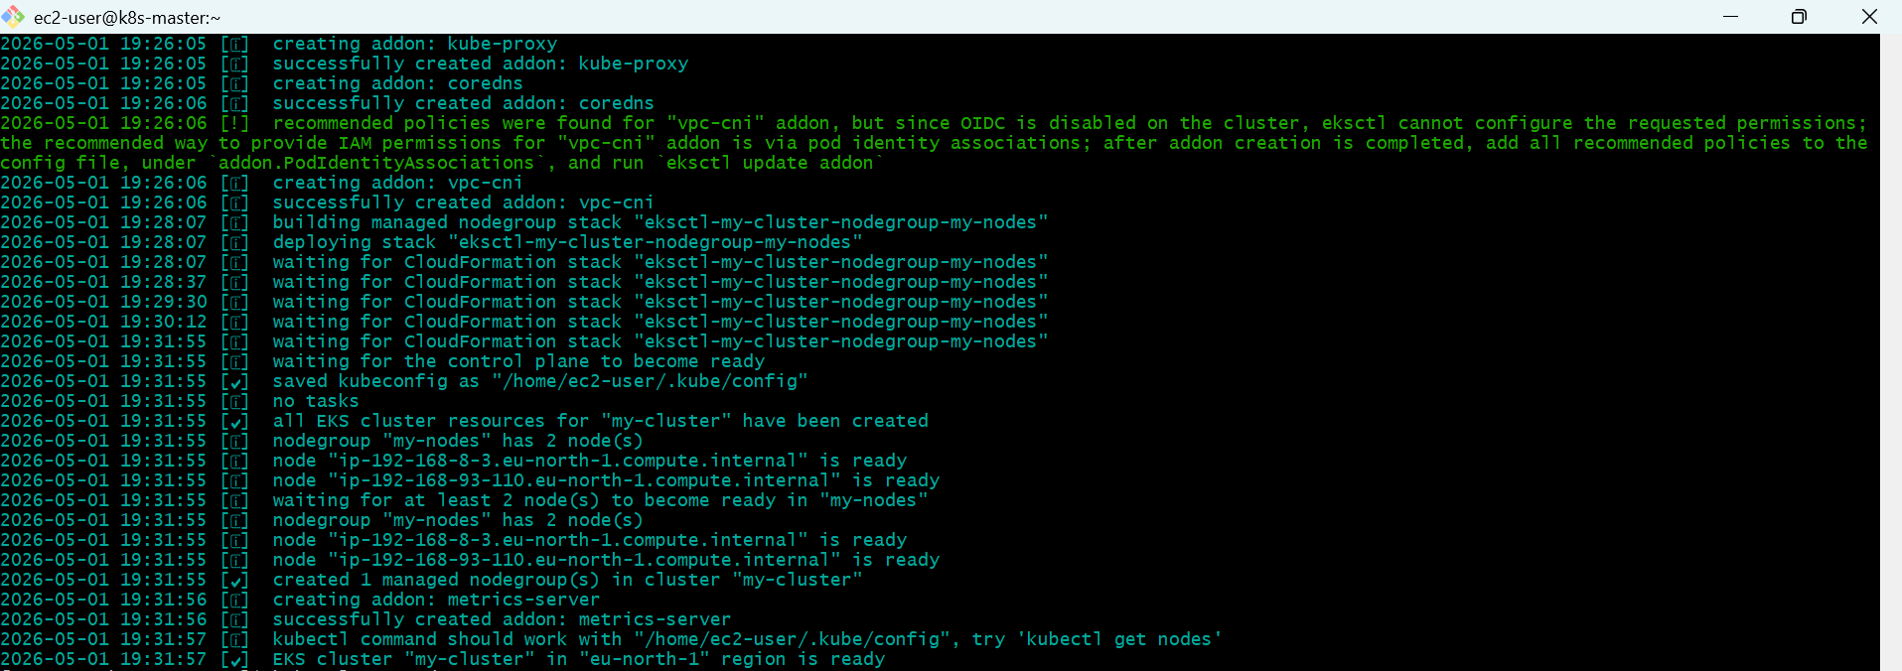
  - Verify In EKS
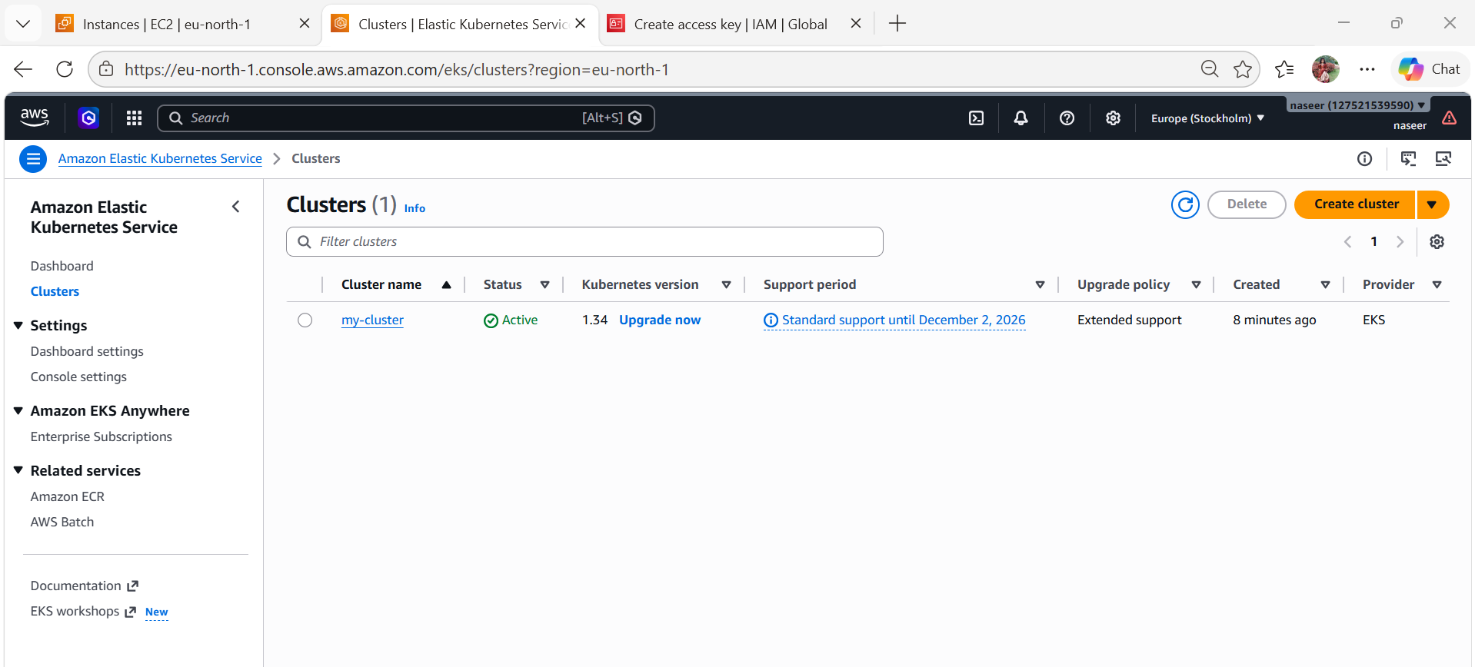
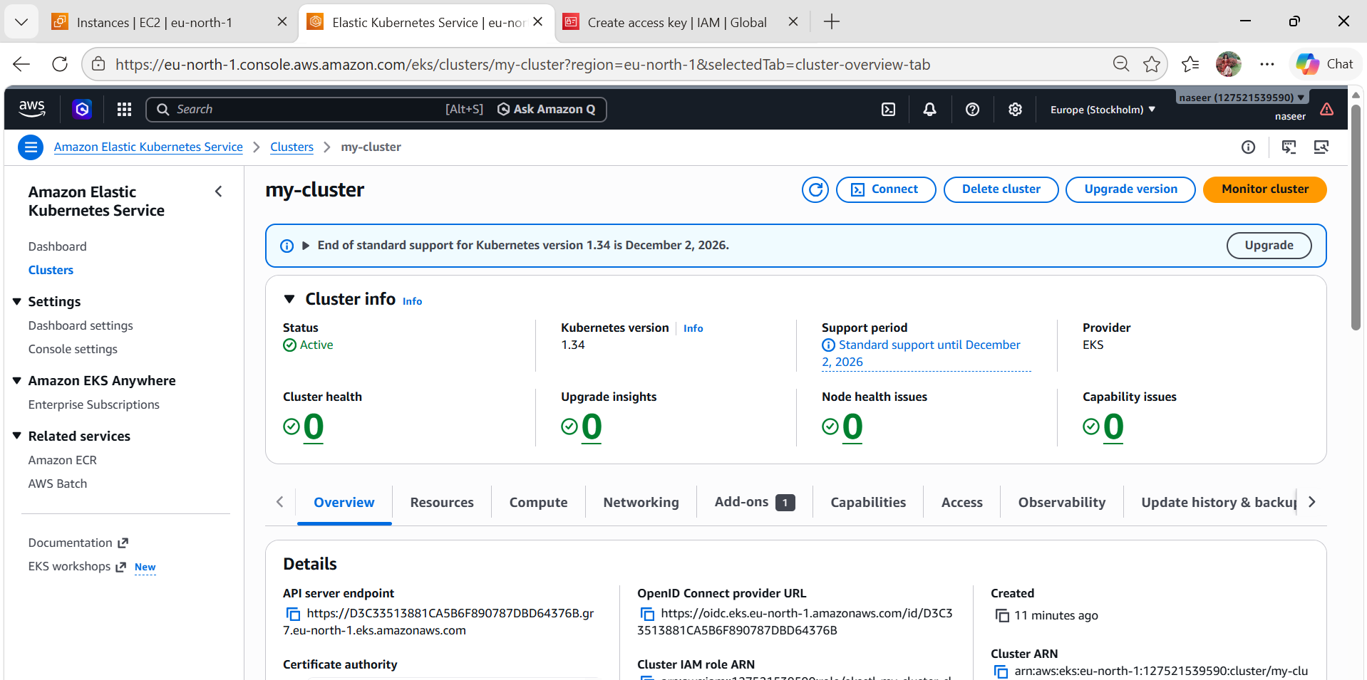
  - Verify In EC2

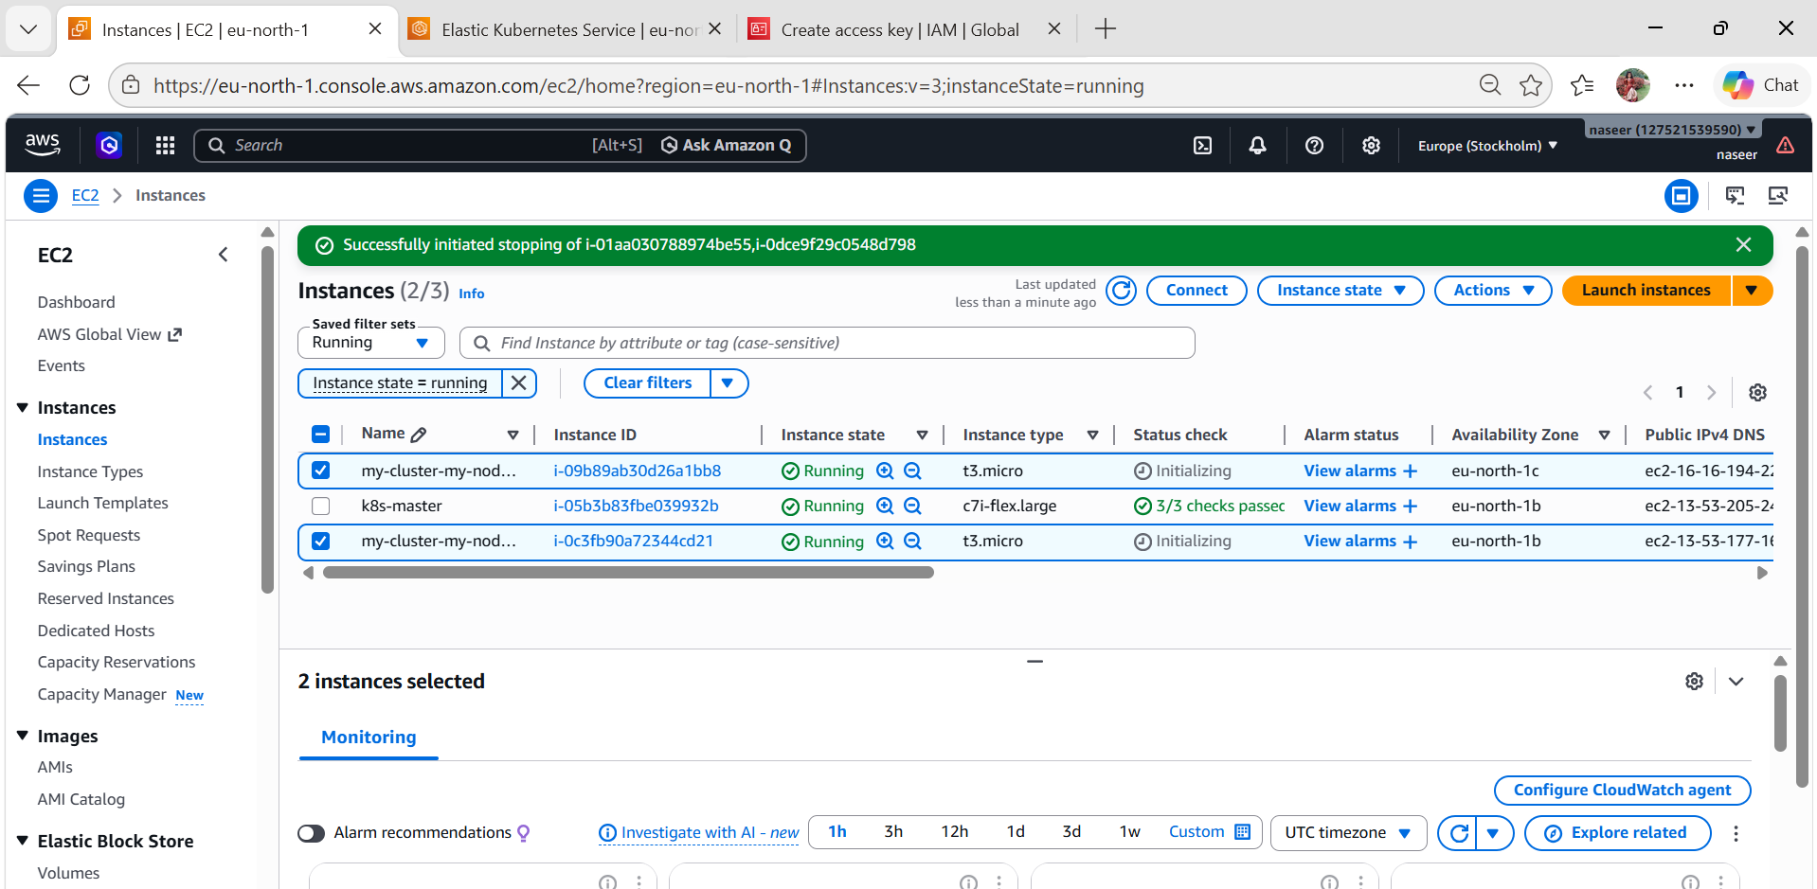
  - Check nodes:
kubectl get nodes

  - Check system pods:
kubectl get pods -A
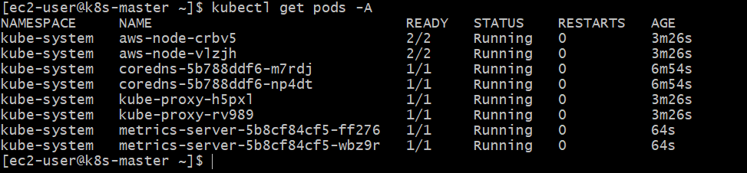
  - Update kubeconfig (if needed)
Usually eksctl does it automatically, but if not:
aws eks update-kubeconfig \
--region eu-north-1 \
--name my-cluster
  - Deploy Sample App
kubectl create deployment nginx --image=nginx
kubectl expose deployment nginx --type=NodePort --port=80
  - Check:
kubectl get svc
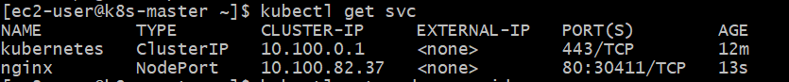
  - Get your worker node Public IP
Run this:
kubectl get nodes -o wide

- setup eks cluster using console
  - EKS Cluster Setup using Console
  - Go to EKS
- Open AWS Console
- Search EKS
- Click Elastic Kubernetes Service
Click Create cluster
  - Configure Cluster
Basic Details
- Name: my-cluster
- Kubernetes version: latest (default)
Cluster Service Role
Click Create recommended role
This creates IAM role automatically
  - Networking (VERY IMPORTANT)
- VPC: Select default VPC (for practice)
- Subnets: Select at least 2 subnets
- Cluster endpoint:
  - Public access
Click Next
  - Logging (optional)
- You can skip or enable all logs
Click Next → Create
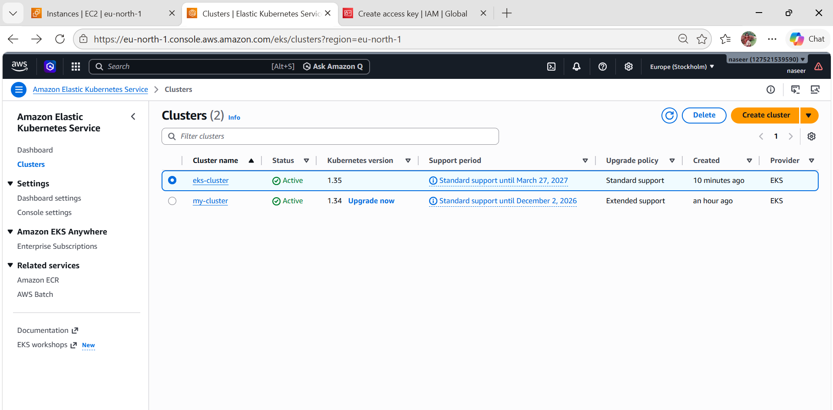

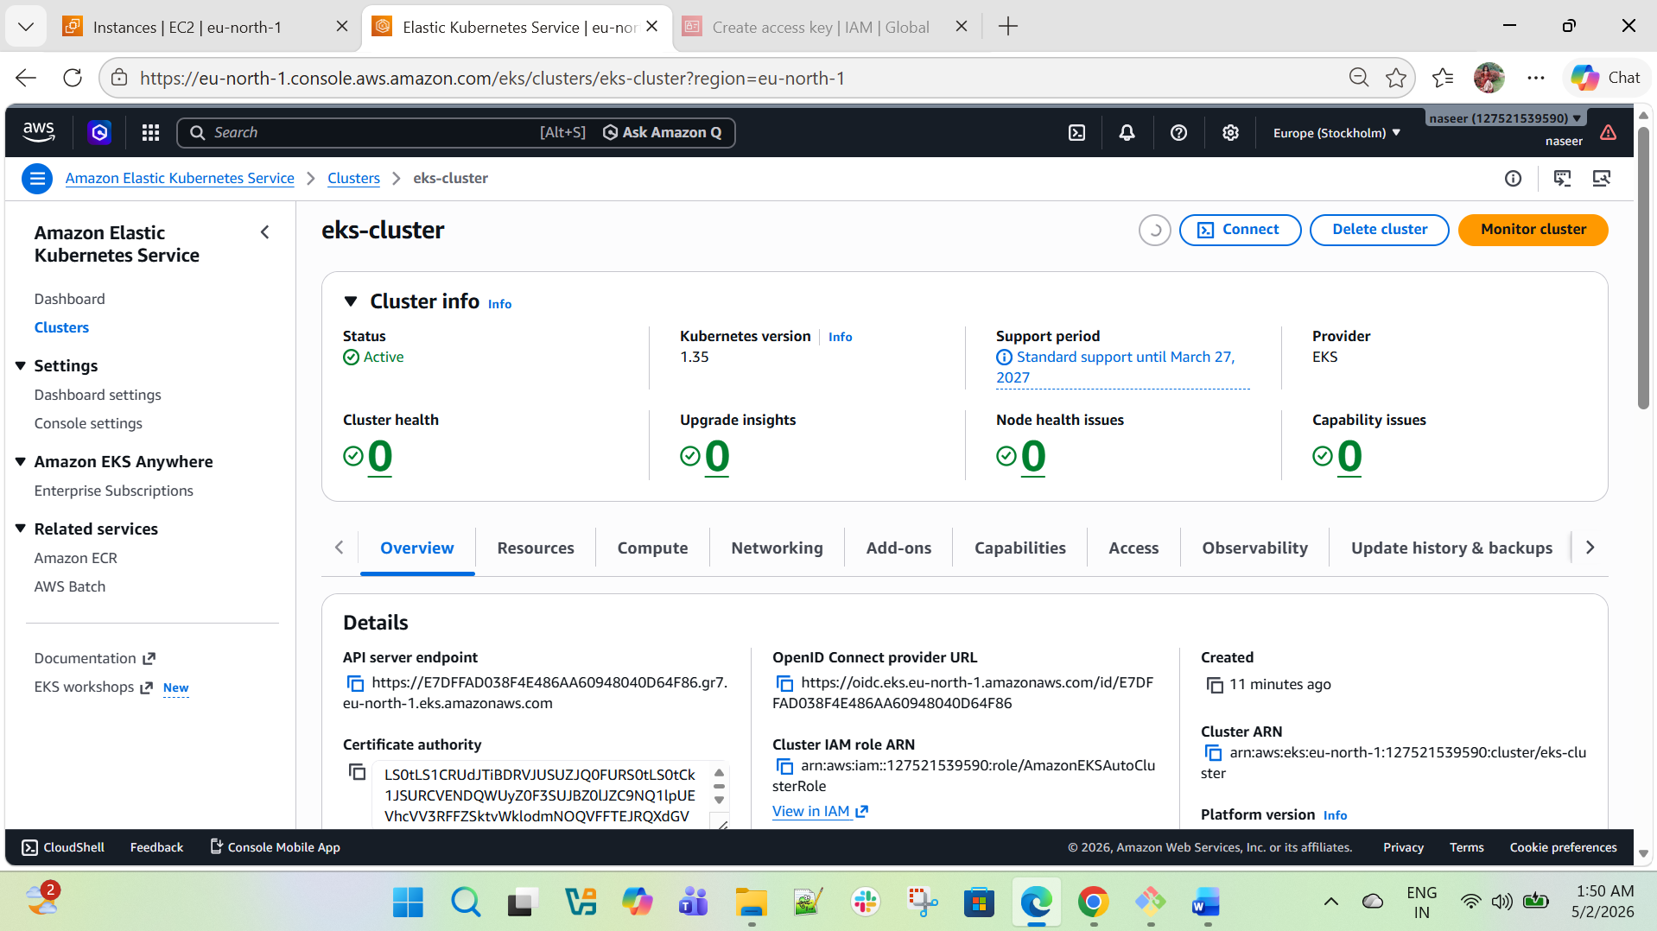
  - Create Node Group (Workers)
Once cluster is ACTIVE:
Go to your cluster → Compute → Add node group
Node Group Settings
- Name: my-nodes
- Node role: Click Create new role
Instance settings
- AMI: Amazon Linux (default)
- Instance type: t3.micro
- Desired size: 2
Networking
- Select same subnets
Click Create
Wait again
Node group creation
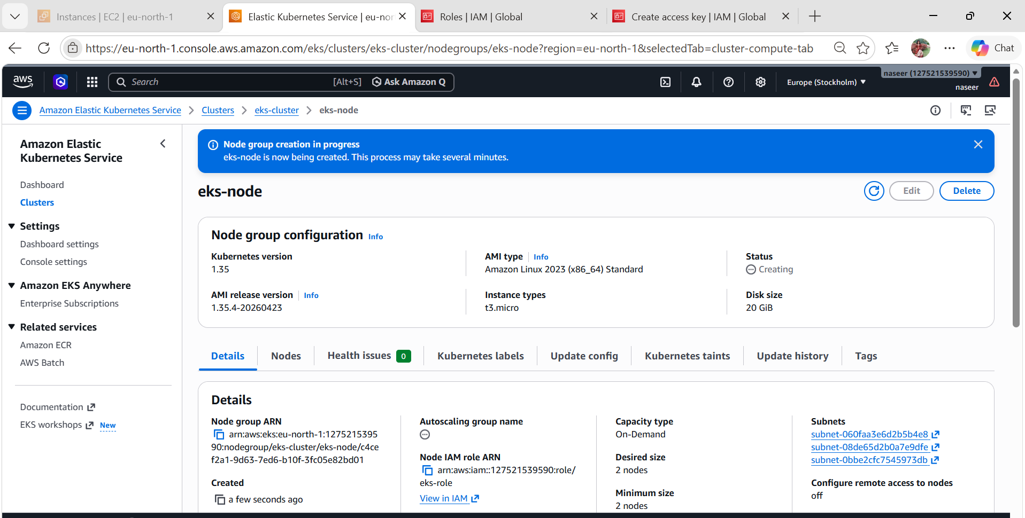
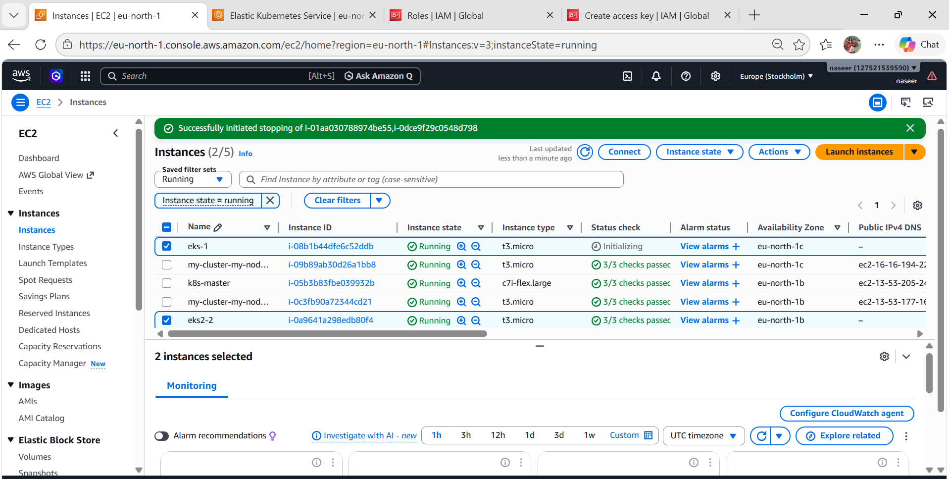
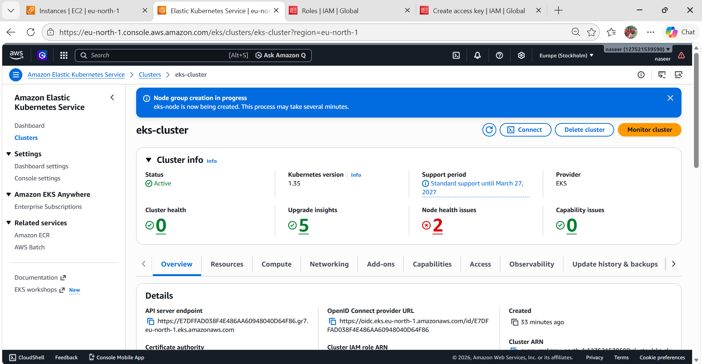

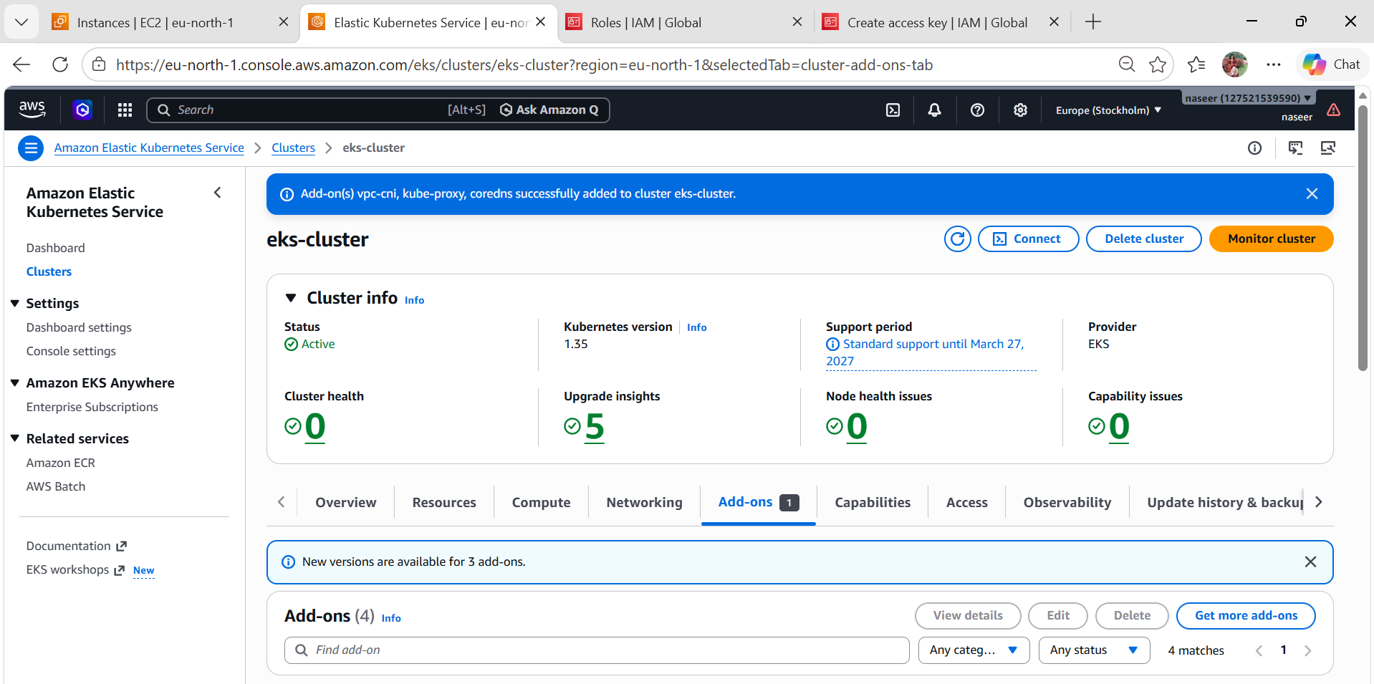
  - Connect to Cluster
Run this on your EC2 or local machine:
aws eks update-kubeconfig \
--region us-east-1 \
--name my-cluster
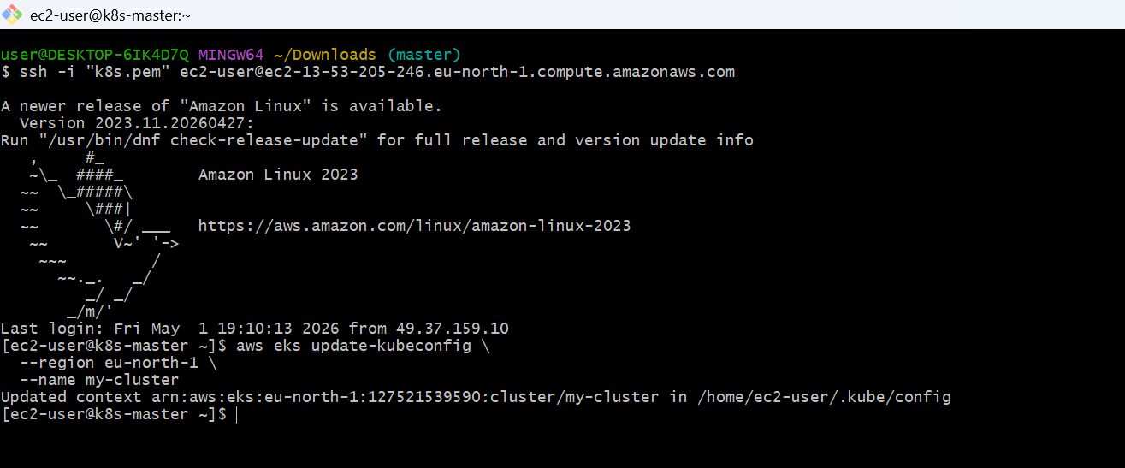
Go to AWS Management Console
  - Open your cluster
- Go to EKS
- Click your cluster: my-cluster_eks
  - Go to Add-ons tab
- Click Add-ons (left menu)
You’ll likely see empty or missing core add-ons
  - Add required add-ons
Click “Get more add-ons”
Now install these ONE BY ONE:
  - VPC CNI (MOST IMPORTANT)
- Name: Amazon VPC CNI
- Version: Latest
- Click → Create
This fixes:
NetworkPluginNotReady
  - CoreDNS
- Name: CoreDNS
- Version: Latest
- Create
  - kube-proxy
- Name: kube-proxy
- Version: Latest
- Create
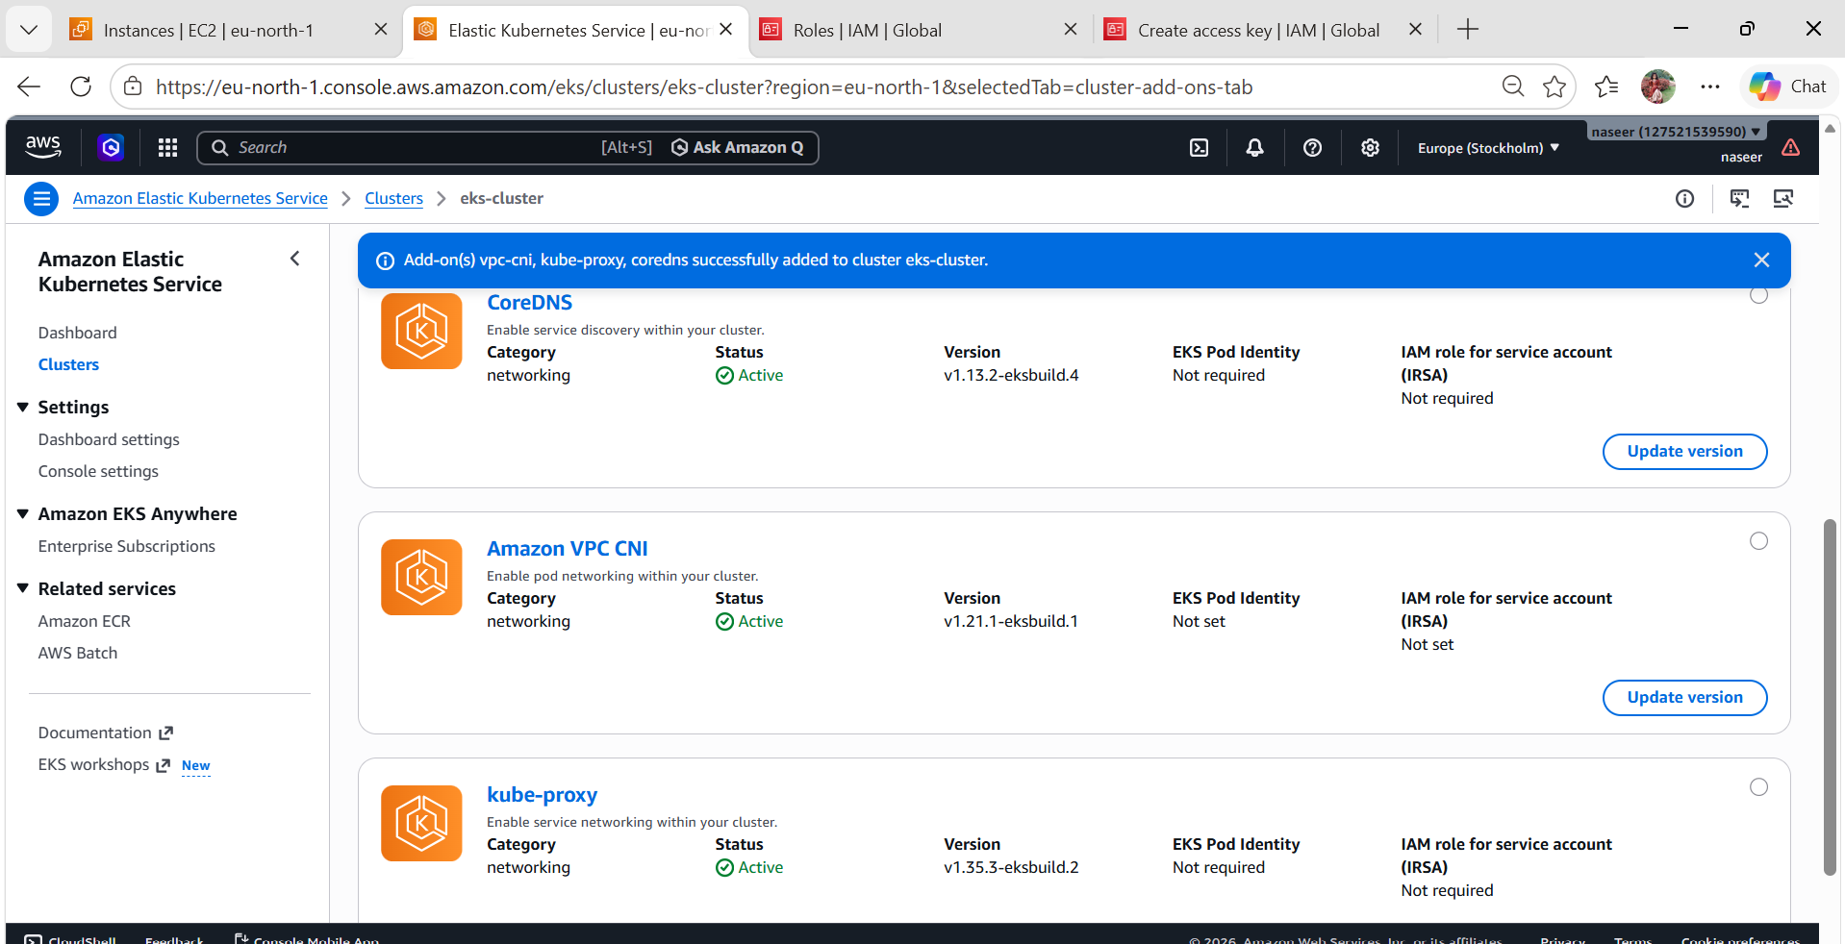
  - Verify
Go back to terminal:
kubectl get pods -n kube-system
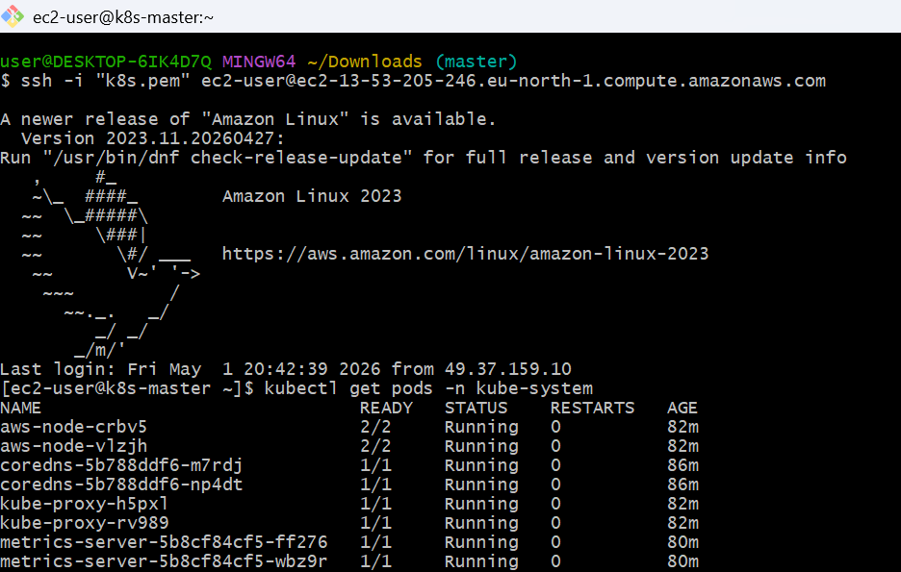
  - Check nodes
kubectl get nodes
Done! Now test app
kubectl create deployment nginx --image=nginx
kubectl expose deployment nginx --type=NodePort --port=80
kubectl get svc
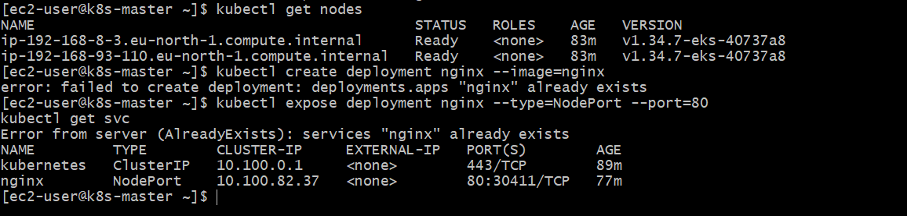

- Setup HPA
  - Vi nginx-deployment.yaml
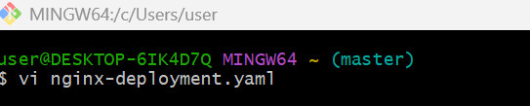
apiVersion: apps/v1
kind: Deployment
metadata:
name: nginx-deployment
spec:
replicas: 1
selector:
matchLabels:
app: nginx
template:
metadata:
labels:
app: nginx
spec:
containers:
- name: nginx
image: nginx
resources:
requests:
cpu: 100m
limits:
cpu: 200m
ports:
- containerPort: 80
kubectl apply -f nginx-deployment.yaml
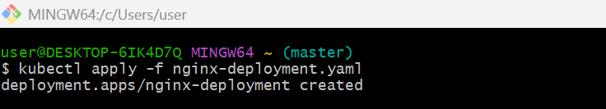
  - Vi hpa.yaml
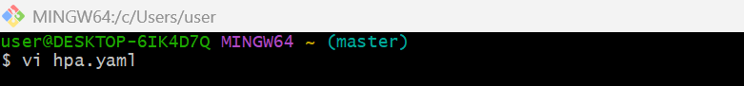
apiVersion: autoscaling/v2
kind: HorizontalPodAutoscaler
metadata:
name: nginx-hpa
spec:
scaleTargetRef:
apiVersion: apps/v1
kind: Deployment
name: nginx-deployment
minReplicas: 1
maxReplicas: 5
metrics:
- type: Resource
resource:
name: cpu
target:
type: Utilization
averageUtilization: 50
  - kubectl apply -f hpa.yaml
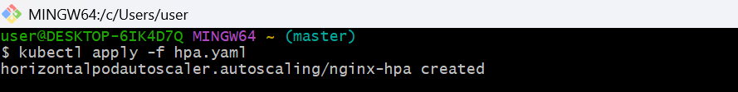
Create one service file:
  - vi nginx-nodeport-service.yaml
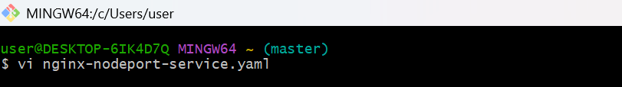
apiVersion: v1
kind: Service
metadata:
name: nginx-service
spec:
type: NodePort
selector:
app: nginx # Make sure this matches your deployment labels
ports:
- port: 80
targetPort: 80
nodePort: 30080 # Must be between 30000–32767
  - kubectl apply -f nginx-nodeport-service.yaml
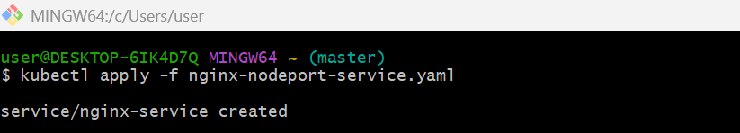
  - kubectl top nodes
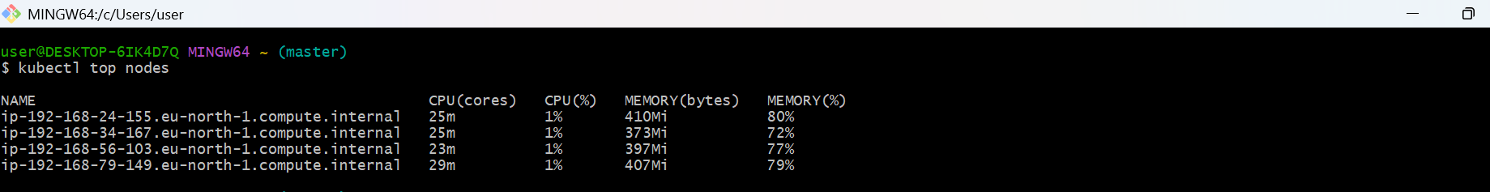
  - kubectl top pods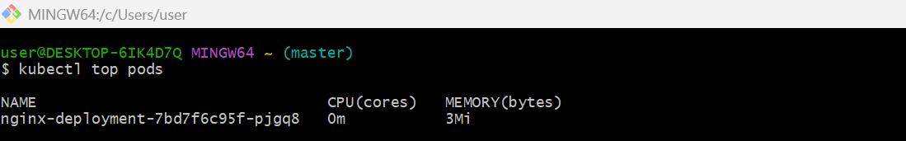
Let's add some fake load to our nginx deployment:
  - vi load-generator.yaml
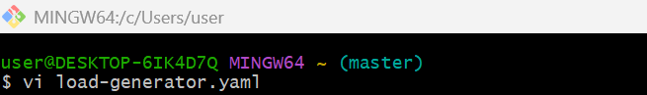
apiVersion: v1
kind: Pod
metadata:
name: load-generator
spec:
containers:
- name: busybox
image: busybox
command: ["/bin/sh"]
args: ["-c", "while true; do wget -q -O- http://nginx-service.default.svc.cluster.local; done"]
  - Kubectl apply -f load-generator.yaml
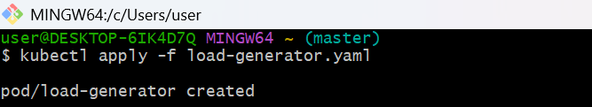

  - kubectl describe hpa nginx-hpa

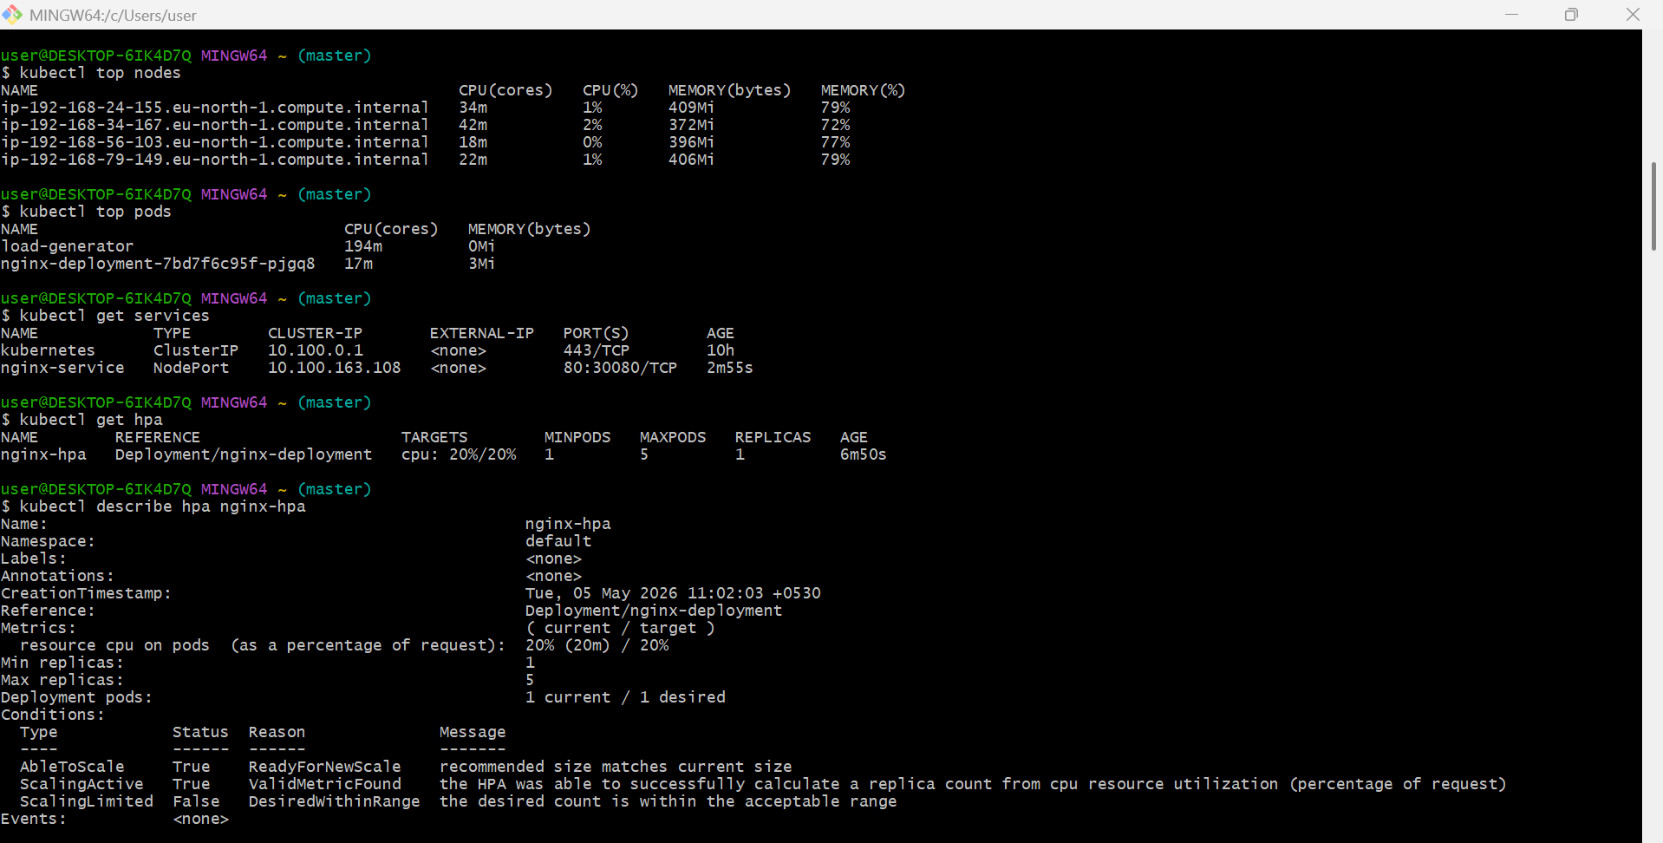
  - kubectl get hpa
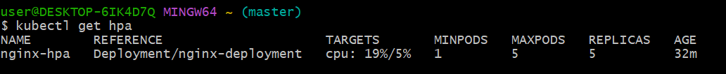

  - kubectl get pods
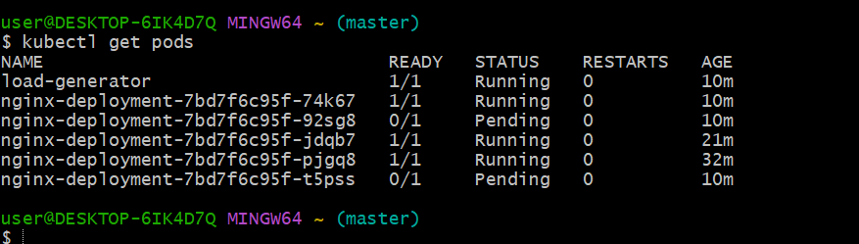
- Setup cluster autoscale
  - Enable Auto Scaling on Node Group (Console)
Go to AWS Management Console
Path:
EKS → Cluster → Compute → Node group
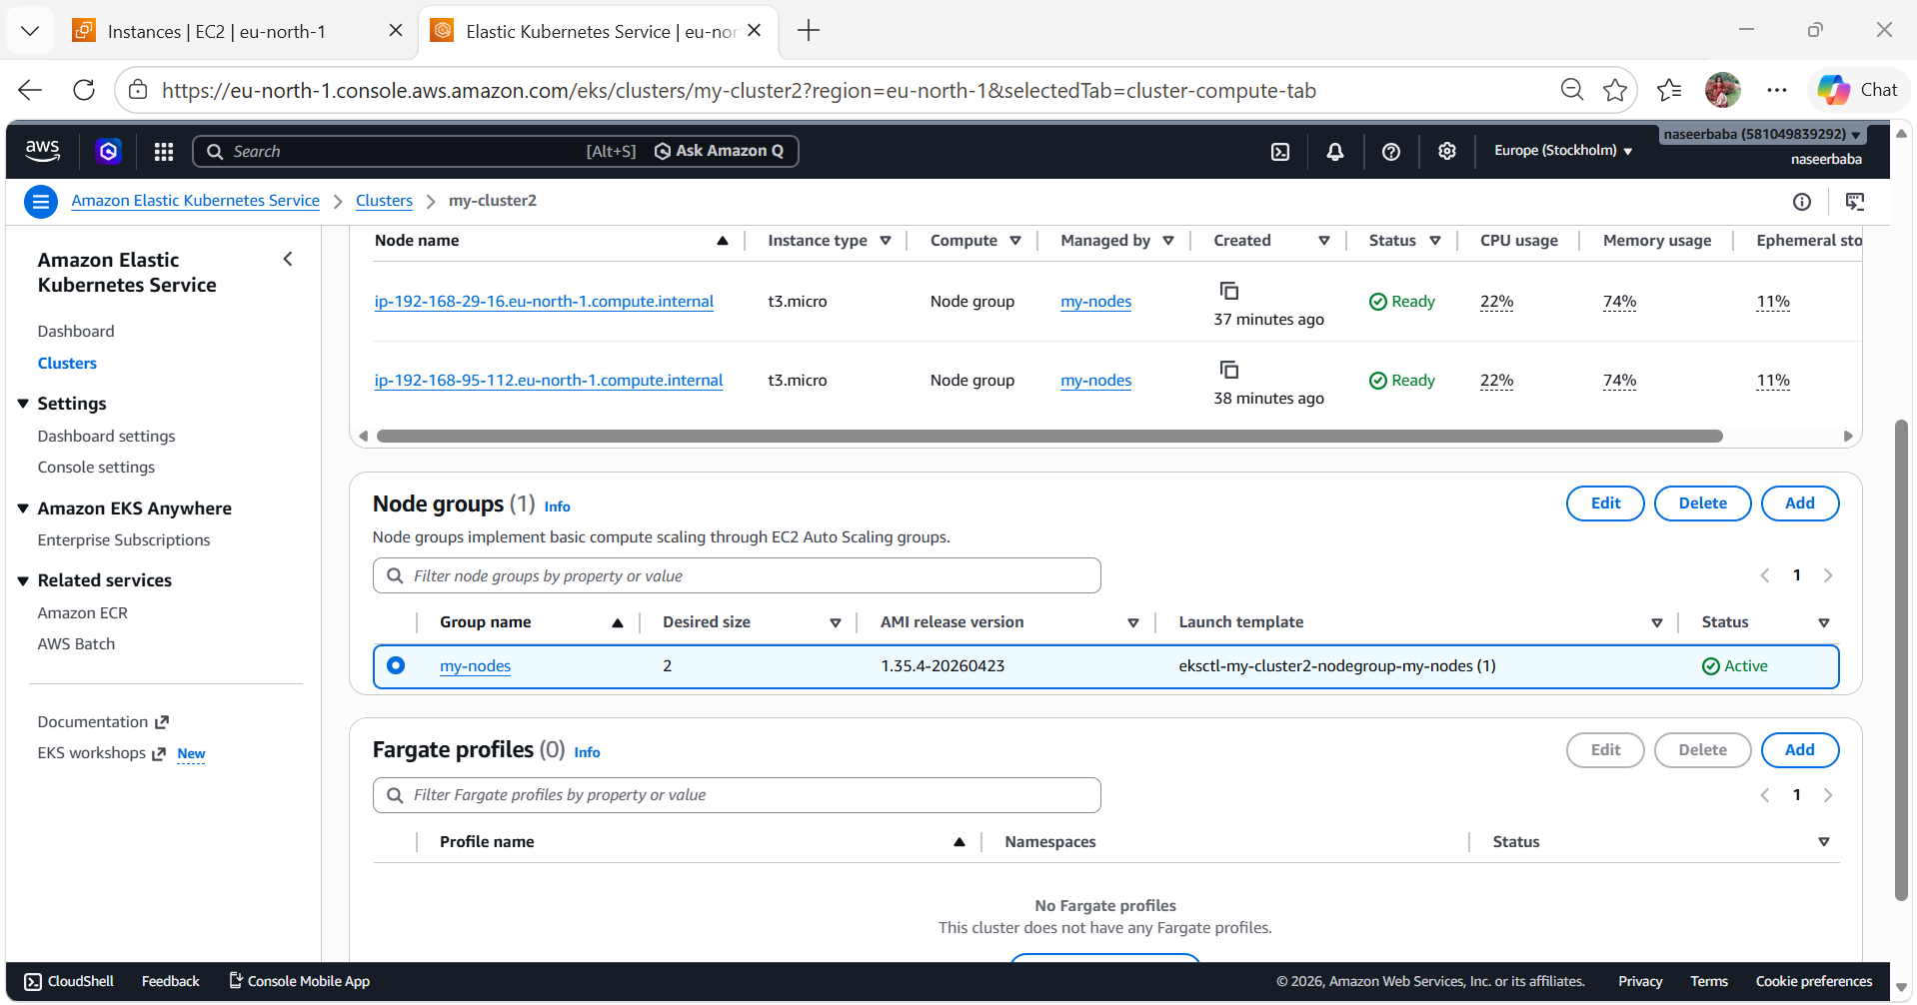
Click your node group → Edit:
Set:
• Min: 1
• Desired: 2
• Max: 3
Save
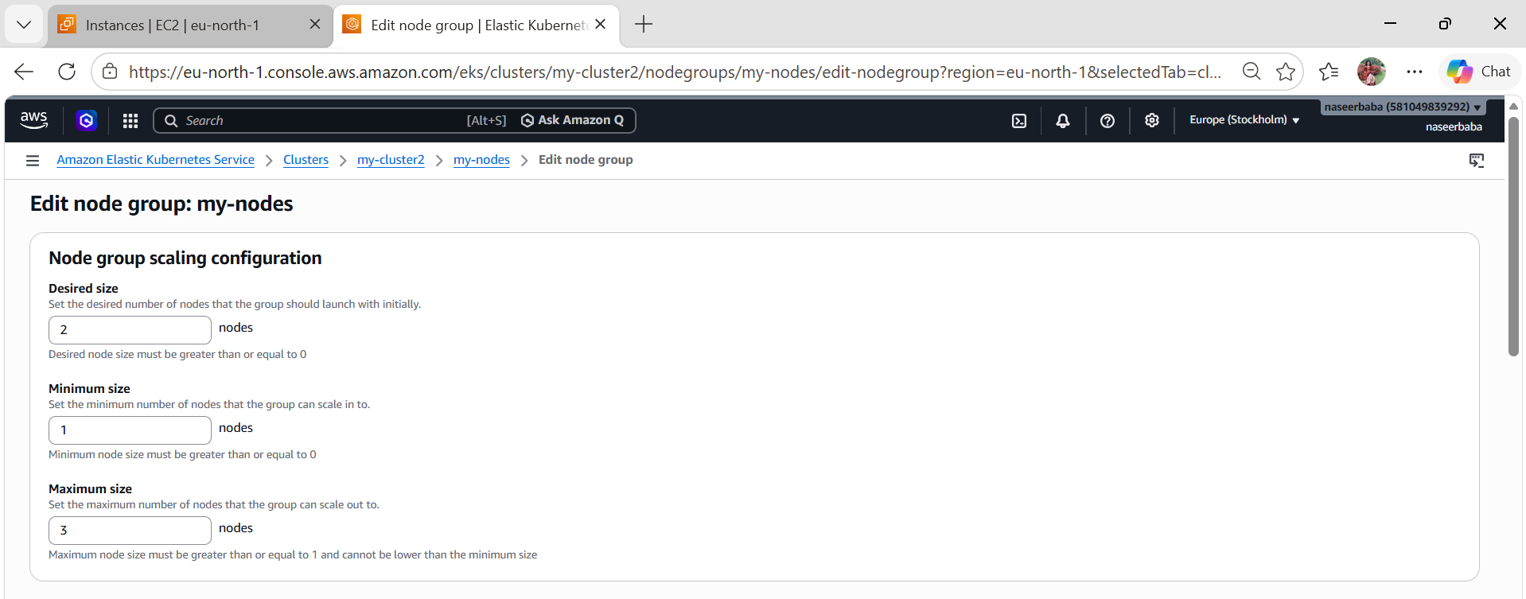
  - Attach IAM Policy (VERY IMPORTANT)
Go to: IAM → Roles → your node IAM role
Attach policy:
Create policy (JSON):
{
"Version": "2012-10-17",
"Statement": [
{
"Action": [
"autoscaling:DescribeAutoScalingGroups",
"autoscaling:DescribeAutoScalingInstances",
"autoscaling:DescribeLaunchConfigurations",
"autoscaling:SetDesiredCapacity",
"autoscaling:TerminateInstanceInAutoScalingGroup",
"ec2:DescribeLaunchTemplateVersions"
],
"Effect": "Allow",
"Resource": "*"
}
]
}
Attach this to node role.
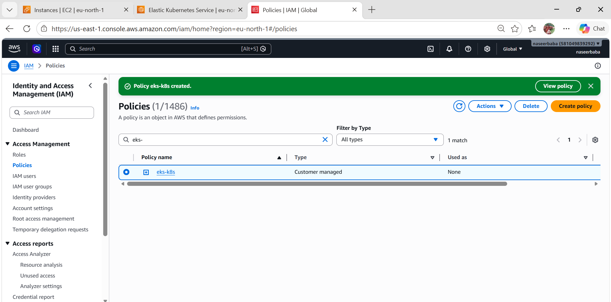
  - Add Tags to Node Group (CRITICAL)
Go to: EC2 → Auto Scaling Groups → your node group ASG
Add tags:
k8s.io/cluster-autoscaler/enabled = true
k8s.io/cluster-autoscaler/my-cluster_eks = owned
Replace cluster name correctly
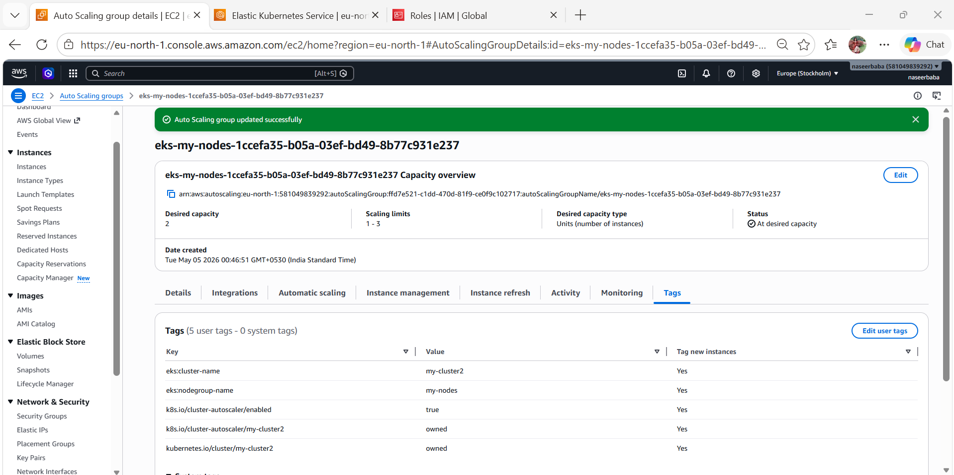
  - Deploy Cluster Autoscaler
Run this:
kubectl apply -f https://raw.githubusercontent.com/kubernetes/autoscaler/master/cluster-autoscaler/cloudprovider/aws/examples/cluster-autoscaler-autodiscover.yaml
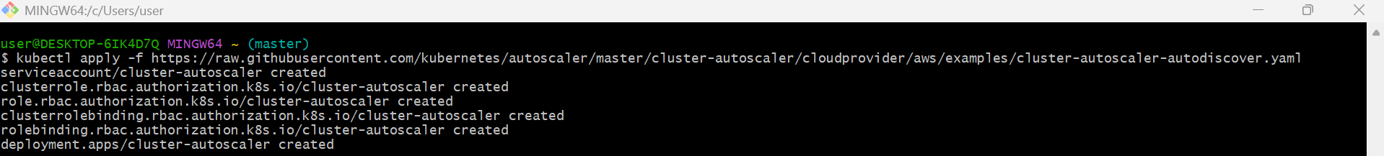
  - Edit deployment
kubectl edit deployment cluster-autoscaler -n kube-system
Find this line:
--cluster-name=<YOUR CLUSTER NAME>
Replace with:
--cluster-name=my-cluster1_eks
Add one more IMPORTANT flag
Under command: add:
--balance-similar-node-groups
--skip-nodes-with-system-pods=false
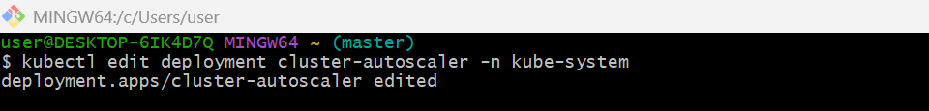
  - Verify
kubectl get pods -n kube-system
You should see:
cluster-autoscaler Running ✅
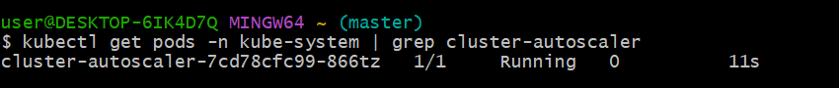
  - Test autoscaling
Create load:
Update BOTH requests + limits:
kubectl set resources deployment nginx \
--requests=cpu=1,memory=1Gi \
--limits=cpu=1,memory=1Gi
kubectl scale deployment nginx-deployment --replicas=10
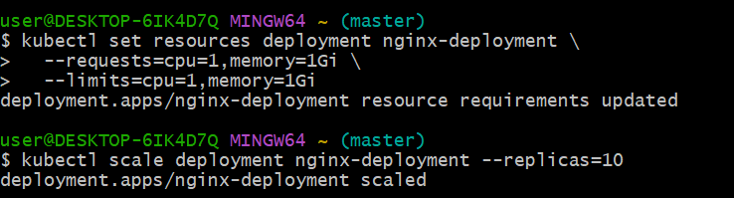
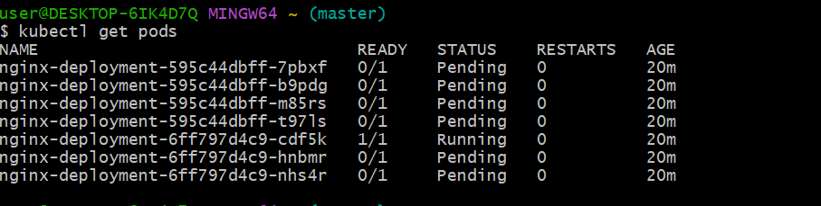

- Setup cronjob and job
  - Create one cronjob.yaml
Vi cronjob.yaml
apiVersion: batch/v1
kind: CronJob
metadata:
name: test-cronjob
namespace: default
spec:
# Cron schedule: “* * * * *” = every minute
schedule: "*/1 * * * *"
# Optional: limit number of successful/failed history
successfulJobsHistoryLimit: 3
failedJobsHistoryLimit: 1
jobTemplate:
spec:
template:
spec:
restartPolicy: OnFailure
containers:
- name: date-printer
# Lightweight image that has “date”
image: busybox:1.35
args:
- /bin/sh
- -c
- date; echo "Hello from EKS CronJob"

  - Run cronjob: kubectl apply -f cronjob.yaml
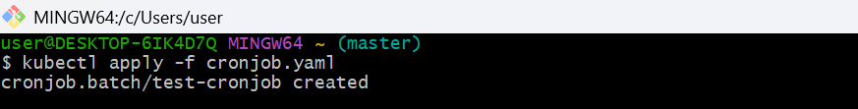
  - How to test: kubectl get cronjob
  - and check logs to see date: kubectl get pods .
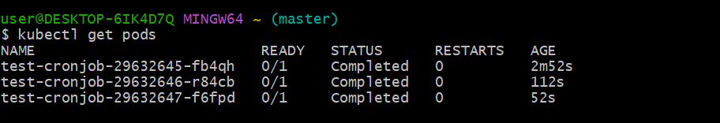
  - Kubectl get pods -w
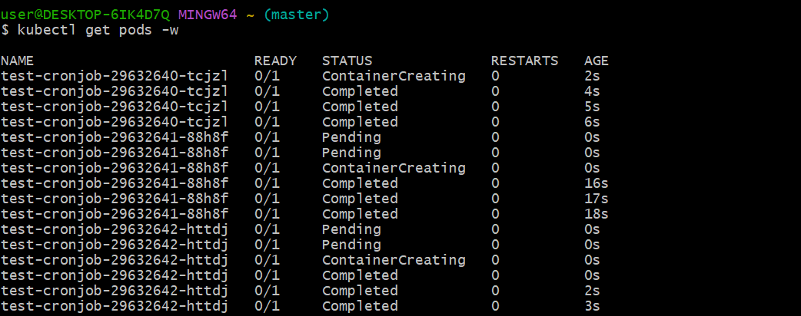
  - kubectl logs job/$(kubectl get jobs -o jsonpath='{.items[-1].metadata.name}')
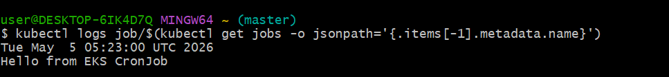

Job:
  - Create a sampleJob
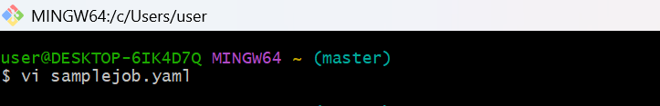
apiVersion: batch/v1
kind: Job
metadata:
name: my-job
spec:
completions: 1
parallelism: 1
template:
spec:
containers:
- name: job-container
image: busybox
command: ["sh", "-c", "echo Hello from Job && sleep 5"]
restartPolicy: Never
  - Apply
kubectl apply -f samplejob.yaml
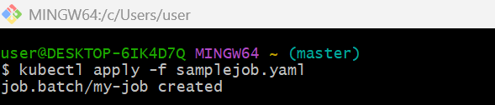
  - Check Job
kubectl get jobs
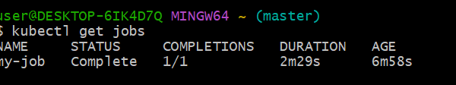
  - Check Pod
kubectl get pods
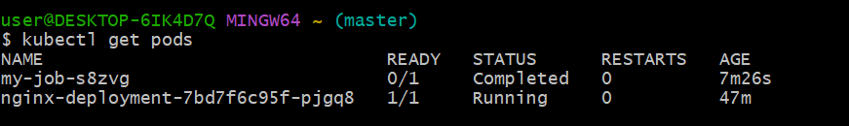
  - Check Logs
kubectl logs <job-pod-name>
kubectl logs my-job-cj26n
Output:
Hello from Job
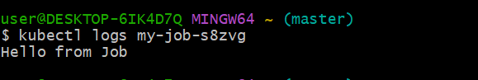

- Create secret and inject inside pod
  - Create Secret (YAML)
vi secret.yaml
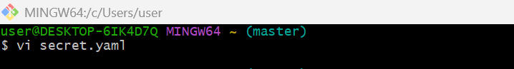
apiVersion: v1
kind: Secret
metadata:
name: my-secret
type: Opaque
data:
username: YWRtaW4= # base64 for "admin"
password: cGFzc3dvcmQ= # base64 for "password"
  - Apply it:
kubectl apply -f secret.yaml
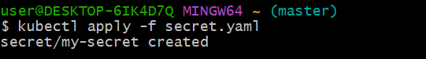
  - Verify:
kubectl get secrets
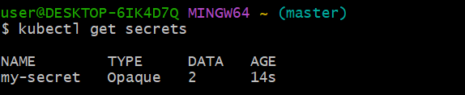
kubectl describe secret my-secret
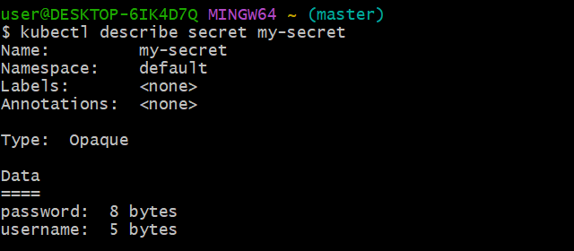
  - Inject Secret into Pod (as ENV variables)
Create pod YAML:
vi secret-pod.yaml
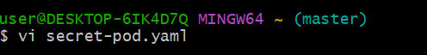
apiVersion: v1
kind: Pod
metadata:
name: secret-pod
spec:
containers:
- name: nginx
image: nginx
env:
- name: USERNAME
valueFrom:
secretKeyRef:
name: my-secret
key: username
- name: PASSWORD
valueFrom:
secretKeyRef:
name: my-secret
key: password
  - Apply:
kubectl apply -f secret-pod.yaml
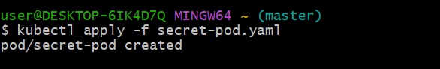
  - Verify inside Pod
kubectl exec -it secret-pod -- printenv | grep USERNAME
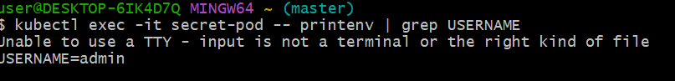
kubectl exec -it secret-pod -- printenv | grep PASSWORD
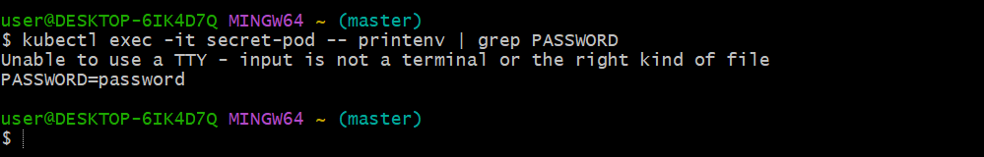
- Check differen add-ons available on eks.
  - Open your cluster
- Go to EKS → Clusters
- Click your cluster → my-cluster2
- Open Add-ons tab
  - Click “Get more add-ons”
- Scroll up and click Get more add-ons
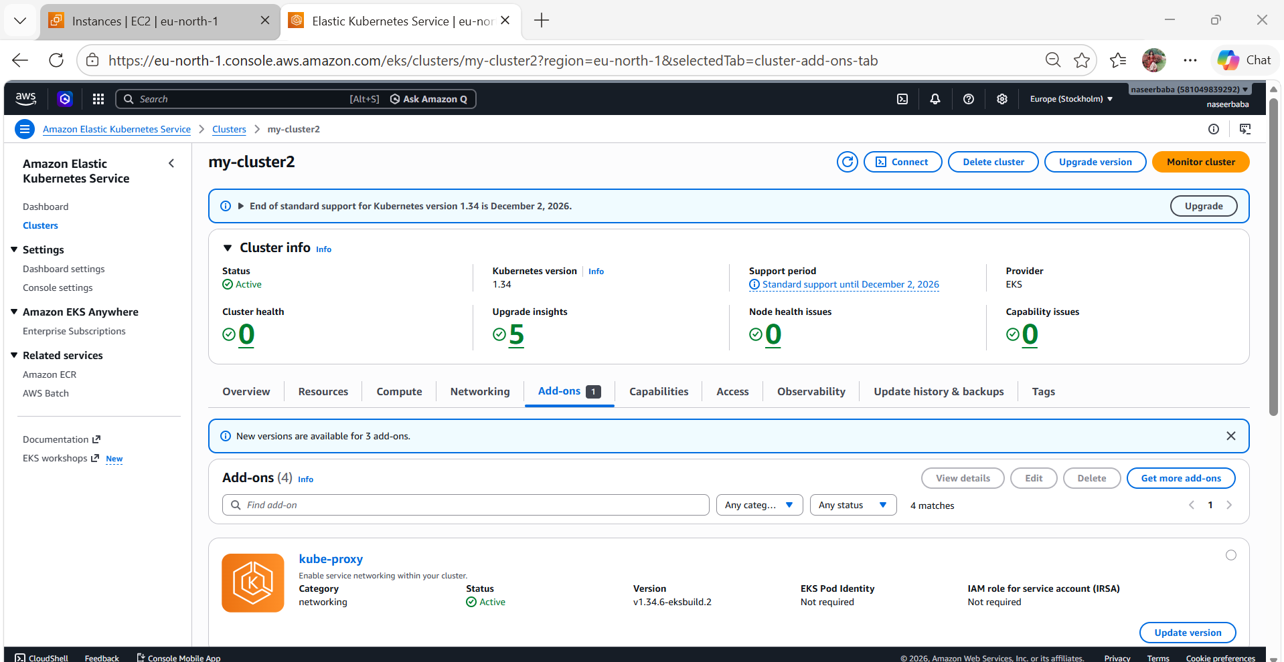
  - Select required add-ons
Search and select:
- ✔ kube-proxy
- ✔ CoreDNS
- ✔ Amazon VPC CNI
- ✔ Metrics Server
  - Configure each add-on
For each add-on:
Click Next
Basic settings:
- Version → Select latest recommended
- Most cases → leave default
IAM (Important for some add-ons):
- VPC CNI / EBS / EFS → may need IAM role
- For now:
  - Select Default (No role) OR
  - Use existing IAM role (if created earlier)
Click Next
  - Install
- Review settings
- Click Create
  - Verify
Go back to Add-ons tab
You should see:
- Status → Active
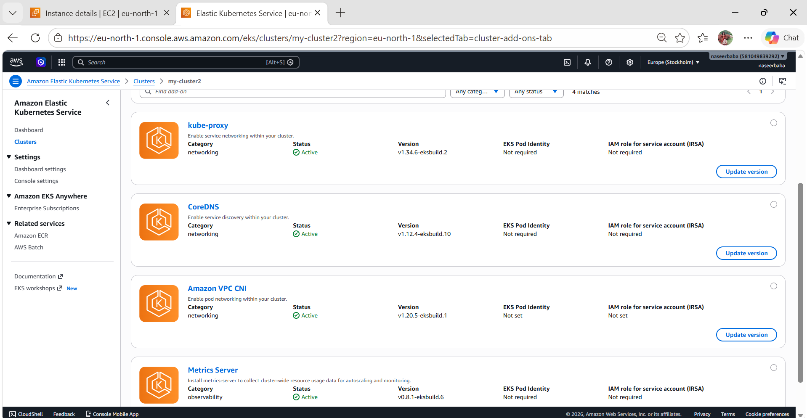
- Upgrade eks cluster
  - Check current version
aws eks describe-cluster \
--name my-cluster \
--region eu-north-1 \
--query "cluster.version"
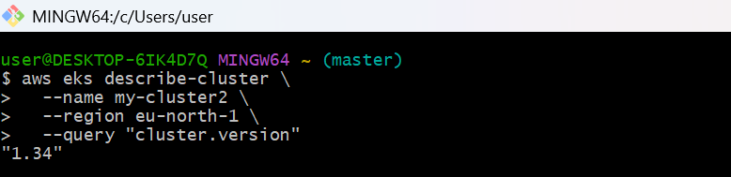
  - kubectl get nodes
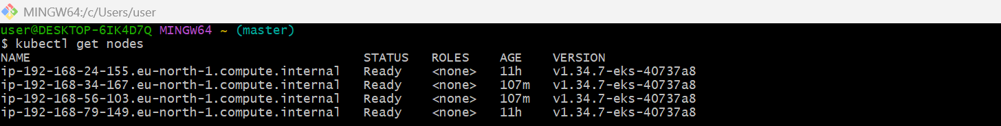 kubectl version
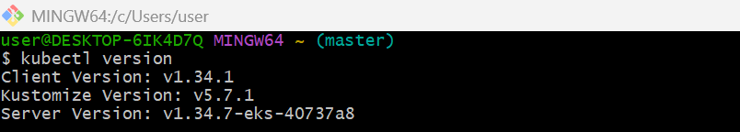
  - Check available EKS versions
aws eks describe-cluster-versions --region eu-north-1
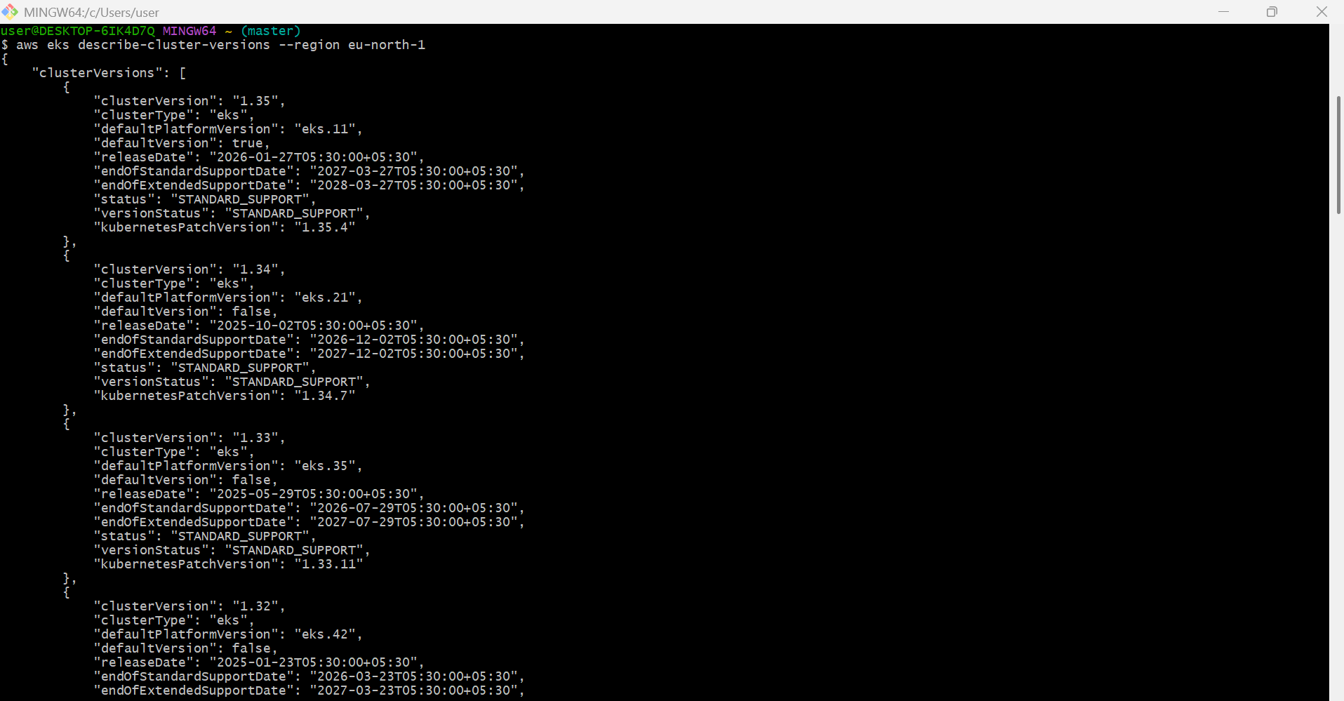
  - Check upgrade issues
In AWS Console:
EKS → Clusters → your cluster → Observability → Upgrade insights
Fix all errors before upgrade. EKS Upgrade Insights checks possible upgrade problems.
  - Upgrade EKS control plane
Example: upgrade to 1.34.
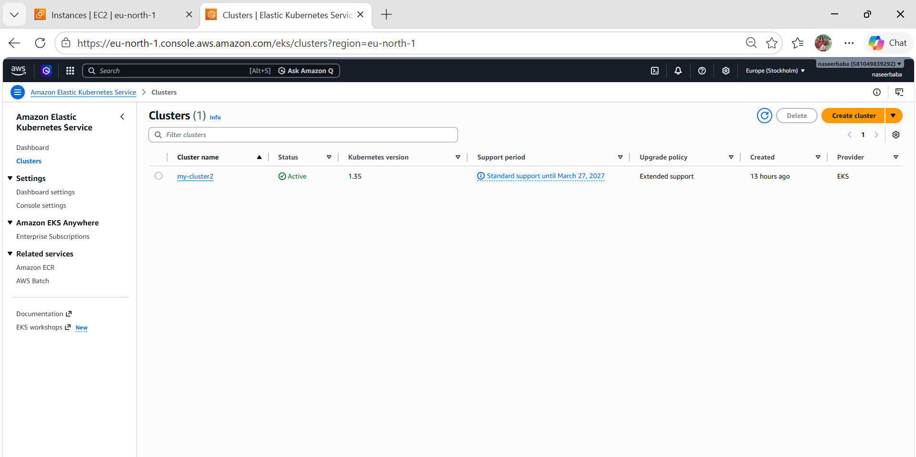
  - Upgrade EKS add-ons
Check current add-ons:
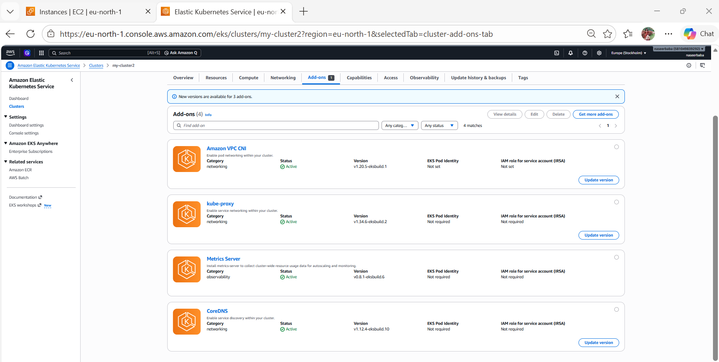
  - Upgrade managed node group
List node groups:
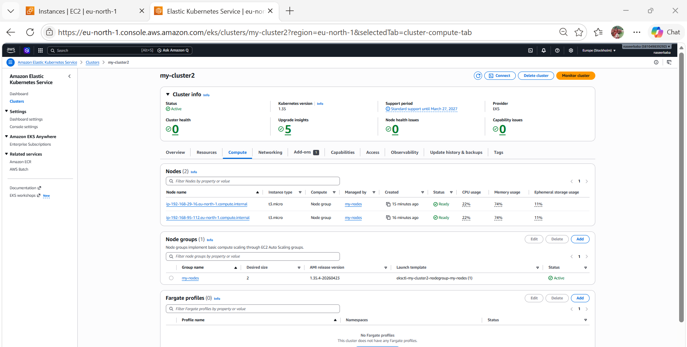
  - Verify everything
kubectl get nodes
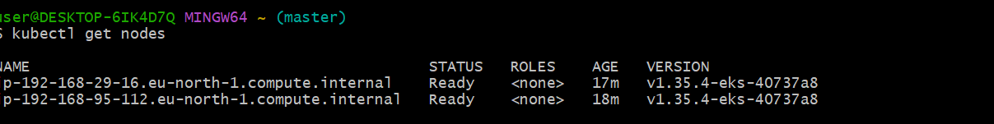
kubectl get pods -A
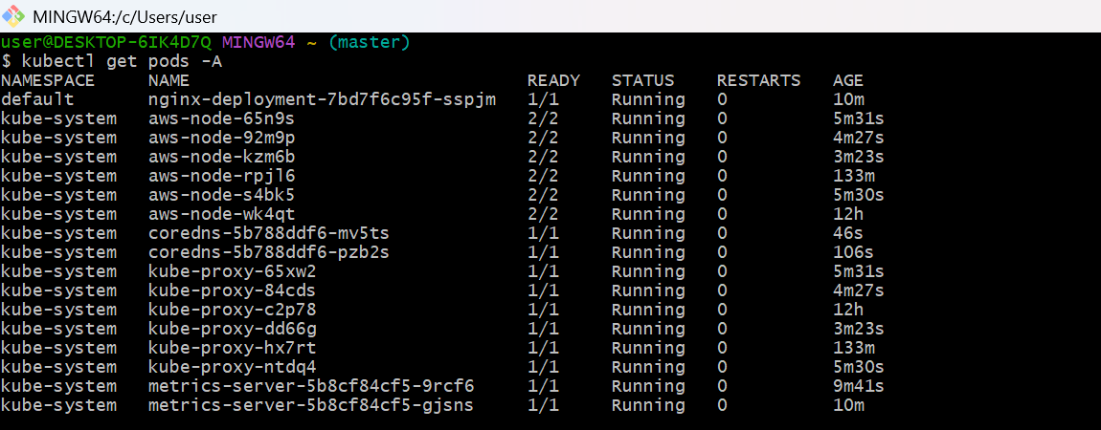

  - kubectl get deployments -A
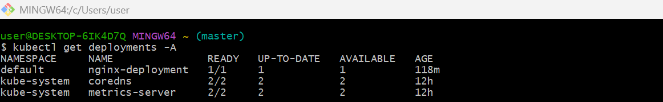
kubectl top nodes
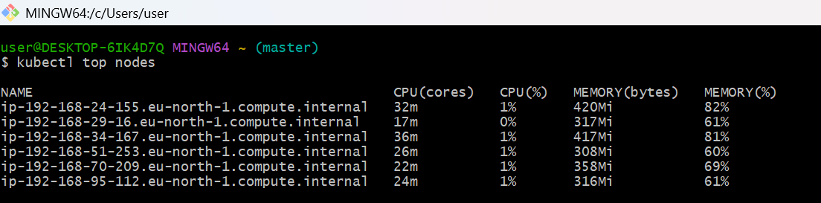
kubectl top pods -A
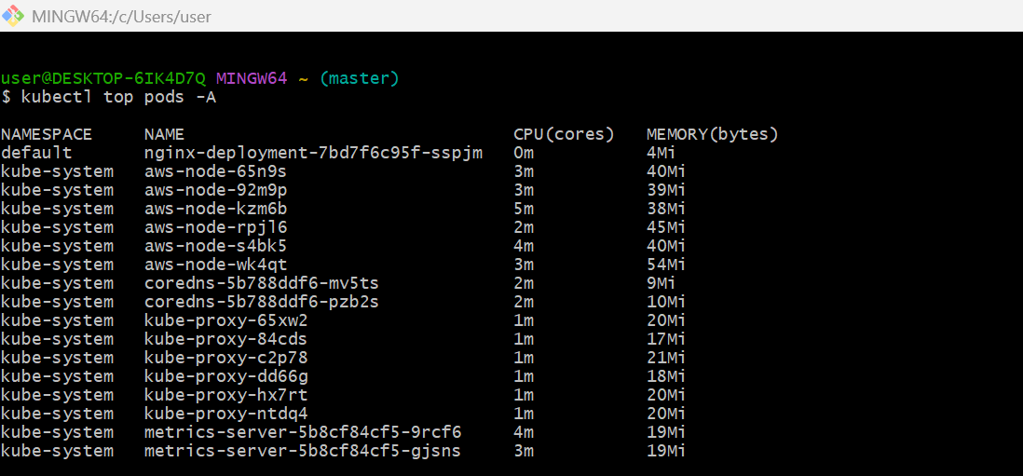
  - Check versions:
kubectl get nodes -o wide
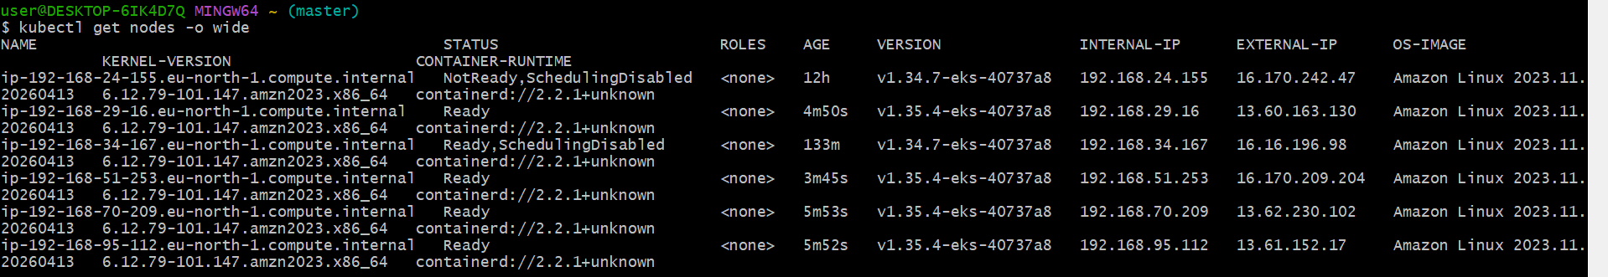
  - Quick Check (Simplest)
aws eks describe-cluster \
--name my-cluster2 \
--region eu-north-1 \
--query "cluster.status"
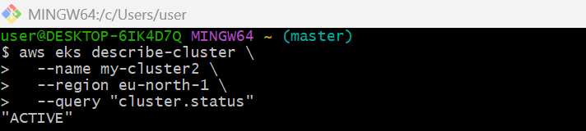
  - Check Version Change
aws eks describe-cluster \
--name my-cluster2 \
--region eu-north-1 \
--query "cluster.version"
Before:
"1.34"

After:
"1.35"
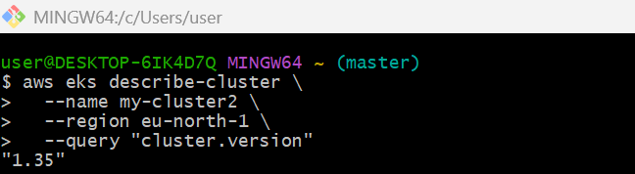
  - Verify using kubectl
kubectl version
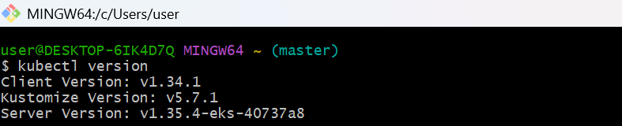
kubectl get nodes
Look for:
Server Version: v1.35.x
