GroupBuy Dubai: Data Analytics for Business Decisions and Automation
Individual Data Analytics Assignment | Syamantak Dey
Draft for review. Check each result against the dashboard, rewrite the yellow passages in your own words, and delete this note before submitting.

Startup and business objective
GroupBuy is a demand-first buying platform for Dubai. Buyers register what they want, suppliers bid against the pooled quantity, and buyers approve the final delivered price before paying. GroupBuy earns a commission on fulfilled orders, assumed in the deck at 7%. The deck names its largest early risks as trust and unit economics, so this project asks: whom should GroupBuy target first, what should it pool together, how large will orders be, and which of these decisions can be automated?

Data
The analysis uses a mock survey of 1,215 rows. Cleaning removed 15 duplicate submissions, leaving 1,200 respondents, and corrected text-formatted spend, impossible values such as an age of 120, and inconsistent labels. Because the deck contains no transactions, I generated a synthetic Year 1 of 120 campaigns and 4,449 buyer commitments, using the deck's commission, variable cost and fixed cost. Survey answers drive the simulation: for example, a buyer is more likely to pay when the net discount clears their stated minimum. None of this data is real market evidence.

Clustering: who are the buyers?
K-Means was used because no segment labels exist. Thirteen behavioural variables were scaled, with intent answers left out. I chose five clusters: this is the elbow and a local silhouette peak. Two clusters scored higher but were too coarse to act on. A silhouette of 0.237 shows that the segments overlap. Bulk Value Seekers have the highest high-intent share (59%), while Affluent Convenience Seekers have 4% and need a 25% average discount. GroupBuy should launch with the first group and avoid spending on the second. New sign-ups can be assigned automatically to a segment and its message flow.
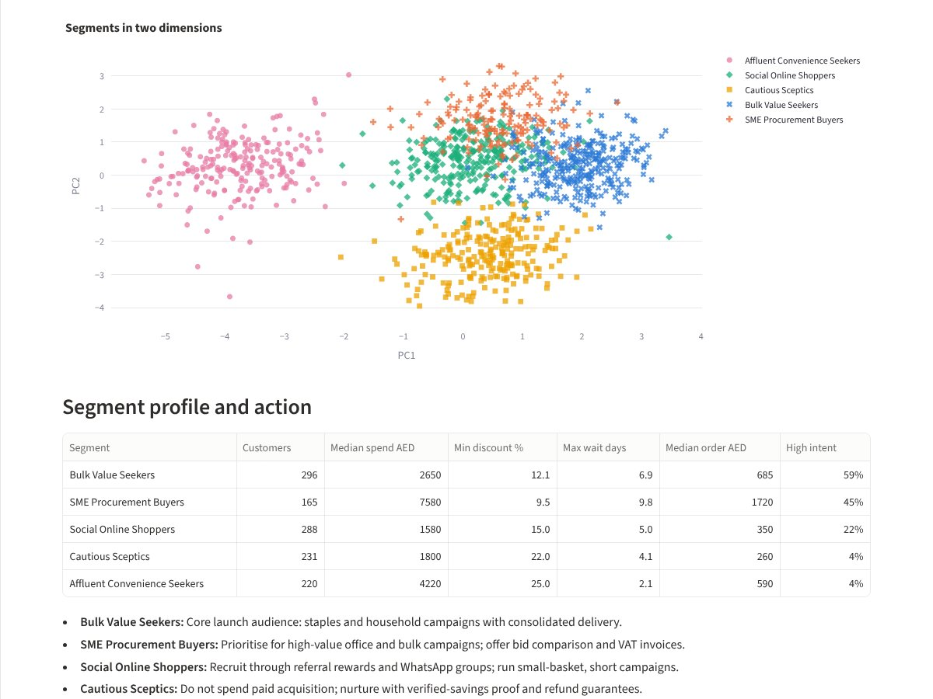
Figure 1. Dashboard: K-Means segments and profiles
[Rewrite in your own words] What surprised you about the segments, and which one would you pursue first?

Classification: which leads come first?
The target is whether a respondent is in the High conversion segment (27.6% of respondents). The conversion score is almost entirely a weighted sum of three intent answers, so these answers, the score and free-text comments were excluded to prevent leakage. Gender and nationality were also excluded so they cannot influence outreach priority. Random Forest was selected using cross-validated F1 on training data.
Classifier (test set) | Accuracy | Precision | Recall | F1
Always majority | 72.3% | 0% | 0% | 0.000
Logistic Regression | 81.3% | 63.1% | 78.3% | 0.699
Decision Tree | 75.7% | 54.3% | 75.9% | 0.633
Random Forest (selected) | 77.7% | 56.6% | 83.1% | 0.673

On 300 test leads the confusion matrix gives 69 true positives (high-intent leads correctly called), 164 true negatives (correctly left in low-cost nurture), 53 false positives (wasted calls) and 14 false negatives (missed buyers). High accuracy would mean little here, since always predicting "not high" reaches 72.3%. During cold start a missed buyer costs more than a wasted message, so recall of 83.1% matters most. Logistic Regression did better on this one test set, so the choice between the two is not clear-cut. Sign-ups can be scored automatically and sent either to a founder call list or a WhatsApp nurture flow.
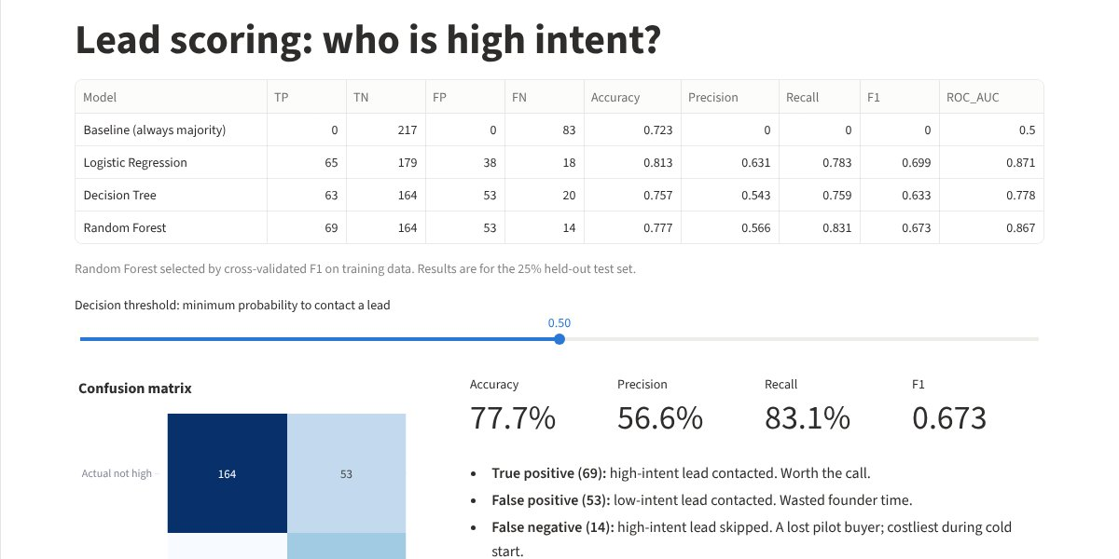
Figure 2. Dashboard: classification comparison and confusion matrix
[Rewrite in your own words] Explain in your own business terms why false negatives or false positives matter more for GroupBuy.

Association rules: what belongs together?
Apriori treated each respondent's selected categories and features as a basket. Baby and groceries interest strongly implies fresh produce and meat (confidence 87%, lift 2.64, support 11%). Building pooling with WhatsApp updates implies consolidated delivery (confidence 86%, lift 2.59). This suggests family bundles on a shared delivery run and one packaged "building campaign". The rules could automatically suggest a related open campaign when a buyer commits. They show overlapping stated interest, not purchases or causation.

Regression: how large will orders be?
Expected order value was predicted from 17 variables. Random Forest (MAE AED 225, MSE 117,008, RMSE AED 342, R² 0.71) beat Multiple Linear Regression (R² 0.47) and a mean baseline. Eligible monthly spend is the leading driver. Errors differ sharply by buyer type: mean error is AED 164 for individuals but AED 609 for SMEs, so the two should be forecast separately. Predicted value multiplied by expected paying buyers can automatically suggest a campaign target quantity.
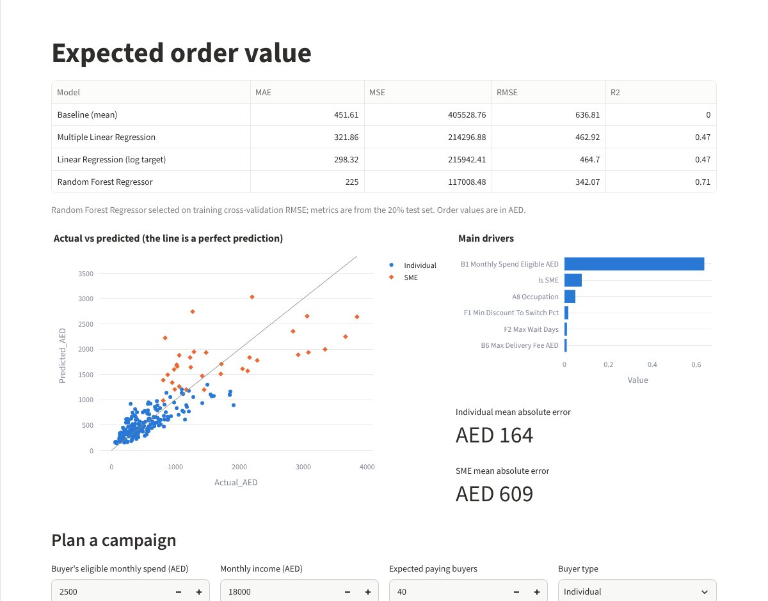
Figure 3. Dashboard: actual versus predicted order value and campaign planner

Business performance and recommendations
The simulation produced AED 1.86M GMV, AED 130,331 commission and a loss of AED 86,906 after fixed costs. Break-even needs about AED 300,000 of monthly GMV, reached only in November. This exposes a tension in the deck: break-even of about 15 orders at AED 20,000 implies AED 3.6M of annual GMV, whereas its Year 1 forecast is AED 1.2M.
I recommend launching with Bulk Value Seekers in staples and household categories, running SMEs as a separate track, ensuring net discounts approach the 16% median minimum (simulated offers average 13.1%), leading with the refund-if-campaign-fails guarantee, and revisiting the Year 1 financial plan.
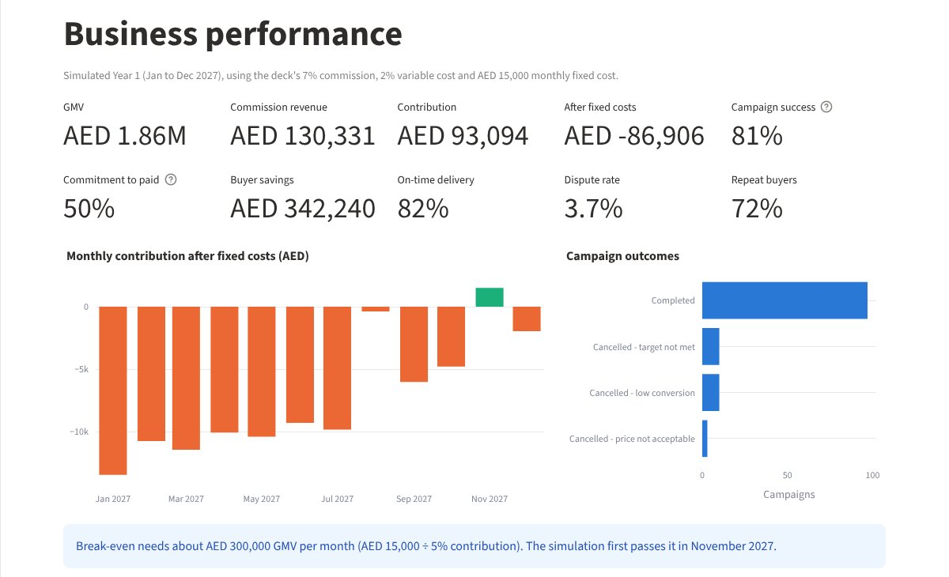
Figure 4. Dashboard: simulated Year 1 performance

Limitations and learning
The models learn patterns that exist in mock data, so good scores do not prove real-world accuracy. Lead scoring predicts stated intent rather than payment. The next step is to retrain on actual pilot outcomes, in line with the deck's 90-day validation plan.
[Rewrite in your own words] What did you personally learn? Cover at least one thing about data leakage or metric choice, and one about turning a model output into a business decision.

