GroupBuy Dubai: Using Data Analytics to Diagnose and Formulate a Business Strategy
Data Analytics Assignment | Syamantak Dey | SP Jain Global, Dubai
Project repository: https://github.com/babandey648-ux/groupbuy-dashboarb1.git
Draft for review. Verify the results, rewrite the explanations in your own words, complete the reflection in Section 9, and delete this note before submitting.

1. Business strategy and objective
GroupBuy is a proposed Dubai platform that pools demand before asking suppliers to quote. A campaign publishes a product and target quantity, buyers make conditional commitments, suppliers bid against the pooled quantity, and buyers approve the final delivered price before paying. GroupBuy earns an assumed 7% commission on fulfilled orders, with variable cost assumed at 2% of GMV and fixed cost at AED 15,000 a month.
The pitch deck states that the largest early risks are trust and unit economics. The business objective is to decide whom GroupBuy should serve first, what it should sell, how it should make the promised savings credible, and whether the model can pay for itself. No real transactions exist yet, so synthetic data is used to describe and diagnose the whole strategy. The focus is on which data is required, why it is required, how algorithms are applied, how their results are checked, and whether they enable something meaningful. Four questions guide the work:
- Who shows genuine intent, and where do prospects drop out?
- Which categories and features should the first campaigns use?
- Does the promised discount survive delivery costs and meet buyer expectations?
- Can the model reach break-even, and what would stop it?

2. Synthetic data generation

2.1 Why synthetic data, and how it maps to the pipeline
A start-up cannot observe a sales pipeline before it operates. Synthetic data allows the pipeline, its metrics and its decision rules to be built and stress-tested now, so real pilot data can replace it later without redesigning the analysis. The data was designed stage by stage, following the deck's process.
Pipeline stage | Dataset | Key measures | Decision supported
Validate demand | customers.csv (mock survey) | Intent, categories, minimum discount | Is there a reachable audience?
Launch campaign | products.csv, campaigns.csv | Reference price, target quantity, duration | What should be launched?
Aggregate demand | transactions.csv | Committed buyers and value | Was the target met?
Negotiate | suppliers.csv, campaigns.csv | Bids, delivered price, net discount | Is the offer acceptable?
Confirm and pay | transactions.csv | Paid flag, GMV, commission | Did commitment become revenue?
Fulfil and retain | campaigns.csv, transactions.csv | On-time delivery, disputes, repeat buyers | Should we scale?

2.2 Datasets
Table | Rows | Columns | Source and role
Raw mock survey | 1,215 | 63 | Respondent profile, attitudes, category and feature choices, intent
customers | 1,200 | 64 | Cleaned survey; one row per buyer
products | 48 | 6 | Synthetic: 12 categories, 4 generic items each
suppliers | 24 | 5 | Synthetic: fictional names, reliability, price position
campaigns | 120 | 18 | Synthetic: Year 1 campaigns (January to December 2027)
transactions | 4,449 | 14 | Synthetic: one row per buyer commitment

2.3 How the data was generated logically
The operating tables are linked to the survey through customer IDs, so they are not independent random numbers. The simulation used a fixed random seed, so it can be reproduced exactly.
- Campaign categories were drawn in proportion to survey category interest.
- Only buyers interested in a category could commit, and their quantity came from their stated order value.
- Net discount rises with pooled value and supplier bids, is capped by category, and is reduced by delivery cost of 1.2% to 4% of price.
- Campaigns are cancelled when pledges fall below 70% of target, net discount is under 5%, or paid quantity falls below 40% of target. This applies the deck's Trust Rule.
- A buyer's probability of paying rises when the discount exceeds their stated minimum, and falls when the campaign runs longer than their maximum wait.
Integrity checks confirmed that every customer, campaign, product and supplier key resolves, and that GMV reconciles between campaigns and transactions. Commission, cost and cancellation rules come from the deck; the 120-campaign volume, item prices, discount ceilings, reliability and payment behaviour are my assumptions. The survey file is labelled mock, so neither source is evidence of real demand.

2.4 Which columns are required, and why
The 107 columns are documented individually in Dataset/Data_Dictionary.csv. The main groups are summarised here.
Column group | Why it is required | Used in
Buyer profile (income, area, SME size) | Identifies who buys and where demand can be pooled | EDA, clustering, regression
Current behaviour (spend, orders, channel) | Shows the purchases available to capture | Clustering, classification, regression
Attitudes (price, wait, trust, convenience) | Tests fit with a slow, pooled, trust-based model | Correlation, clustering, classification
Category selections | Shows what can be pooled together | Apriori, campaign simulation
Feature selections | Shows what must be built first | Apriori, classification
Terms (minimum discount, maximum wait) | Sets the offer buyers will accept | Diagnostics, classification
Intent (join, register, contact) | Measures the outcome; never used as a predictor | Classification target, funnel
Expected order value | Sizes campaigns and supplier requests | Regression target
Prices, bids, net discount | Verifies whether savings are real | Diagnostics, unit economics
Paid, GMV, commission, cost | Tests whether commitments create revenue | Sales analysis, break-even
On-time, dispute | Tracks the deck's fulfilment KPIs | Operations review

3. Data preparation

3.1 Cleaning
The raw survey contained deliberate quality problems. Every rule was logged. Implausible values were set to missing instead of being guessed, and later imputation in modelling uses training data only, which prevents leakage.
Issue | Column | Rows | Treatment
Duplicate submissions | Respondent ID | 15 | Kept first
Text or error spend ("AED 1,310", -1) | Monthly eligible spend | 23 | Parsed; -1 missing
Age outside 18 to 80 | Age | 4 | Set missing
Household above 10 | Household size | 6 | Set missing
Income outside AED 2,000 to 150,000 | Income | 13 | Set missing
Orders above 40 a month | Online orders | 5 | Set missing
Discount above 60% | Minimum discount | 6 | Set missing
Likelihood outside 0 to 10 | Join likelihood | 4 | Set missing
Inconsistent labels | Gender | 79 | Standardised
Inconsistent labels | Area | 42 | Standardised
Inconsistent labels | Primary channel | 33 | Standardised
Inconsistent labels | Pilot registration | 82 | Standardised

SME employee count was blank for individuals by design, so it was set to 0. Monthly spend still contains 10 values above AED 30,000. None come from SMEs, so they may be entry errors, but they could not be confirmed either way. They were retained and flagged, and their influence is reduced by a log transformation and rank-based correlation.

3.2 Transformation
New variable | Method | Purpose
High_Intent | 1 if conversion segment is High | Clear diagnostic outcome
Log_Spend, Log_Income | log(1 + value) | Reduce right skew
Income_Band | Four bands | Compare intent by income
Prior_Group_Buying | Ordinal 0, 1, 2 | Use order of experience
WhatsApp_Group, Shared_Contact | Binary 0, 1 | Numeric analysis
Category_Count, Feature_Count | Sum of selections | Breadth of interest
Target_Attainment | Pledged ÷ target quantity | Campaign viability
Paid_Share | Paid ÷ committed buyers | Offer conversion
Month | From start date | Time-series aggregation

4. Descriptive analytics: what the data shows
Variable | Count | Mean | Median | Min | Max
Age | 1,172 | 36.7 | 37 | 18 | 60
Monthly income (AED) | 1,081 | 24,208 | 18,700 | 5,400 | 108,700
Monthly eligible spend (AED) | 1,197 | 4,042 | 2,510 | 0 | 110,358
Online orders per month | 1,159 | 6.7 | 6 | 0 | 17
Minimum discount to switch (%) | 1,194 | 16.7 | 16 | 2 | 38
Maximum wait (days) | 1,164 | 5.4 | 5 | 0 | 15
Expected order value (AED) | 1,200 | 726 | 490 | 50 | 6,320

Mean spend and order value sit far above their medians, so a few large buyers pull the averages up. Medians are the better guide when planning a typical campaign.
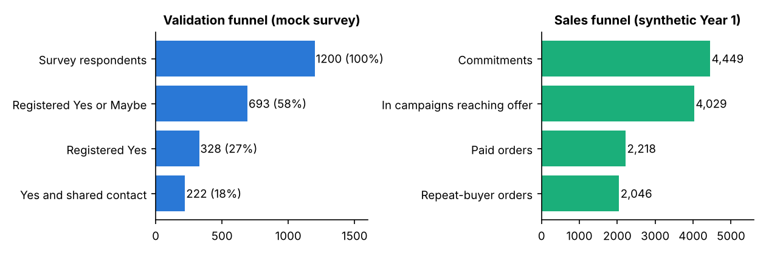
Figure 1. Validation and sales funnels
What it shows. Of 1,200 respondents, 693 (58%) said Yes or Maybe to the pilot, 328 (27%) said Yes, and 222 (19%) also shared contact details. In the simulated sales funnel, 4,449 commitments became 2,218 paid orders, or 50%.
Interpretation. The largest loss occurs between general interest and a firm yes. Sharing contact details is a stronger signal than a stated intention, so 222 is the realistic lead pool. It comfortably exceeds the deck's 30-commitment pilot target. The 50% paid share meets the deck's target only under simulated assumptions.
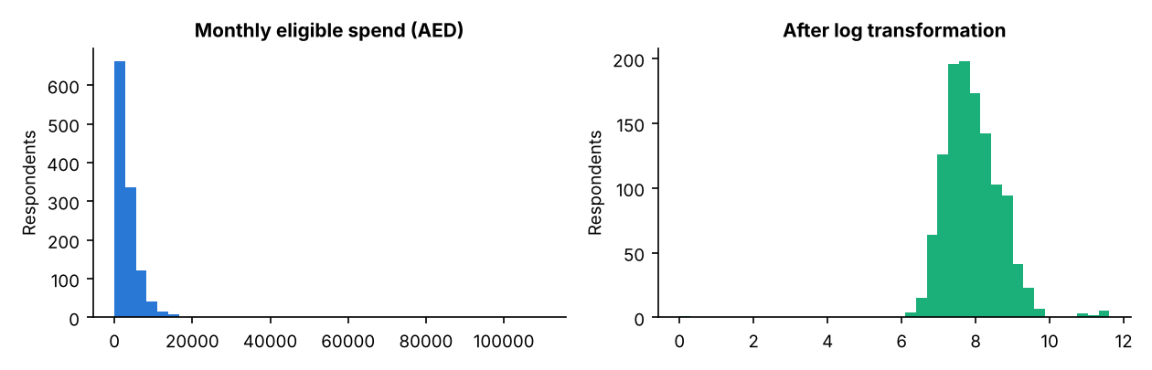
Figure 2. Monthly eligible spend before and after log transformation
What it shows. Raw spend is extremely right-skewed (skewness 10.09), with most buyers compressed at the left. After log transformation, skewness is -0.05 and the distribution is nearly symmetrical.
Interpretation. The transformation justifies the preparation step: without it, a few very large buyers would dominate distance-based methods and linear measures.
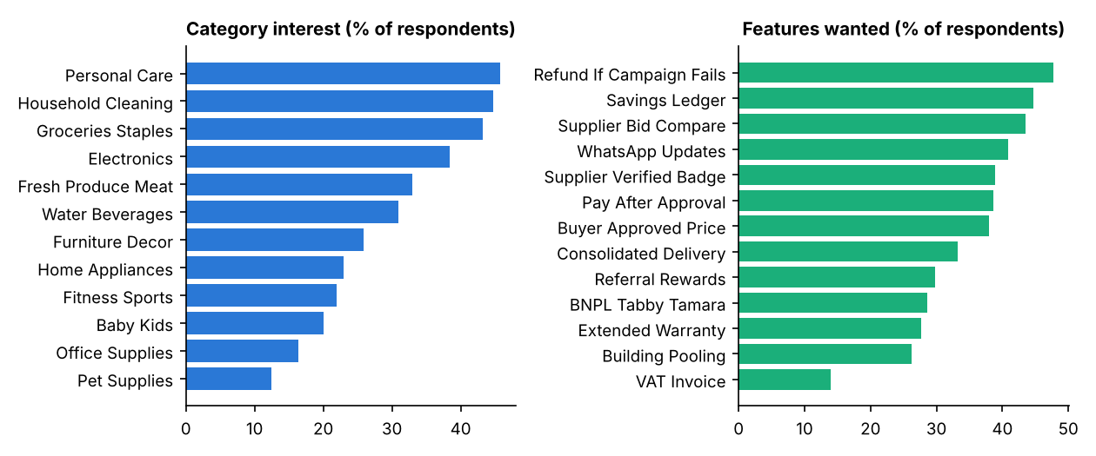
Figure 3. Category interest and desired platform features
What it shows. Personal care (45.8%), household cleaning (44.8%) and groceries (43.2%) lead category interest, whereas office supplies (16.3%) and pet supplies (12.5%) are niche. Refund if a campaign fails (47.7%), savings ledger (44.8%) and supplier bid comparison (43.5%) are the most wanted features.
Interpretation. The first campaigns should use frequently bought household goods. The top features all reduce uncertainty, which supports the deck's view that trust is a central risk.
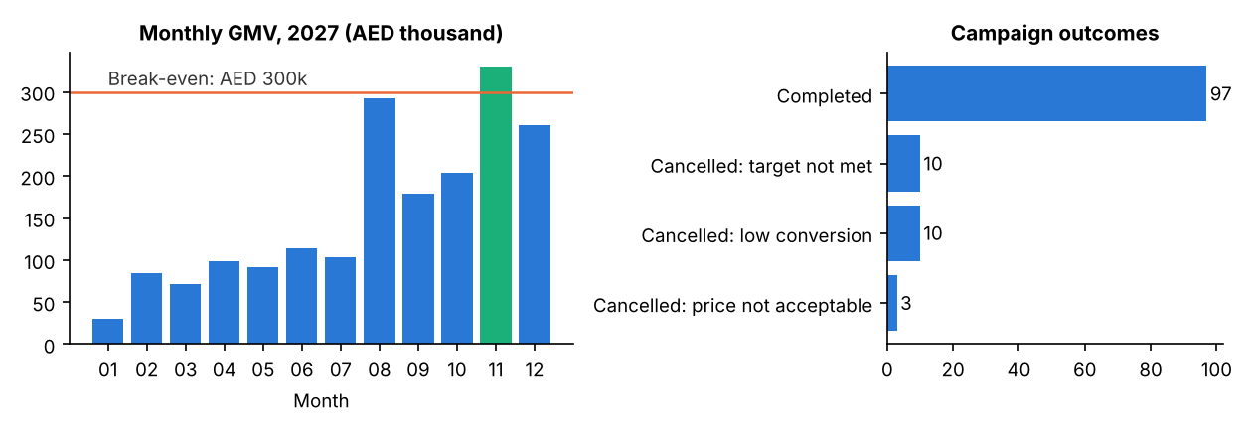
Figure 4. Monthly GMV against break-even, and campaign outcomes
What it shows. Simulated GMV totals AED 1.86M, climbing from AED 30,669 in January to a peak of AED 330,320 in November. Only November clears the AED 300,000 break-even line (AED 15,000 ÷ 5% contribution). Of 120 campaigns, 97 completed, 10 missed target, 10 had low conversion and 3 had an unacceptable price.
Interpretation. Commission of AED 130,331 less variable cost of AED 37,238 leaves AED 93,094, which is AED 86,906 short of annual fixed costs. This reveals a tension in the deck: its break-even implies AED 3.6M annual GMV, but its Year 1 forecast is AED 1.2M.

5. Diagnostic analytics: why it happens
Spearman rank correlation was used because many variables are 1 to 5 ratings and spend is skewed. Correlation shows association only, not cause.
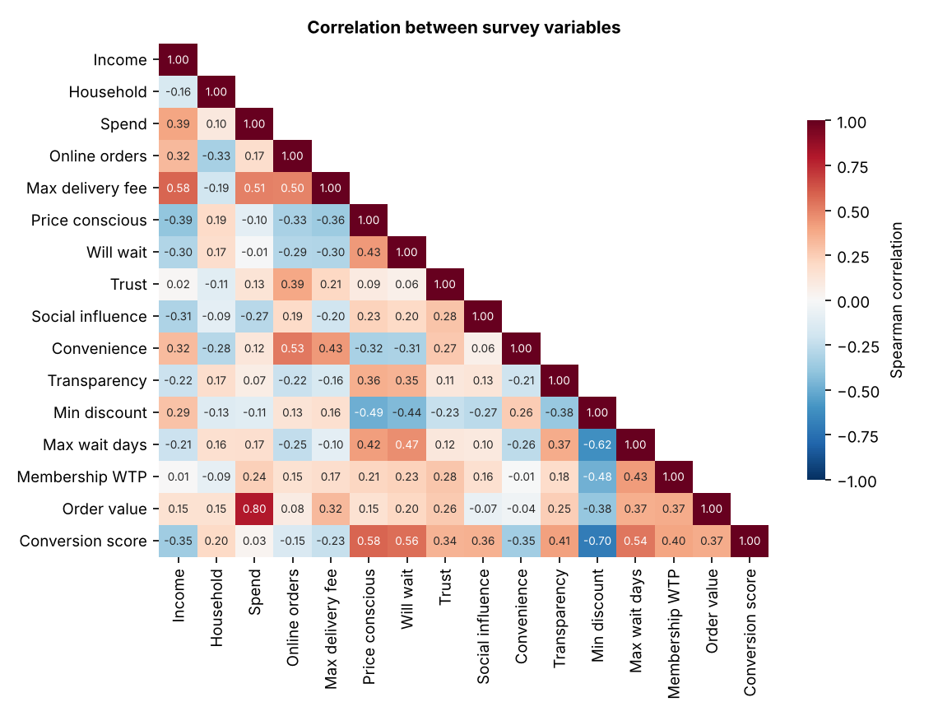
Figure 5. Spearman correlation matrix of survey variables
What it shows. Strongest pairs: spend and order value (0.80), minimum discount and conversion score (-0.70), and minimum discount and maximum wait days (-0.62). Income relates positively to the delivery fee buyers accept (0.58). Online orders relate to convenience priority (0.53).
Interpretation. Two groups emerge. Bargain-oriented buyers accept smaller discounts and longer waits. Affluent, convenience-oriented buyers order often, tolerate delivery fees and want a larger incentive to change. GroupBuy's slow, pooled model naturally suits the first group.
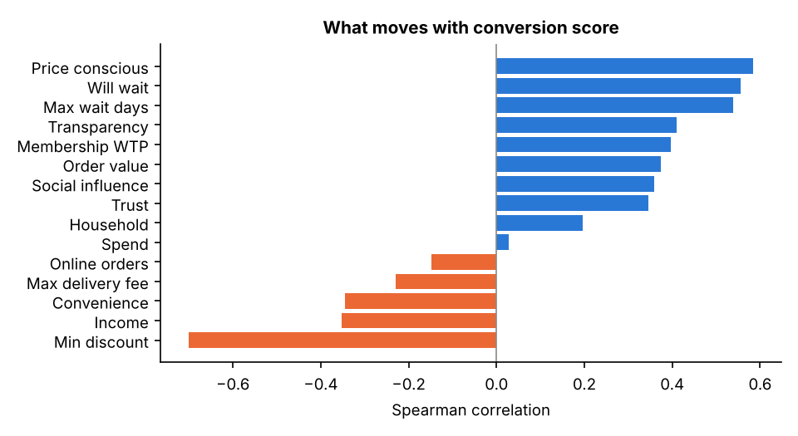
Figure 6. Variables most associated with conversion score
What it shows. Conversion score falls as the required minimum discount (-0.70), income (-0.35) and convenience priority (-0.35) rise. It rises with price consciousness (0.58), willingness to wait (0.56), maximum wait days (0.54) and transparency (0.41). Spend has almost no relationship (0.03).
Interpretation. Attitude predicts conversion better than purchasing power. Targeting high spenders alone would be a mistake. Marketing should screen for price sensitivity and patience.
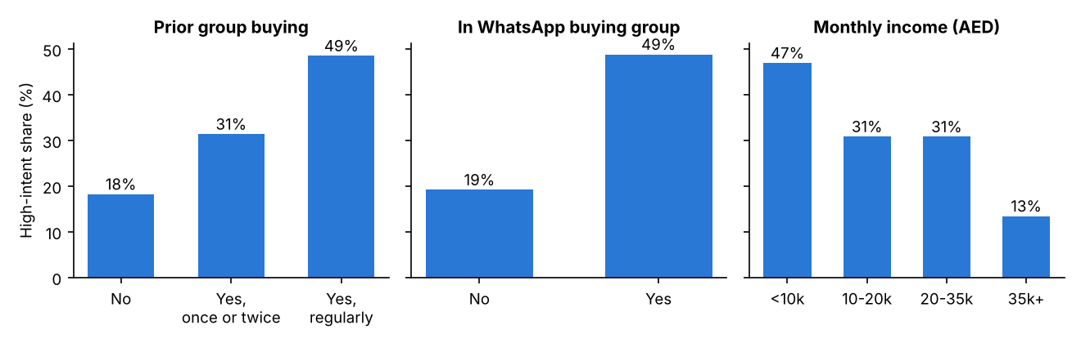
Figure 7. High-intent share by experience, community and income
What it shows. High-intent share climbs from 18% for those with no group-buying experience to 49% for regular users. WhatsApp buying group members reach 49%, against 19% for non-members. Income shows a reverse pattern, from 47% below AED 10,000 to 13% above AED 35,000.
Interpretation. Existing WhatsApp groups are an efficient starting channel, consistent with the deck's manual WhatsApp pilot. The lowest income band has only 98 respondents, so its figure is less stable.
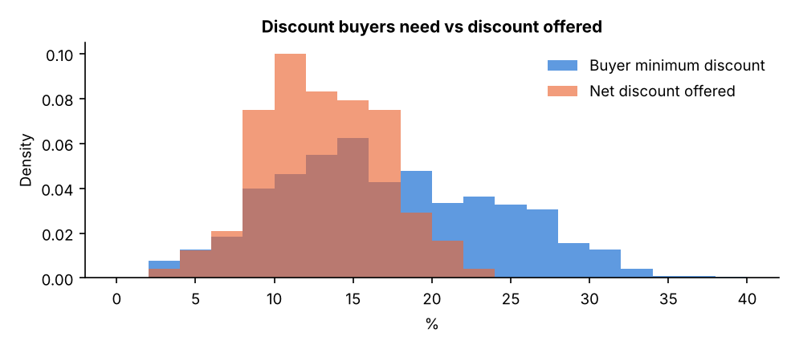
Figure 8. Discount buyers require compared with net discount offered
What it shows. The median buyer needs 16%, but the median simulated net discount is 13.0%. Only 30.5% of respondents would accept the median offer on price alone.
Interpretation. This diagnoses the deck's "savings disappear in delivery" risk. Campaigns need larger pooled volume, better supplier terms or lower delivery cost before the headline offer is competitive.
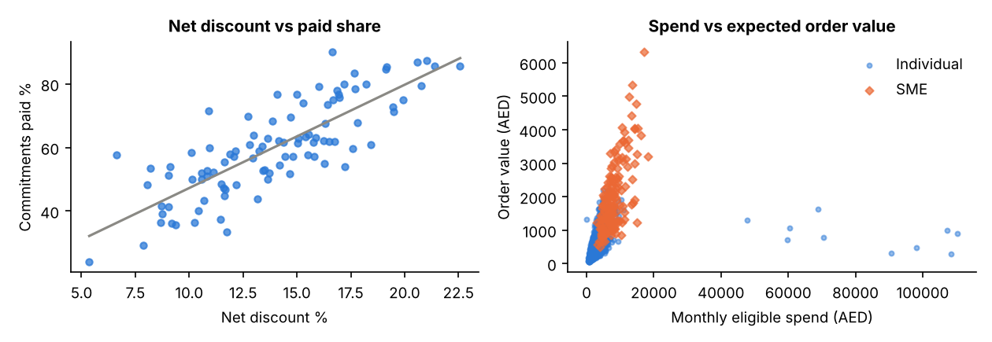
Figure 9. Net discount against paid share, and spend against order value
What it shows. Across 97 completed campaigns, net discount and paid share correlate at 0.81. Paid share rises from 42% below a 10% discount to 75% at 16% or more, about 3.25 percentage points for each discount point. In the right panel, order value rises with spend for individuals (0.73) and SMEs (0.60). Median SME order value is AED 1,750, against AED 430 for individuals.
Interpretation. The left panel partly reflects a rule built into the simulation, so it confirms the pipeline logic instead of proving real price response. A real pilot should measure this slope. The right panel supports separate campaign tracks and forecasts for SMEs.

Why campaigns failed
Target-not-met campaigns averaged 61% of target quantity and a 10.7% net discount. Low-conversion campaigns reached 88% of target but offered 9.5%. Completed campaigns averaged 161% of target and 13.9%. Failure therefore has two separate causes: too little demand, or enough commitments but an offer too weak to convert them.

6. Analytics techniques: rationale and results
Each technique was chosen for a specific business decision. All predictive models exclude the intent answers and conversion score, because the score is almost exactly a weighted sum of those answers (R² about 0.99). Using them would give impressive but meaningless accuracy.
Technique | Why this technique | Input | Business output
K-Means clustering | No segment labels exist; groups similar buyers | 13 scaled behaviours | Target segments
Classification | The outcome is yes or no: high intent or not | 52 non-intent fields | Lead priority
Apriori | Finds items that occur together in baskets | 12 categories, 13 features | Bundles and offers
Regression | The outcome is a number in AED | 17 non-intent fields | Campaign size

6.1 Clustering
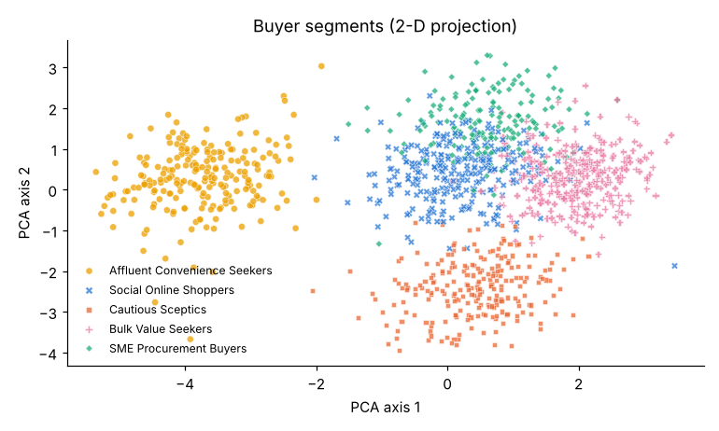
Figure 10. K-Means buyer segments, shown in two dimensions
Five clusters were selected because k=5 is the elbow and a local silhouette peak. Two clusters scored higher (0.296 against 0.237) but only separated affluent buyers from everyone else. The five segments differ sharply in intent, although intent was not used to create them: Bulk Value Seekers 59%, SME Procurement Buyers 45%, Social Online Shoppers 22%, Cautious Sceptics 4% and Affluent Convenience Seekers 4%. SME buyers have a median expected order of AED 1,720.

6.2 Classification
Test-set model | Accuracy | Precision | Recall | F1
Always majority (baseline) | 72.3% | 0% | 0% | 0.000
Logistic Regression | 81.3% | 63.1% | 78.3% | 0.699
Decision Tree | 75.7% | 54.3% | 75.9% | 0.633
Random Forest (selected) | 77.7% | 56.6% | 83.1% | 0.673

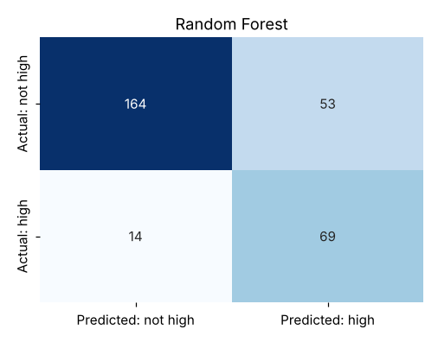
Figure 11. Confusion matrix for the selected Random Forest
On 300 test leads, 69 true positives are high-intent leads correctly called. The 164 true negatives are correctly left in low-cost nurture. The 53 false positives are wasted calls, and the 14 false negatives are missed buyers. Accuracy alone would mislead, because a model that predicts nobody reaches 72.3% and finds no customers. In cold start a missed buyer costs more than a wasted message, so recall is the priority.

6.3 Association rule mining
If a buyer wants | They also want | Support | Confidence | Lift
Baby + Groceries | Fresh produce and meat | 11.2% | 87% | 2.64
Baby | Fresh produce + Groceries | 11.2% | 56% | 2.72
Building pooling + WhatsApp updates | Consolidated delivery | 11.4% | 86% | 2.59
Buyer-approved price + Pay after approval | Refund if campaign fails | 14.2% | 89% | 1.87

Support is how common the combination is, confidence is how reliable the rule is, and lift shows how much stronger it is than chance. These rules support family bundles on one delivery run, a packaged building campaign, and a joint trust guarantee.

6.4 Regression
Test-set model | MAE (AED) | MSE | RMSE (AED) | R²
Mean baseline | 452 | 405,529 | 637 | -0.00
Multiple Linear Regression | 322 | 214,297 | 463 | 0.47
Linear Regression (log target) | 298 | 215,942 | 465 | 0.47
Random Forest Regressor (selected) | 225 | 117,008 | 342 | 0.71

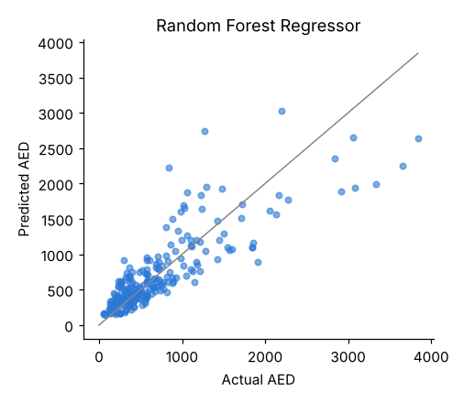
Figure 12. Actual and predicted expected order value
The closer points are to the diagonal, the better the prediction. Eligible spend is the main driver. Mean error is AED 164 for individuals but AED 609 for SMEs, so SME demand needs separate planning.

7. Are the results right, and are they meaningful?
A good score on one split is not proof. Each technique was therefore tested again across repeated samples.
Technique | Test | Result
Classification | 5-fold cross-validation, 3 repeats | Random Forest F1 0.673 (SD 0.043), ROC-AUC 0.867; Logistic Regression F1 0.667
Classification | Labels shuffled to detect leakage | ROC-AUC 0.49, about the same as guessing
Regression | 5-fold cross-validation, 3 repeats | Random Forest R² 0.738 (SD 0.030), MAE AED 224; Linear R² 0.529
Clustering | Refit on 30 random 80% samples | Adjusted Rand Index 0.990: segments are stable
Apriori | Mined on two separate halves | 62 of 65 half-A rules also appear in half B; lift correlation 0.95

Random Forest and Logistic Regression are effectively tied on F1, given the variation between folds. A founder might reasonably prefer Logistic Regression because it is simpler to explain. The shuffled-label test falling to chance indicates that the pipeline is not leaking the answer. These tests show that the methods are internally sound; they cannot show that mock answers match real buyers.
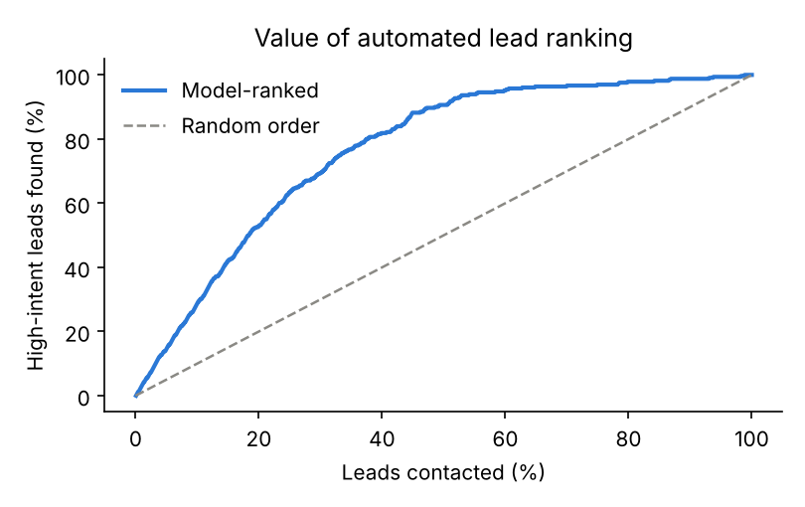
Figure 13. Share of high-intent leads found by model-ranked and random contact order
Is the automation useful? Yes, within this dataset. If GroupBuy can contact only 20% of its 1,200 leads, ranking by model score finds 175 high-intent leads, compared with about 66 in random order, or 2.6 times as many. At 50% it finds 91% of them.
Campaign planning. For 1,000 simulated 40-buyer campaigns, the regression forecast has a median error of 5.3% of campaign value, about half the 10.6% error from using the overall average. That makes target quantities sent to suppliers more dependable.
Technique | Decision | Automation
Clustering | Which segment gets which offer | Assign each sign-up to a segment message flow
Classification | Who the founders call first | Route score to call list or WhatsApp nurture
Apriori | What to bundle | Suggest the highest-lift open campaign at commitment
Regression | How much demand to promise | Calculate suggested target quantity

8. Streamlit dashboard
The same data and model outputs feed an 11-section Streamlit dashboard covering performance, customers, correlation, all four techniques, validation and recommendations. The screenshots below are actual captures of the running application.
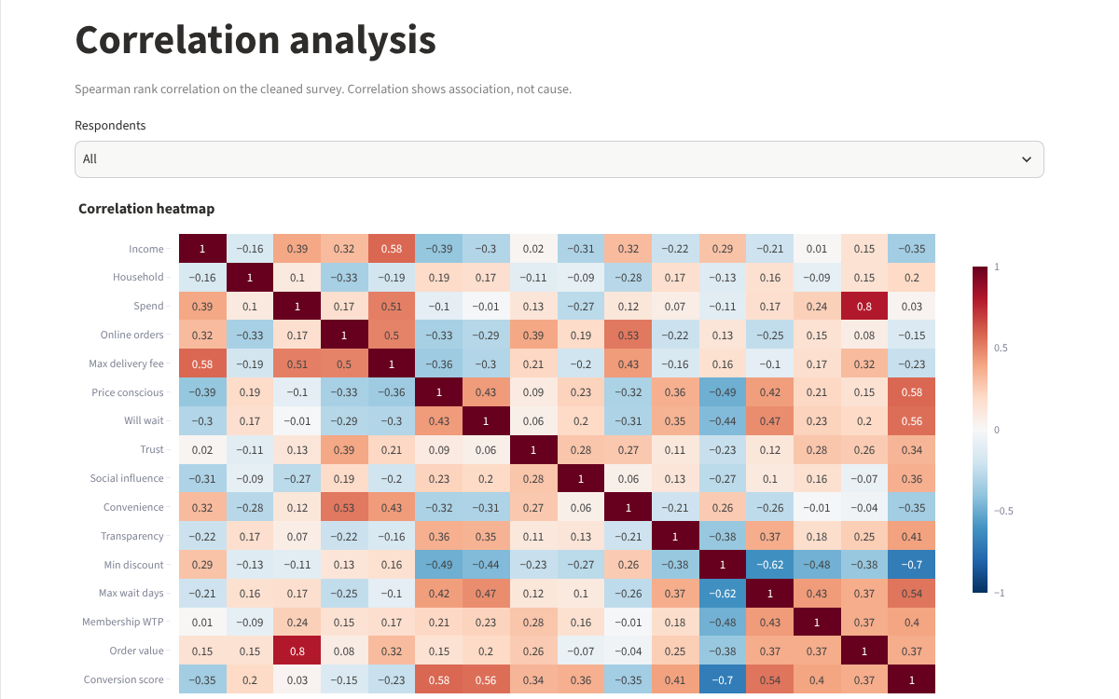
Figure 14. Streamlit dashboard: correlation analysis
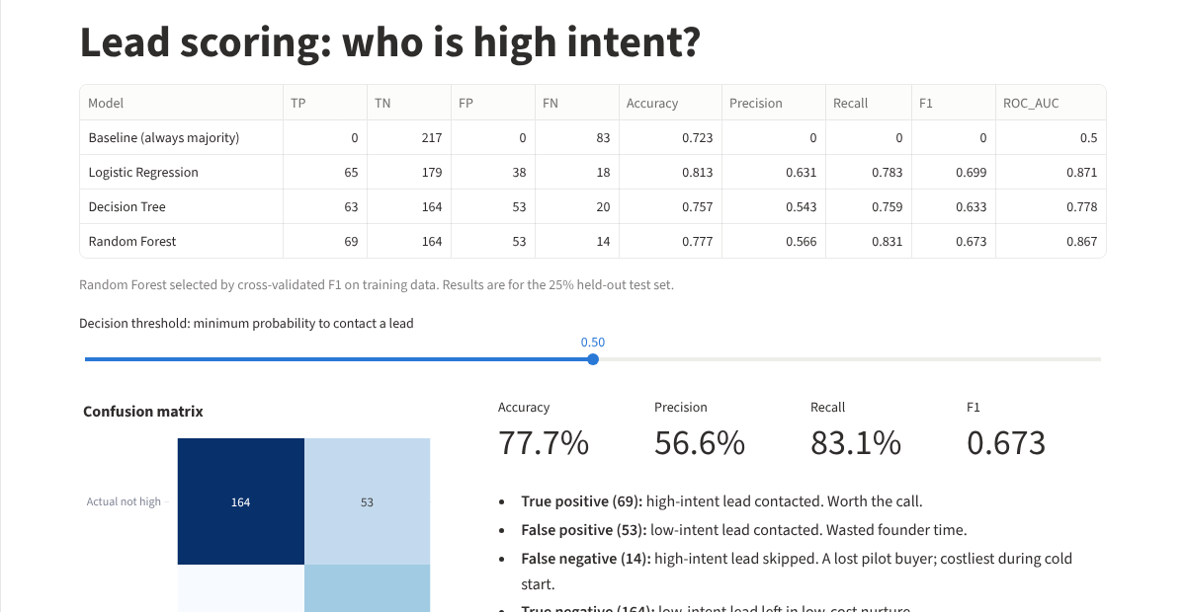
Figure 15. Streamlit dashboard: classification with adjustable threshold
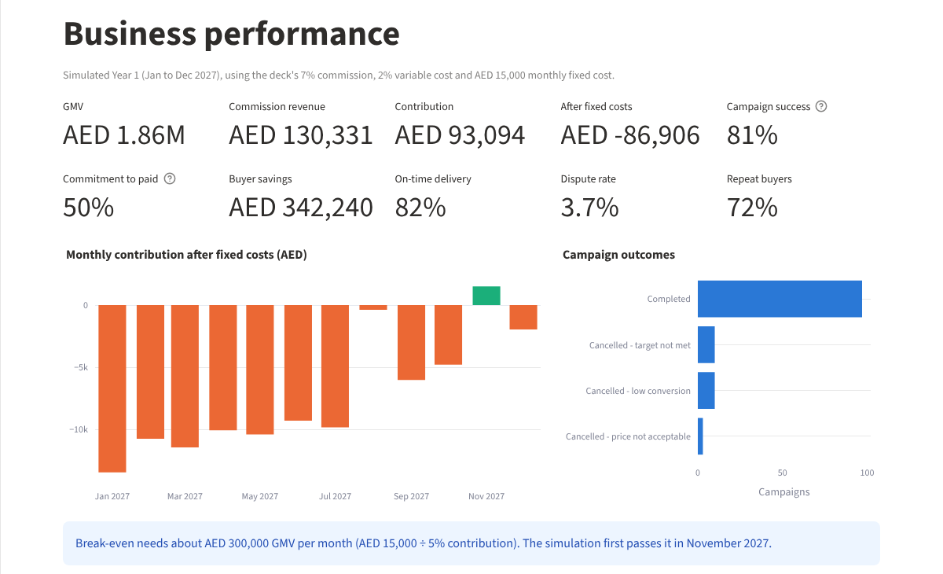
Figure 16. Streamlit dashboard: simulated business performance

9. Recommended strategy and conclusion
Strategy element | Evidence | Formulated decision
Target market | Bulk Value Seekers 59% high intent; WhatsApp members 49% vs 19% | Launch with price-sensitive buyers through existing WhatsApp groups
Product | Household, personal care and groceries lead interest | Start with staples; add family bundles
SME track | Median order AED 1,720, largest simulated GMV segment | Run a separate procurement track
Pricing | Median need 16%; median simulated offer 13.0% | Do not launch offers that fall well short; pool more or cut delivery cost
Trust | Refund guarantee is the top feature at 47.7% | Lead with refund, approval and savings ledger
Economics | Break-even AED 300,000 GMV monthly; simulated loss AED 86,906 | Revisit Year 1 plan, volume or fixed costs

The analysis supports a pipeline with explicit gates. Thresholds come from the deck, the survey or the simulation, and should be confirmed in the pilot.
Gate | Proceed when | If not
Lead qualification | Pilot Yes and contact shared | Move to low-cost WhatsApp nurture
Demand | Pledges at least 70% of target | Revise or cancel, with terms disclosed
Offer | Net discount at least 5%; aim for 16% | Seek more bids or consolidate delivery
Conversion | At least 50% of eligible commitments paid | Review discount and campaign duration
Fulfilment | On-time delivery improves on the simulated 82%; disputes stay low | Replace or re-verify the supplier
Scale | Monthly GMV near AED 300,000, with repeat purchases | Modify or stop, as the deck's Day 90 review states

The analysis suggests GroupBuy should launch with price-sensitive, patient buyers already in WhatsApp groups, focusing on household staples with a visible refund guarantee. It should treat SMEs as a separate high-value track, and close the gap between its typical offer and the 16% discount buyers want. Its Year 1 financial plan needs revisiting.
The main limitation is the data. Survey answers are mock and operating records are synthetic, so patterns partly reflect assumptions. The results finalize how to validate the business; they do not prove that the business is valid. The next step is to replace the simulated tables with real data from the 90-day pilot and rerun the same analysis.
[Your reflection] In your own words: which graph changed your view of GroupBuy most, and what did you learn about cleaning data or interpreting correlation?

