BarCode Demo

Barcode image
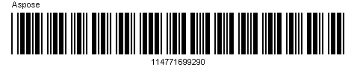

Barcode properties
Symbology Type | Code39Standard
Code Text | 114771699290
Supplement Data | 77272
Rotation Angle | 0

