1. K-means Clustering
Definition:
K-means clustering is an unsupervised machine-learning algorithm that divides data into K groups (clusters) based on similarity.
How it works:
Data points
↓
Choose K
↓
Place K centroids
↓
Assign each point to nearest centroid
↓
Move centroids to cluster centers
↓
Repeat until clusters stabilize
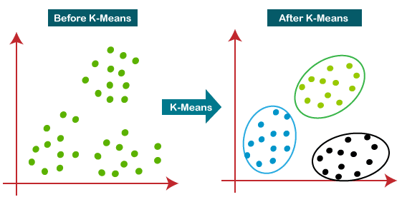
Usage:
- Customer segmentation
- Grouping similar patients
- Image segmentation
- Market research
- Finding patterns in datasets
Key point:
K-means = group similar observations without using predefined labels.

2. Cross-validation
Definition: Cross-validation is a technique used to evaluate how well a machine-learning model will perform on new, unseen data.
The most common method is K-fold cross-validation.
Graphic example: For 5-fold cross-validation:
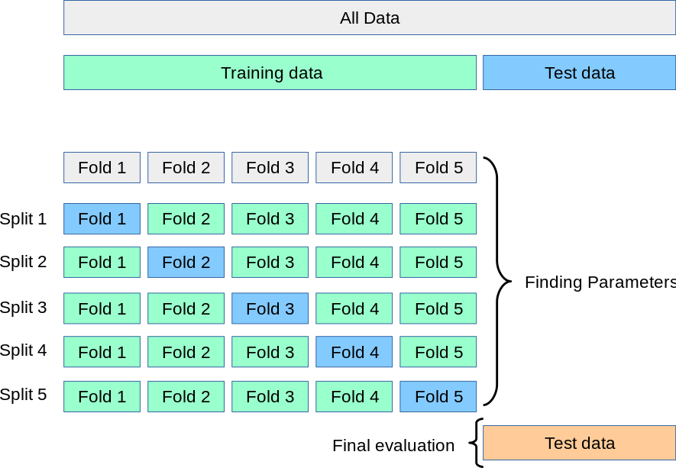
The model is trained and tested 5 times.
Accuracy:
Round 1 → 82%
Round 2 → 86%
Round 3 → 84%
Round 4 → 88%
Round 5 → 85%
Average = 85%
Usage:
- Comparing machine-learning models
- Selecting the best model
- Detecting overfitting
- Choosing hyperparameters
- Getting a more reliable estimate of model performance
Key point:
Cross-validation = test the model several times using different portions of the data.
3. Confusion Matrix
Definition:
A confusion matrix is a table used to evaluate a classification model by comparing actual classes with predicted classes.
Binary classification
Where:
- TP (True Positive): Correctly predicted positive
- TN (True Negative): Correctly predicted negative
- FP (False Positive): Predicted positive but actually negative
- FN (False Negative): Predicted negative but actually positive
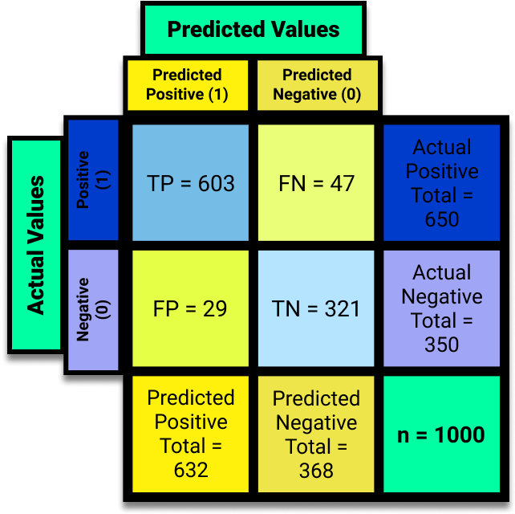
Visual interpretation:
Prediction
Correct Wrong

Positive TP FN
Negative TN FP
Usage:
- Classification model evaluation
- Medical diagnosis
- Fraud detection
- Spam detection
- Disease prediction
- Survival prediction
Key point:
Confusion matrix = shows exactly where a classification model is correct and where it makes mistakes.
4. Sensitivity and Specificity
Sensitivity
Definition:
Sensitivity measures how well a model identifies actual positive cases.
Sensitivity =
True Positives
────────────────────────
True Positives + False Negatives
Think:
Of all people who actually have the disease, how many did the model detect?
Example:
100 sick patients
↓
90 correctly detected
10 missed
Sensitivity = 90%
Specificity
Definition:
Specificity measures how well a model identifies actual negative cases.
Specificity =
True Negatives
────────────────────────
True Negatives + False Positives
Think:
Of all people who are actually healthy, how many did the model correctly identify as healthy?
Example:
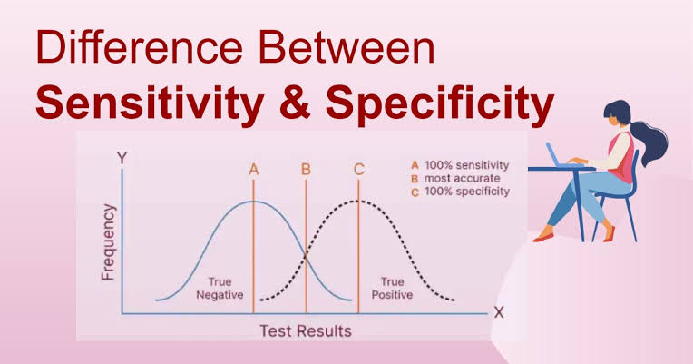
100 healthy people
↓
95 correctly identified
5 incorrectly classified as sick
Specificity = 95%

Easy memory trick:
Sensitivity → Sick detected
Specificity → Healthy detected

5. Bias–Variance
Definition:
Bias and variance describe two major sources of prediction error in machine-learning models.
Bias
Bias = model is too simple.
The model makes strong assumptions and misses important patterns.
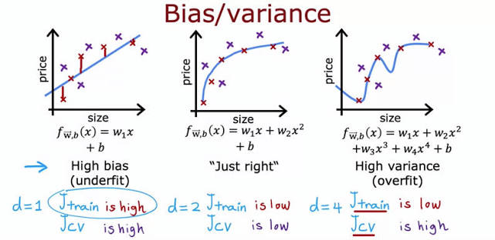
Example:
Actual data:

• •
• •
•
• •
• •

High-bias model:

──────────────
The model is underfitting.
Variance
Variance = model is too sensitive to the training data.
It learns noise instead of the general pattern.
Actual data:

• •
• •
•
• •

High-variance model:

╱╲
╱ ╲___
╱ ╲╱
The model is overfitting.
The goal
High Bias High Variance
Underfitting Overfitting
↓ ↓
Too simple Too complex

↓
Balanced model
↓
Good generalization
Usage:
- Choosing model complexity
- Diagnosing underfitting
- Diagnosing overfitting
- Improving model performance
Key point:
Bias = too simple. Variance = too sensitive.
$$Var\left(X\right)=E\left(X^{2}\right)-{\left[E\left(X\right)\right]}^{2}$$
$$Var\left(X\right)={\left(\text{1.4}\right)}^{2}=\text{1.96}$$
$$σ$$
$$σ$$
μ-σ+σVar(X) ≈ 1.96
Give feedback

6. Entropy
Definition:
Entropy measures impurity or uncertainty in a dataset.
It is commonly used in decision trees to decide the best split.
Example 1: Pure group
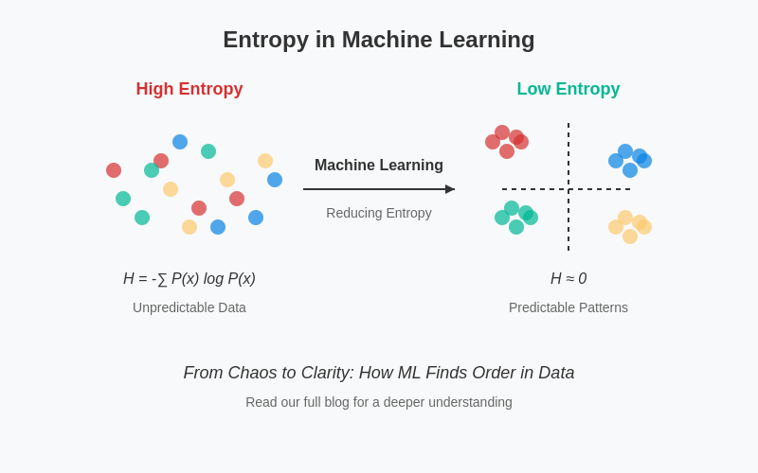
10 passengers

Survived: 10
Died: 0

🟢 🟢 🟢 🟢 🟢
🟢 🟢 🟢 🟢 🟢

Entropy = 0
There is no uncertainty.
Example 2: Mixed group
10 passengers

Survived: 5
Died: 5

🟢 🔴 🟢 🔴 🟢
🔴 🟢 🔴 🟢 🔴

High entropy
There is high uncertainty.
Pure group Mixed group

🟢 🟢 🟢 🟢 🟢 🔴 🟢 🔴
🟢 🟢 🟢 🟢 🔴 🟢 🔴 🟢

Low entropy High entropy
Usage:
- Decision trees
- Selecting the best data split
- Measuring class impurity
- Classification problems
Key point:
Low entropy = more pure. High entropy = more mixed/uncertain.

7. Linear Regression
Definition:
Linear regression is a supervised machine-learning/statistical method used to predict a continuous numerical value from one predictor.
The basic equation is:
ŷ = b₀ + b₁x
Where:
- ŷ = predicted value
- b₀ = intercept
- b₁ = slope
- x = predictor
$$\hat{y}=b_{0}+b_{1}x$$
$$\hat{y}=8.49-0.54x$$
R² = 0.72 · b₀ = intercept · b₁ = slope · least squares minimizes squared vertical residual gaps.
Focus
DataLinePredictionsResiduals
DataLinePredictionsResiduals
Drag a point to refit the line.
246810246810
Give feedback
Example
Suppose we want to predict house price from house size.
Price
↑
| •
| •
| •
| •
| •
| •
+----------------------→ Size
The regression line finds the best-fitting straight line:
Price
↑
| •
| • /
| • /
| • /
| • /
| • /
+----------------------→ Size
Example:
House size = 2,000 sq ft

Predicted price = $250,000
Usage:
- Predicting prices
- Predicting yield
- Predicting income
- Predicting temperature
- Studying relationships between variables
Key point:
Linear regression = predict a continuous outcome using one predictor.

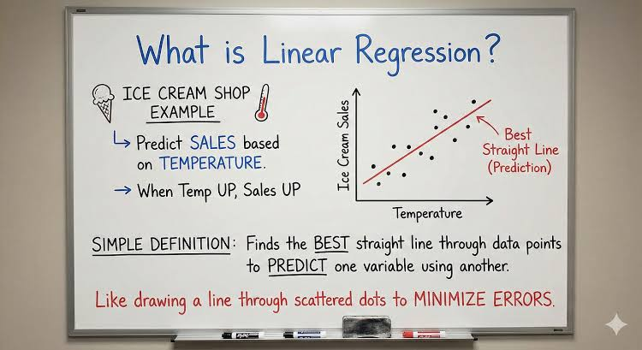

8. Multiple Regression
Definition:
Multiple regression predicts one continuous outcome using two or more predictor variables.
The general equation is:
ŷ = b₀ + b₁x₁ + b₂x₂ + b₃x₃ + ...
Example
Predicting crop yield using:
- Fertilizer
- Rainfall
- Temperature
- Plant density
Fertilizer
│
↓
Rainfall ───────→ CROP YIELD ←────── Temperature
↑
│
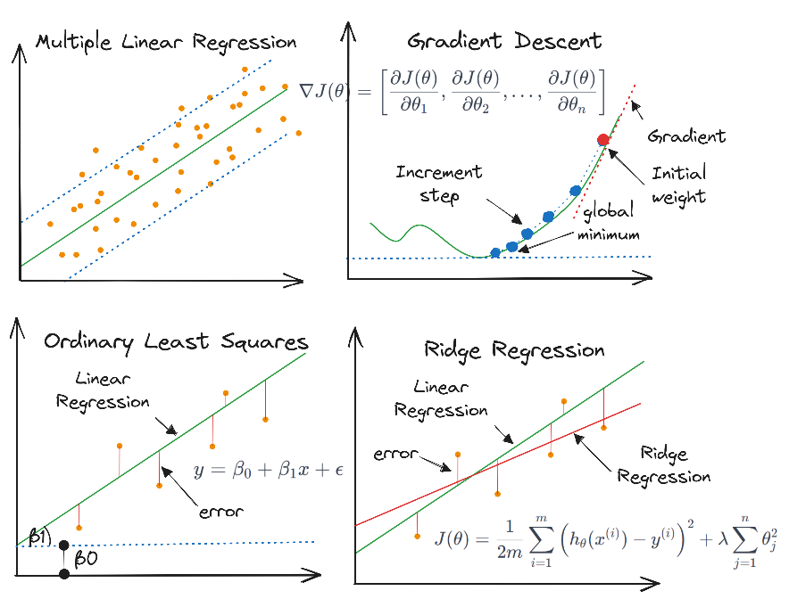
Plant density
Instead of:
Yield ← Fertilizer
we use:
Yield ← Fertilizer
+ Rainfall
+ Temperature
+ Plant density
Example equation
Yield = 1.5
+ 0.8(Fertilizer)
+ 0.3(Rainfall)
- 0.2(Temperature)
Usage:
- Predicting crop yield
- Predicting house prices
- Economic forecasting
- Agricultural experiments
- Identifying effects of multiple factors
Key difference:
Method | Number of predictors | Example
Linear regression | 1 | Yield ← Fertilizer
Multiple regression | 2 or more | Yield ← Fertilizer + Rainfall + Temperature
Easy memory:
Linear regression = one X → Y
Multiple regression = many Xs → one

