Operating System Concepts
OS File System Simulator
Assignment 4: File System Simulation

Course Code | CS313
Course Title | Operating System Concepts
Instructor | Ms. Naveen Ahmed
University | Abasyn University
Semester | Spring 2026
Prepared For | Assignment 4 only
Hosted Website | os-file-system-simulator-assignment.vercel.app
GitHub Repository | babarnaeem0001/os-file-system-simulator-assignment-4

Team Members
Member | Student ID | Simulator Role
Hamid Saleem | 9061 | Process P-9061
Babar Naeem | 8963 | Process P-8963
Muhammad Sabeel Khan | 8926 | Process P-8926
Abdul Sami | 8929 | Process P-8929

PROJECT
Executive Overview
Submission Summary
The project is a production-deployed Next.js application that simulates file system operations, allocation strategies, disk performance, process file access, synchronization, and deadlock recovery for Assignment 4.

The simulator focuses on the file system component of the operating system project. It gives users a dashboard where files can be created, read, written, deleted, allocated on a simulated disk, accessed by processes, and used to demonstrate shared-resource conflicts.
- A 48-block simulated disk is used, with each block representing 4 KB.
- Files can be allocated through contiguous, linked, or indexed allocation.
- The frontend posts each operation to a Vercel route handler at /api/filesystem.
- The backend returns the next simulation state, including disk blocks, locks, wait queues, metrics, and deadlock cycles.
- The application is deployed through a GitHub-connected Vercel production project.
ASSIGNMENT 4
Requirement Coverage
Requirement | Status | Evidence
File creation, deletion, reading, writing | Implemented | CRUD controls and route-backed actions.
Contiguous allocation | Implemented | Finds a free run and stores adjacent data blocks.
Linked allocation | Implemented | Places data blocks flexibly and models traversal cost.
Indexed allocation | Implemented | Allocates an index block plus data blocks.
File system interface for processes | Implemented | Each operation is issued by one of the four team processes.
Disk usage and fragmentation metrics | Implemented | Calculates used blocks, free runs, largest run, and fragmentation.
File access times | Implemented | Estimates time based on allocation method, block count, mode, and fragmentation.
Shared-file conflict and deadlock | Implemented | Read/write locks, wait-for graph cycles, and recovery button.

IMPLEMENTATION
Architecture
The application uses a stateless serverless backend pattern. The client sends the current state and a typed action to the route handler. The backend executes the simulation logic and returns a new state. This makes the app easy to host on Vercel because no external database is required.
Frontend | React client component dashboard with Tailwind CSS and lucide-react icons.
Backend | Next.js route handler: GET/POST /api/filesystem.
Simulation Core | TypeScript engine in src/lib/filesystem.ts.
Deployment | GitHub repository connected to Vercel production hosting.
Domain | https://os-file-system-simulator-assignment.vercel.app

ALGORITHMS
File Allocation Algorithms
- Contiguous allocation searches for a consecutive run of free blocks large enough to store the file. It is fast for sequential access but can fail when free space is fragmented.
- Linked allocation selects available blocks without requiring adjacency. It reduces allocation failure caused by fragmentation, but access time increases because blocks must be traversed in sequence.
- Indexed allocation reserves one index block and stores pointers to all data blocks. It gives direct lookup behavior while consuming one extra block for the index structure.
Performance Metrics
The simulator calculates disk usage, free block count, number of free runs, largest free run, fragmentation percentage, average access time, active locks, and waiting requests after every operation.

CONCURRENCY
Synchronization and Deadlock
Every file access request is issued by a process. Read locks can be shared, while write locks require exclusive access. When a request cannot be granted, it enters the waiting queue and records the process that is blocking it.
- Active locks store the file, mode, holder process, and tick when the lock was acquired.
- Waiting requests form a wait-for graph between blocked processes and lock holders.
- A cycle in the wait-for graph is reported as a deadlock.
- Deadlock recovery preempts one process, releases its locks, and retries waiting requests.
Demonstrated Scenario
Hamid Saleem holds a write lock on ledger.db while Babar Naeem holds a write lock on shared.cfg. Each then requests the other's file, creating a two-process deadlock that the app detects and resolves.

DESIGN
User Interface Design
The interface follows the provided local design guidance: top-bar navigation, a clean dashboard layout, purple as the primary accent, glass-like panels, soft shadows, compact cards, and clear hierarchy. The UI avoids a sidebar and keeps the main workflow on the first screen.
- Top navigation contains Overview, Disk, Files, and Conflicts views.
- Cards and tables are used for repeated data, metrics, process records, and file records.
- Buttons include icons for create, read, write, release, compact, reset, and resolve actions.
- Forms use visible labels, keyboard focus states, and accessible contrast.
EVIDENCE
Deployment and Verification
GitHub Repo | View repository
Production URL | Open hosted site
Vercel Target | Production
Deployment Status | Ready
API Verification | GET /api/filesystem returned HTTP 200.
Browser Verification | No console errors, no Next.js overlay, hosted pages loaded successfully.
Build Verification | npm run lint and npm run build completed successfully.
Log Check | Vercel error logs showed no errors for the last hour after deployment.

HOSTED SCREENSHOT
Hosted Dashboard
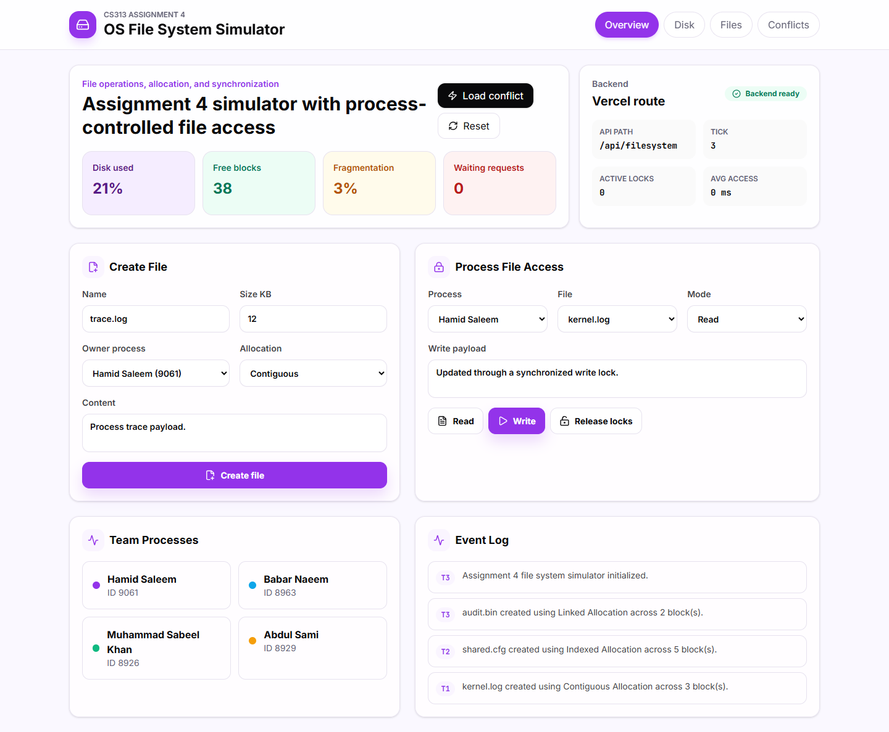
Figure 1: Production overview page showing file operations, process access, metrics, and backend status.

HOSTED SCREENSHOT
Disk Allocation View
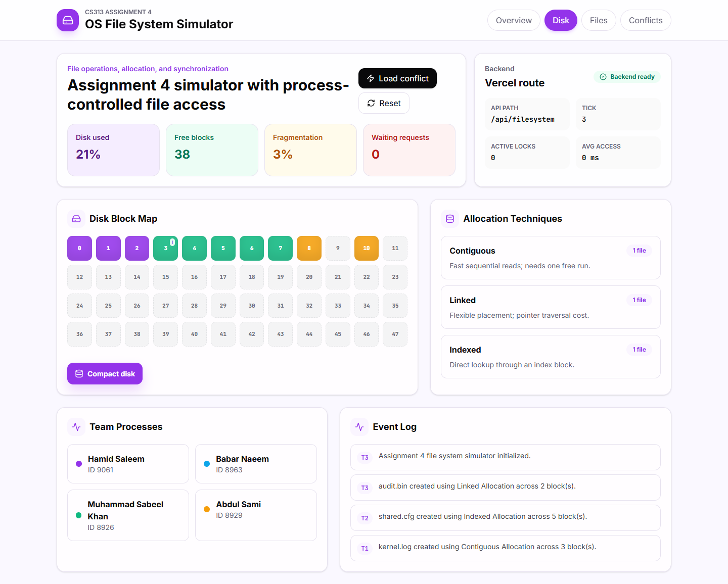
Figure 2: Disk block map showing contiguous, linked, and indexed allocation blocks.

HOSTED SCREENSHOT
Deadlock Detection View
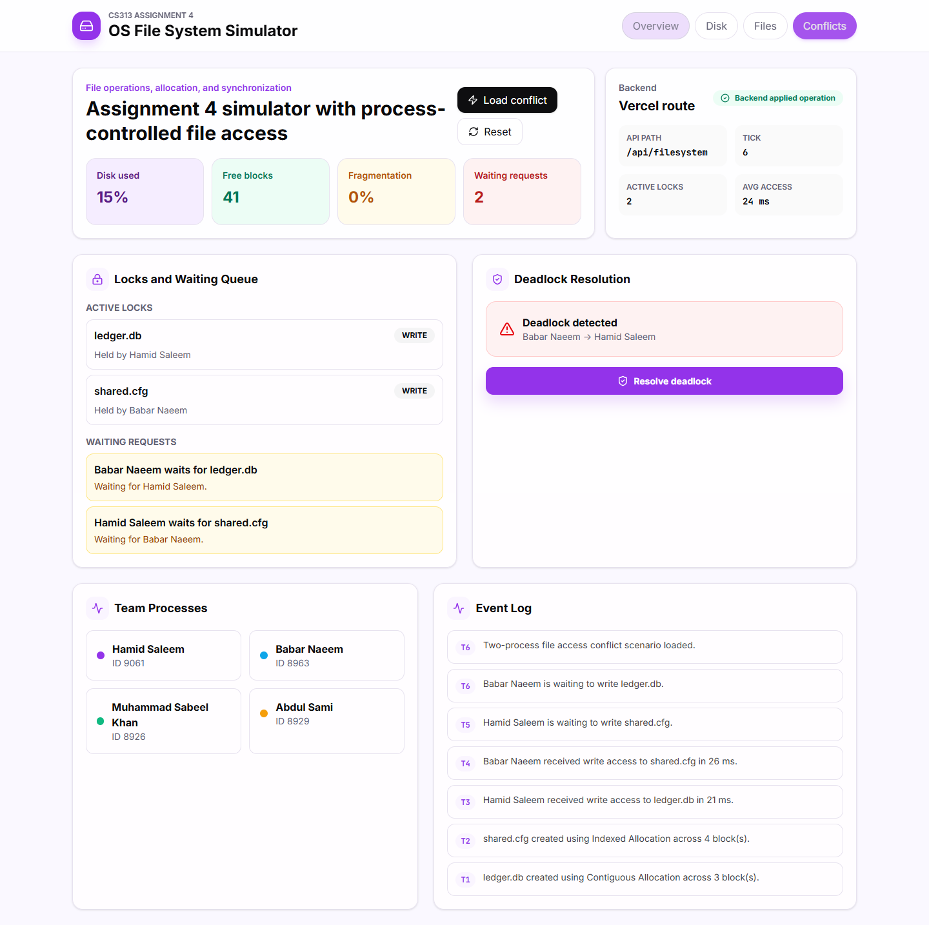
Figure 3: Hosted conflict scenario with active locks, waiting queue, and detected deadlock cycle.

HOSTED SCREENSHOT
Mobile Layout
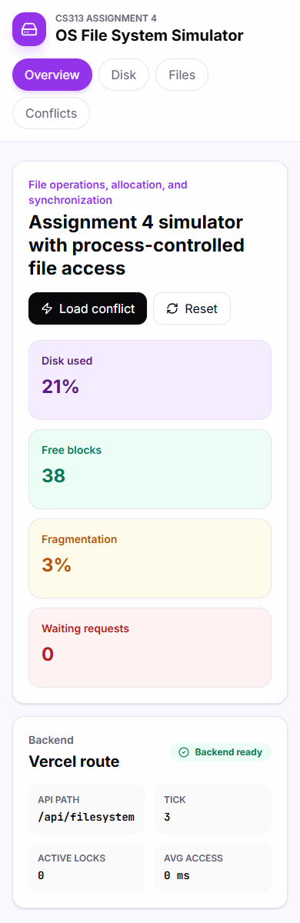
Figure 4: Responsive mobile viewport of the deployed simulator.
RESULT
Conclusion
The Assignment 4 file system simulation is complete, deployed, and verified. It demonstrates file operations, allocation schemes, disk performance tracking, process file access, synchronization, and deadlock handling in one cohesive dashboard.

