**BABASAHEB PINJAR** 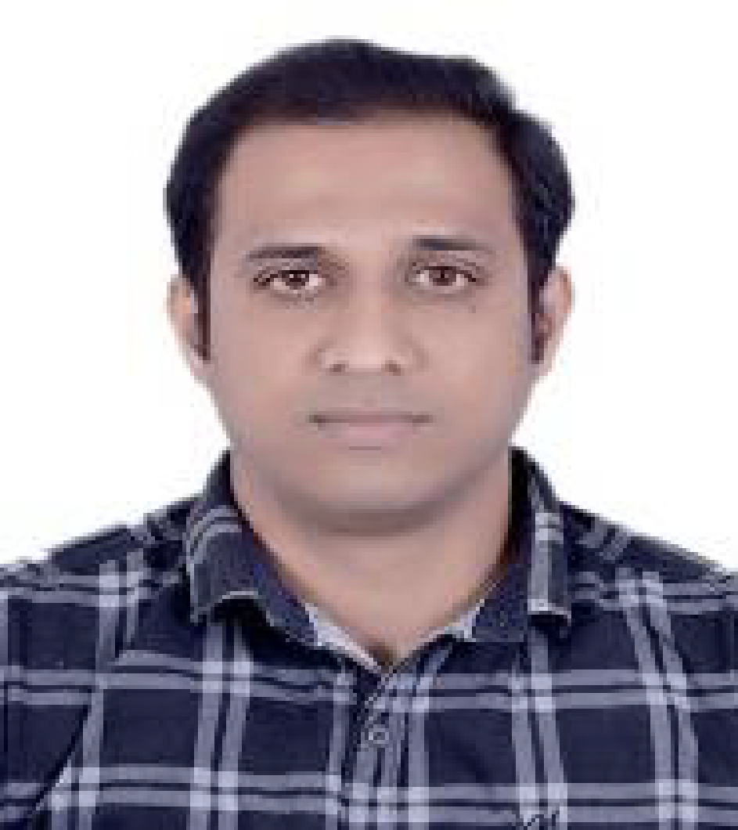

Email: [babasahebpinjar@gmail.com](mailto:babasahebpinjar@gmail.com)

Phone: +91-9945625785

*Results-driven Software professional with a demonstrated ability to deliver valuable insights via data analytics and advanced data-driven methods.*

**EXPERIENCE SUMMARY:**

* A Software Professional with 11.6years of qualitative experience in Software/Application Development with highly technology-driven organizations
* Possess strong analytical, problem solving and communication skills.
* Experience of working at client location in Europe and California R&D centre
* Possess US : B1/B2, Canada : Work Permit Visa

**EXPERTISE:**

* Machine Learning Algorithms, Data Mining Algorithms, Deep Learning Frameworks
* Visualization Tools: Tableau, ELK
* Big Data Technologies: Cloudera Hadoop Distribution and Hadoop Ecosystem Data Mining and Visualization Tools
* Web Automation Frameworks: Django, REST
* Research, Reports and Forecasts
* Middleware development

**TECHNOLOGY AND PLATFORMS:**

Languages : C, C++, R, Python, ADA83, Shell scripting,SQL

Framework and libraries : QTdesigner, OpenGL, SVN, github, Makefiles, : OCAP,RASA, Twilio

Platforms : Linux, Windows.

Cloud and Infrastructure Platforms : AWS, Docker, ELK.

Debugger : gdb, Windows Debugger.

Engineering : Big Data (Hadoop, spark, PIG, HIVE)

Technologies : Blockchain

Database : SQL server

**EMPLOYMENT HISTORY:**

**CCPL Global Pvt Ltd (Senior Principal Engineer, June 2018 till date)**

Responsibilities:

* Develop solutions using advanced machine learning algorithm and predictive analytics to facilitate
  + Fraud detection in Telecom Billing Module.
  + Customer segmentation.
  + Customer affinity analysis.
  + Customer churn and retention.
  + Recommender systems for optimal Internal routes.
* Developing a tool for analysis of MasterLog of Nokia SBC.
* Developing a WhatsApp Chatbot using RASA and Twilio framework for quick reference.

**Microfocus Pvt. Ltd (Senior Software Engineer, Feb-2016 to June 2018)**

Responsibilities:

* Implementation of reporting tool for enterprise software using ELK stack.
* Security features development on Windows.
* Bug fixing raised at customer’s place.
* Deployment of Secure login tool on new customer’s environment.
* Handling issues with integrating Secure login with third party software.
* Attending customer calls to gather new requirements.

**Seachange International Pvt.Ltd (Senior Software Engineer, Sep-2012 to Jan, 2016)**

Responsibilities:

* Involved in DLNA certification for LGI set box.
* Development of Resource Management for tuners of Set top box.
* Implementation of analytical engine for logs analysis and prediction of failure.
* Integration of Log4c logging with OCAP stack.
* Middleware development for OCAP stack.
* Customer onsite visit to deploy and test new features.
* Bug fixing.

**Indian Space Research Organisation (ISRO) (Software Engineer, Nov-2010 to Jan-2016)**

Responsibilities:

* Development of a Satellite simulation model.
* Development of Test-suite for on-board software of Satellite.
* Analysis of logs generated by Satellite.
* Testing of MA-1750 compiler used for development of onboard software.
* Published a report on MA-1750 compiler.
* Development of parsers for logs generated by different satellites.
* Gathering requirements for new payloads of new satellites.

**HACKATHONS AND CONFERENCES:**

* Novell Hackathon: Automation of monitoring and decreasing the load on CPU by closing applications based on the priority using Secure login.
* Novell Hackathon: Adding analytical intelligence to Secure login to determine which enterprise applications are least used.
* Travelled to California to present a POC on Resource Manager in the R&D centre.
* Represented Sea change International in CES, Amsterdam.
* Published a testing manual of MA31750 compiler in ISRO.

**ACADEMIC DETAILS:**

* PGP in Big Data Analytics and Optimization at INSOFE, Bangalore.
* B.E in Computer Science from Gogte Institute of Technology (GIT), Belgaum.

**PERSONAL DETAILS:**

Date & Place of Birth : 20th July 1987.

Nationality : Indian

Languages known : English, Hindi and Kannada

Permanent Address : 36 Bastioni hosayallapur, Dharwad.