

Module code and name: | 7BDIN007C - Big Data Theory and Practice
Assessment: | Individual Coursework
Student ID: | 002983
Submission deadline: | 02.04.2026
Wordcount | 781
Results date and type of feedback
Result (Pass or Fail)
Feedback

Executive Summary
This individual coursework focuses on applying advanced data analytics techniques to selected questions from the group report, using Amazon PySpark for data processing and analysis. The results obtained through PySpark were converted into a Pandas DataFrame to facilitate further analysis and visualization
Selected Analytical Questions

How has the ratio of suicide deaths to total mortality evolved over time? Are there observable increase or decreasing trends?

How are suicide incidents distributed by gender, and how has the male-to-female proportion evolved over time?

Data management and data processing procedures

A new cluster was launched on Amazon EMR with JupyterHub integration, and the 'AmazonS3FullAccess' policy was attached in the IAM Roles section to enable data retrieval from the S3 bucket as in shown Figure 1

Figure 1

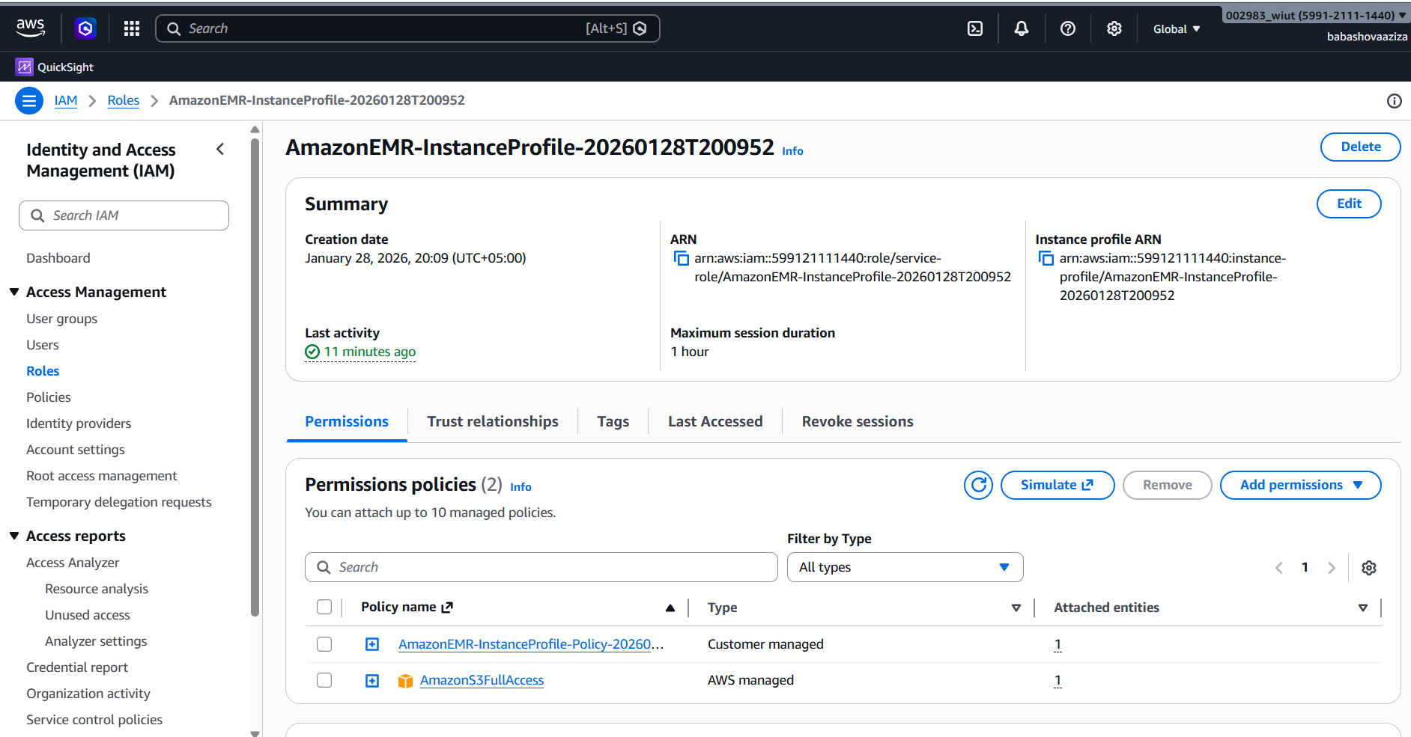

The cluster was accessed via Windows Terminal using the SSH command: ssh -i .\spark2.pem hadoop@ec2-18-219-248-240.us-east-2.compute.amazonaws.com (Figure 2)
Figure 2
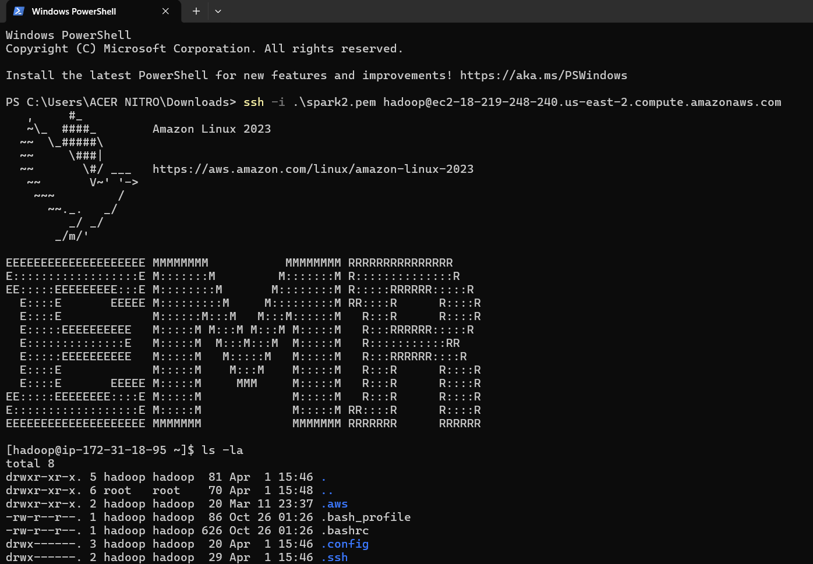

The dataset from the S3 bucket was downloaded to the EMR cluster using the following command: aws s3 cp s3://bdtp-cw-project-mortality-2026/4-final-harmonized-labelled/ ./ --recursive (Figure 3)

Figure 3
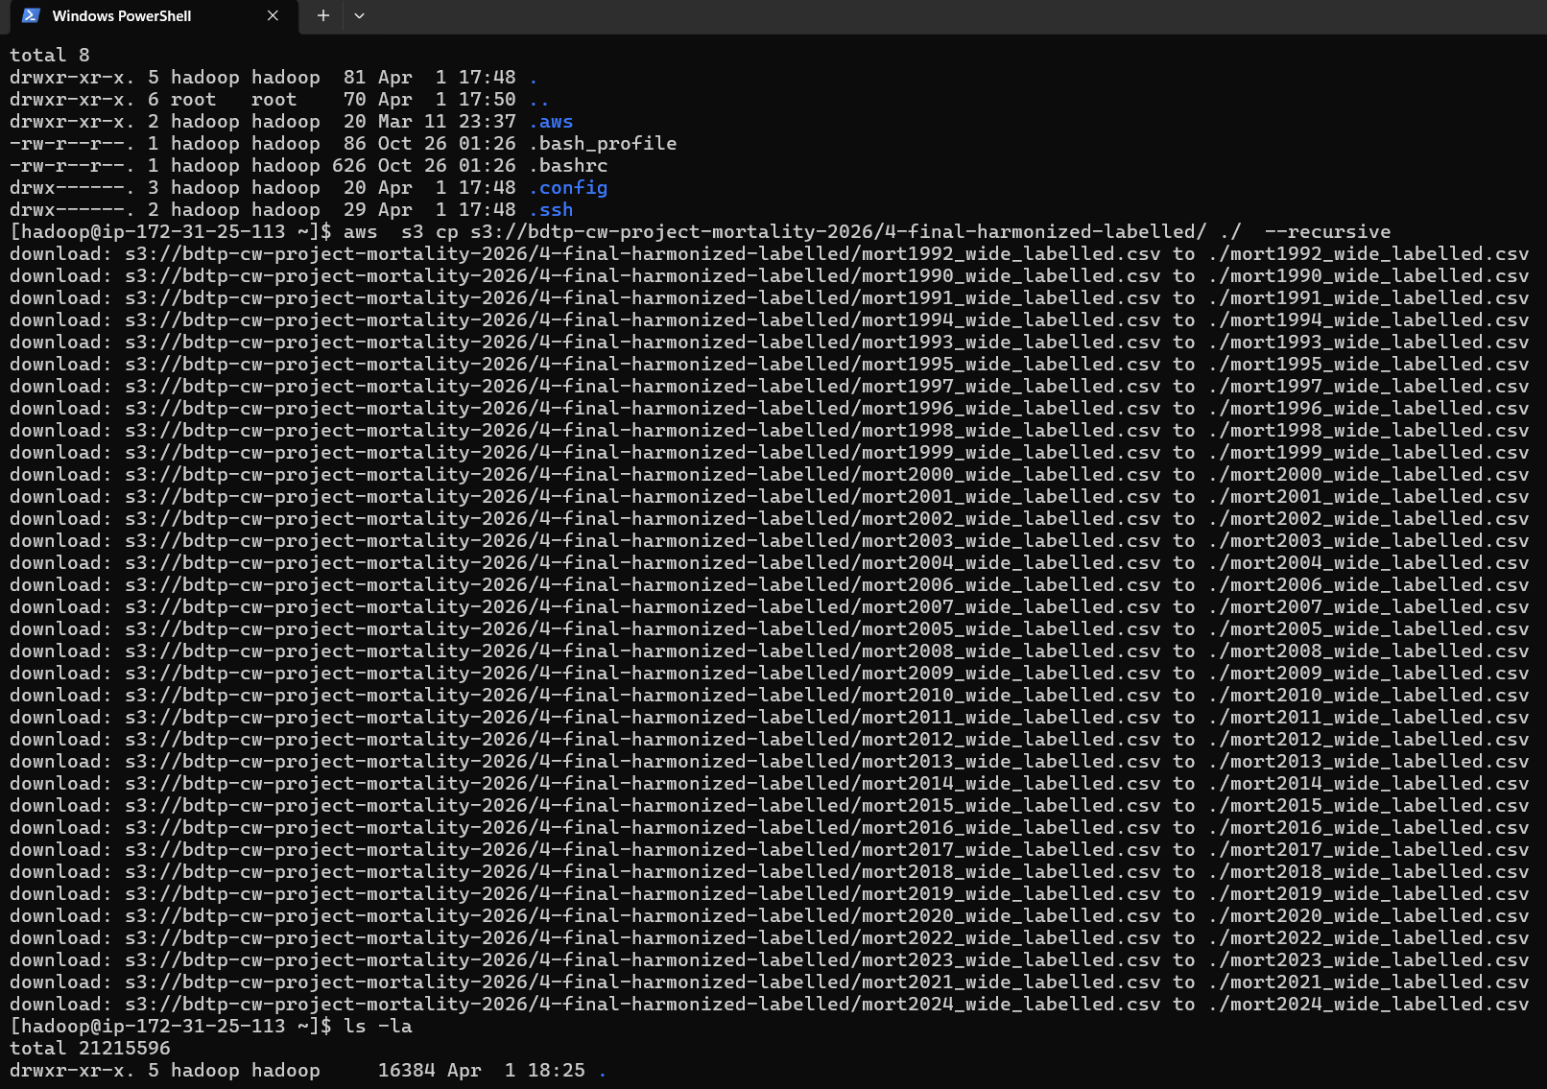

The 35 CSV files obtained from the S3 bucket were individually uploaded to Hadoop HDFS using the command hdfs dfs -put ./mort1990_wide_labelled.csv /user/hadoop/ making them available for distributed processing on the EMR cluster.(Figure 4)
Figure 4
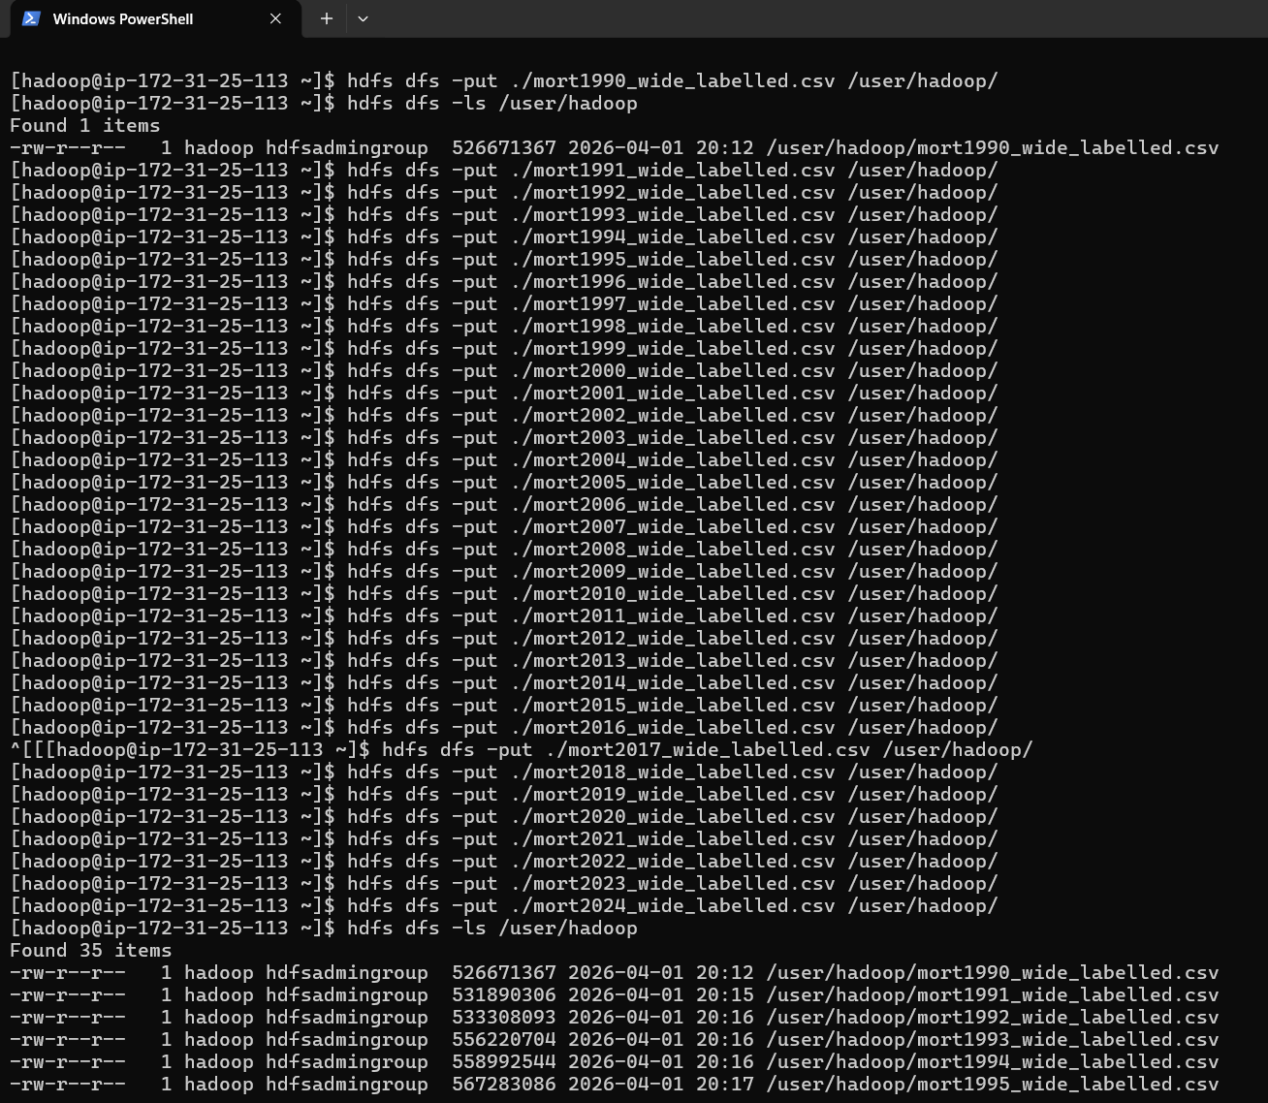

Data Analysis Using JupyterHub

Analysis of Suicide-to-Total Mortality Ratio Over Time
To answer the question “How has the ratio of suicide deaths to total mortality evolved over time? Are there observable increasing or decreasing trends?”, the following steps were carried out in JupyterHub:
- Data Preparation: Two separate DataFrames were created:
- The first DataFrame consisted of two columns: one for the year and the second for the total number of suicides in that year.
- The second DataFrame contained the year and the total number of all-cause deaths for the corresponding year.
- Data Integration: The two DataFrames were merged using an inner join on the year column to ensure that only matching years were included. on the sequence illustrated in Figures 5 and 6.
- Analysis and Visualization: The resulting merged dataset was converted into a Pandas DataFrame, and a line chart was plotted to visualize the trend of the suicide-to-total mortality ratio over time. (Figure 7)
This approach allowed clear observation of trends and facilitated the identification of any increases or decreases in the ratio across the years.

Figure 5
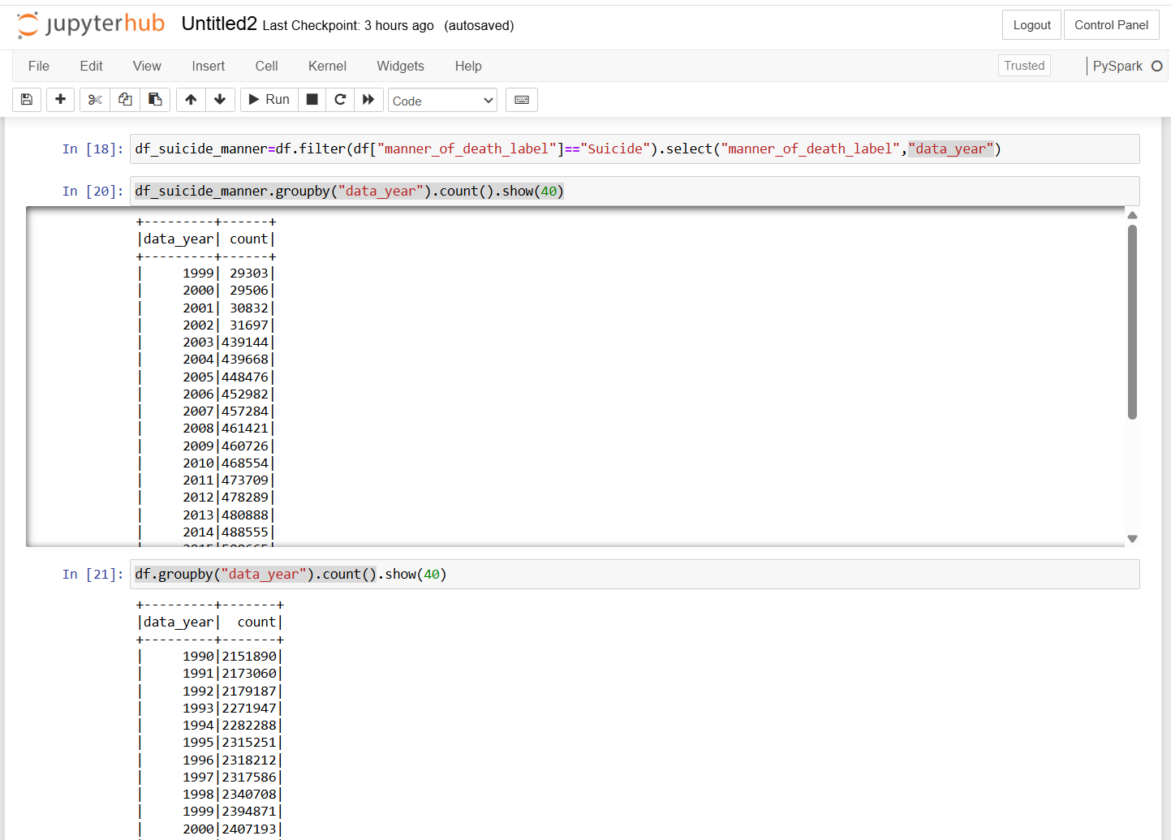

Figure 6
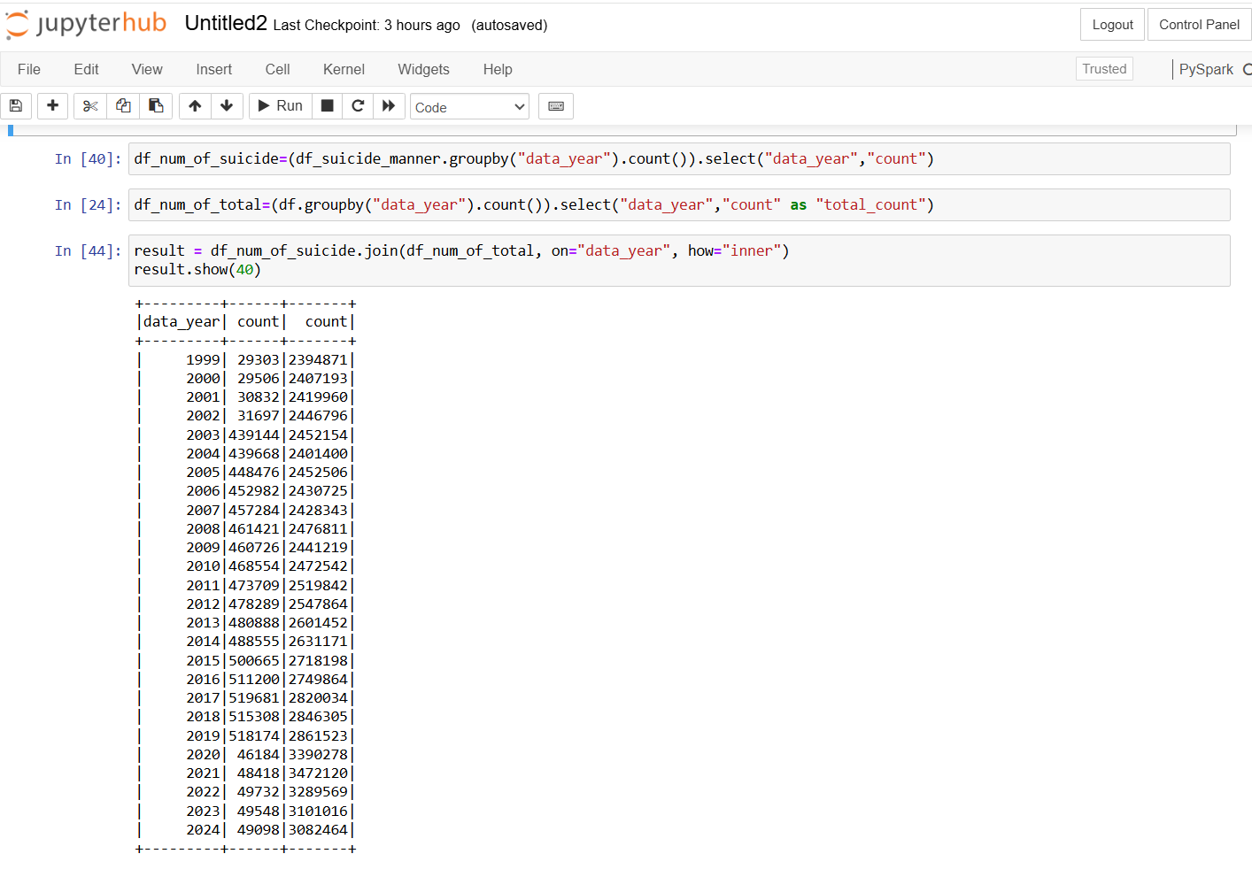
Figure 7

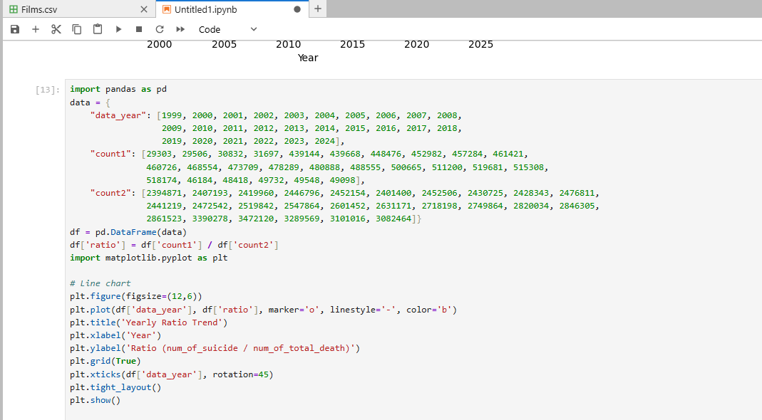

Figure 8
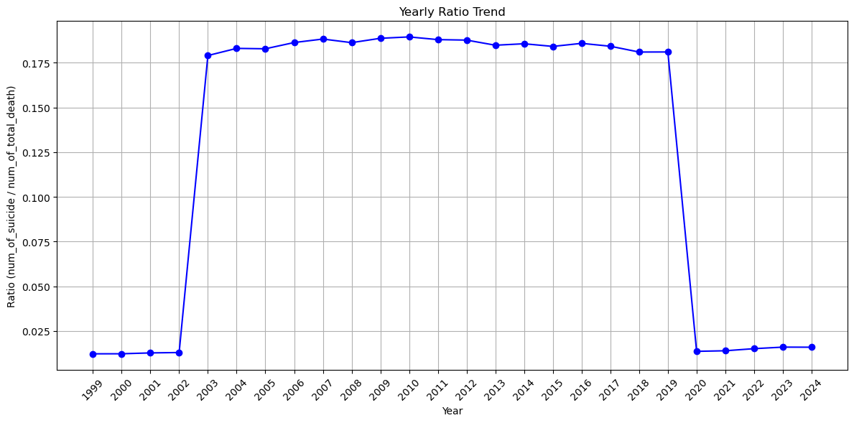

Gender Distribution of Suicide Incidents

To answer the question “How are suicide incidents distributed by gender, and how has the male-to-female proportion evolved over time?”, the following procedure was implemented:
- Data Aggregation by Gender: Initially, the total number of suicides was calculated separately for males and females for each year.
- Yearly Gender Distribution: In addition, the distribution of suicides by gender was examined for each year, allowing visualization of trends and changes in male and female suicide rates over time. (Figure 9)
- Data Analysis and Visualization: The aggregated data was converted into a Pandas DataFrame, and line charts were plotted to show both the gender-specific trends and the evolution of the male-to-female proportion across the years. (Figures 10,11,12,13)
This approach provided a clear understanding of how suicide incidents vary by gender and highlighted any increasing or decreasing patterns in the male-to-female ratio over time.
Figure 9
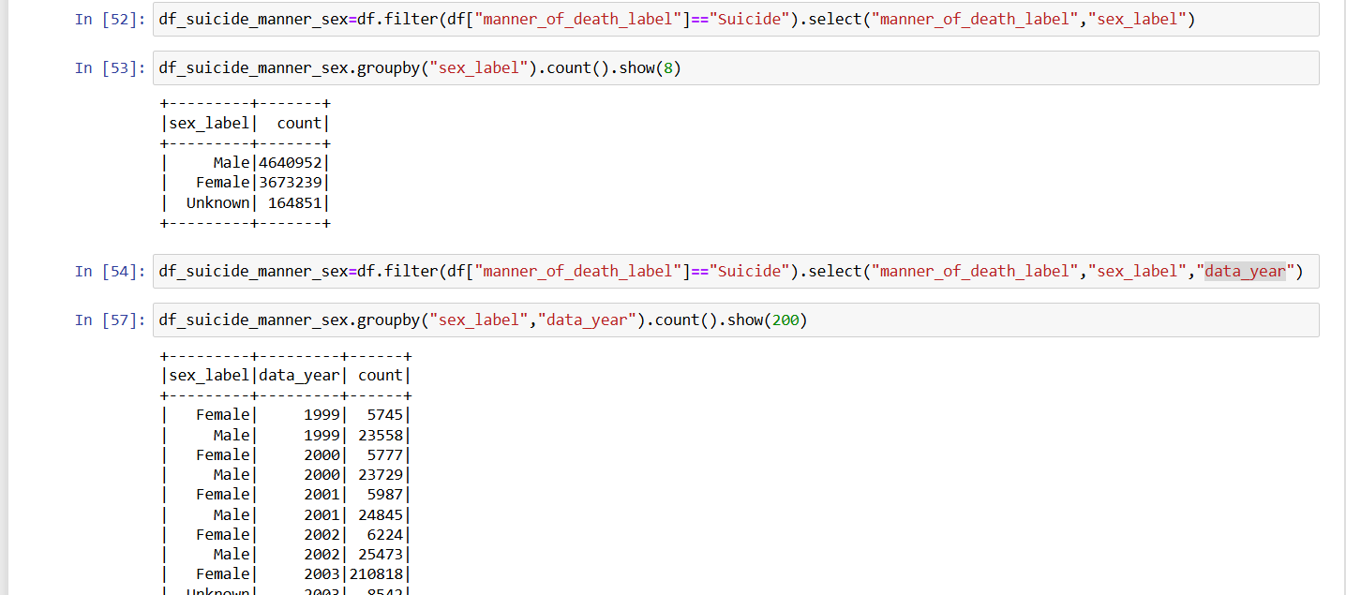

Figure 10
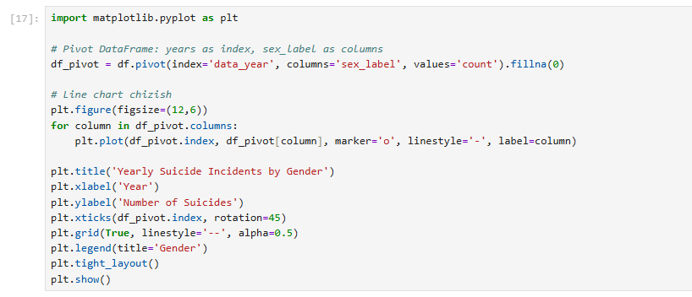
Figure 11
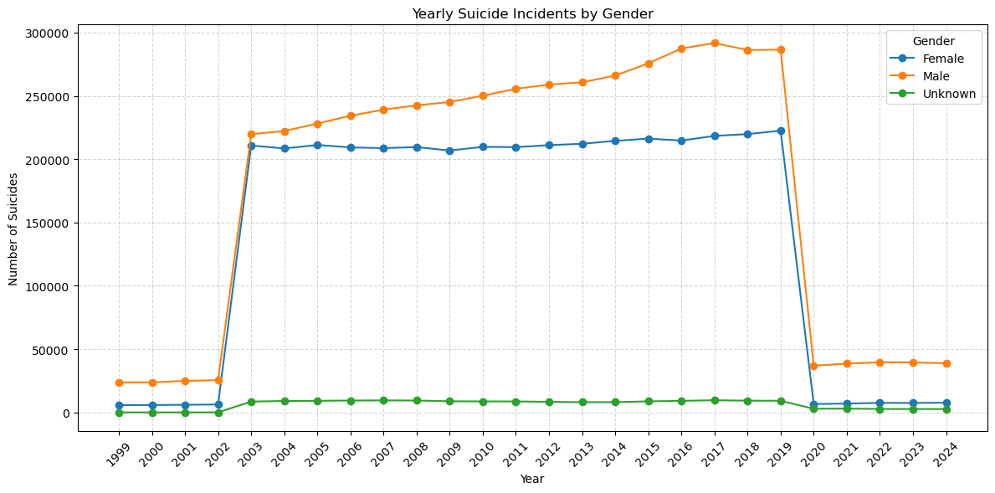

Figure 12
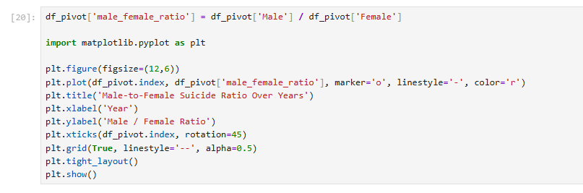

Figure 13
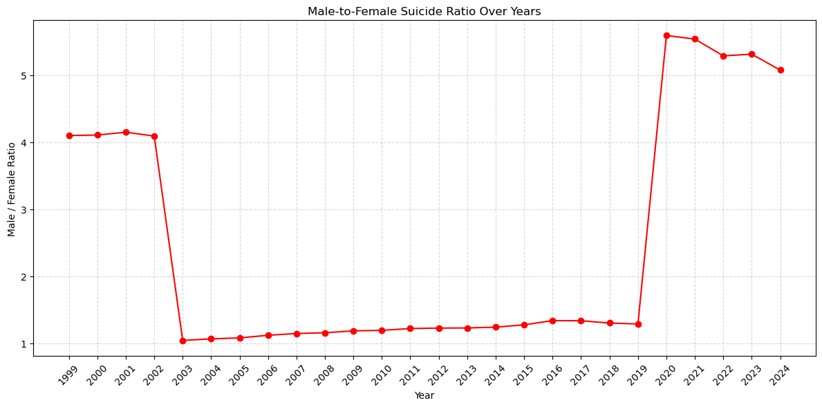
Outcomes
The analysis of suicide incidents by gender revealed several important insights:
- Gender Distribution:
- Across all years, the number of suicides among males consistently exceeded those among females.
- The Unknown category was present in some years but represented a small proportion compared to Male and Female.
- Yearly trends, visualized through line charts, clearly show that male suicides dominate the overall gender distribution.
- Male-to-Female Ratio:
- The calculated male-to-female ratio highlights that, on average, male suicides were approximately 3–4 times higher than female suicides in most years.
- The line chart of this ratio over time indicates slight fluctuations, but the overall trend shows a persistent higher risk among males.
- Trends over Time:
- While both male and female suicide numbers gradually increased over the years until around 2019, a notable decrease is observed in 2020–2024, likely reflecting data anomalies or external events.
- The male-to-female ratio remained relatively stable, demonstrating that the gender disparity in suicide incidence is consistent over time.
Conclusion:
These outcomes highlight the importance of gender-specific interventions and preventive measures. Males are at significantly higher risk, and policy or healthcare strategies should consider this persistent disparity to effectively target suicide prevention.

