**ThingWorx Installation via Docker Image**

**Prerequisites:**

Microsoft Windows 10, with image size of D-series or E-series.

Docker Versions: Docker Desktop

**Setting Up ThingWorx Docker Builds:**

Required below Files/Software under staging folders (already done):

1. Copy **jdk-8u212-linux-x64.tar.gz** to the folder **\Thingworx-DockerFile8-5-5\dockerfiles\base\staging**
2. Copy **ThingWorx-Platform-Postgres-8-5-5.zip** to the folder **\Thingworx-DockerFile8-5-5\dockerfiles\databases\postgres\staging**
3. Copy **apache-tomcat-9.0.21.tar.gz** to the folder **\Thingworx-DockerFile8-5-5\dockerfiles\platform\base\staging.**
4. Copy **ThingWorx-Platform-Postgres-8-5-5.zip** to the folder **\Thingworx-DockerFile8-5-5\dockerfiles\platform\postgres\staging**

**Building the ThingWorx Docker Images:**

1. Run Docker Desktop application.
2. Open Powershell or command prompt with Admin rights:
3. Go to : **Thingworx-DockerFile8-5-5/dockerfiles/base** then run below command to build Docker Image for JDK:

docker build --build-arg JAVA_VERSION=8u212 --build-arg JAVA_ARCHIVE=jdk-8u212-linux-x64.tar.gz -t thingworx/base:java8u212-tomcat9.0.21 -t thingworx/base:latest .

1. Go to : **Thingworx-DockerFile8-5-5/dockerfiles/platform/base** then run below command to build Docker Image for Tomcat:

docker build --build-arg TAG_VERSION=java8u212-tomcat9.0.21 --build-arg TOMCAT_VERSION=9.0.21 --build-arg TOMCAT_ARCHIVE=apache-tomcat-9.0.21.tar.gz --build-arg LICENSE_FILE=LICENSE --build-arg PLATFORM_SETTINGS_FILE=platform-settings.json --build-arg TEMPLATE_PROCESSOR_ARCHIVE=template-processor-12.1.0.13-application.tar.gz --build-arg SECURITY_TOOL_ARCHIVE=security-common-cli-1.0.2.46-application.tar.gz -t thingworx/tw-platform-base:java8u212-tomcat9.0.21 -t thingworx/tw-platform-base:latest .

1. Go to : **Thingworx-DockerFile8-5-5/dockerfiles/databases/postgres** then run below command to build Docker Image for Postgres DB:

docker build --build-arg PLATFORM_ARCHIVE=ThingWorx-Platform-Postgres-8-5-5.zip --build-arg PLATFORM_VERSION=8-5-5 -t thingworx/postgres-db:java8u212-tomcat9.0.21-platform8-5-5 -t thingworx/postgres-db:latest .

1. Go to : /**Thingworx-DockerFile8-5-5/dockerfiles/platform/postgres** then run below command to build Docker Image for Thingworx Platform:

docker build --build-arg TAG_VERSION=java8u212-tomcat9.0.21 --build-arg PLATFORM_ARCHIVE=ThingWorx-Platform-Postgres-8-5-5.zip --build-arg PLATFORM_VERSION=8-5-5 -t thingworx/platform-postgres:java8u212-tomcat9.0.21-platform8-5-5 -t thingworx/platform-postgres:latest .

1. Go to : /**Thingworx-DockerFile8-5-5** then run below command to Compose Thingworx with postgers(Create container):

docker-compose -f docker-compose-postgres.yml up -d

**Once Above step completed without any error then you will see as below on Docker desktop:**

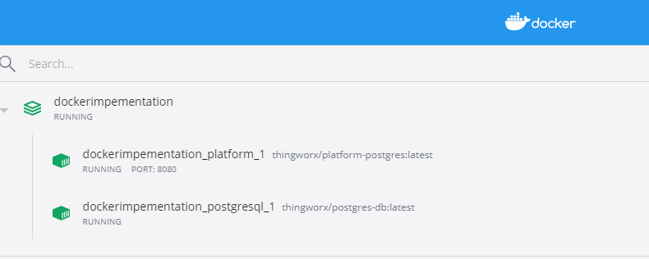

Thingworx is accessible via below URL:

<http://13.71.94.48:8080/Thingworx/Composer/index.html>

UserName : Administrator / thingworx@1234