Heuristic Analysis of the Air Cargo Problem

In the book Artificial Intelligence: A modern Approach, 3rd Edition, by Stuart J. Russell and Peter Norvig, algorithms for classical planning are discussed in Chapter 10. Several planning problems are discussed, including the air cargo problem which seeks to find the most optimal set of actions that will get cargo to the correct destination airport.

Below, the air-cargo problem is first setup by specifying the schema for each allowed action (load, unload, fly). The schema includes the pre conditions required to execute the action as well as the results of the action. Then, for three increasingly complicated scenarios, the initial states and the goals are described.

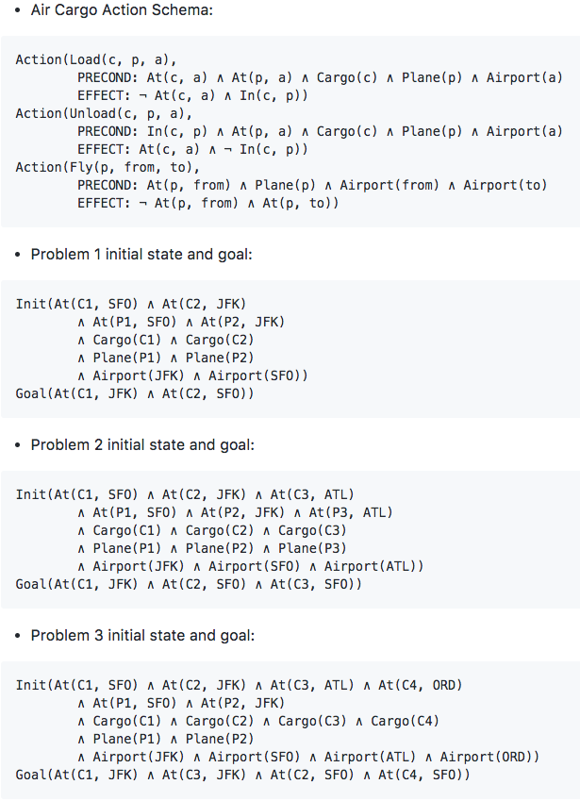

Three uninformed algorithms (Breadth First, Depth First, Uniform Cost) are compared as well as two informed algorithms (A* with Ignore Preconditions, A* with Level-Sum).

All the algorithms were able to find optimal solutions except Depth First. The fastest solution for each problem is listed in the following table:

Problem 1  Breadth First | Problem 2  A* with Ignore Preconditions | Problem 3  A* with Ignore Preconditions
Load(C1, P1, SFO) | Load(C1, P1, SFO) | Load(C1, P1, SFO)
Load(C2, P2, JFK) | Fly(P1, SFO, JFK) | Fly(P1, SFO, ATL)
Fly(P1, SFO, JFK) | Unload(C1, P1, JFK) | Load(C3, P1, ATL)
Fly(P2, JFK, SFO) | Load(C2, P2, JFK) | Fly(P1, ATL, JFK)
Unload(C1, P1, JFK) | Fly(P2, JFK, SFO) | Unload(C1, P1, JFK)
Unload(C2, P2, SFO) | Unload(C2, P2, SFO) | Load(C2, P2, JFK)
 | Load(C3, P3, ATL) | Fly(P2, JFK, ORD)
 | Fly(P3, ATL, SFO) | Load(C4, P2, ORD)
 | Unload(C3, P3, SFO) | Fly(P2, ORD, SFO)
 |  | Unload(C2, P2, SFO)
 |  | Unload(C3, P1, JFK)
 |  | Unload(C4, P2, SFO)

Comparison of the algorithms for the three problems are in the tables below. The first three algorithms in each table are uninformed and the last two are informed by automatic heuristics.

Problem 1:

Algorithm | Expansions | Goal Tests | New Nodes | Plan Length | Optimal | Time (msec)
Breadth First | 43 | 56 | 180 | 6 | Yes | 22
Depth First | 21 | 22 | 84 | 20 | No | 10
Uniform Cost | 55 | 57 | 224 | 6 | Yes | 26
A* with Ignore Preconditions | 41 | 43 | 170 | 6 | Yes | 35
A* with Level-Sum | 11 | 13 | 50 | 6 | Yes | 637

Problem 2:

Algorithm | Expansions | Goal Tests | New Nodes | Plan Length | Optimal | Time (sec)
Breadth First | 3343 | 4609 | 30509 | 9 | Yes | 9.8
Depth First | 624 | 625 | 5602 | 619 | No | 2.4
Uniform Cost | 4853 | 4855 | 44041 | 9 | Yes | 8.2
A* with Ignore Preconditions | 1450 | 1452 | 13303 | 9 | Yes | 3.8
A* with Level-Sum | 86 | 88 | 841 | 9 | Yes | 58.9

Problem 3:

Algorithm | Expansions | Goal Tests | New Nodes | Plan Length | Optimal | Time (sec)
Breadth First | 14663 | 18098 | 129631 | 12 | Yes | 70.2
Depth First | 408 | 409 | 3364 | 392 | No | 1.3
Uniform Cost | 18236 | 18238 | 159726 | 12 | Yes | 36.6
A* with Ignore Preconditions | 5038 | 5040 | 44926 | 12 | Yes | 14.5
A* with Level-Sum | 314 | 316 | 2894 | 12 | Yes | 316.3

As the tables show, Depth First is a poor algorithm in all the problems as it returns the first solution found which most likely is not optimal.

The results confirm Russell and Norvig statement (p. 382) that searches are not efficient unless they use heuristics to cut down on the number of paths that are explored.

And as we learned from the Build a Game Playing Agent project, it can be faster to use a simpler heuristic (such as A* with Ignore Preconditions) , that computes fast, over a complicated but smarter heuristic (such as A* with Level-Sum) that requires much time to compute.

