

ADipIT02 – Object-Oriented Design and

Programming

TOPIC: Online Job Portal

**Name:** Alishan Gurung

**Student ID: NP03A180127**

**Submitted date:** Week 3

**Submitted to:** Mr. Raj Prasad Shrestha

# Individual Contribution

Our group project in on Online Job Portal. Every member of the group had different task to complete after we had group meeting and I assisted on making use case diagram for the project. Following work that I’ve done in this first assessment is given below:

## Use-case diagram with explanation

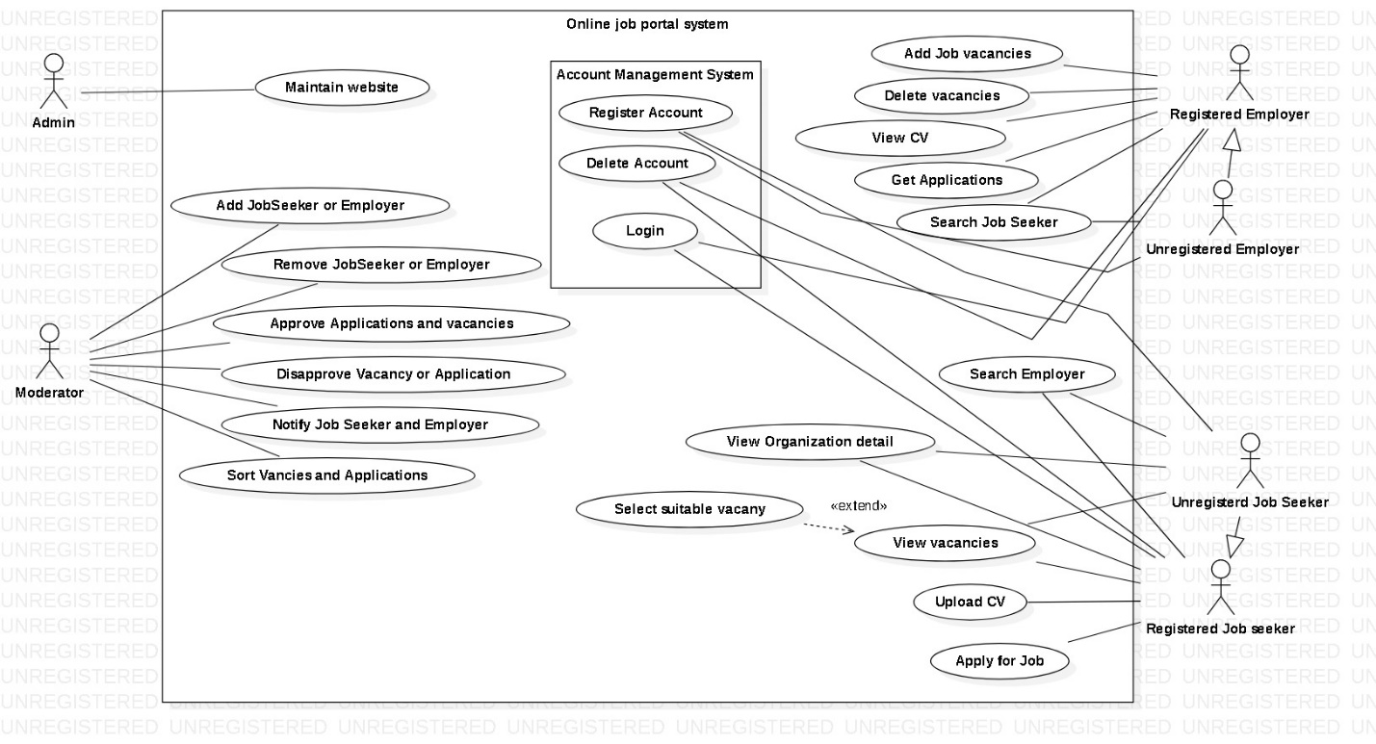

In the above use case diagram , there is basically four actors which is admin, moderator, employer and employee of which employer and employee are customers of the web application and they may be both registered or unregistered. The role of admin is to maintain the website which maybe it’s advertisement or it’s maintenance cost or other things. The role of a moderator is huge and is probably the most. He/she approves the application, vacancies, CV for its customer (i.e. Employer and Employee) and disapproves if the criteria is not fulfilled. It notifies its customers of either they got what they needed and manage all the applications from customers. Account Management System is another diagram inside the main diagram which handles register and login account of a customer. Employer maybe registered or unregistered and there are features which can used by only the verified employers i.e. to Add Job Vacancies, delete vacancies, view CV of employees, application from employees and many more which unregistered are not familiar with. Similarly, Job seeker maybe registered and unregistered and only registered member can apply for the job, upload CV and other features while unregistered can only view vacancy, organization detail and look for employers.