Numeric Converter User Guide

When you start the program, you will see the form below.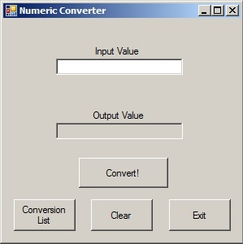

As you can see, there are several buttons at the bottom, and two boxes above.

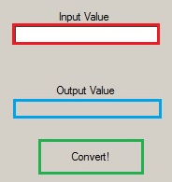

Up above, we have the input box (outlined in red). This is where you put in either an Arabic number (i.e. 405, 622, 12, 3956, etc.) or a Roman numeral (IV, MMCDXIII, XXV, DCVIII, etc.). Once you’ve put in the value you wish to convert, you left-click the “Convert!” button (outlined in green) with your mouse. The program will then take what you put in the input box through the necessary process, and it will display the result in the output box (outlined in blue.)

If you wish to convert a Roman numeral into an Arabic number in this program, you must use proper syntax for the numeral. For example, if you attempted to convert the value “VV”, you would get an error, as you cannot put two V’s right next to each other; rather, you would want to use the Roman numeral “X”, as “VV” would theoretically equal 10, and “X” is the Roman numeral for 10. If you wish to get a better idea of how Roman numerals work, you can refer to the Conversion List to see how to properly input any number that this program can handle.

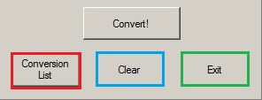

To get to the Conversion List, you can click the “Conversion List” button (outlined in red) at the bottom of the form. Before we move on, the two other buttons should also be covered. The “Clear” button (outlined in blue) will erase everything inside of the input box and the output box. The “Exit” button will

