LIMKOKWING UNIVERSITY OF CREATIVE TECHNOLOGY, SIERRA LEONE
Department of Information and Communication Technology
PROG101: PRINCIPLES OF PROGRAMMING LOGIC AND DESIGN
Individual Assignment 1
Designing Logical Solutions for Sierra Leone Community Challenges
Community Flood Early Warning System (CFEWS-SL)
Student Name | [Your Full Name]
Student ID | [Your Student ID]
Examiner | Elijah Fullah
Semester | 01, September 2026 to January 2027
Submission | Week 4
GitHub Repository | https://github.com/[username]/PROG101_Assignment1_[StudentName]_[StudentID]

TABLE OF CONTENTS

1. Rationale

1.1 Problem Description
Flooding and flood-related mudslides are one of the most dangerous recurring hazards in Sierra Leone, especially in Freetown during the rainy season (May to October). Many residents of low-lying and hillside settlements such as Kroo Bay, Kissy, Susan's Bay and Regent do not receive timely, understandable warnings before water levels become dangerous. Information about rainfall and river conditions exists in different places (weather agencies, disaster offices, community leaders) but is not combined into one simple, logical process that ends with a clear message to the people at risk.

1.2 Background
The mudslide and flooding disaster in the Regent area of Freetown in August 2017 killed more than one thousand people and left thousands homeless. Since then, every rainy season brings new flood events that damage homes, roads, markets and schools, and spread waterborne diseases such as cholera and typhoid. Rapid urban growth, informal settlements in flood plains, blocked drainage and heavy rainfall linked to climate change increase the risk. Many households rely on basic mobile phones, so any solution must work through SMS and not depend on expensive smartphones or constant internet access.

1.3 Community Impact
Problem being solved: late, unclear or missing flood warnings.
Who is affected: residents of flood-prone communities, market traders, school children, health workers, the National Disaster Management Agency (NDMA), the Sierra Leone Meteorological Agency, local councils and community leaders.
Expected impact: earlier evacuation, fewer injuries and deaths, reduced property loss, faster response by officials, and a public record of flood events that supports better planning.
Long-term sustainability: the design uses simple rules and open standards, so local universities and developers can maintain it, councils can adapt thresholds for each zone, and the cost per alert stays low because it relies on SMS.

1.4 Proposed Solution
The proposed system reads three inputs for each community zone: 24-hour rainfall (mm), river level (m) and the number of community flood reports. It converts each input into a score, adds the scores, and classifies the zone as GREEN (safe), YELLOW (watch), ORANGE (warning) or RED (emergency). A safety override rule forces RED when the river is at or above its danger level and heavy rain is falling. For any level above GREEN, the system builds a clear message and sends it by SMS to every registered subscriber in the zone, then records the event in a public log.

1.5 Computational Thinking Process
Decomposition: the large problem ("warn people about floods") is broken into smaller parts: collect data, validate data, score risk, classify risk, build message, send alerts and log the event.
Pattern recognition: floods follow patterns: heavy rain plus high river level plus community reports repeatedly lead to dangerous situations; every zone follows the same assessment steps.
Abstraction: details such as rainfall gauge hardware, SMS gateways and map displays are hidden; the design focuses on numbers, thresholds and decisions.
Algorithm design: the steps are written in a fixed order using sequence, selection (IF) and iteration (loops), then expressed as pseudocode and flowcharts.

1.6 Algorithm Design Summary
The main algorithm loops through all zones. For each zone it reads and validates inputs (with up to three attempts), calls scoring and classification functions, decides whether an alert is needed, calls the alert procedure, and logs the result. Constants hold the thresholds so officials can change them in one place. Boolean logic (AND, OR) is used in validation and the override rule. The full algorithm, pseudocode and flowcharts follow in Sections 2 to 4.

1.7 SDG Alignment
- SDG 11 (Sustainable Cities and Communities): reduces disaster deaths and losses in settlements (Target 11.5).
- SDG 13 (Climate Action): builds resilience and adaptive capacity to climate-related hazards (Target 13.1).
- SDG 3 (Good Health and Well-being): prevents injuries and reduces flood-related disease outbreaks.

1.8 Open Source Justification
Why open source: flood safety is a public interest. Open design allows the government, NGOs and universities to inspect, trust and adapt the logic without licence fees or vendor lock-in.
Benefits for Sierra Leone: zero licensing cost, local skills development, ability to translate messages into Krio, Mende and Temne, and freedom to adjust thresholds for each district.
Community contributions: students and developers can add new zones and languages, improve thresholds using local data, write test scenarios, translate documentation, and report issues on GitHub.

1.9 Digital Public Goods Justification
The system could become a Digital Public Good by publishing the design, documentation and later the code under an open licence (for example MIT for code and CC BY 4.0 for documents), using open data formats for the event log, doing no-harm-by-design (only phone numbers needed, with consent and privacy protection), and following the Digital Public Goods Standard. It promotes accessibility (works on any phone through SMS, multiple languages), openness (public logic and public event data) and public benefit (free for communities, reusable by other countries with similar flood risks).

2. Algorithm
Input, Processing and Output are shown for the whole system. Variables and data types: zoneName (String), rainfall (Real), riverLevel (Real), dangerLevel (Real), reportCount (Integer), score (Integer), level (String), isValid (Boolean), message (String). Constants: RAIN_WATCH = 50, RAIN_WARNING = 100, RAIN_SEVERE = 150, MAX_RAIN = 500, REPORT_LOW = 3, REPORT_HIGH = 10, MAX_ATTEMPTS = 3.
- START and define the constants.
- Load the list of zones and their subscribers.
- Is there another zone to assess? If NO, go to step 14.
- INPUT rainfall, river level and number of community reports using readValidated (up to MAX_ATTEMPTS tries each).
- If any value is still invalid, display a data error, flag the zone for manual checking and go back to step 3.
- PROCESS: rainfall score = 3 if rain >= 150, 2 if >= 100, 1 if >= 50, otherwise 0.
- PROCESS: river score = 3 if river >= danger level, 2 if >= 80% of it, 1 if >= 60% of it, otherwise 0.
- PROCESS: report score = 2 if reports >= 10, 1 if reports >= 3, otherwise 0.
- PROCESS: total score = rainfall score + river score + report score (0 to 8).
- PROCESS: if river >= danger AND rain >= 100, level = RED; else if score >= 6 RED; else if score >= 4 ORANGE; else if score >= 2 YELLOW; else GREEN.
- If level is GREEN, OUTPUT "No alert needed" and go to step 13.
- Build the message for the level and send it by SMS to every subscriber in the zone (loop), counting sent and failed messages.
- Log the event (date, zone, level, score) and go back to step 3.
- OUTPUT a summary report for all zones.
- END.

3. Pseudocode
PROGRAM CommunityFloodEarlyWarning

// ---------- CONSTANTS ----------
CONSTANT RAIN_WATCH = 50 // mm in 24 hours
CONSTANT RAIN_WARNING = 100
CONSTANT RAIN_SEVERE = 150
CONSTANT MAX_RAIN = 500 // highest believable reading
CONSTANT REPORT_LOW = 3 // community reports
CONSTANT REPORT_HIGH = 10
CONSTANT MAX_ATTEMPTS = 3

// ---------- VARIABLES (name : data type) ----------
// zoneName : STRING rainfall : REAL
// riverLevel : REAL dangerLevel : REAL
// reportCount : INTEGER score : INTEGER
// level : STRING isValid : BOOLEAN
// message : STRING zones : LIST of ZONE records

// ---------- FUNCTIONS ----------
FUNCTION validateInput(value, minVal, maxVal) RETURNS BOOLEAN
IF value IS NOT A NUMBER THEN
RETURN FALSE
ENDIF
RETURN (value >= minVal) AND (value <= maxVal)
END FUNCTION

FUNCTION readValidated(promptText, minVal, maxVal) RETURNS NUMBER
SET attempts = 0
WHILE attempts < MAX_ATTEMPTS DO
DISPLAY promptText
INPUT value
IF validateInput(value, minVal, maxVal) THEN
RETURN value
ELSE
DISPLAY "Invalid value, please try again"
attempts = attempts + 1
ENDIF
ENDWHILE
RETURN -1 // invalid flag
END FUNCTION

FUNCTION rainScore(rain) RETURNS INTEGER
IF rain >= RAIN_SEVERE THEN RETURN 3
ELSE IF rain >= RAIN_WARNING THEN RETURN 2
ELSE IF rain >= RAIN_WATCH THEN RETURN 1
ELSE RETURN 0
ENDIF
END FUNCTION

FUNCTION riverScore(river, danger) RETURNS INTEGER
IF river >= danger THEN RETURN 3
ELSE IF river >= 0.8 * danger THEN RETURN 2
ELSE IF river >= 0.6 * danger THEN RETURN 1
ELSE RETURN 0
ENDIF
END FUNCTION

FUNCTION reportScore(count) RETURNS INTEGER
IF count >= REPORT_HIGH THEN RETURN 2
ELSE IF count >= REPORT_LOW THEN RETURN 1
ELSE RETURN 0
ENDIF
END FUNCTION

FUNCTION calculateRiskScore(rain, river, danger, count) RETURNS INTEGER
RETURN rainScore(rain) + riverScore(river, danger) + reportScore(count)
END FUNCTION // maximum score = 8

FUNCTION classifyRisk(score, rain, river, danger) RETURNS STRING
IF (river >= danger) AND (rain >= RAIN_WARNING) THEN
RETURN "RED" // safety override rule
ELSE IF score >= 6 THEN RETURN "RED"
ELSE IF score >= 4 THEN RETURN "ORANGE"
ELSE IF score >= 2 THEN RETURN "YELLOW"
ELSE RETURN "GREEN"
ENDIF
END FUNCTION

FUNCTION buildMessage(level, zone) RETURNS STRING
IF level = "RED" THEN
RETURN "FLOOD EMERGENCY in " + zone + ": move to high ground now."
ELSE IF level = "ORANGE" THEN
RETURN "FLOOD WARNING in " + zone + ": prepare to evacuate."
ELSE
RETURN "FLOOD WATCH in " + zone + ": stay alert and monitor updates."
ENDIF
END FUNCTION

PROCEDURE sendAlerts(zone, message)
SET sent = 0, failed = 0
FOR i = 1 TO number of subscribers in zone DO
GET subscriber[i]
IF sendSMS(subscriber[i].phone, message) = SUCCESS THEN
sent = sent + 1
ELSE
failed = failed + 1
ADD subscriber[i] TO retryList
ENDIF
ENDFOR
DISPLAY "Sent: " + sent + " Failed: " + failed
END PROCEDURE

PROCEDURE logEvent(zone, level, score)
APPEND (current date/time, zone, level, score) TO public event log
END PROCEDURE

// ---------- MAIN PROGRAM ----------
BEGIN
LOAD zones
FOR EACH zone IN zones DO
rainfall = readValidated("Rainfall (mm/24h):", 0, MAX_RAIN)
riverLevel = readValidated("River level (m):", 0, 20)
reportCount = readValidated("Community reports:", 0, 1000)

IF (rainfall = -1) OR (riverLevel = -1) OR (reportCount = -1) THEN
DISPLAY "Data error for " + zone.name + " - manual check needed"
ELSE
score = calculateRiskScore(rainfall, riverLevel, zone.dangerLevel, reportCount)
level = classifyRisk(score, rainfall, riverLevel, zone.dangerLevel)
IF level = "GREEN" THEN
DISPLAY "No alert needed for " + zone.name
ELSE
message = buildMessage(level, zone.name)
sendAlerts(zone.name, message)
ENDIF
logEvent(zone.name, level, score)
ENDIF
ENDFOR
DISPLAY summary report
END

4. Flowcharts
The flowcharts use standard symbols: oval (start/end), parallelogram (input/output), rectangle (process) and diamond (decision). They were drawn with Graphviz (DOT).

4.1 Main Program Flowchart
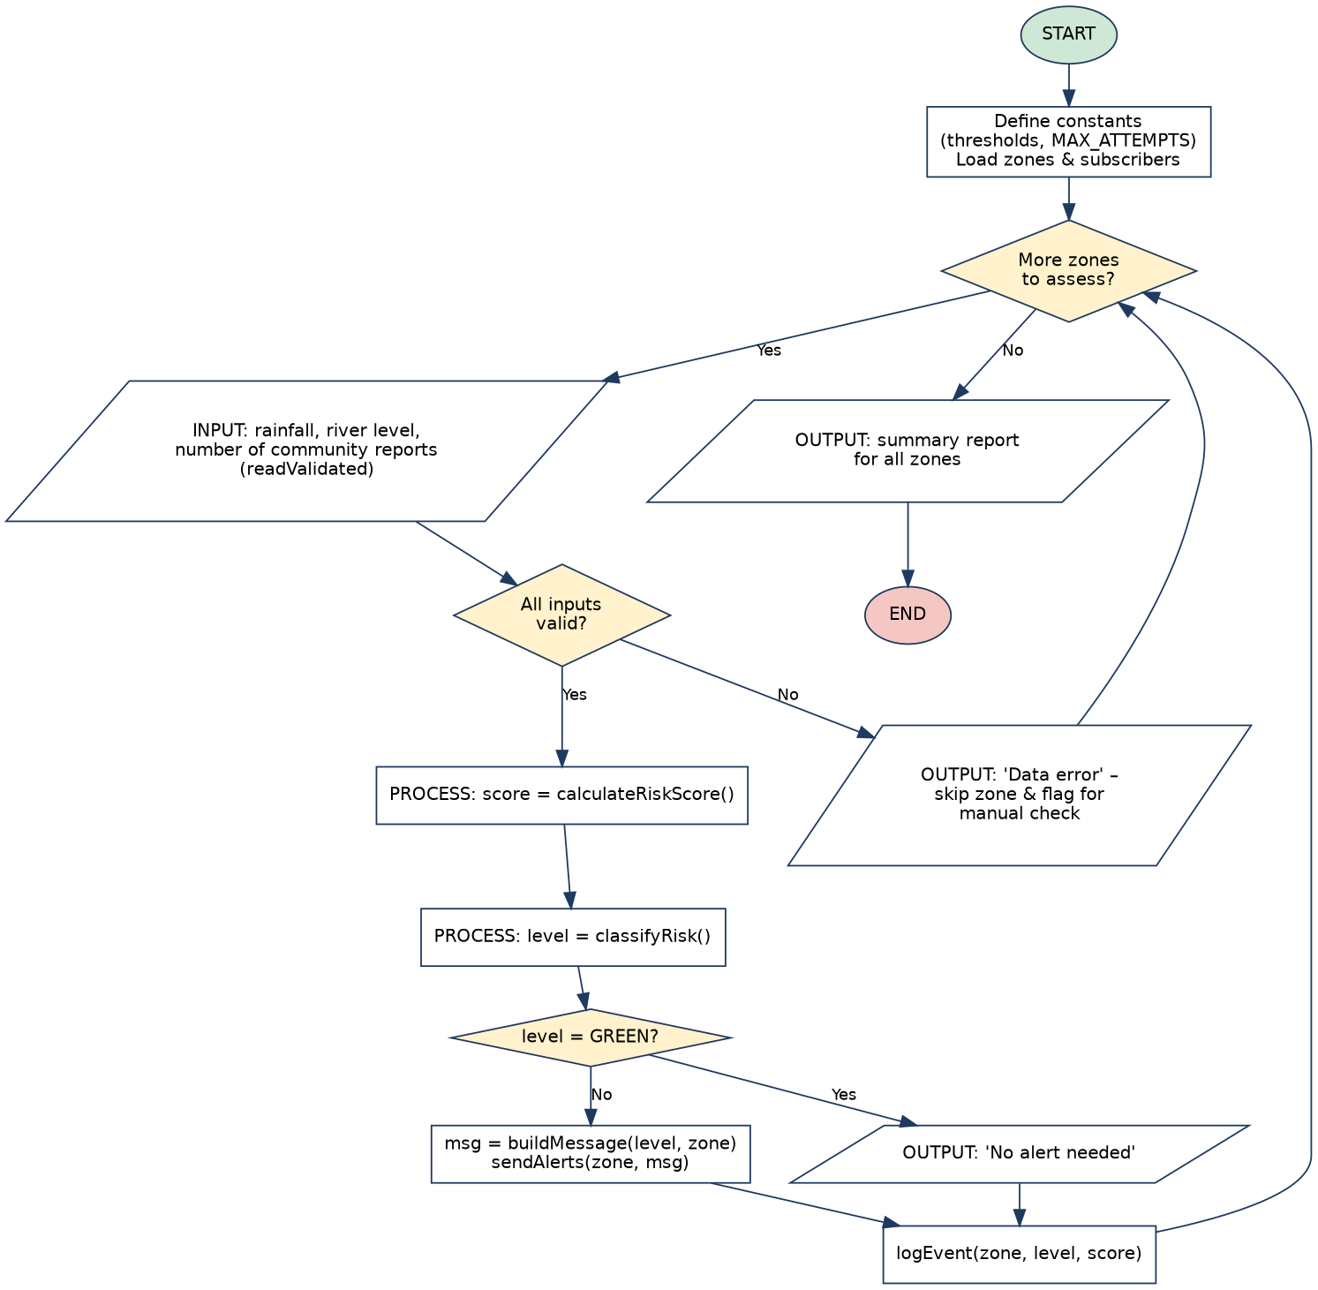
Figure 1: Main program flowchart

4.2 Input Validation Function (readValidated)
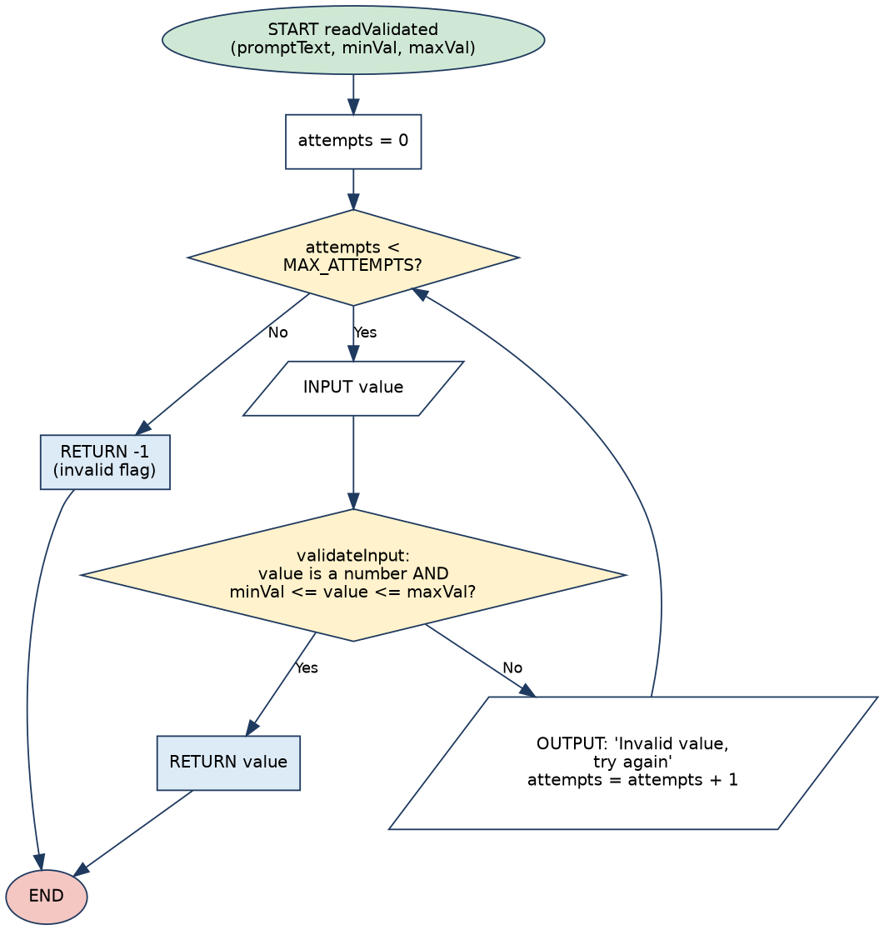
Figure 2: Input validation with repetition

4.3 Risk Classification Function (classifyRisk)
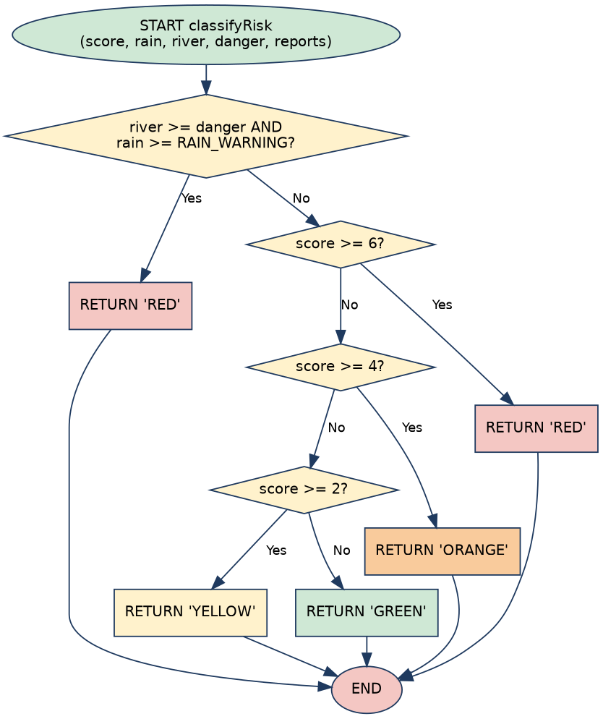
Figure 3: Risk classification with decisions and override rule

4.4 Alert Dispatch Procedure (sendAlerts)
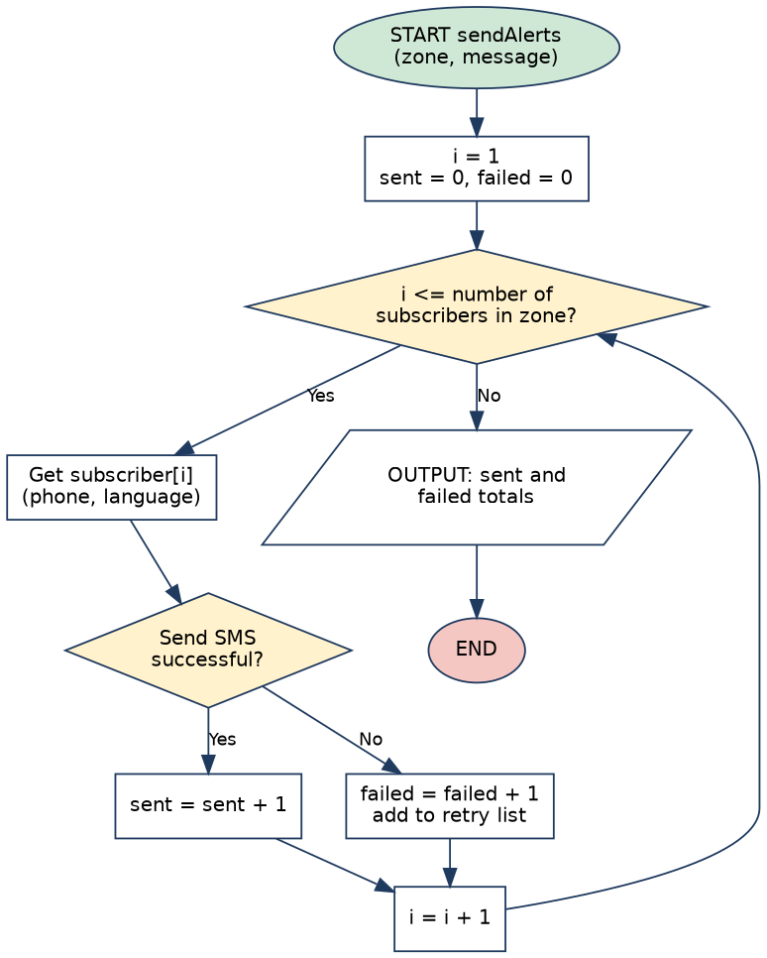
Figure 4: Alert dispatch loop

5. Functional Modules
Module / Function | Purpose | Inputs | Output
validateInput | Check a value is numeric and within range (Boolean logic) | value, min, max | TRUE / FALSE
readValidated | Read input with up to 3 attempts (repetition) | prompt, min, max | Number or -1
rainScore | Convert rainfall to score 0 to 3 (decisions) | rain | Integer
riverScore | Convert river level to score 0 to 3 | river, danger | Integer
reportScore | Convert report count to score 0 to 2 | count | Integer
calculateRiskScore | Add the three scores | rain, river, danger, count | Integer 0 to 8
classifyRisk | Decide GREEN / YELLOW / ORANGE / RED | score, rain, river, danger | String
buildMessage | Create SMS text for the level and zone | level, zone | String
sendAlerts | Loop through subscribers and send SMS | zone, message | Sent and failed totals
logEvent | Save event to the public log | zone, level, score | Log record
Main program | Loop through zones and call all modules | Zone list | Summary report

Problem decomposition: the system is split into three layers: (1) data input and validation, (2) risk analysis, and (3) communication and record keeping. Each module does one job and can be tested and improved separately.

6. Expected Outputs
Danger levels used in the samples: Kroo Bay = 3.0 m, Kissy = 3.0 m, Regent = 3.0 m, Susan's Bay = 2.5 m (sample values for illustration).
Scenario | Rain (mm) | River (m) | Reports | Score | Level | Output
A: Kroo Bay, dry day | 30 | 1.0 | 0 | 0 | GREEN | No alert needed for Kroo Bay
B: Kissy, light rain | 70 | 2.0 | 1 | 2 | YELLOW | FLOOD WATCH in Kissy: stay alert and monitor updates.
C: Susan's Bay, rising river | 120 | 2.1 | 4 | 5 | ORANGE | FLOOD WARNING in Susan's Bay: prepare to evacuate.
D: Regent, severe storm | 160 | 3.2 | 12 | 8 | RED | FLOOD EMERGENCY in Regent: move to high ground now.
E: Kroo Bay, override | 105 | 3.0 | 0 | 5 | RED | Override rule: river at danger level and rain >= 100 gives RED
F: Kissy, bad input | -5, then abc, then -1 | n/a | n/a | n/a | Error | Invalid value x3, then: Data error, manual check needed

Working for Scenario C (Susan's Bay, danger level 2.5 m): rain 120 gives 2; river 2.1 is at least 80% of 2.5 (2.0), so it gives 2; reports 4 gives 1; total = 5, so ORANGE. For Scenario E: rain 105 gives 2; river 3.0 is at least the danger level, so 3; reports 0 gives 0; total = 5, but the override rule applies first, so RED.
Sample screen output for Scenario D:
Zone: Regent
Rainfall (mm/24h): 160
River level (m): 3.2
Community reports: 12
Risk score: 8 Level: RED
SMS: FLOOD EMERGENCY in Regent: move to high ground now.
Sent: 248 Failed: 3 (3 added to retry list)

7. GitHub Evidence
Repository name: PROG101_Assignment1_[StudentName]_[StudentID]
Repository URL: https://github.com/[username]/PROG101_Assignment1_[StudentName]_[StudentID]
Insert below: (1) a screenshot of the repository home page, (2) a screenshot of the commit history, and (3) a screenshot of the rendered README.md. Replace the boxes with your own screenshots.
[Screenshot: Repository home page]

[Screenshot: Git commit history]

[Screenshot: README.md]

README.md content
# PROG101 Assignment 1 – Community Flood Early Warning System (CFEWS-SL)

**Student:** [Your Name] **Student ID:** [Your ID]
**Course:** PROG101 Principles of Programming Logic and Design, Limkokwing University of Creative Technology, Sierra Leone
**Examiner:** Elijah Fullah

## Problem
Communities in Freetown (e.g. Kroo Bay, Kissy, Regent) face repeated flood and mudslide risk, and warnings often arrive late or not at all.

## Solution (logical design only – no source code)
A low-bandwidth, SMS-based early warning system. It reads rainfall, river level and community reports for each zone, calculates a risk score, classifies risk as GREEN / YELLOW / ORANGE / RED and sends alerts to registered residents.

## Repository contents
| File | Description |
|---|---|
| `Report.docx` | Full report |
| `flowcharts/` | Main, input validation, risk classification and alert dispatch flowcharts |
| `pseudocode.txt` | Complete pseudocode |
| `README.md` | This file |

## SDGs supported
SDG 11 (Sustainable Cities and Communities), SDG 13 (Climate Action), SDG 3 (Good Health and Well-being)

## Open Source and Digital Public Good
The design is released under an open licence (e.g. MIT / CC BY 4.0) so that government agencies, NGOs and students can adapt it.

## Licence
MIT (design documents: CC BY 4.0)

8. References
- United Nations (2015). Transforming our world: the 2030 Agenda for Sustainable Development. https://sdgs.un.org/goals
- Digital Public Goods Alliance. The Digital Public Goods Standard. https://digitalpublicgoods.net
- Open Source Initiative. The Open Source Definition. https://opensource.org/osd
- Government of Sierra Leone and partners (2017). Sierra Leone: Rapid Damage and Loss Assessment of August 14th, 2017 Landslides and Floods in the Western Area. World Bank / GFDRR.
- Sierra Leone National Disaster Management Agency (NDMA). https://ndma.gov.sl
- GitHub Docs. Git and GitHub learning resources. https://docs.github.com
- Please verify each source and add the access date before printing.

