

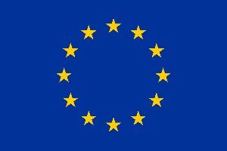

**European Research Council (ERC)**

**ERC Data Management Plan**

**Template**

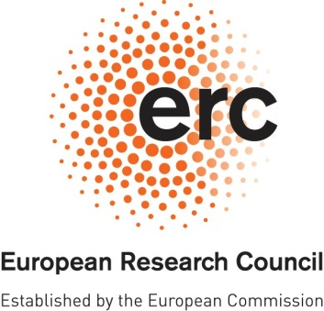**ERC OPEN RESEARCH**

**DATA MANAGEMENT PLAN (DMP)**

# 

|  |  |
| --- | --- |
| **Project Acronym** | **Project Number** |
|  |  |

***Template for the ERC Open Research Data Management Plan (DMP). The following sections should describe how you plan to make the project data Findable, Accessible, Interoperable and Reusable (FAIR). Each of the following five issues should be addressed with a level of detail appropriate to the project.***

|  |
| --- |
| **SUMMARY** *(dataset[1] reference and name; origin and expected size of the data generated/collected; data types and formats)* |
| FA – DNA sequence files (500 MB – 2 GB)  plaintext TXT for genomic locations – 10 GB  landmark ASCII files – 50 KB  CSV files – 10 MB  XML  XLSX files – 200 MB  .k2b database files 600 GB  .db database files  PNG, TIFF, JPG, GIF  SVG, PDF, Postscript |

|  |
| --- |
| **1. MAKING DATA FINDABLE** *(dataset description: metadata, persistent and unique identifiers e.g., DOI)* |
| README.txt – basic description about the contents of a repository / archive  Digital object identifer  metadata – glossary of variable, dictionary, data about the data |

|  |
| --- |
| **2. MAKING DATA OPENLY ACCESSIBLE** *(which data will be made openly available and if some datasets remain closed, the reasons for not giving access; where the data and associated metadata, documentation and code are deposited (repository?); how the data can be accessed (are relevant software tools/methods provided?)* |
| Public hosting platforms:  - EDMOND (assigns DOI)  - OSF – open science framework → osf.io  - data dryad  Gated Access platforms:  - keeper (allows gated access)  - github (public and private both possible)  “available by request” is probably bad!  **What kind of license do you want to use?**  - MIT license  - Creative Commons licenses |

|  |
| --- |
| **3. MAKING DATA INTEROPERABLE** *(which standard or field-specific data and metadata vocabularies and methods will be used)* |
| No proprietary formats!  SPSS  SAS  Stata  XLSX!  FileMaker – Mac-ONLY  matlab! .m code files |

|  |
| --- |
| **4. INCREASE DATA RE-USE** *(what data will remain re-usable and for how long, is embargo foreseen; how the data is licensed; data quality assurance procedures)* |
| Planning circles of access changing over time  high resolution / high fidelity file types, good equipment?  Dropping cases / filtering / q: can you show exactly how you modified the data for a paper? STROBE diagrams |

|  |
| --- |
| **5. ALLOCATION OF RESOURCES and DATA SECURITY** *(estimated costs for making the project data open access and potential value of long-term data preservation; procedures for data backup and recovery; transfer of sensitive data and secure storage in repositories for long term preservation and curation)* |
| Cloud-backups (Nextcloud, Dropbox)  “321 principle”  - 3 copies  - 2 different media  - 1 other location |

**DISCLAIMER. Please note that the ERC Data Management Plan is not a part of the Ethics Review. It is the responsibility of the Principal Investigator to inform the ERCEA Ethics Team of any ethics issues/concerns regarding the collection, processing, sharing and storage of data in relation to the project.**

1. *Several datasets may be included into a single DMP.*