Inception

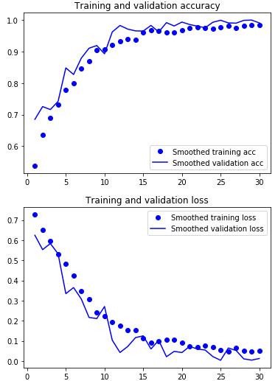

Training accuracy: 99.99%

Test Accuracy: 99.1%

VGG

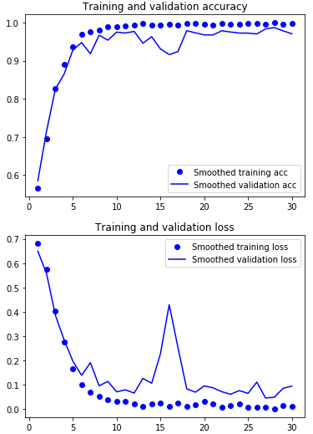

Training accuracy: 99.98%

Test Accuracy: 97.9%

Resnet:

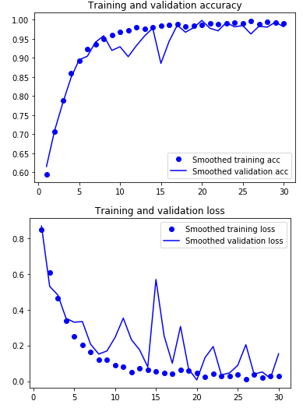

Training accuracy: 99.9%

Test Accuracy: 99.9%

Raw model:

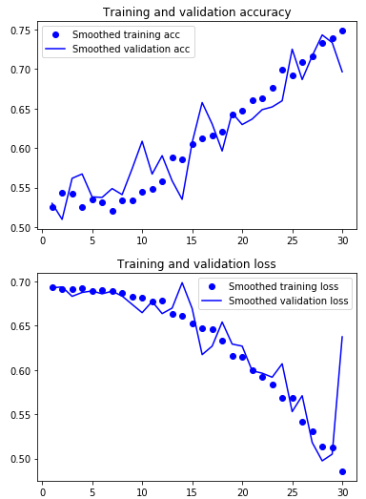

Training accuracy: 89.40%

Test Accuracy: 86.7%