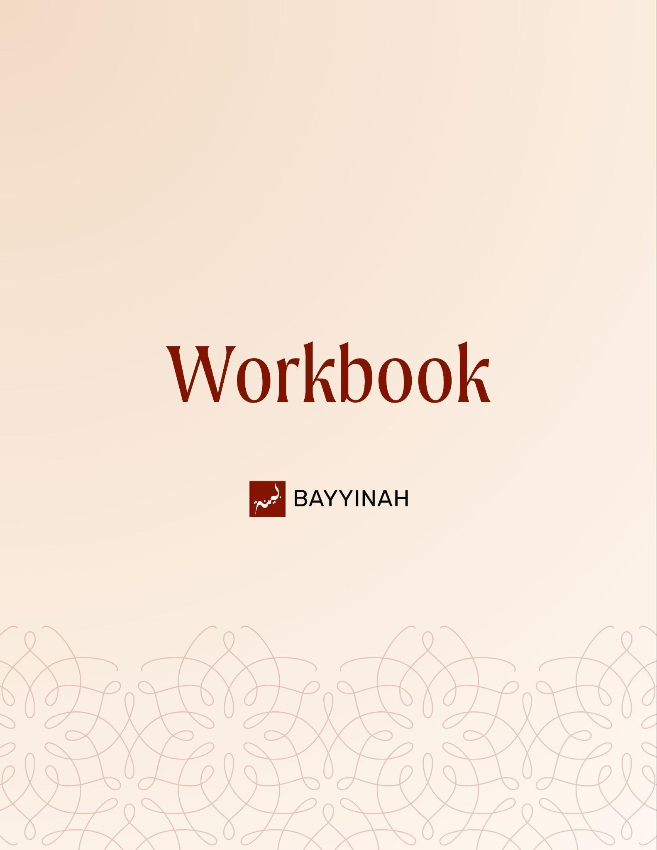
Divine Speech: The Quran from a Literary Perspective

Divine Speech: The Quran from a Literary Perspective

Contents
Introduction...............................................................................................3
Section 1: Two Lenses for Studying the Quran: Micro and Macro............ 4
Section 2: Teaching Versus Scholarship....................................................5
Section 3: The Quran as Literature Not Just Religious Text.......................6
Section 4: What an Ayah Really Is..............................................................7
Section 5: The Linguistic Depth of the Word “Ayah”...................................8
Section 6: The Ayah Exists Inside and Outside the Book...........................9
Section 7: Why Classical Arabic Is Essential for Quran Study..................10
Quiz Questions.........................................................................................11
Reflection Questions...............................................................................12
Conclusion & Dua....................................................................................13

Introduction: When Questions Become Proof
For many readers, their first experience with the Quran in translation brings questions. Why are certain ideas repeated? Why do stories appear in parts rather than being told straight through? Why are some Surahs long while others are only a few Ayat? Why does the Quran not follow chronology or topic the way most books do?
These questions are not a sign of distance from the Quran. They come from paying attention. The Quran does not follow the patterns of human speech or writing. Its structure is deliberate and often unfamiliar. That unfamiliarity can come before clarity.
This workbook begins by slowing down and reconsidering how the Quran is approached. Before moving into meanings, rulings or discussions, it asks the reader to adjust their lens. At times, the focus narrows to a single word or phrase. At other times, it widens to take in the design of a Surah or the Quran as a whole.
Both ways of looking are necessary. This course is not about covering everything or presenting academic detail. It is about learning how to read Allah’s speech with care and attention so what the Quran is doing becomes easier to notice, insha’Allah.
May Allah grant us clarity when we read His Book, patience as we learn and sincerity in our effort. May He allow the Quran to guide us, correct us and draw us closer to Him. Ameen.

Section 1: Two Lenses for Studying the Quran: Micro and Macro
The Quran invites more than one way of paying attention. At times, the focus is narrow and precise. At other times, it widens to take in the larger picture. Both approaches are intentional and both are necessary.
A closer reading looks carefully at the wording of an Ayah, the choice of a verb, a repeated sound or a grammatical structure. A wider reading steps back to consider how a Surah is arranged, why themes return and how accounts are spread across the Quran.
Neither approach stands on its own. Meaning becomes clearer when attention moves between detail and structure, between what is said and how it is placed.

Key takeaways:
- The Quran calls for more than one way of reading.
- Close attention to wording and structure is intentional, not incidental.
- Stepping back to observe Surah arrangement and recurring themes is equally necessary.
- Detail and design work together to clarify meaning.
- Moving between these perspectives helps the reader understand how the Quran communicates.
- Neither approach replaces the other. Both are part of engaging Allah’s speech.

“When you’re staring at the flower, you lose sight of the valley. When you’re on the mountain, you see a different kind of beauty.”

Section 2: Teaching Versus Scholarship
This program is not designed as an academic study. Its focus is understanding. Complex linguistic and scholarly discussions are distilled so readers can engage with the Quran without feeling burdened by technical detail. The aim is to make the material accessible while remaining faithful to the sources it is built upon.

Key takeaways:
- The priority is clarity, not scholarly display.
- Simplifying material does not mean altering it.
- Classical scholarship informs the content even when not cited explicitly.
- Teaching involves translating complexity into clear language.
- Technical terminology is not always necessary for understanding.
- Knowledge is meant to be shared and carried forward.

“I am not a scholar. I’m a teacher. And the job of a teacher is to help you understand information.”

Section 3: The Quran as Literature Not Just Religious Text
The Quran is often approached only as a book of theology or debate. When read this way, much of its beauty and precision can be missed. Reading the Quran as literature does not remove its sacredness. It allows its structure, wording and arrangement to be seen more clearly. This approach opens a space of appreciation rather than argument and changes how the Quran is encountered by both Muslims and non-Muslims.

Key takeaways:
- The Quran can be studied with literary attention without reducing its sacred role.
- Focusing only on polemics can obscure how the Quran communicates.
- Literary reading invites understanding rather than confrontation.
- Structure and language are part of the Quran’s guidance.

Section 4: What an Ayah Really Is
An Ayah is often described as a verse or sentence but the Quran uses the word more carefully than that. An Ayah is something meaningful that points beyond itself and invites reflection. It can be a single word, a phrase or several sentences. The Quran also uses the term Ayah for history, nature, the human self and future events. This shared use is deliberate. It reshapes how reality itself is understood.

Key takeaways:
- An Ayah is not limited to sentence structure.
- It points, signals and invites attention.
- Ayat can appear in revelation, history and the natural world.
- The Quran uses this word consistently to train perception.

“When you study the Quran, you stop asking ‘What is an ayah?’ and start asking ‘What is not an ayah?”

Section 5: The Linguistic Depth of the Word “Ayah”
In classical Arabic, the word Ayah carries a range of meanings. It refers to something valuable, striking, purposeful and attention-drawing. It suggests direction and meaning, not randomness. Reducing Ayah to a single English equivalent limits how the Quran is understood and how its guidance is experienced.

Key takeaways:
- Ayah carries multiple layers of meaning in Arabic.
- No single English word captures its full range.
- Language shapes how revelation is approached.
- Preserving meaning requires linguistic care.

Section 6: The Ayah Exists Inside and Outside the Book
The Quran refers to natural events, human experience and history as Ayat. Wind, sleep, love and time itself are described this way. Engaging with these signs is a form of reflection guided by the Quran. In this way, the world becomes a place where revelation is recognized, not separate from it.

Key takeaways:
- Ayat exists beyond the written text.
- Creation and experience point back to revelation.
- Observing the world is part of Quranic reflection.
- The Quran trains the reader to see meaning everywhere.

Section 7: Why Classical Arabic Is Essential for Quran Study
The Quran was revealed in a refined form of Arabic that is no longer spoken. Even formal modern Arabic has passed through layers of change. To read the Quran carefully, it must be approached through preserved classical Arabic. This is not about fluency for its own sake but about seeing the Quran as it was revealed.

Key takeaways:
- The Quran’s language belongs to a preserved form of Arabic.
- Modern usage cannot fully represent Quranic meaning.
- Classical Arabic provides clarity, not complication.
- Understanding language supports accurate reading.

Quiz Questions

1. What is the purpose of this program in relation to scholarship?
A) To show off academic knowledge
B) To make complex ideas approachable and clear
C) To provide detailed technical citations for every claim
D) To focus on memorizing Arabic grammar rules only
E) To replace classical scholarship entirely

2. How does the Quran invite readers to engage with its text?
A) Only by reading it from start to finish in chronological order
B) By focusing only on theological debates
C) By examining both details of individual ayat and the overall design of surahs
D) By ignoring repeated themes
E) By studying modern Arabic translation alone

3. What does the word “Ayah” in the Quran primarily signify?
A) A sentence or a line of text only
B) A random statement with no deeper meaning
C) Something meaningful that points beyond itself, inviting reflection
D) Only a historical event
E) Only a grammatical rule

4. Why is classical Arabic important for Quran study?
A) Because modern Arabic is identical to Quranic Arabic
B) To understand the Quran as it was revealed and preserve its meaning
C) To make learning Arabic more fashionable
D) To simplify memorization without understanding
E) Because the Quran cannot be translated

5. How does reading the Quran as literature help?
A) It removes its sacredness and makes it secular
B) It focuses only on debates and arguments
C) It allows the structure, wording, and precision to be appreciated
D) It makes memorization easier
E) It replaces the need for understanding theological rulings

Reflection Questions
When you encounter repetition or unfamiliar structure in the Quran, how do you usually respond inwardly, and how might adopting both a micro and macro perspective change that response?

Which approach comes more naturally to you focusing on precise wording or stepping back to see broader themes and what might you be missing by relying mostly on one?

In what ways can learning to “zoom in” and “step back” deepen humility and patience in your personal journey with the Quran?

Quiz Answers: 1.B, 2.C, 3.C, 4.B, 5.C

Conclusion
Engaging with the Quran requires both care and attention. It asks us to look closely at individual Ayat while also stepping back to see the broader design of Surahs and the Quran as a whole. Understanding does not come from complexity or technical display, but from clarity, reflection, and sincerity. Approaching the Quran as literature, studying the depth of its words, recognizing its signs in creation, and learning through classical Arabic all help us see the Quran as it was revealed. Alhamdulillah, when we combine careful study with reflection and du‘aa, the Quran becomes a living guide for understanding, awareness, and connection with Allah.

Dua
O Allah, make us among those who read your book with understanding, act upon its guidance, and carry its lessons into our lives.May Allah grant us understanding that benefits and knowledge that is clear. Make what we learn easy to carry and easy to share.May Allah open our eyes to His signs within revelation and creation when we look closely, and wisdom when we step back. May Allah allow us to approach His book as it was revealed. Grant us clarity through its language and sincerity in seeking its meaning.

