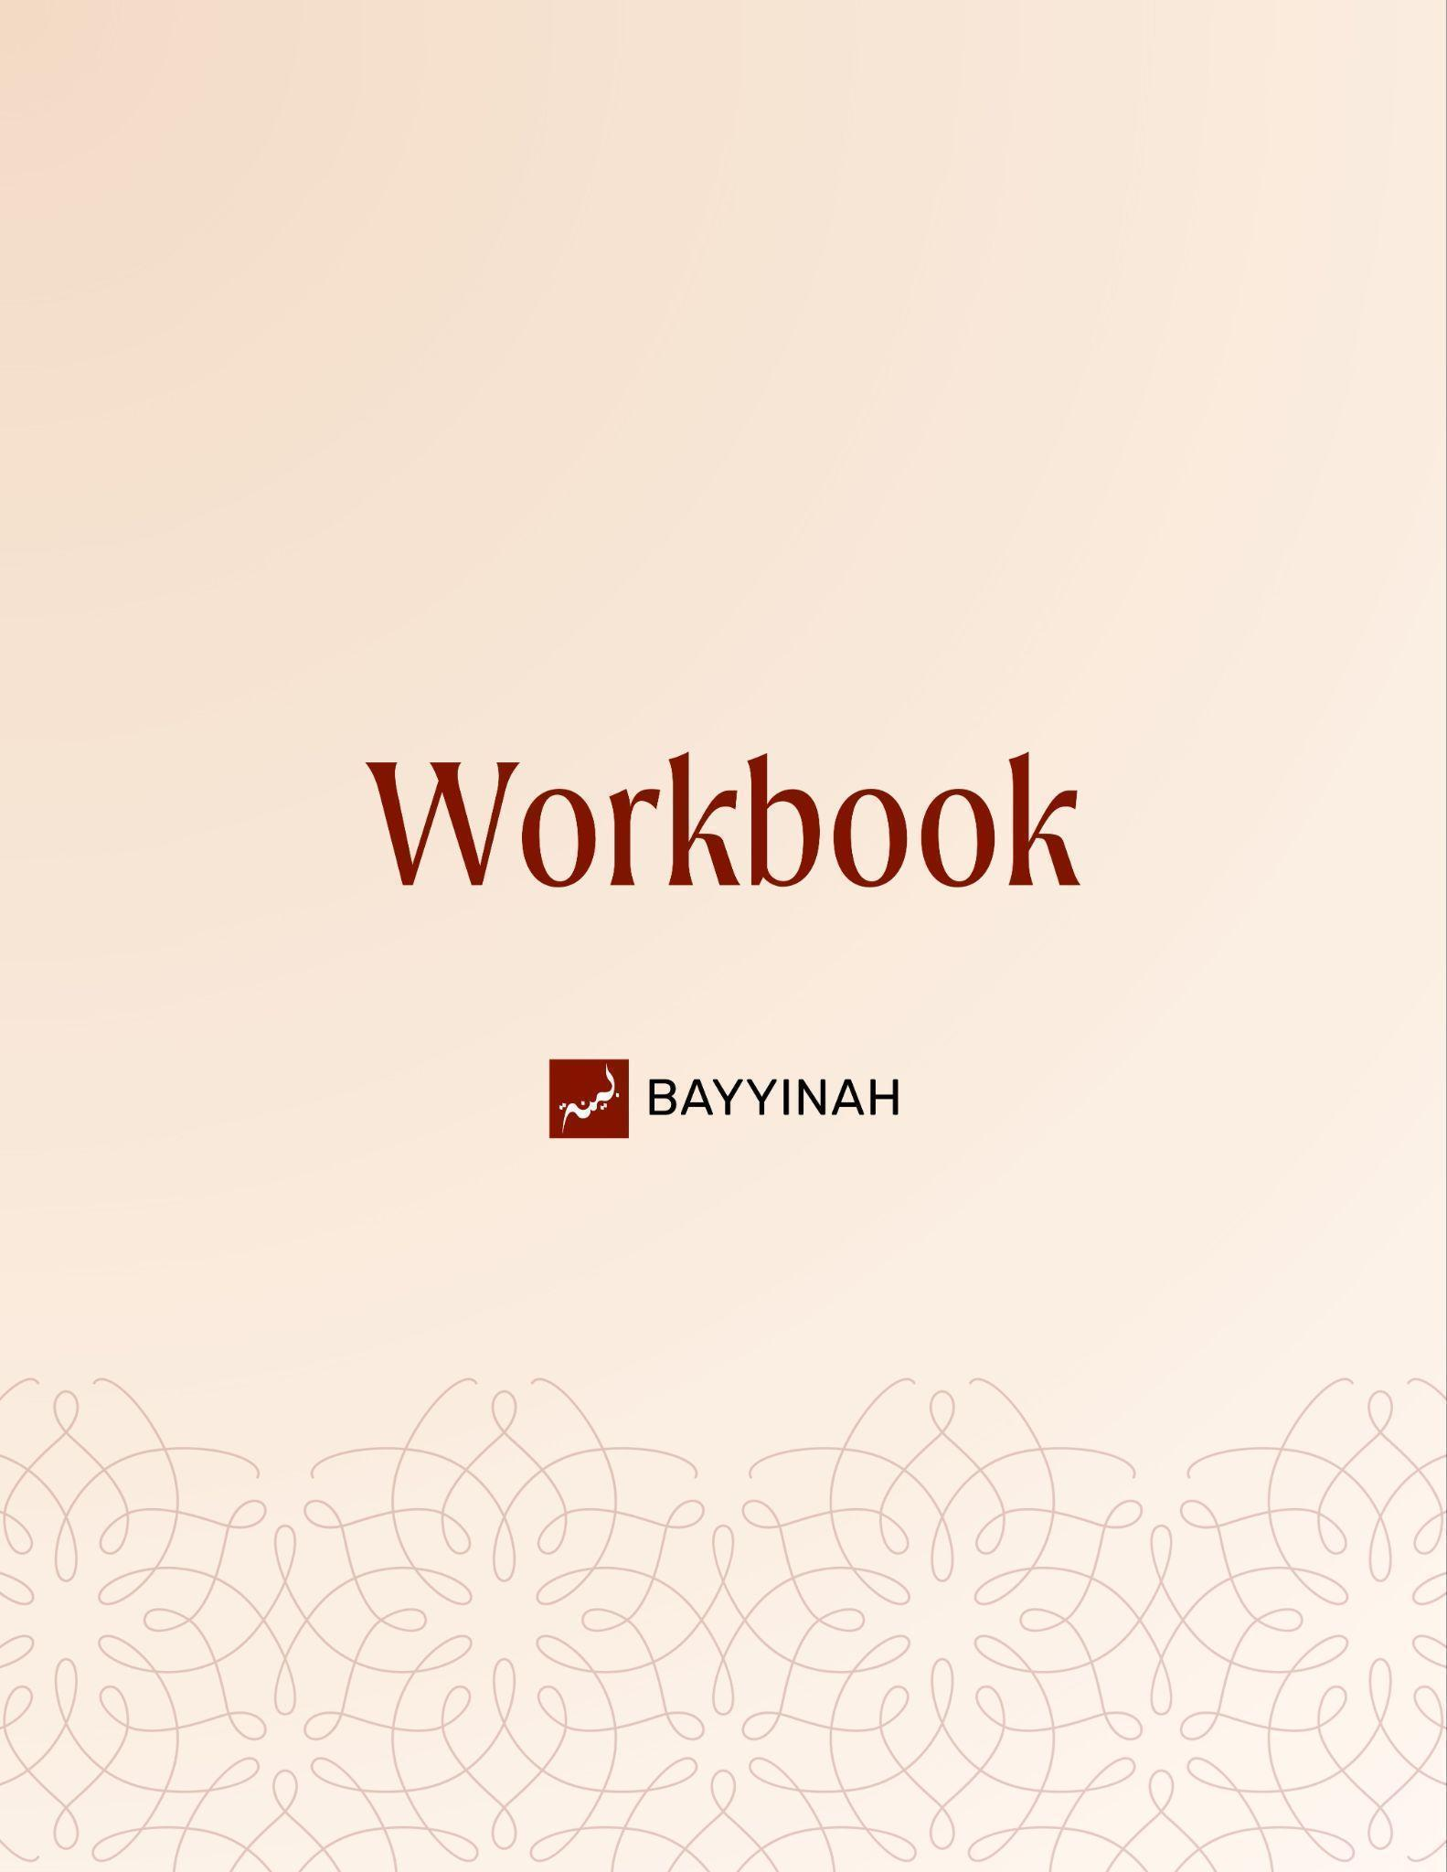
Divine Speech: Verbal Idioms in the Quran

Divine Speech: Verbal Idioms in the Quran

Contents
Introduction.................................................................................................3
Section 1: Verbal Idioms: Meaning Beyond Words....................................4
Section 2: Coolness of the Eyes................................................................5
Section 3: Lowering the Wings.................................................................6
Section 4: Untying the Knot......................................................................7
Ayat References........................................................................................8
Quiz Questions......................................................................................9-10
Reflection Questions................................................................................11
Conclusion & Dua.....................................................................................12

Introduction
This lesson explores how the Quran uses familiar verbal expressions to convey deeper meaning. By studying three idioms: lowering the wings, untying the knot of the tongue and the coolness of the eyes we learn how Allah teaches humility, clarity in speech and true relief through language the Arabs already used.

Key takeaways:
- Idioms as language choices, not inner techniques
- Humility as restraint despite ability
- Clarity in speech under pressure
- Relief that culminates in Allah

Section 1: Verbal Idioms: Meaning Beyond Words
Verbal idioms don’t always mean what the words literally say. Meanings shift with usage, culture, and context, not just dictionaries. Everyday expressions like “what’s up” show this. Arabs spoke this way before Islam, and the Quran uses the same style, so understanding their language helps us understand Allah’s message.

Key takeaways:
- Words don’t stand alone; how people use them gives them meaning.
- When words join together, their meaning can change completely.
- Language isn’t fixed, it grows and shifts with people and time.
- Taking expressions literally often leads to confusion.
- Arabs already spoke in idioms before Islam.
- The Quran speaks in the language people already understood.
- To understand the Quran deeply, you must understand how Arabs expressed meaning.

“You cannot just learn language by looking words up in a dictionary. Language is alive.”

Section 2: Coolness of the Eyes
“Coolness of the eyes” beautifully explains tears of pure joy and a sense of deep relief from life’s storms. In the Qur’an, it refers to the peace a happy family brings and the comfort our beloved Prophet Muhammad ﷺ found in prayer, a direct contrast to the “warmth of the eyes,” which signifies tears of sorrow.

Key takeaways:
- Arabs used these expressions metaphorically, not literally.
- Coolness of eyes also means finding refuge after a storm.
- Family is meant to be an emotional refuge, not another storm.
- Musa’s mother’s reunion shows coolness through joy.
- Fir‘aun’s wife used “coolness of eyes” to calm and persuade.
- Coolness can mean eyes fixed with love and attachment.
- Salah is the Prophet’s ﷺ ultimate relief from life’s storms.
- In worship, tears are not only from fear, but also from joy and gratitude.

“I want a happy house that is so happy that when I come home from work and I see the wife and I see the kids, it makes me so happy that I cry."

Section 3: Lowering the Wings
Lowering your wings means choosing humility despite having strength and independence. Though capable of standing firm, you soften yourself before your parents out of mercy, patience, and obedience. Just as they once protected and endured you, Allah asks you to restrain your power, honor them gently, and earn His mercy in return.

Key takeaways:
- Protective humility: Lowering the wings shows self-sacrifice, like a mother bird shielding her nest at her own cost.
- Chosen weakness (dhull): You act as if your power and independence don’t exist, even though they do.
- Bird metaphor: Raised wings mean rising and flying; lowered wings mean landing and staying grounded.
- Moral choice: The bird lowers its wings by choice, not force—so do we with our parents.
- Role reversal: Parents once lowered their wings for us; now we are commanded to do the same for them.

“When you're dealing with them [parents], I know you have wings, but you need to lower them.”

Section 4: Untying the Knot
This idiom explains “untying the knot” as a request for clear, steady speech. A knot symbolizes tangled thoughts and confusion. Untying it means being able to speak calmly, stay focused, and make sense, especially when under pressure or facing someone who tries to confuse or overpower you.

Key takeaways:
- A “knot” in the tongue is like tangled wires,thoughts are mixed, and nothing comes out clearly.
- Untying the knot means speaking in a straight line: a clear start, middle, and end.
- Fear, anger, and pressure tighten this knot and confuse speech.
- Musa asked for strength to speak despite being mocked for his stutter.
- True clarity comes from Allah, not preparation alone.
- This dua is a prayer for confidence when words threaten to disappear.

“This is one of my favorite duas, actually. Why? Because this dua helped me in public speaking. It's the dua of confidence.”

Ayat References

Surah Al-Furqan (25:74)
رَبَّنَا هَبْ لَنَا مِنْ أَزْوَاجِنَا وَذُرِّيَّاتِنَا قُرَّةَ أَعْيُنٍ وَاجْعَلْنَا لِلْمُتَّقِينَ إِمَامًا
Our Lord! Bless us with pious spouses and offspring who will be the joy
of our hearts, and make us models for the righteous.

Surah Al-Isra (17:24)
وَاخْفِضْ لَهُمَا جَنَاحَ الذُّلِّ مِنَ الرَّحْمَةِ
and lower your wing in humility towards them in kindness

Surah Ta-Ha (20:27)
وَٱحْلُلْ عُقْدَةًۭ مِّن لِّسَانِى
untie my tongue

Quiz Questions

1. The idiom “coolness of the eyes” conveys joy, relief, and focused attention. What is the common idea linking these meanings?
A) A calming pause that relieves distress and distraction
B) Physical sensations caused by temperature changes
C) Emotional release through crying
D) The eye’s natural response to tears
E) The symbolic importance of eyesight in desert life

2. In the context of the "lowering the wings" metaphor, what is the strategic significance of the term dhull (humility/weakness)?
A) It refers to a child’s actual lack of resources or power when dealing with parents
B) Choosing to act humbly and subordinate oneself despite having the ability
C) It represents the physical exhaustion that comes from caretaking for the elderly
D) It is a literal description of a bird that has been injured and can no longer fly
E) It suggests that children must seek their parents' permission for every minor life decision

3. In the story of Firaun’s wife, why is her use of “coolness of the eye” rhetorically effective?
A) It directly opposes Firaun’s political goals
B) It temporarily disarms a tyrant by replacing anger with vulnerability
C) It appeals first to reason before emotion
D) It exposes Firaun’s inconsistency before his generals
E) It redirects the discussion from policy to theology

4. The plea to “untie the knot in my tongue” (uqdatan) is best understood as a prayer for?
A) Perfect eloquence regardless of the audience
B) Removal of all personal insecurities
C) Superior language skills over opponents
D) Freedom from being mocked by others
E) Speech that stays clear and organized under psychological pressure

5. Why is Salah described as the Prophet’s “coolness of the eyes” in contrast to his daily encounters with Quraysh?
A) Prayer replaced the need for social engagement
B) Prayer acted as a reward after difficulty
C) It is a time to reflect specifically on one’s sins and feel the warmth of sorrow
D) Prayer restored inner peace after facing hostility and insult
E) Prayer reminded him of eventual victory

Reflection Questions
Think of a moment when relief or joy reached your eyes before your words. What was happening, and why did it bring that kind of peace?

There are times when we have the power to assert ourselves but choose humility instead. When have you lowered your “wings,” and what effect did it have?

Under pressure, speech and thoughts can tangle easily. When you’ve experienced that, was there anything that helped “untie the knot” for you?

Quiz Answers: 1.A, 2.C, 3.B, 4.E, 5.D

Conclusion
These verbal idioms teach us that the Quran does not speak only to the mind but to moments of pressure, fear and fatigue that shape our lives. To lower the wings is to choose humility when strength is available. To ask for the knot of the tongue to be untied is to admit weakness before responsibility. To seek coolness of the eyes is to long for relief when the heart has been heated by struggle. In each case, Allah guides us away from ego and toward dependence on Him. Family can be a source of that coolness when Allah places peace there. But when people exhaust us and words fail us, salah remains the place where the eyes and heart finally settle. The Prophet ﷺ carried the heat of rejection all day and returned to prayer for relief because only Allah can cool what the world continually burns. These expressions invite us to live with humility, clarity and trust, lowering ourselves where Allah loves it, speaking with care and returning to Him whenever the weight becomes too heavy.

Dua
May Allah teach us to lower our wings in humility, untie the knots of our speech and seek relief where He placed it. May He make our prayer a refuge, our words a trust and our conduct a reflection of the mercy He showed us first.

