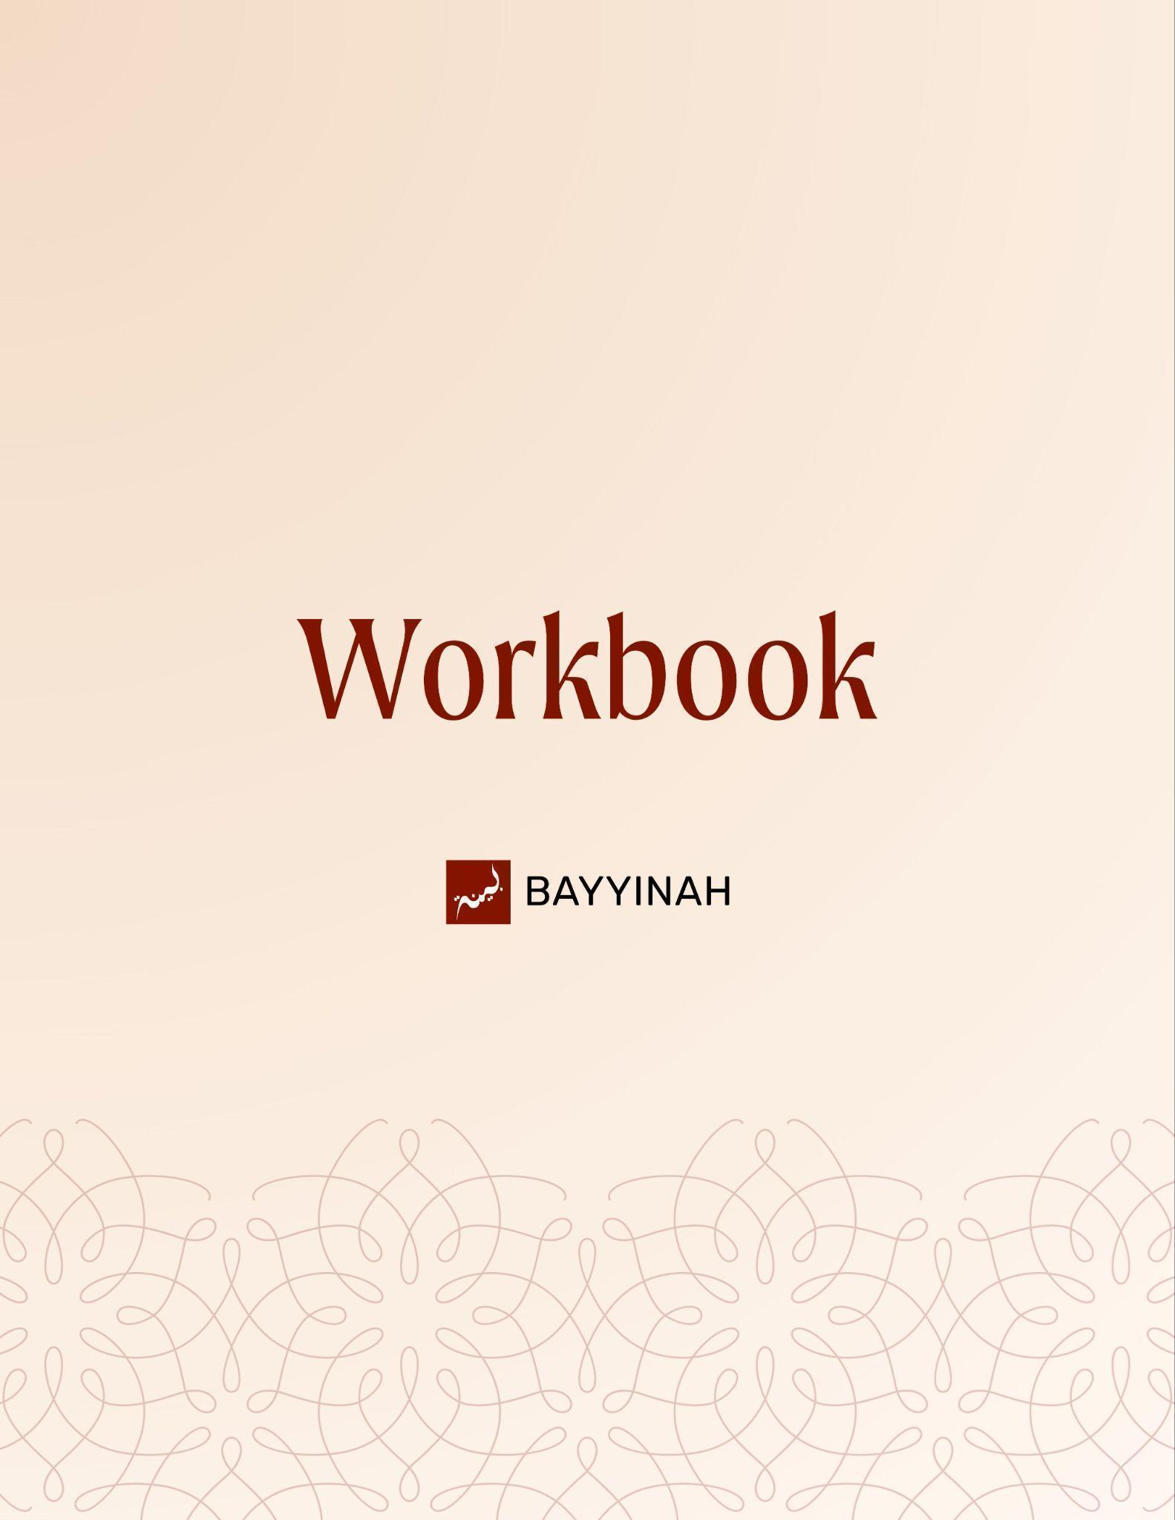
Divine Speech: The Quran is Beyond Explanation

Divine Speech: The Quran is Beyond Explanation

Contents
Introduction............................................................................................. 3
Section 1: The Quran’s Precision in Language and Imagery..................... 4
Section 2: Temporary Human Resolve vs Permanent Divine Decree........ 5
Section 3: Entertainment, Poetry and the Loss of Moral Direction.............6
Section 4: Living in the World of “What Is” vs the World of “What If...........7
Section 5: Exposure of Hypocrisy During Times of Trial.............................8
Section 6: Accusations Against the Prophet ﷺ Unintended Admissions.....9
Section 7: The Quran’s Unmatched Internal Coherence..........................10
Quiz Questions.........................................................................................11
Reflection Questions...............................................................................12
Conclusion & Dua....................................................................................13

Introduction
The Quran speaks with remarkable restraint and depth, using familiar words and images to uncover belief, resistance and sincerity. Its language draws a quiet but firm contrast between the instability of human judgment and the certainty of divine decree, guiding the believer to clarity, honesty and responsibility before Allah.
The Quran speaks to how people think and respond to truth. Through familiar words and precise choices, it reveals where certainty weakens, where resistance begins and how faith is tested, calling the believer to clarity, restraint and responsibility before Allah.

Section 1: The Quran’s Precision in Language and Imagery
Allah speaks with breathtaking economy. Familiar Arabic expressions, knots, valleys, collapsing roofs, convey belief, stubbornness, moral decay, and historical consequence. In a single word, He carries emotional depth, legal finality, and spiritual warning all at once, revealing a precision that no human speech can match.

Key takeaways:
- Quranic language borrows everyday Arab imagery to communicate abstract spiritual truths.
- Words like abrama describe decisions that are sealed and no longer negotiable.
- Small phrases capture both immediacy and long spans of time simultaneously.
- Imagery is never decorative; it always serves guidance and warning.
- Human resolve is portrayed as fragile even when it appears firm.
- The Quran expects reflection not passive reading.

“Allah speaks very briefly and He says a lot. He just gives you an entire picture.”

Section 2: Temporary Human Resolve vs Permanent Divine Decree
The Quran exposes a striking contrast: human decisions feel final but remain reversible while Allah’s decisions are sealed beyond reversal. Through verb and noun forms, Allah reveals that misguidance is chosen first by people yet made permanent only when Allah decrees it.

Key takeaways:
- Human resolve is expressed as a verb, suggesting instability and reversal.
- Divine resolve appears as a noun, signaling permanence and finality.
- Allah does not seal hearts arbitrarily; sealing follows deliberate human refusal.
- People may wish to undo their choices once reality becomes undeniable.
- Regret on Judgment Day reveals the weakness of earlier certainty.
- Allah’s decree overrides human hesitation and second thoughts.
- Language itself teaches accountability before consequence.

“As firm as you think you are, you’re not that firm.”

Section 3: Entertainment, Poetry and the Loss of Moral Direction
The Quran’s description of poets exposes a life without anchoring truth. Chasing applause forces constant reinvention where dignity erodes and purpose disappears. What begins as creativity ends as desperation as people wander from one moral low point to another without restraint.

Key takeaways:
- Poets represent a culture driven by validation not truth.
- “Wandering into every valley” symbolizes moral aimlessness.
- Popularity creates temporary highs followed by deeper desperation.
- Reinvention often requires lowering standards and dignity.
- Entertainment shapes societal values not just individual taste.
- Audiences and artists become mutually dependent and unstable.
- The Quran warns against living without a higher purpose.

“They keep lowering themselves and lowering themselves and lowering themselves.”

Section 4: Living in the World of “What Is” vs the World of “What If”
The Quran trains the mind to anchor itself in reality, not endless speculation. Faith grows through observation, reflection and evidence while doubt multiplies through hypotheticals. Clear thinking is not optional in Islam; it is a spiritual discipline rooted in revelation.

Key takeaways:
- The Quran emphasizes observation over speculation.
- Endless “what if” questions produce confusion not clarity.
- Truth is grounded in signs within creation history and the self.
- Philosophical doubt often jumps from one uncertainty to another.
- Imaan is built on recognizing reality not escaping it.
- Muslims are taught how to think not just what to believe.
- Clear thinking protects faith under pressure.

“The Quran teaches you and me to live in the world of what is, not in the world of what if.”

Section 5: Exposure of Hypocrisy During Times of Trial
The Quran reveals that hypocrisy survives comfort but collapses under fear. Loyalty spoken in ease dissolves when risk appears. Through a single word choice, Allah exposes who truly belonged to the Prophet ﷺ and who only stayed close while benefit seemed guaranteed.

Key takeaways:
- Hypocrisy thrives when faith carries no cost.
- Ease allows false loyalty to blend in unnoticed.
- Crisis forces hidden intentions into the open.
- Language itself becomes a means of exposure.
- Calling the city Yathrib signals rejection of prophetic authority.
- True commitment remains steady under pressure.
- Trials clarify who follows truth and who follows advantage.

“You don’t have to accuse the hypocrite of being a hypocrite. They’ll tell you themselves.”

Section 6: Accusations Against the Prophet ﷺ as Unintended Admissions
The Quraysh’s insults were not merely mockery; they exposed surrender. Unable to explain the Quran rationally, they labeled it magic. Unable to dismiss its persistence, they called the Prophet ﷺ a relentless liar. Their accusations confessed that revelation defied ordinary explanation.

Key takeaways:
- Calling the Quran magic admits it exceeds rational dismissal.
- Magic implies belief in an unseen force beyond explanation.
- Accusations reflected confusion rather than certainty.
- Repeated claims of lying acknowledged unwavering commitment.
- Insults masked intellectual defeat.
- Language reveals inner acknowledgment of truth.

“When you cannot explain things through common sense, you call it a mystery of the unknown. And the mystery of the unknown is called magic.”

Section 7: The Quran’s Unmatched Internal Coherence
Allah speaks with breathtaking economy. Familiar Arab expressions—knots, valleys, collapsing roofs—are repurposed to convey belief, stubbornness, moral decay and historical consequence. A single word choice carries emotional psychology, legal finality and spiritual warning at once, revealing a precision no human speech can maintain.

Key takeaways:
- Similar objections across Surahs receive proportionate linguistic emphasis.
- Additional claims trigger additional layers of reinforcement.
- The Quran cross-references meaning without repetition or contradiction.
- Emphasis increases only when the argument requires it.
- Memory across revelation defies human capacity.
- Language adjusts with mathematical precision.
- Coherence itself becomes proof of divine origin.

“The Quran remembers what it said in one surah and compares it perfectly to another surah.”

Quiz Questions

1. What does the Quran’s use of everyday imagery like knots valleys and collapsing roofs primarily demonstrate?
A) Historical construction methods
B) Cultural nostalgia
C) Decorative storytelling
D) Precision in conveying layered spiritual meaning
E) Linguistic simplicity

2. Why does the Quran describe human decisions with verb forms and divine decisions with noun forms?
A) To reflect grammatical preference
B) To indicate emotional expression
C) To show temporary human resolve versus permanent divine decree
D) To mirror classical Arabic poetry
E) To simplify translation

3. What does “wandering into every valley” symbolize in the Quran’s description of poets and entertainers?
A) Intellectual curiosity
B) Love of travel
C) Spiritual exploration
D) Moral aimlessness driven by validation
E) Artistic freedom

4. According to the lecture, what exposes hypocrisy most clearly?
A) Public debate
B) Times of ease
C) Private worship
D) Economic success
E) Times of trial and fear

5. Why did calling the Prophet ﷺ a magician unintentionally affirm the Quran’s power?
A) It acknowledged artistic beauty
B) It suggested political manipulation
C) It reflected tribal rivalry
D) It showed belief in folklore
E) It admitted the message could not be rationally dismissed
Reflection Questions
Where in your life have you “tied a knot” in your thinking and convinced yourself you will never reconsider it even if truth becomes clearer later?

How do moments of hardship expose the sincerity of your faith and what do they reveal about the loyalties you claim in times of ease?

When doubts arise do your thoughts move toward observable reality and revelation or do they spiral into endless “what if” scenarios?

Quiz Answers: 1.D, 2.C, 3.D, 4.E, 5.E

Conclusion
The Quran guides the believer to live with awareness, restraint, and courage. Its teachings ask us not only to listen but to respond, to soften when pride resists, to steady ourselves when obedience feels heavy, and to uphold the truth even when it costs comfort. When its language is taken seriously, faith becomes clearer, intentions purer, and loyalty manifests through action. Its words shape our choices, discipline our hearts, and draw us closer to Allah with honesty and resolve.

Dua
May Allah grant us clear thinking and sincere resolve, protect us from hardened hearts and distracted minds, and keep us firmly grounded in His revelation. Let the Quran guide our understanding, strengthen our faith and settle our hearts upon truth.

