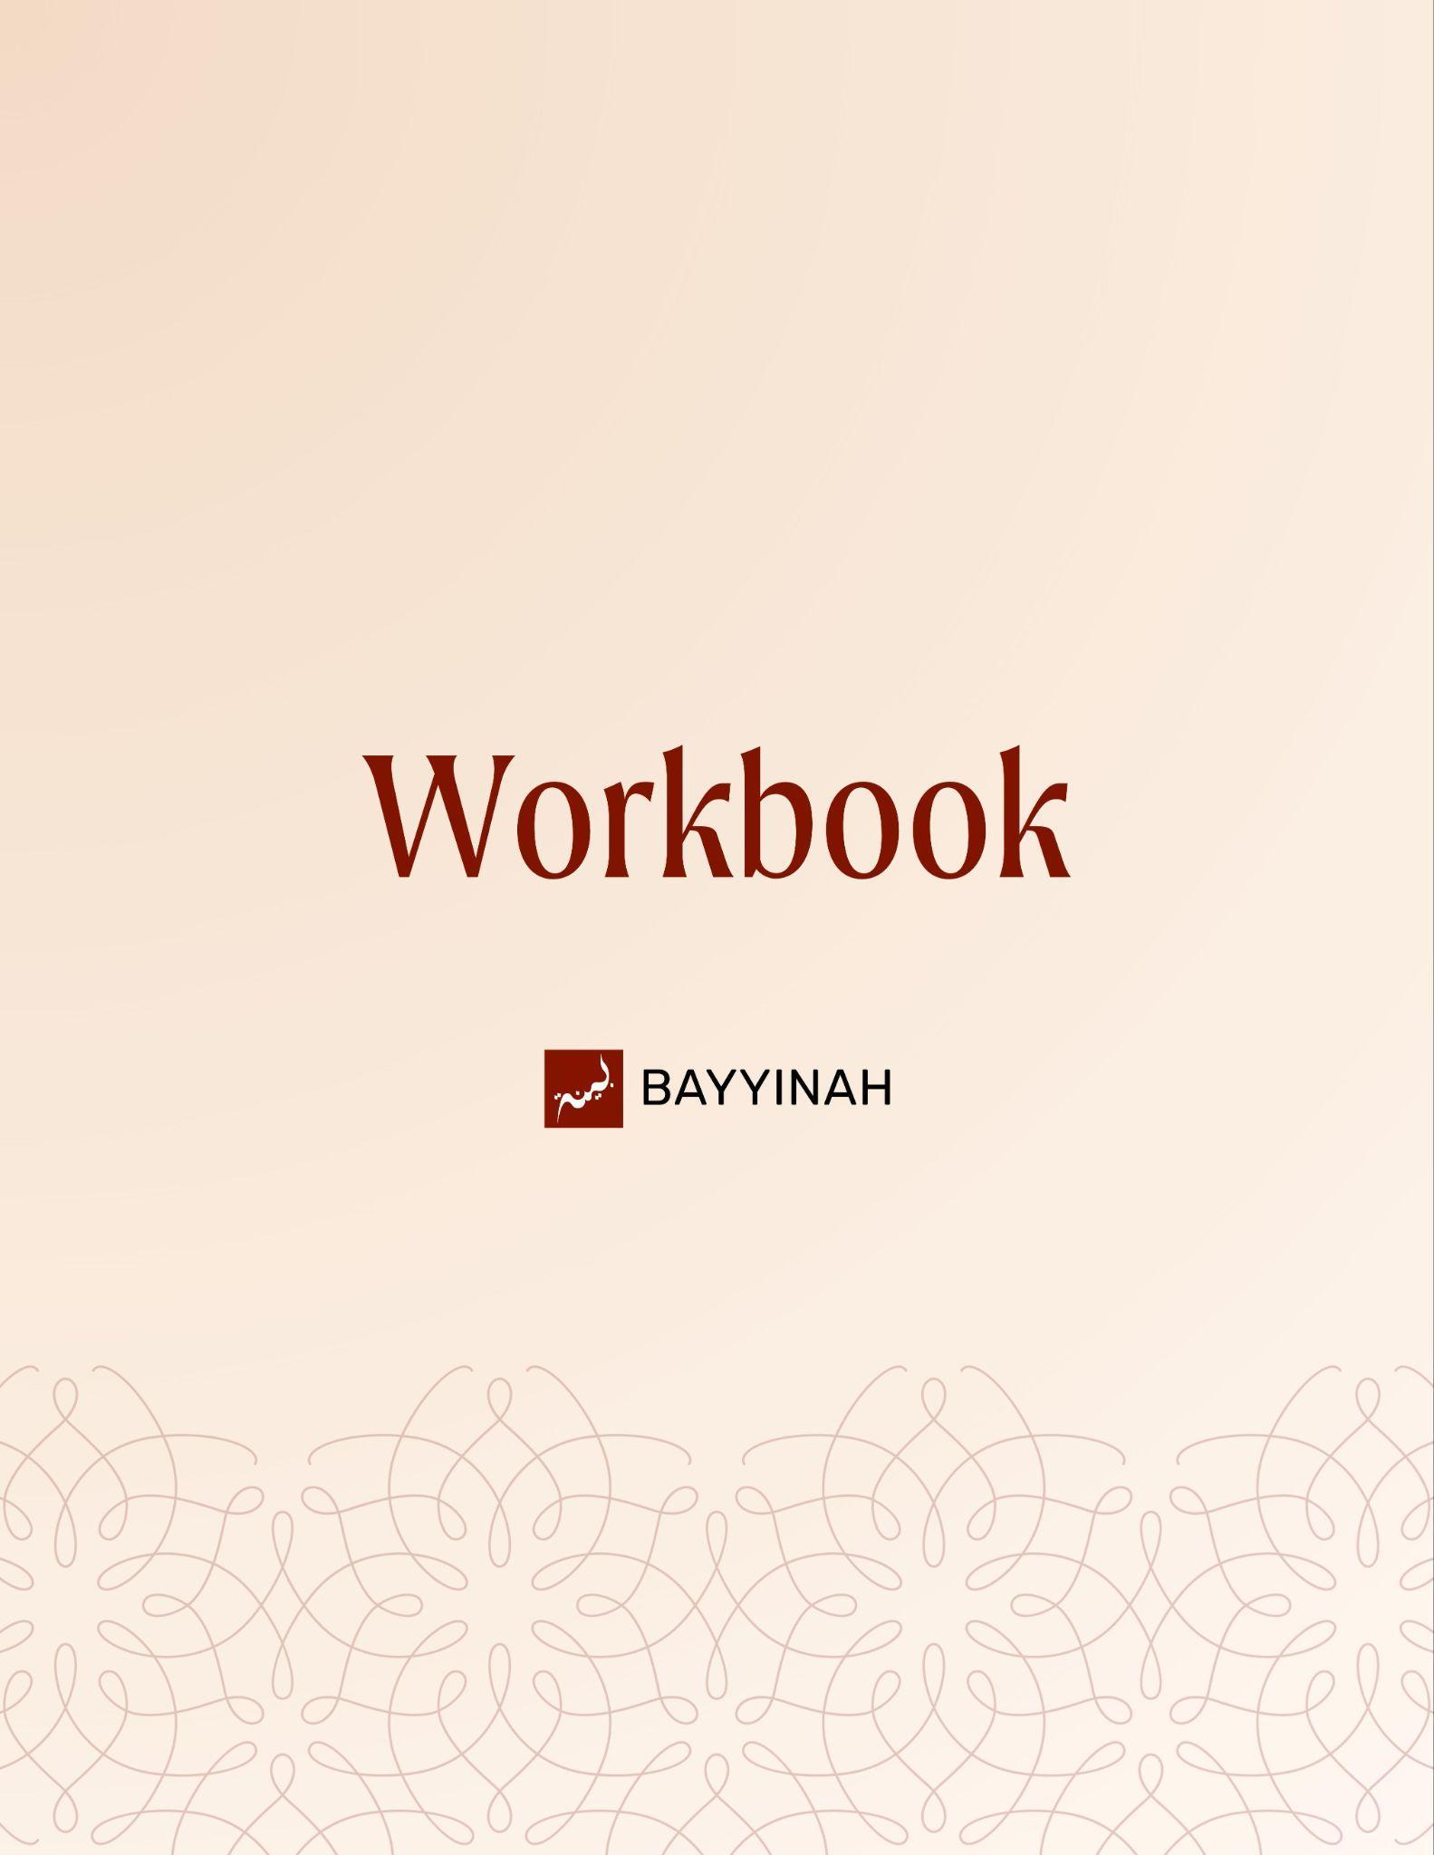
Divine Speech: What Does Allah See in You

Divine Speech: What Does Allah See in You

Contents
Introduction: The Precision of Quranic Language Is Meaning-Bearing…..3
Section 1: Weak and Strong Plurals Shape How Allah Frames Reality......4
Section 2: Allah’s Absolute Reassurance and Control………………..........5
Section 3: Allah Expands the Door to Jannah on Purpose………………...6
Section 4: Allah Chooses in Different Ways and That Includes You..........7
Section 5: Being Chosen Does Not Mean the Task Is Easy……...............8
Section 6: Emotional States Do Not Excuse Behavior……………….........9
Quiz Questions........................................................................................10
Reflection Questions...............................................................................11
Conclusion & Dua....................................................................................12

Introduction: The Precision of Quranic Language Is Meaning-Bearing
The episode repeatedly demonstrates that Arabic word choices in the Quran are never interchangeable. Whether it is singular vs plural or one plural form over another, Allah’s choices carry theological and emotional meaning. Translation alone flattens these layers and hides divine intent. This theme establishes the Quran as deliberate speech where even subtle grammar shifts reflect spiritual realities.

Key takeaways:
- The Quran does not use synonyms casually
- Grammar in the Quran carries theology
- Translation often hides meaning rather than reveals it
- Allah teaches through linguistic contrast
- Studying Arabic reveals divine intentionality
- Precision in wording reflects precision in guidance

“We say the Quran uses every word perfectly, but we don’t taste it. I want you to taste it.”

Section 1: Weak and Strong Plurals Shape How Allah Frames Reality

Arabic plurals are not equal. Some indicate scarcity while others suggest overwhelming abundance. Allah deliberately selects which plural to use based on the spiritual reality being described, not the numerical count. Language here becomes a lens through which Allah trains perception.

Key takeaways:
- Arabic has multiple plurals for a single word
- Weak plurals suggest limited quantity or capacity
- Strong plurals suggest abundance and power
- Allah chooses plurals based on meaning not math
- Similar numbers can carry opposite implications
- Quranic language reshapes how we measure value.

“It’s the same number but one is mysteriously far more powerful than the other.”

Section 2: Allah’s Absolute Reassurance and Control
When Allah describes Ibrahim (AS) as grateful for “a few blessings” it feels surprising until perspective shifts. No matter how sincere or constant gratitude is human effort can never match divine generosity. The Quran humbles even the greatest believer without diminishing their rank.

Key takeaways:
- Human gratitude has a ceiling
- Even prophets cannot thank Allah fully
- One blessing contains countless favors
- Allah measures gratitude realistically
- Weak plurals reflect human limitation not failure
- Humility is embedded in Quranic praise.

“You can’t even fully account for one gift of Allah.”

Section 3: Allah Expands the Door to Jannah on Purpose

By comparing “rushing” and “racing” toward Jannah the Quran shifts tone and audience. One invitation is demanding and exclusive. Another is wide and reassuring. Allah does this intentionally to prevent despair and to remind believers that mercy is not accidental.

Key takeaways:
- The Quran issues different invitations to Jannah
- Language intensity reflects spiritual access
- Some descriptions narrow the audience
- Others deliberately widen the door
- Allah does not want believers to give up
- Mercy is a calculated divine choice.

“He didn’t have to open it wider. He chose to.”

Section 4: Allah Chooses in Different Ways and That Includes You

The Quran uses different words for choice depending on reason and process. Prophets are chosen purely by divine will. Believers are chosen based on unseen potential. Becoming Muslim is not random inheritance. It is Allah recognizing something worth investing in.

Key takeaways:
- Not all “choices” mean the same thing in the Quran
- Prophethood is pure divine selection
- Belief is selection based on qualification
- Being Muslim is not accidental
- Allah sees potential before performance
- Faith itself is an act of divine confidence.

“Allah decided you will be Muslim.”

Section 5: Being Chosen Does Not Mean the Task Is Easy
Allah assigns impossible standards then immediately removes despair by promising ease. The believer is asked to strive as Allah deserves while being reassured that hardship is not the goal. Difficulty does not disqualify. It confirms divine support.

Key takeaways:
- Allah sets an impossible standard intentionally
- Feeling unqualified is expected
- Ease comes from Allah not from the task
- Prophetic struggle defines the legacy
- Comparison to Ibrahim (AS) reframes hardship
- Complaints shrink in light of divine aid.

“If Allah can make the impossible easy for Ibrahim what are you going to complain about?”

Section 6: Emotional States Do Not Excuse Behavior

The Quran distinguishes between the heart that changes and the heart that burns with emotion. Allah holds humans accountable even in moments of anger, fear or intensity. Emotional overwhelm does not suspend moral responsibility.

Key takeaways:
- The Quran names different states of the heart
- Intense emotion does not remove accountability
- Anger fear and passion are not excuses
- Allah interrogates emotional behavior
- Self-control is a spiritual obligation
- Responsibility extends to inner states.

“You don’t get to blame your fu’ad.”

Quiz Questions
1. Why does the Quran use different plural forms for the same word??
A) To preserve poetic rhythm
B) To reflect dialect differences
C) To distinguish historical periods
D) To convey spiritual meaning beyond quantity
E) To simplify memorization

2. Why is Ibrahim (AS) described as being grateful for “a few blessings”?
A) Because his blessings were limited
B) Because gratitude was not his defining trait
C) Because human gratitude can never match divine generosity
D) Because earlier Prophets had fewer favors

3. What is the key difference between sāri‘ū and sābiqū in Quranic invitation?
A) One refers to worldly effort and the other to worship
B) One implies individual action and the other communal action
C) One suggests urgency and the other competition
D) One applies to Prophets only
E) One describes fear and the other hope

4. According to the episode, why does Allah use ijtibā’ when referring to believers?
A) Because belief is inherited
B) Because believers earn faith through effort alone
C) Because belief is culturally conditioned
D) Because Allah chooses believers based on unseen potential
E) Because belief removes human weakness

5. Why does the Quran mention fu’ād instead of qalb in accountability?
A) To describe physical health
B) To excuse emotional behavior
C) To emphasize emotional intelligence
D) To justify extreme reactions
E) To show that intense emotions are still accountable

Reflection Questions
Which Quranic example from this lesson most challenged how you think about gratitude and why?

How does knowing that Allah chose you as a believer change the way you view your responsibilities in the deen?

In moments of emotional intensity anger, fear or excitement, how do you usually justify your reactions and how does the concept of fu’ād challenge that?

When you think about Allah expanding the invitation to Jannah rather than restricting it, which feelings arise and how should that shape your relationship with hope and effort?

Quiz Answers: 1.D, 2.C, 3.C, 4.D, 5.E

Conclusion

This lesson quietly shifts how we see ourselves in the Quran. Allah’s speech is not distant or abstract. It is carefully measured to meet human weakness with mercy and human potential with trust. The Quran does not flatter us yet it never abandons us. It reminds us that our gratitude will always fall short yet it is still cherished. Our efforts will always be imperfect yet they are still invited. Allah sets standards that feel impossible not to discourage but to show us that success was never meant to come from our strength alone. Being chosen as a believer is not proof of arrival but proof of responsibility. Allah saw something in us worth nurturing long before we saw it in ourselves. The language of the Quran trains the heart to think honestly about limits without surrendering hope. It teaches us that emotional intensity does not excuse behavior and that divine mercy is not narrow or elitist. Every invitation to rush or race toward forgiveness is a reminder that Allah wants us moving forward not frozen by guilt or fear. What remains is not admiration of linguistic beauty alone but action shaped by humility, gratitude, restraint and trust in the One who chose us.

Dua
May Allah deepen our reverence for His words and allow us to taste their meaning beyond translation. May He help us recognize the potential He sees in us and give us the courage to act on it with sincerity. May He accept our limited gratitude, overlook our shortcomings and guide our emotions toward what pleases Him. May Allah make us of those who rush toward forgiveness, race toward goodness and live with responsibility, hope and humility until we return to Him.

