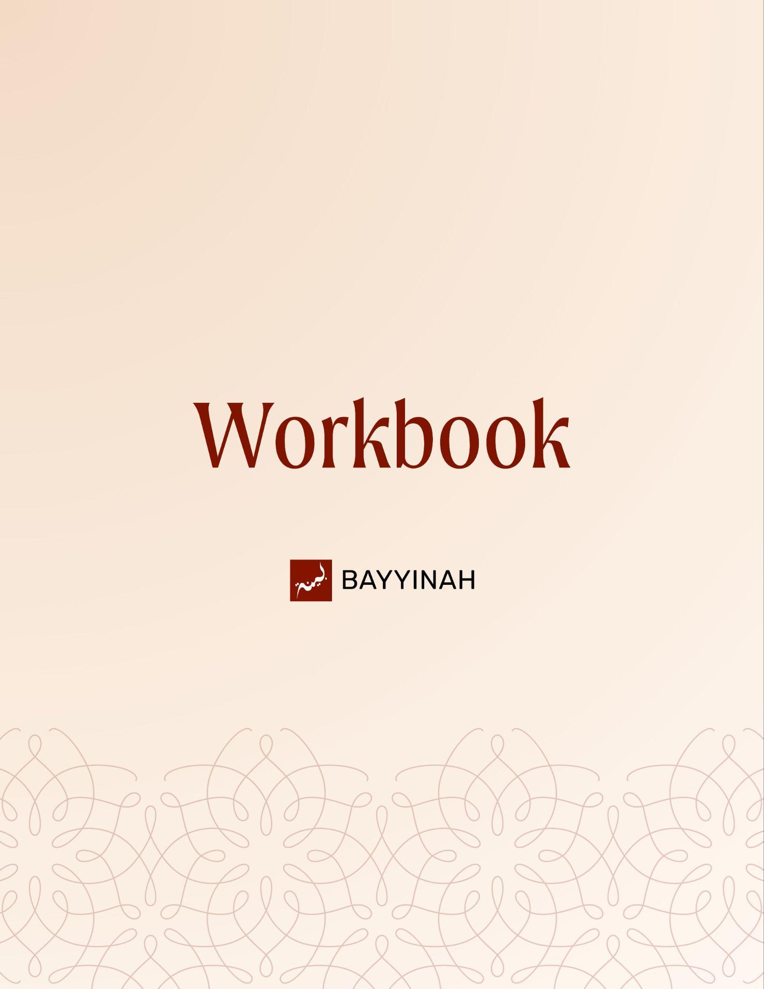
Divine Speech: Consistency in the Quran

Divine Speech: Consistency in the Quran

Contents
Section 1: Fu’ad vs. Qalb: When the Heart Is Overwhelmed……....….......3
Section 2: Rabt al-Qalb: Allah ﷻ Steadying What Humans Cannot ..……..4
Section 3: Healing the Heart Beyond Imaan..……….……….……...………5
Section 4: Being Trapped in the Past and Allah ’s Power to Heal…….......6
Section 5: Miṣran: Asking for Egypt Without Saying Egypt.………..………7
Section 6: The Psychology of Slavery....…...…….…….….……..…............8
Section 7: Dignity in Quranic Address……………..………..............………9
Quiz Questions……..…..………...………………………………...………….10
Reflection Questions…………..……………………………...…...…………..11
Conclusion and Dua.…………..…….…….…………………...…………...12

Section 1: Fu’ad vs. Qalb: When the Heart Is Overwhelmed
The Quran does not speak about the heart in vague or interchangeable terms. It tracks emotional intensity with precision. When emotion overwhelms beyond control the Quran calls the heart fu’ad. When calm and restraint return it becomes qalb again. Allah ﷻ names inner chaos and shows that emotional states are real measured and addressed by revelation.

Key takeaways:
- Qalb refers to a heart that is stable and functioning.
- Fu’ad describes a heart overtaken by intense emotion.
- The Quran changes vocabulary as emotional states change.
- Emotional overwhelm is recognized not criticized.
- Allah ﷻ tracks inner states with exact wording.
- Language itself becomes a form of tafsir.
- Precision in revelation mirrors precision in human experience..

“The rage of emotions were so many that her heart is not described as just qalb but as fu’ad because it’s overwhelmed. It’s burning.”

Section 2: Divine Intervention in Human Emotional Limits (Rabt al-Qalb)
Some emotional moments exceed human capacity entirely. The mother of Musa (AS) was not expected to manage her fear or restraint on her own. Allah ﷻ intervened directly tying her heart with calm.
This calm was not self-generated from a human perspective, her restraint was psychologically impossible. A mother’s instinct to protect overrides logic, fear and consequence.Yet she did not run after the basket. Not because she was strong, but because Allah stabilized her heart. Emotional stability here was not self-control but divine intervention.

Key takeaways:
- Some emotional reactions are psychologically impossible to manage alone.
- Maternal instinct makes restraint nearly unthinkable.
- Allah ﷻ intervenes when human limits are reached.
- Rabt al-qalb means imposed calm not learned patience.
- Emotional strength can be gifted not earned.
- Healing can be immediate by Allah’s ﷻ will.
- Calmness is sometimes an act of mercy not effort.

“The calmness of her heart did not come from her, it came from Allah ﷻ ”

Section 3: Healing the Heart Beyond Imaan
The Quranic idea of a healthy heart extends beyond belief alone. A heart can affirm Allah ﷻ yet remain damaged by resentment, jealousy or unresolved conflict. Spiritual health includes how we carry people inside us. A heart trapped in memory cannot be a qalb salim. Emotional health is not optional. It is a requirement for meeting Allah.

Key takeaways:
- A healthy heart is not limited to faith alone.
- Emotional wounds toward people live in the heart.
- Grudges and hatred compromise spiritual health.
- Judgment Day success depends on a sound heart.
- Relationships are part of religious accountability.
- Worship cannot cancel unresolved bitterness.
- Healing requires repairing human ties.

“If I have feelings towards other people, my heart is not healthy.”

Section 4: Living in the Past vs. Allah’s ﷻ Power to Heal
The lecture confronts emotional stagnation head-on. Reliving old pain reopens wounds that Allah ﷻ has already offered to heal. The Quran rejects the idea that people are trapped by their past. Allah ﷻ can intervene between a person and their heart and move them forward.

Key takeaways:
- Living in past trauma keeps the heart wounded.
- Replaying old conflicts renews emotional damage.
- Healing is possible even after severe loss.
- Emotional paralysis is not permanent.
- Allah ﷻ intervenes directly in the human heart.
- Letting go is a divine gift not weakness.
- Forward movement is part of faith..

“Allah ﷻ has the capacity to move you forward to let you let go of the past to heal the previous damage that was done and you can live your life.”

Section 5: Miṣran: Asking for Egypt Without Saying Egypt
A single grammatical shift carries sharp moral critique. When Musa(AS) says Miṣran instead of Miṣra he exposes the real request behind food complaints. Craving Egypt’s menu means craving its humiliation bondage and rage. Here the quranic language delivers history judgment and sarcasm at once.

Key takeaways:
- Small linguistic shifts carry massive meaning.
- Miṣran signals countryside not Egypt.
- The word choice mirrors their desire to return to slavery.
- Food nostalgia reflects spiritual regression.
- Egypt symbolizes humiliation, stagnation and fear.
- Musa’s response is deliberate and biting.
- The Quran embeds critique inside grammar.

“In one word, Musa said, you’re asking for another Egypt.”

Section 6: Slavery as a Psychological State Not Just a Physical One
Egypt in the Quran is more than a place. It represents a mindset shaped by humiliation, fear and stagnation. Even after physical freedom people can crave the familiarity of oppression. The Israelites’ longing reveals how captivity can live inside the heart long after chains are removed.

Key takeaways:
- Slavery reshapes how people think and desire.
- Freedom feels threatening after long humiliation.
- Oppression conditions people to accept stagnation.
- Nostalgia for comfort can mask trauma.
- Egypt symbolizes fear, humiliation and rage.
- Psychological chains outlast physical ones.
- True liberation requires inner change.

“When you say I miss prison food, isn’t it the same as saying I miss prison?”

Section 7: How the Quran Addresses Other Communities With Dignity
The Quran models engagement without hatred. Allah ﷻ speaks directly to Bani Isra’eel not about them. Precision in language preserves theological truth while maintaining respect. Disagreement does not cancel human dignity. The Quran teaches conversation clarity and restraint not hostility or inherited resentment.

Key takeaways:
- Allah ﷻ addresses other communities directly.
- Speaking to people is different from speaking about them.
- Disagreement does not justify dehumanization.
- The Quran maintains dignity even in correction.
- Isa (AS) is identified with precision not polemic.
- Identity is handled carefully through language.
- Believers are taught restraint not rage..

“The Quran does not command, encourage, or tell us to hate Jews.”

Quiz Questions
- Why does the Quran use fu’ad instead of qalb for the mother of Musa (AS)?
A) To describe physical pain
B) To show disbelief
C) To indicate emotional overwhelm
D) To describe long-term sadness
E) To emphasize intellect
- What does rabt al-qalb demonstrate in the story of Musa’s mother?
A) Learned patience through hardship
B) Emotional suppression
C) A test of faith alone
D) Divine intervention beyond human capacity
E) Habitual self-control
- According to the lecture what compromises the soundness of the heart besides weak Imaan?
A) Lack of knowledge
B) Financial struggle
C) Unresolved resentment toward people
D) Physical illness
E) Social isolation
- Why is the word Miṣran used instead of Miṣr in Surah Al-Baqarah?
A) To refer to a specific city
B) To soften Musa’s tone
C) To indicate travel distance
D) To mock agricultural life
E) To morally critique a desire to return to slavery
- How does the Quran model engagement with other communities?
A) Through silence
B) Through hostility
C) Through debate
D) Through inherited resentment
E) Through direct address with dignity

Reflection Questions
What emotional reaction in your life feels genuinely beyond your control and how does the story of rabt al-qalb change the way you seek Allah ﷻ ’s help in that moment?

Are there past conflicts or memories you continue to replay even after circumstances have changed and how might letting go be an act of faith?

In what ways do your relationships with people affect the spiritual health of your heart?

How does the Quran’s respectful address of disagreement challenge the way you speak about or to those you differ with?

Quiz Answers: 1.C, 2.D, 3.C, 4.E, 5.E

Conclusion
This passage reminds us that the Quran does not speak in abstractions. It speaks to real hearts in real pain. Allah ﷻ names emotional overwhelms, acknowledges human limits and then steps in with mercy. Whether it is a mother frozen by fear, a community longing for the comfort of oppression or believers trapped in unresolved resentment, the Quran insists that hearts can change. Not through denial or toughness but through Allah’s direct intervention. The heart is not sealed by trauma nor defined by the past. Allah can loosen what feels knotted and steady what feels like it is burning.
At the same time the Quran widens our understanding of spiritual health. Faith is not isolated from people. A heart that prays but carries bitterness is still wounded. A heart that believes but dehumanizes others is still unwell. Precision in language teaches precision in living. We are asked to be honest about our emotions, courageous about healing and dignified in how we deal with others. This is not passive spirituality. It calls for repair, forgiveness, restraint and trust that Allah ﷻ can do what we cannot. The Quran invites us to bring our hearts as they are and to believe that Allah ﷻ can return them to soundness.

Dua
May Allah tie our hearts with calm when emotions overwhelm us. May He heal wounds we thought were permanent and release us from living in the past. May He grant us hearts that are sound with Him and gentle with people. May He replace resentment with clarity, fear with trust and bitterness with dignity. May Allah allow us to walk forward lighter, steadier and closer to Him.

