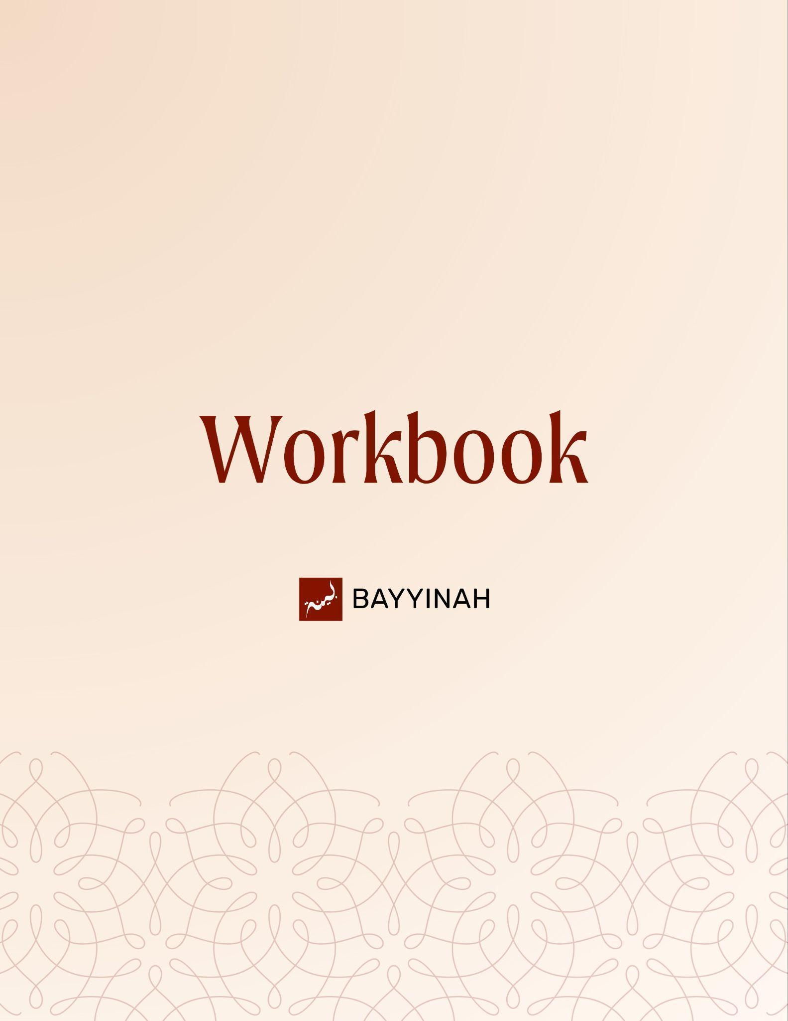
Divine Speech: Transitions in the Quran

Divine Speech: Transitions in the Quran

Contents
Section 1: How the Quran Speaks About Justice......................................3
Section 2: Intricate Word Choice as Moral Guidance…............................4
Section 3: The Power of Transitions in the Quran ....................................5
Section 4: Shifts of Address in Quranic Discourse....................................6
Quiz Questions..........................................................................................7
Section 5: Subject Choice in the Quran.....................................................8
Section 6: Tense as Meaning.....................................................................9
Section 7: How the Quran Uses Words to Teach......................................10
Section 8: How Quranic Language Records History..................................11
Section 9: The Perfection in Quranic Sequencing.....................................12
Quiz Questions.........................................................................................13
Reflection Questions...............................................................................14
Conclusion & Dua....................................................................................15

Section 1: How the Quran Speaks About Justice
Surah Al-Hujurat (49:9) teaches justice through how it speaks, not only through what it commands. It begins by calling for peace between two groups, then shifts when wrongdoing continues. By using both ʿAdl—open, visible justice—and Qist—personal fairness and restraint from injustice the Quran shows that justice lives both in public action and inner honesty. Strong communities grow where personal integrity supports just collective response.

Key takeaways:
- Both fighting groups remain believers; faith is not negated by conflict.
- The community’s first duty is neutral reconciliation, not judgment.
- Violating a peace agreement makes the aggressor accountable to the whole community.
- After renewed aggression, collective action against the transgressor becomes obligatory.
- Repeated wrongdoing shifts resolution from private to public accountability.
- Allah loves those who uphold justice personally and communally, openly and privately.

“This is the formula Allah ﷻ is teaching us to solve community problems.”

Section 2: Intricate Word Choice as Moral Guidance
Surah Ali Imran (3:141) shows that purification is not abstract or easy. The word Maḥaṣa is used, a term drawn from refining gold through fire. It points to how believers are shaped through real trials. Moments like the Battle of Uhud revealed hidden hypocrisy and strengthened sincere faith. Through this wording, the Quran teaches that hardship is often the means by which character and belief are refined.

Key takeaways:
- The Quran teaches meaning not only through statements, but through precise word choice.
- In Surah Ali-Imran, Allah uses tamḥīṣ to describe purification, a word associated with refining gold through fire.
- This choice shows that believers are not purified through ease, but through intense trials.
- The hardship of Uhud served to expose what was hidden within the community.
- Hypocrisy is portrayed as an impurity that surfaces only under pressure.
- At the same time, believers are likened to precious metal, not discarded but refined.

“Believers cannot be cleaned unless they are put to the flames, and the flames in this case are the flames of war.”

Section 3: The Power of Transitions in the Quran
The Quran often shifts between “they,” “you,” and “we” to teach with precision. Allah ﷻ begins by speaking about another group or a future scene, then directly addresses the listener. These transitions remove distance and place the listener within the message itself. By moving between past nations, future outcomes, and present commands, the Quran turns description into direct guidance and responsibility.

Key takeaways:
- The Quran can address more than one audience at the same time within a single verse.
- Shifts between “you” and “they” are intentional and guide each listener to examine themselves.
- References to earlier nations are not historical distance; they are direct moral warnings for later communities.
- Sudden changes in address prevent listeners from feeling detached or uninvolved.
- The Quran draws the listener emotionally into scenes of reward or warning through direct speech.
- These linguistic transitions show that divine teaching works through form as much as meaning.

“And these transitions, this is 1400 plus years ago.”

Section 4: Shifts of Address in Quranic Discourse
The Quran uses shifts in perspective, distance, and focus to convey deep lessons. Allah ﷻ moves the reader from land to sea, from the battlefield to the heart, and from outward scenes to inner belief. These transitions are deliberate. By changing who is addressed and how close the view feels, the Quran draws the reader into fear, hope, and trust, turning description into lived guidance.

Key takeaways:
- The Quran presents scenes in a gradual and deliberate way, guiding the reader from one moment to the next.
- The shift from “you” to “they” reflects increasing distance, moving from safety on land to danger at sea.
- Pronoun changes show how a person’s state changes from control to helplessness.
- The calm journey turning into a storm teaches how ease can suddenly become a test.
- In moments of fear, all distractions fade and supplication becomes sincere.
- The Quran describes both what happens outwardly and what occurs within the heart.
- These transitions show that Allah’s knowledge surrounds events, emotions, and thoughts alike.

“Allah ﷻ provides the aerial view.”

Quiz Questions
- Why is the first attempt at reconciliation implied to be discreet?
A) To hide wrongdoing
B) To avoid legal consequences
C) To protect dignity while trust still exists
D) To delay judgment
E) To establish authority
- How does the Ayah distinguish between true believers and hypocrites?
A) By lineage
B) By social status
C) By wealth
D) By endurance and integrity under trial
E) By public speech
- What lesson are Muslims meant to take when hearing criticism of Bani Israel in the Quran?
A) Historical curiosity
B) Superiority over past nations
C) Detachment from the narrative
D) Personal caution and self-reflection
E) Political instruction
- What does the Quran’s “camera-like” narration in this Ayah achieve?
A) Provides detailed legal instructions
B) Creates cinematic immersion, linking physical, emotional, and spiritual experience
C) Highlights a literary rhyme
D) Lists historical names
E) Provides geographic detail only
- What linguistic shift occurs in Surah At-Tur (52:19)?
A) From command to narrative
B) From future to past
C) From third-person to second-person address
D) From warning to threat
E) From metaphor to law

Section 5: Subject Choice in the Quran
The Quran carefully shifts how actions are attributed to teach belief and proper adab. At times, actions are mentioned without naming an agent, while at other times Allah ﷻ is named directly. This is intentional. In Surah Al-Jinn (72:10), evil is mentioned without attribution, while good is clearly linked to Allah. In Surah Al-Hajj (22:73), focus shifts from the speaker to the message itself, guiding how people listen and reflect.

Key takeaways:
- The difference between intent to protect and actual protection.
- Believers receive both Allah’s willingness and His active support, while disbelievers are left without true protection.
- The altered sentence order elevates Allah’s majesty and diminishes false protectors.
- Quranic language maintains adab by avoiding attribution of evil to Allah.
- The Quran adjusts its expression to ensure guidance reaches receptive hearts.

““People don't just look at what is being said, they also look at how it's being said. They also look at who is saying it.”

Section 6: Tense as Meaning
The Quran uses past and present tense with great care to convey meaning beyond time. Past tense often reflects a single, completed act, while present tense can indicate continuity or repetition. In dreams, actions, crimes, and even descriptions of Judgment Day, tense choice shapes how intention, habit, and certainty are understood. Through this precision, the Quran shows that Allah’s knowledge of time is complete, while human actions unfold gradually.

Key takeaways:
- The Quran uses verb tense as a tool for meaning, not merely for indicating time.
- Present tense in the Quran can suggest repetition or continuity, not only current action.
- Past tense may indicate a single, completed event, even when the subject is significant.
- Ibrahim’s dream is expressed in the present tense to reflect its repeated occurrence.
- Yusuf’s dream is stated in the past tense, showing it happened once.
- Accidental killing appears in the past tense to reflect its unintended and non-recurring nature.
- Future events are sometimes described in the past tense to express Allah’s complete certainty and knowledge.

“The Quran will use past tense and present tense to teach phenomenal lessons, even lessons about time and how we think about time.”

Section 7: How the Quran Uses Words to Teach
The Quran uses small grammatical endings to convey deep meaning. Different forms of negation express different levels of certainty. An ending like –un generally denies something while allowing rare exceptions, whereas –a expresses absolute negation with no exception. Through these precise choices, the Quran teaches balance, mercy, and firmness in belief and action.

Key takeaways:
- The Qur’an uses different forms of negation to show whether a “no” allows exceptions or allows none.
- Some verses deny something generally, while still leaving room for Allah’s mercy.
- Other verses use absolute negation to state truths that admit no exception, such as pure monotheism.
- These choices protect correct belief and clarify Allah’s justice.

“The word no is used in degrees of intensity.”

Section 8: How Quranic Language Records History
The Quran shows deep meaning through small changes in wording. In the two prayers of Ibrahim (AS), Allah ﷻ records slightly different phrases that reflect different moments in time. In one prayer, Ibrahim asks for a barren land to become a peaceful city. In the later prayer, he asks for an already existing city to remain peaceful. This change in wording reveals history, growth, and wisdom through precise language.

Key takeaways:
- Ibrahim’s (AS) dua moves from asking for a city to asking for the safety of an existing city, indicating different stages in Makkah’s history.
- A subtle change in phrasing shows that faith speaks truthfully to reality, whether something exists or is still hoped for.
- Ibrahim (AS) highlights peace and provision as the foundations of a sound society, linking spirituality with social stability.
- Peace provides safety and order, while provision sustains dignity; each depends on the other to endure.
- The Quran presents prophetic supplications as insights into how societies are preserved or undone.

“To have a stable society today, what do you need? You need law and order and you also need a strong economy.”

Section 9: The Perfection in Quranic Sequencing
In Surah As-Saba (34:2), the Qur’an reverses the usual order of Allah’s ﷻ attributes by placing Rahim before Ghafūr. This reflects the Ayah’s universal scope: what descends from Allah ﷻ expresses His care for all creation, while what ascends—human deeds—requires forgiveness. The word order reveals the Quran’s precision, showing how subtle linguistic choices convey deep truths about divine attributes and their relevance to creation.

Key takeaways:
- The verse declares that Allah’s knowledge fully encompasses all movement between the earth and the sky.
- The order of Ar-Rahim and Al-Ghafur is intentionally reversed to reflect this theme of knowledge.
- What descends from the sky represents divine mercy and care.
- What ascends to the sky reflects human deeds that require forgiveness.
- The verse addresses all creation, not only human beings.
- Ar-Rahim applies universally, while Al-Ghafur is specific to human accountability.
- The verse demonstrates the Quran’s precise and deliberate use of language.

“So this Ayah is not restricted to human activity. It is about all things.”

Quiz Questions

1.1What is the key grammatical difference between “I intended” and “it was intended”?
A) One is past tense and one is present
B) One shows certainty and one shows doubt
C) One identifies the doer and one hides the doer
D) One refers to belief and one to action
E) One is formal speech and one is informal

2. How does Allah’s ﷻ view of time differ from human perception in these verses?
A) He sees only past actions
B) He sees potential recurrence and continuous impact
C) He ignores human actions
D) He only cares about intentional acts
E) He is limited to the present moment

3. Why are peace and prosperity considered interdependent according to the du’a?
A) Without one, the other can cause imbalance in society
B) They are unrelated concepts
C) Prosperity ensures peace automatically
D) Peace eliminates the need for prosperity
E) They compete for priority in society

4. Why is Ghafoor specifically associated with humans?
A) Because humans are accountable for their actions
B) Because animals also seek forgiveness
C) Because it is universal
D) Because forgiveness is irrelevant for humans
E) Because humans never make mistakes

5. Why is understanding grammatical endings important in reading the Quran?
A) It helps memorize the text faster
B) It reveals subtle meanings and divine precision
C) It is only relevant for Tajwīd
D) It allows improvisation in translation
E) It has no effect on interpretation

Reflection Questions
How does the Quran’s precise word choice shape the way justice should be practiced both within yourself and within your community?

Why do you think the Quran is careful about attributing good directly to Allah ﷻ while avoiding direct attribution of evil?

How does Allah’s ﷻ control over time shown through tense shifts reshape how humans think about urgency, delay, and certainty?

How can understanding the Quran’s use of transitions help someone read the Quran more attentively instead of passively?

1st Quiz Answers: 1.C, 2.D, 3.C, 4.B, 5.C
2nd Quiz Answers : 1.C, 2.B, 3.A, 4.A, 5.B

Conclusion
In reflecting on the Quran’s transitions, we learn that Allah ﷻ speaks to both our minds and our hearts. Through changes in language, perspective, and time, the Quran reminds us that its message is meant to be lived, not just read. These shifts teach us to take responsibility for our actions, to be fair even when it is difficult, and to remain sincere whether others are watching or not. They also help us see ourselves in the stories of the past and imagine the future we are working toward. The Quran does not allow us to remain distant observers; it gently pulls us into reflection and calls us to improve our character, our choices, and our relationships. When we understand these lessons, we are encouraged to act with justice, honesty, and awareness of Allah ﷻ in our daily lives.

Dua
May Allah ﷻ soften our hearts through the Quran, guide us to act upon its teachings, and help us live with justice, sincerity, and gratitude. May Allah ﷻ allow His words to transform our actions and bring us closer to Him. Ameen.

