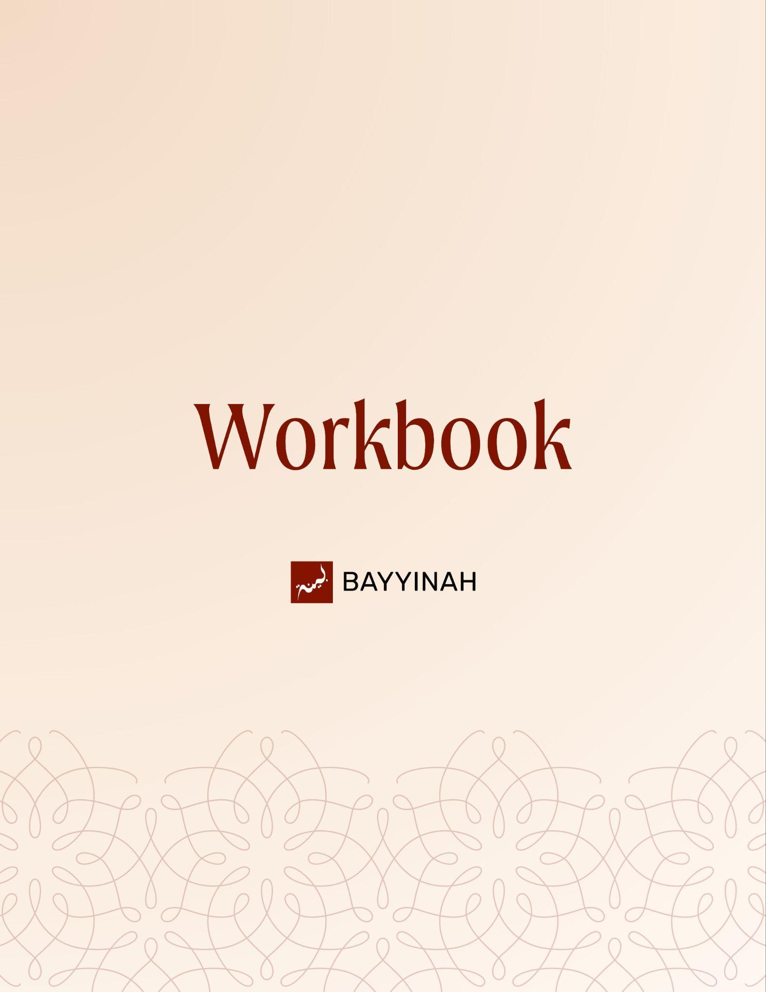
Divine Speech: Sequencing in the Quran

Divine Speech: Sequencing in the Quran

Contents
Introduction: The Precision of Quranic Sequence.....................................3
Section 1: How The Quran’s Structure Shapes Meaning............................4
Section 2: Spoken Revelation Without an Editorial Process.......................5
Section 3: Seeing vs Hearing and Why Order Matters...............................6
Section 4: From Specific Incidents to Universal Warnings..........................7
Section 5: Flow Without Fracture Between Quranic Themes.....................8
Section 6: Vastness of Creation Compared to the Mercy of Allah..............9
Quiz Questions...........................................................................................10
Reflection Questions..................................................................................11
Conclusion & Dua......................................................................................12

Introduction: The Precision of Quranic Sequence
Human speech frays as it unfolds. Patterns repeat, errors slip in and memory falters. Yet the Quran arrives as spoken revelation with no revision, no correction and no loss of precision. A word moved forward or held back can carry theology, psychology and law at once. What feels subtle in reading becomes decisive once attention shifts from vocabulary to order.

Key takeaways:
- The Quran’s precision lies not only in the content of its words but also in the deliberate order in which those words are arranged, each placement serving a purpose.
- Subtle shifts in sequence can redefine meaning without the need for added language or explicit clarification.
- Word order in the Quran teaches theology, psychology, and discipline at once.
- Structural precision in the Quran asks for humility in interpretation, patience in study and close attention to detail.
- Meaning unfolds naturally when structure is allowed to speak.

“It took me about 10—15 minutes to explain, but Allah ﷻ did that just by switching the words”

Section 1: How The Quran’s Structure Shapes Meaning
We repeat phrases in the same order because our minds default to familiar patterns. The Quran disrupts those patterns deliberately. By breaking expected order, it forces the listener to slow down and notice. Meaning is not added through explanation but discovered through placement, teaching that structure itself can carry belief.

Key takeaways:
- Meaning is sometimes carried not by emphasis but by disruption, highlighting the significance of unexpected shifts.
- The Quran’s refusal to follow familiar patterns invites the reader to slow down and notice what normally goes unquestioned.
- When expected order is broken, attention is redirected from sound to sense, compelling us to seek meaning in the disruption.
- Disruption in meaning is not meant to confuse interrupts passive listening to awaken conscious engagement with Allah ﷻ’s words.
- The Quran trains the believer to listen actively rather than coast on familiarity.

“We don’t even realize how much of our speech is on autopilot – His speech never is”

Section 2: Spoken Revelation Without an Editorial Process
The Quran was revealed as speech, not text. Once spoken, it could not be revised, corrected or refined. Yet it arrived complete and maintained flawless precision, even across surahs revealed years apart. Meaning remained consistent without rehearsal, proving a level of control beyond memory, authorship or editorial design.

Key takeaways:
- Human speech depends on revision to reach clarity, yet the Quran arrives complete without rehearsal or correction.
- The absence of any editorial process highlights the impossibility of human authorship.
- Precision across years of revelation suggests memory beyond human capacity.
- The Quran responds to itself across surahs without repeating explanations.
- Consistency is maintained without flattening nuance or context.

“This was spoken once – there was no chance to go back and fix anything”

Section 3: Seeing vs Hearing and Why Order Matters
Seeing and hearing are not interchangeable in the Quran. Their order reflects responsibility. Allah ﷻ orders senses according to purpose. In secrecy, His sight precedes all. In dunya, faith begins with listening. In akhirah, belief follows seeing. When sequence changes, it signals a shift in moral expectation not a stylistic variation. Provision, responsibility and accountability follow the same logic, structured by circumstance not repetition.

Key takeaways:
- The Quran doesn’t treat seeing and hearing as interchangeable faculties – their order reflects moral responsibility.
- In dunya, guidance comes through listening, as seeing is not a requirement for faith.
- In akhirah, seeing precedes listening because belief is no longer a matter of acceptance.
- Word order preserves this moral journey without explanation, embedding accountability into language itself.

“In this world, you were supposed to listen. In the next world, you will see whether you wish to or not”

Section 4: From Specific Incidents to Universal Warnings
The Quran never confines meaning to a single incident. It begins with the specific, then widens the lesson. By reversing the sequence within a single ayah, it shifts focus from the immediate cause to the deeper patterns, exposing the distractions most likely to pull hearts away from remembrance across generations. What once distracted becomes a universal threat, with entertainment emerging as the most persistent spiritual diversion.

Key takeaways:
- The Quran often begins with a specific incident before expanding to a universal lesson.
- Historical context is preserved even when guidance becomes universal.
- Not all people abandon faith for profit but most are tested by pleasure.
- Punishment in the Quran mirrors the crime that precedes it – nothing is arbitrary.
- Sequence allows Allah ﷻ to honor the original moment while speaking to every generation afterwards.

“The incident was small but the lesson wasn’t meant to stay small”

Section 5: Flow Without Fracture Between Quranic Themes
Sabr is not listed like other virtues. It is elevated through structure. The Quran teaches through flow, ensuring that ideas mature rather than collide. Meaning deepens without announcing itself. By altering grammatical form, sabr rises above the list. Flow replaces force and hierarchy replaces decoration. Meaning settles naturally, showing that guidance is often more effective when it is recognized rather than declared.

Key takeaways:
- Sabr (patience) is presented as the backbone of all righteous actions.
- Good deeds without consistency fail to shape character.
- Structural shifts signal spiritual hierarchy, not stylistic flourish. What appears grammatically irregular becomes morally clarifying.
- Past tense affirms certainty rather than limitation, teaching confidence in divine promise.

“Allah ﷻ did not forget to mention sabr – He put it above the list”

Section 6: Vastness of Creation Compared to the Mercy of Allah
Allah ﷻ shapes curiosity before providing answers, inviting the heart to ask and guiding it gently. The Kursi holds creation beneath the ‘Arsh, yet remains unfilled. Mercy, however, encompasses all. The Quran limits language for creation but expands it for mercy, illustrating that doubts stem from underestimating Allah ﷻ’s care, which far exceeds the vastness of the universe.

Key takeaways:
- The Quran stretches the imagination not to overwhelm but to humble.
- Complaints shrink when framed against divine care that envelops creation without exhaustion.
- Doubts about Allah ﷻ’s care come from underestimating His mercy, not from its absence.
- Cosmic scale reframes human anxiety and complaint, revealing personal worries as small against the vastness of divine care.
- Rahmah surpasses even the Throne; Allah ﷻ’s mercy is immeasurable and envelops all creation.

“If all of this fits inside His mercy, what exactly are you afraid He forgot about you?”

Quiz Questions
- What gives the Quranic sequence its precision and order?
A) Poetic Style
B) Memorization ease
C) Cultural habit
D) Precise placement of meaning
E) Translation flexibility

- What most strongly indicates that the Quran was delivered without an editorial process?
A) Its length and scope
B) Its emotional impact on listeners
C) Its internal cross-referencing across years of revelation
D) Its memorization by large communities
E) Its poetic symmetry

- How does the Quran challenge familiar speech patterns to convey meaning?
A) By repeating phases across surahs
B) By altering expected order to slow the listener
C) By using rare vocabulary
D) By explaining meaning directly
E) By shortening sentences

- What does a change in word order in the Quran most often indicate?
A) A stylistic variation
B) A shift in moral responsibility
C) Emphasis without deeper meaning
D) A grammatical inconsistency
E) Simple repetition

- Which distraction does the Quran highlight as the most widespread spiritual test across people and generations?
A) Pleasure
B) Power
C) Wealth
D) Knowledge
E) Fear

Reflection Questions
In what areas of life do you tend to rush past meaning instead of sitting with it and letting it settle?

When Allah ﷻ changes the sequence in an ayah, how does that challenge your assumptions about how meaning should appear?

How might paying closer attention to the Quranic structure change the way you act on what you read?

What distractions tend to pull your heart most easily when life feels calm and comfortable?

Quiz Answers: 1.D, 2.C, 3.B, 4.B, 5.A

Conclusion
This Journey through Quranic sequencing invites careful attention to what is often overlooked: order. The Quran does not merely say true things; it places them precisely. When words are rearranged, belief is clarified, responsibility is assigned and guidance deepens. Understanding begins when structure is allowed to speak. By learning to notice sequence, the believer learns to slow down, listen deeply and approach revelation with humility. What first appears subtle becomes decisive and what once felt familiar begins to speak again. The Quran teaches us not only what to believe but how to listen. It teaches us that meaning is never wasted, placement is never random and mercy is always larger than what we imagine.

Dua
May Allah ﷻ teach us to listen before demanding sight and to trust before proof overwhelms us. May He reorder our habits, anchor us in sabr and allow the Quran to refine our instincts and priorities. May His mercy encompass our weaknesses and guide us towards constancy in obedience.

