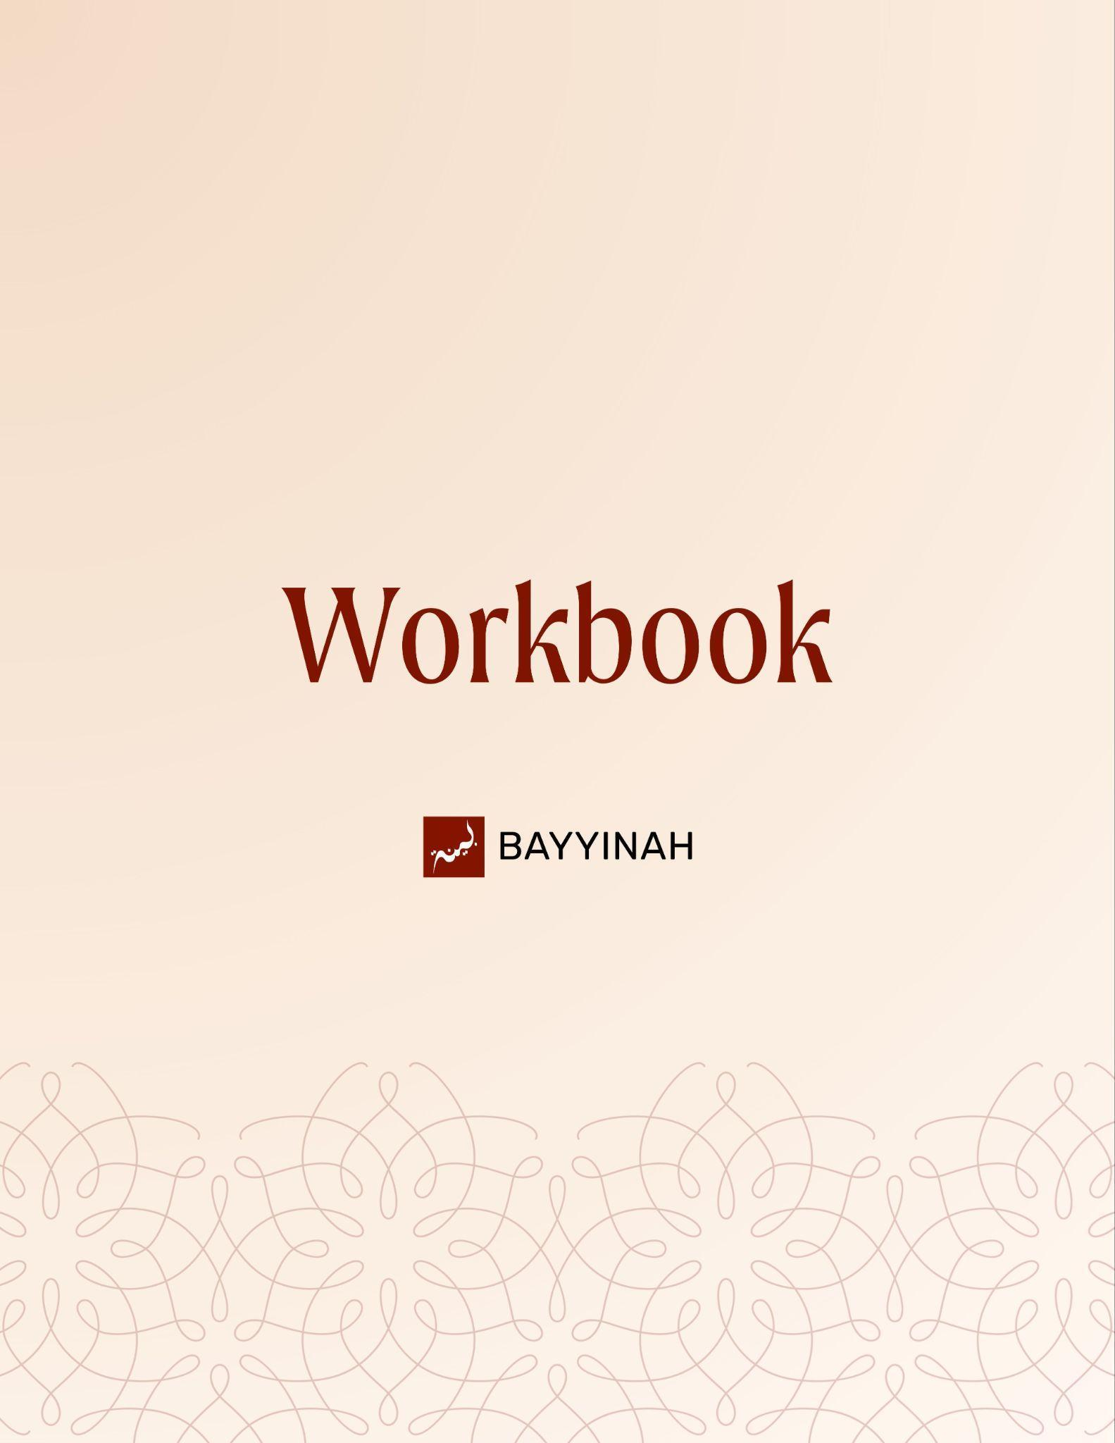
Divine Speech: The Quran is in Perfect Order

Divine Speech: The Quran is in Perfect Order

Contents
Section 1: Tafsir as a Human Endeavor......................................................3
Section 2: The Quran’s Endless Depth.......................................................4
Section 3: What Changes and What Never Does.......................................5
Section 4: Beauty Without Limiting the Miracle...........................................6
Section 5: What a Surah Really Is..............................................................7
Section 6: Divine Order Of The Quran........................................................8
Section 7: How Surah Speak To Each Other..............................................9
Quiz Questions...........................................................................................10
Reflection Questions..................................................................................11
Conclusion & Dua......................................................................................12

Section 1: Tafsir as a Human Endeavor
This episode reflects on how the Quran is understood, studied and preserved. It explores the humility required in tafsir, the endless depth of revelation, the unity of Surahs and the divine order of the Quran, guiding the reader to approach Allah’s words with care, reflection and reverence.
The Quran invites reflection without granting ownership. Every insight is an attempt, never a verdict. Scholars ponder, compare, disagree and return the matter to Allah. This humility protects the Quran from being reduced to any one mind while keeping the door of reflection permanently open.

Key takeaways:
- Engaging the Quran begins with wonder, not certainty
- Scholars observe patterns but do not speak with divine authority
- Context, language and Sahabah explanations anchor interpretation
- Every ayah holds more than one lifetime can uncover
- Human effort must end with “Allah knows best.”

“At the end of the day, all we can do with the word of Allah is ponder and wonder and inquire and try to find meaning.”

Section 2: The Quran’s Endless Depth
Each ayah stands like an ocean, offering something to anyone willing to step in. What scholars extract are not final meanings but small treasures drawn from immeasurable depth. Reflection never exhausts revelation. What is found today does not cancel what remains unseen tomorrow.

Key takeaways:
- Every ayah contains layers beyond what can be fully grasped
- Human reflection can uncover benefits but never exhaust meaning
- Observations are insights, not absolute explanations
- Difference in understanding is part of sincerity, not deviation
- True engagement leaves room for Allah’s knowledge above our own.

“I don’t think of the Quran as an ocean. I think of every ayah as an ocean.”

Section 3: What Changes and What Never Does
Some parts of the Quran anchor humanity permanently while others invite fresh reflection with every generation. Acts of worship and law are fixed across time, while Ayat about creation, emotion and history invite renewed understanding as human perspective grows without crossing sacred limits.

Key takeaways:
- Allah’s commands in worship are not shaped by time, culture or preference
- Permanence in Shariah is a mercy, not a limitation
- Reflection may deepen understanding but not alter obligations
- Growth in perspective is not deviation when boundaries are honored
- The Quran welcomes new insight without surrendering authority

“Salah is salah. Zakah is Zakah. Hajj is hajj. It’s settled. It’s permanent.”

Section 4: Beauty Without Limiting The Miracle
The Quran overwhelms the human mind not because it fits one proof but because it refuses to be contained. Every scholar walks away astonished for a different reason. That diversity of awe is not confusion. It is mercy. The miracle is larger than any explanation we offer.

Key takeaways:
- What moves one heart may not move another and that is by design.
- Human analysis always remains limited and fallible.
- Declaring one reason as the miracle quietly reduces Allah’s speech.
- Disagreement with a reflection is not disagreement with revelation.
- Wonder should lead to humility, not claims of authority.

“At the end of the day, my best effort will still be a human effort. And the word of Allah is far above and beyond human effort.”

Section 5: What a Surah Really Is
A surah is not a chapter broken into parts. It is a unified landscape viewed from above. Different scenes appear side by side—law, story, warning, mercy—yet nothing stands alone. Every element leans on the others until a single view emerges, cohesive,

Key takeaways:
- A Surah is defined by unity, not uniformity.
- Diversity within a surah is a feature, not a flaw.
- Meaning emerges when connections are observed, not isolated.
- The Surah invites a higher vantage point, not a narrow reading.
- Beauty emerges from contrast and connection.

“When it's Baqarah, when it's Al Imran, when it's Kawthar, whatever it is, it's like you climbed up and you look down and you look at this scape and it's gonna have lots of different things in it.”

Section 6: Divine Order of The Quran
The Quran was not assembled through trial and preference. It was delivered with precision, preserved with care and arranged with intent. Its order reflects divine wisdom, not human convenience. To accept its speech as perfect while doubting its structure is to separate meaning from design.

Key takeaways:
- Reverence for the Quran includes trusting where each Surah stands.
- Divine speech is not fragmented or accidental in its arrangement
- The companions did not edit the revelation; they safeguarded it
- The Quran links its recited form to its preserved form in the Lawh Mahfuz
- Order itself can be a form of guidance

“The one who created this universe and knew where to place the sun and the stars does not know where to place the Surahs of the Quran—and left that to me? I can’t accept that”

Section 7: How Surahs Speak To Each Other
Surahs are not isolated units. When placed side by side, Surahs echo, answer and complete one another. Meanings rise not only within a Surah but between them, where openings respond to endings and stories unfold in dialogue. The Quran reveals itself as a carefully woven conversation.

Key takeaways:
- Nearness between Surahs invites reflection beyond individual passages.
- Beginnings and endings often mirror or complete one another
- Repeated stories shift emphasis based on their neighbors.
- Contrast between Surahs sharpens meaning rather than fragmenting it.
- Order reveals meaning, not just beauty

“The two surahs (Al-Kahf , Al-Isra) are perfectly complementing each other in multiple ways.”

Quiz Questions
- What attitude must accompany all Quranic interpretation, according to the lecture?
A) Absolute certainty in one’s conclusions
B) Rejection of scholarly disagreement
C) Intellectual humility and recognition of human limits
D) Independence from classical tafsir
E) Reliance on personal inspiration alone

- How does the lecture describe each ayah of the Quran?
A) An ocean of layered meaning
B) A historical record
C) A fixed conclusion
D) A complete legal code
E) A symbolic placeholder

- Which category of Quranic guidance is described as permanent and not open to reinterpretation?
A) Acts of worship like Salah and Zakah
B) Ayat about nature
C) Emotional descriptions
D) Social commentary
E) Historical narratives

- Why does the speaker prefer describing the Quran as “beautiful” rather than defining a single reason it is miraculous?
A) To avoid academic study
B) To prevent limiting Allah’s word to one argument
C) To reject scholarly tradition
D) To emphasize emotional response over meaning
E) To prioritize poetry over guidance

- What does the pairing of Surah Al-Isra and Surah Al-Kahf demonstrate?
A) Chronological revelation order
B) Legal contrast between Makki and Madani surahs
C) Repetition without variation
D) Thematic dialogue and structural harmony between surahs
E) Independent messages with no relationship

Reflection Questions
How does recognizing tafsir as a human effort change the way you respond to differing interpretations of the Quran?

Which ayah or Surah has felt especially layered or unfinished in your understanding and how might you return to it with greater patience?

In what ways do you sometimes limit the beauty of the Quran by insisting on a single explanation or proof?

How might reading Surahs in relation to their neighbors deepen your connection to the Quran’s structure and message?

Quiz Answers: 1.C, 2.A, 3.E, 4.B, 5.D

Conclusion
The Quran is a living guide, full of layers that invite reflection, humility, and wonder. Each Surah connects to others, and every ayah challenges us to think, feel, and act with sincerity. As we study, may we approach the Quran with open hearts, patience, and a readiness to learn continuously.

Dua
May Allah grant us humility before His words, clarity in our thinking and patience in our study. May He protect us from arrogance in interpretation and from limiting His speech to our understanding. May He open our hearts to connections we once overlooked and make the Quran a living guide in how we think, worship and walk through life.

