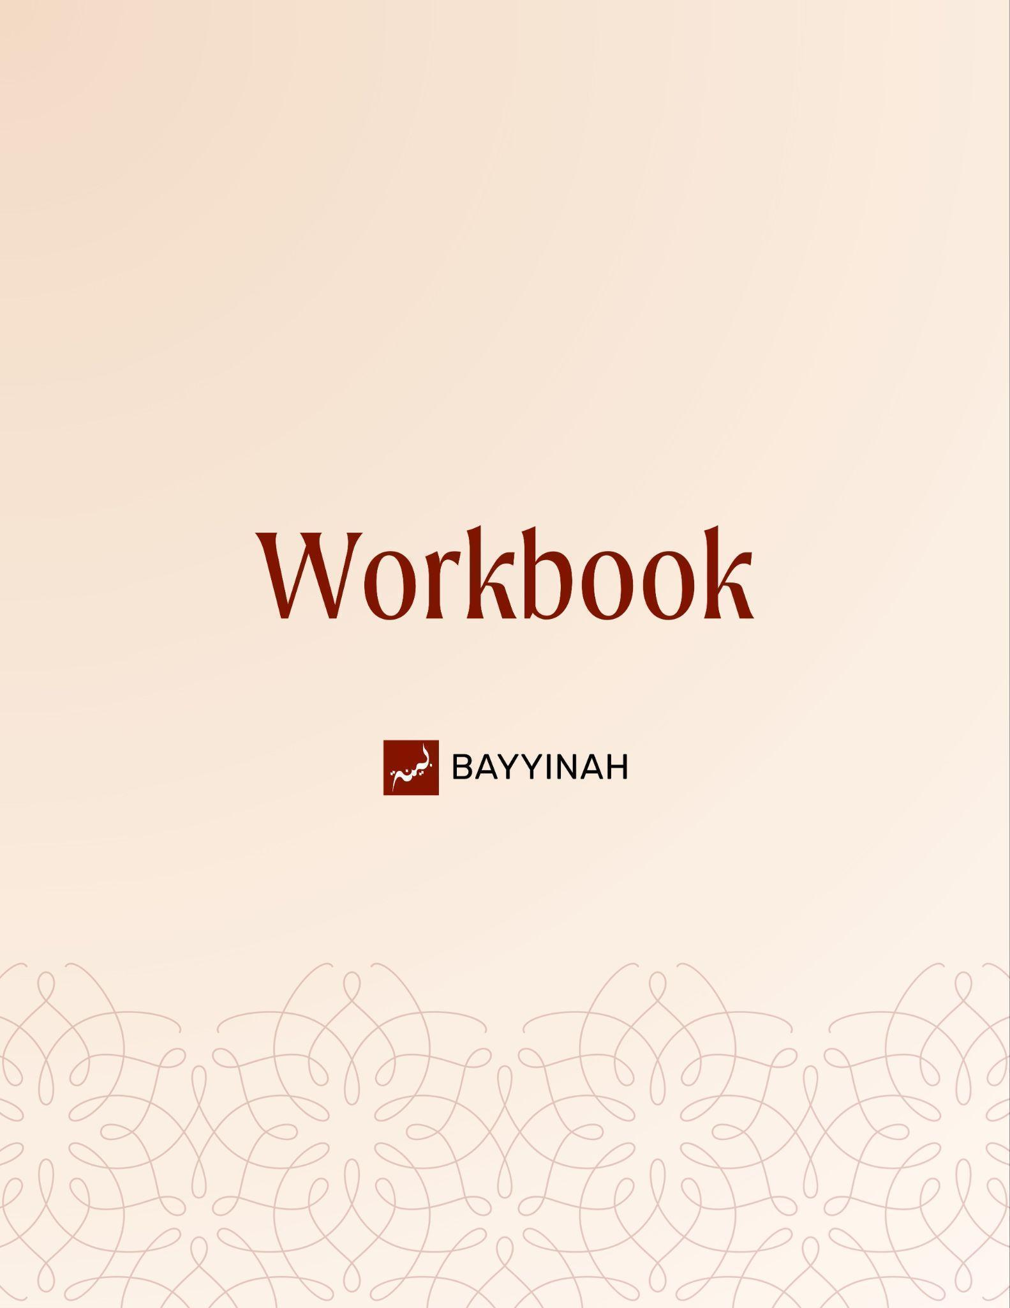
Divine Speech: Order Within a Surah
Divine Speech: Order Within a Surah

Contents
Section 1: Divine Order of the Quran…..………….………………….…...3
Section 2: Legacy of Ibrahim (AS)........………………….………………..4
Section 3: Qualification for Leadership.……………..…………..….….....5
Section 4: Declaration, Conflict, Victory………….…….…...….…...……6
Section 5: Purpose Beyond Victory.………………….……….….………7
Section 6: Protection of Faith………………..…………..………….……..8
Section 7: Balance of Humility and Confidence.…………….…….…….9
Ayat References…………………………………….……………………10-12
Quiz Questions……………………..……………….………………………13
Reflection Questions………………………………………………………..14
Conclusion & Dua………………………………………………….………..15

Section 1: Divine Order of the Quran

The Quran does not move randomly, it advances with purpose. Surahs follow one another like carefully placed steps, fulfilling dua, exposing failure, establishing truth, promising victory, and finally safeguarding faith so the believer never loses sight of why the journey began.
Key takeaways:
- Allah’s promises unfold with precision, not haste.
- History, dua, and revelation are deeply intertwined.
- Honor comes from faithfulness, not lineage.
- Victory without purpose leads to spiritual loss.
- Tawheed remains the heart of every struggle.

“Everything is connected to everything else, and it goes together to make a comprehensive argument.”

Section 2: The Legacy of Ibrahim (AS)
Safety, provision, and honor were granted long before they were earned. These blessings were answers to a father’s dua, not a people’s merit. When gratitude fades, legacy is not inherited, it is withdrawn and handed to those who remain true.
Key takeaways:
- Blessings trace back to sincere dua, not entitlement.
- Lineage without loyalty holds no weight with Allah.
- Tawheed is the core of every lasting legacy.
- Gratitude is proven through obedience, not claims.
- When a trust is neglected, Allah replaces its carriers.

“He built that house not so you could do shirk, not so you could worship false gods. He built that house so you can worship Him.”

Section 3: Qualification for Leadership
True worth is measured by devotion and service, not bloodlines or status. When people abandon sincerity and compassion, they disqualify themselves. Allah then raises those who pray with meaning, sacrifice with purpose, and carry the trust others neglected.
Key takeaways:
- Leadership begins with sincerity before Allah.
- Ritual without compassion empties faith of meaning.
- Serving people is inseparable from worship.
- Legacy is proven through action, not ancestry.
- Allah entrusts His mission to those who uphold it.
.

“You are supposed to be living up to the legacy of Ibrahim, yet let’s see how you measure up.”

Section 4: Declaration, Conflict, Victory
When truth is clearly chosen, separation becomes inevitable. Standing for Tawheed redraws loyalties, even against one’s own people. Once that line is crossed, Allah Himself announces the outcome: victory is written, even if its arrival feels distant.

Key takeaways:
- Choosing truth reshapes relationships.
- Faith sometimes demands painful separation.
- Conflict begins when compromise ends.
- Allah declares victory before it is seen.
- Certainty in Allah steadies the heart through delay.

“When you tell your tribe, ‘I have nothing to do with you,’ that is considered a declaration of war.”

Section 5: Purpose Beyond Victory
When obstacles are removed and success becomes visible, the greatest danger is forgetfulness. Triumph can blur intention. The struggle was never for dominance, it was to uphold Tawheed. Victory only matters if it preserves the reason the journey began.

Key takeaways:
- Success tests sincerity more than hardship.
- Power without remembrance leads to loss.
- The original intention must be guarded.
- Tawheed is the compass after victory.
- Forgetting “why” risks losing everything gained
.

“ I need you to remember what this struggle was about. To begin with, this struggle was about the legacy of Ibrahim.”

Section 6: Protection Of Faith
Iman is not only threatened by open enemies but by quiet whispers. Allah seals the heart, yet allows the chest to be tested. Faith survives when believers recognize where danger enters and who truly holds the door.

Key takeaways:
- Not every threat to iman is visible.
- Shaytaan approaches, but does not control.
- The heart remains guarded by Allah.
- Neglect opens doors that disbelief cannot.
- Seeking refuge is an act of strength.

“Allah did not give the devils access to our hearts. The only one who can open the door for them is us.”

Section 7: Balance Of Humility and Confidence
True character stands between self-erasure and self-importance. Faith nurtures humility before Allah while demanding courage in responsibility. When gifts are denied out of fear, trust is betrayed. When gifts are owned with gratitude, service becomes possible and leadership finds its balance.

Key takeaways:
- Humility does not mean denying Allah’s gifts.
- Confidence is responsibility, not ego.
- Arrogance begins with self-admiration.
- Silence can be a failure to serve.
- Stepping forward can itself be an act of worship.

“Islam is against arrogance, but Islam is not against confidence.”

Ayat References

Surah Al-Fil (105)
أَلَمْ تَرَ كَيْفَ فَعَلَ رَبُّكَ بِأَصْحَابِ الْفِيلِ
Have you not considered how your Lord dealt with the Companions of the Elephant?
Surah Quraysh (106:1–4)
لِإِيلَافِ قُرَيْشٍ ۝ إِيلَافِهِمْ رِحْلَةَ الشِّتَاءِ وَالصَّيْفِ ۝
فَلْيَعْبُدُوا رَبَّ هَٰذَا الْبَيْتِ ۝ الَّذِي أَطْعَمَهُم مِّن جُوعٍ وَآمَنَهُم مِّنْ خَوْف
For the security of Quraysh, their security during winter and summer journeys, let them worship the Lord of this House, who has fed them against hunger and made them safe from fear.
Surah Al-Ma‘un (107:1–7)
أَرَأَيْتَ الَّذِي يُكَذِّبُ بِالدِّينِ ۝ فَذَٰلِكَ الَّذِي يَدُعُّ الْيَتِيمَ ۝ وَلَا يَحُضُّ عَلَىٰ طَعَامِ الْمِسْكِينِ
فَوَيْلٌ لِّلْمُصَلِّينَ ۝ الَّذِينَ هُمْ عَن صَلَاتِهِمْ سَاهُونَ الَّذِينَ هُمْ يُرَاءُونَ
۝ وَيَمْنَعُونَ الْمَاعُونَ
Have you seen the one who denies the Judgement? It is he who pushes aside the orphan and does not urge the feeding of the poor. So woe to those who pray but are heedless of their prayer, those who show off and refuse small kindnesses.
Surah Al-Kawthar (108:1–3)
إِنَّا أَعْطَيْنَاكَ الْكَوْثَرَ۝ فَصَلِّ لِرَبِّكَ وَانْحَرْ۝ إِنَّ شَانِئَكَ هُوَ الْأَبْتَرُ
We have given you abundance.So pray to your Lord and sacrifice.It is your enemy who is cut off.
Surah Al-Kafirun (109:1–6)
قُلْ يَا أَيُّهَا الْكَافِرُونَ ۝ لَا أَعْبُدُ مَا تَعْبُدُونَ ۝ وَلَا أَنتُمْ عَابِدُونَ مَا أَعْبُدُ۝ وَلَا أَنَا عَابِدٌ مَّا عَبَدتُّمْ
وَلَا أَنتُمْ عَابِدُونَ مَا أَعْبُدُ ۝ لَكُمْ دِينُكُمْ وَلِيَ دِينِ

Say, ‘Disbelievers, I do not worship what you worship, nor do you worship what I worship, nor will I worship what you worship, nor will you worship what I worship: you have your religion and I have mine.’
Surah An-Nasr (110:1–3)
إِذَا جَاءَ نَصْرُ اللَّهِ وَالْفَتْحُ ۝ وَرَأَيْتَ النَّاسَ يَدْخُلُونَ فِي دِينِ اللَّهِ أَفْوَاجًا ۝
فَسَبِّحْ بِحَمْدِ رَبِّكَ وَاسْتَغْفِرْهُ إِنَّهُ كَانَ تَوَّابًا
When God’s help comes and He opens up your way, when you see people entering God’s religion in crowds,celebrate the praise of your Lord and ask His forgiveness: He is always ready to accept repentance.
Surah Al-Masad (111:1)
تَبَّتْ يَدَا أَبِي لَهَبٍ وَتَبَّ
May Abu Lahab’s hands perish and he himself perish.
Surah Al-Ikhlas (112:1–4)
قُلْ هُوَ اللَّهُ أَحَدٌ ۝ اللَّهُ الصَّمَدُ ۝ لَمْ يَلِدْ وَلَمْ يُولَدْ
وَلَمْ يَكُن لَّهُ كُفُوًا أَحَدٌ
Say, ‘He is God the One, God the eternal.He begot no one nor was He begotten. No one is comparable to Him.’
Surah Al-Falaq (113)
قُلْ أَعُوذُ بِرَبِّ الْفَلَقِ ۝ مِن شَرِّ مَا خَلَقَ ۝ وَمِن شَرِّ غَاسِقٍ إِذَا وَقَبَ
وَمِن شَرِّ النَّفَّاثَاتِ فِي الْعُقَدِ ۝ وَمِن شَرِّ حَاسِدٍ إِذَا حَسَدَ
Say, ‘I seek refuge with the Lord of daybreak against the harm of what He has created, against the harm of the night when darkness gathers, against the harm of those who blow on knots, and against the harm of an envier when he envies.’

Surah An-Nas (114:1–6)
قُلْ أَعُوذُ بِرَبِّ النَّاسِ ۝ مَلِكِ النَّاسِ ۝ إِلَٰهِ النَّاسِ ۝ مِن شَرِّ الْوَسْوَاسِ الْخَنَّاسِ
الَّذِي يُوَسْوِسُ فِي صُدُورِ النَّاسِ ۝ مِنَ الْجِنَّةِ وَالنَّاسِ
Say, ‘I seek refuge with the Lord of people, the King of people, the God of people, from the evil of the sneaking whisperer who whispers into the hearts of people, from jinn and from people.’
Surah Yusuf (12:4)
إِذْ قَالَ يُوسُفُ لِأَبِيهِ يَا أَبَتِ إِنِّي رَأَيْتُ أَحَدَ عَشَرَ كَوْكَبًا وَالشَّمْسَ وَالْقَمَرَ رَأَيْتُهُمْ لِي سَاجِدِينَ
Joseph said to his father, ‘Father, I dreamed that I saw eleven stars and the sun and the moon; I saw them prostrate themselves before me.’
Surah Ar-Rahman (55:1–2)
الرَّحْمَٰنُ ۝ عَلَّمَ الْقُرْآنَ
The Lord of Mercy taught the Quran.
Surah Ar-Rahman (55:46)
وَلِمَنْ خَافَ مَقَامَ رَبِّهِ جَنَّتَانِ
There are two Gardens for those who fear standing before their Lord.
Surah Al-Waqi‘ah (56:10–11)
وَالسَّابِقُونَ السَّابِقُونَ ۝ أُولَٰئِكَ الْمُقَرَّبُونَ
And the foremost are the foremost—they are the ones brought close.
Surah Al-Waqi‘ah (56:95–96)
إِنَّ هَٰذَا لَهُوَ حَقُّ الْيَقِينِ ۝ فَسَبِّحْ بِاسْمِ رَبِّكَ الْعَظِيمِ
This is the absolute truth. So glorify the name of your Lord, the Almighty.

Quiz Questions

1. According to the episode, what fundamentally distinguishes the Quran from a collection of isolated verses?
A) Its historical references
B) Its linguistic difficulty
C) Its intentional order and flow
D) Its thematic repetition
E) Its memorization tradition

2. What do Surah Al-Fil and Surah Quraysh collectively demonstrate?
A) The military power of Quraysh
B) The downfall of Arabian tribes
C) The fulfillment of Prophet Ibrahim’s (AS) Dua
D) The origins of idol worship
E) The beginning of prophethood

3. Why were the Quraysh able to travel safely when other tribes could not?
A) Their military strength
B) Their alliances with tribes
C) Favorable geography
D) Fear associated with the Ka‘bah and idols
E) Their economic dominance

4. What core qualities define the legacy of Prophet Ibrahim(AS) as presented in the lecture?
A) Worship of Allah and service to people
B) Lineage and tribal authority
C) Political leadership and wealth
D) Scholarship and eloquence
E) Military sacrifice

5. In Surah Al-Ma‘un, what behavior is most strongly criticized?
A) Public disbelief
B) Excessive ritual worship
C) Political corruption
D) Insincere prayer and lack of compassion
E) Tribal arrogance

Reflection Questions
Where do you see the legacy of Ibrahim reflected or neglected in your own worship and dealings with people?

After achieving success or stability, what spiritual risks do you become more vulnerable to?

How does the distinction between the heart and the chest affect how you view whispers and temptations?

What lesson from the structure of Surah Yusuf helps you balance humility with confidence in your own life?

Quiz Answers: 1.B, 2.C, 3.E, 4.A, 5.D

Conclusion
The Qur’an invites us to slow down and notice how everything fits together. When we follow its flow, we see our own journey reflected in its struggle, clarity, patience, and purpose. Faith is not random. When we hold onto Tawheed, Allah shows us the way forward.

Dua
May Allah grant us hearts that recognize the divine order of His Book, sincerity that endures success and vigilance that protects our Tawheed, and may He make the Quran a light that orders our lives as He ordered His words.

