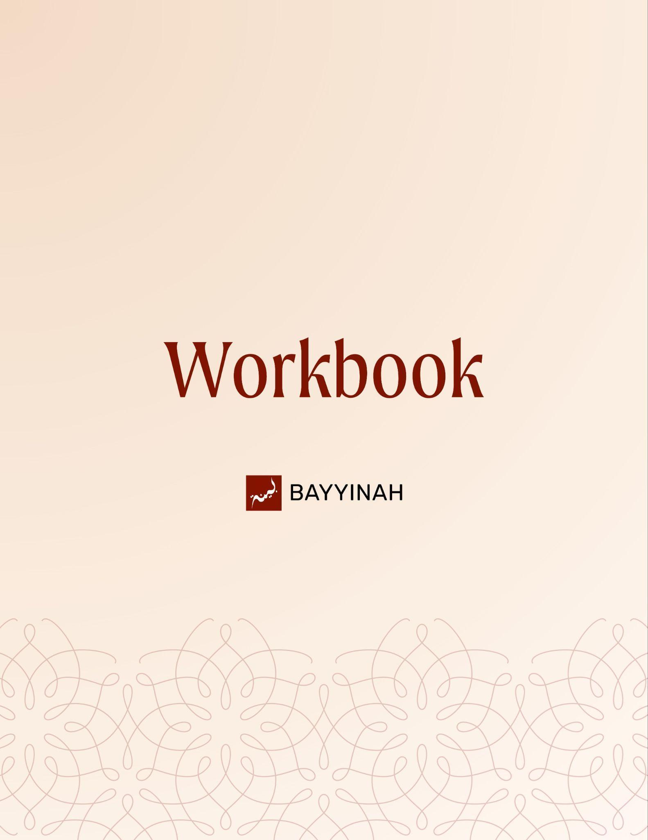
Divine Speech: A Quranic Way of Thinking

Divine Speech: A Quranic Way of Thinking

Contents
Introduction…….........................................................................................3
Section 1: Why Humans Swear and Why Allah Swears.............................4
Section 2: How Quranic Oaths Actually Work.............................................5
Section 3: Time as a Living Argument.........................................................6
Section 4: Inevitable Progression and Measured Hope..............................7
Section 5: Loyalty Proven Under Pressure.................................................8
Section 6: Humiliation Without an Afterlife..................................................9
Section 7: Hearts Revealed Through Divine Examples............................10
Ayat References.........................................................................................11
Quiz Questions...........................................................................................13
Reflection Questions..................................................................................14
Conclusion & Dua......................................................................................15

Introduction: Understanding Oaths and Divine Examples in the Quran
When Allah takes an oath in the Quran, He is not adding emphasis for decoration. He is interrupting inattentive hearts. An oath forces the listener to slow down and recognize that what follows is weighty and easily ignored. Familiar realities are turned into proof, training the believer to read the world as evidence.

Key takeaways:
- Oaths in the Quran function as deliberate interruptions, forcing attention where it would normally drift.
- Allah does not swear to strengthen truth but to awaken listeners who are neglecting it.
- The object of an oath is drawn from familiar reality so the unseen becomes undeniable.
- Quranic oaths teach belief by reshaping perception, not by increasing information.
- What people casually witness every day becomes an argument for what they hesitate to accept.

“Allah is not filling space – He’s forcing you to stop and listen”

Section 1: Why Humans Swear and Why Allah Swears
People swear when words feel insufficient—when anger rises, trust collapses or attention is slipping. In old Arab culture, oaths were a way to arrest attention. Allah ﷻ adopts this familiar tool not out of need, but to awaken reflection and expose how easily revelation is dismissed.

Key takeaways:
- Human beings swear because their words alone fail to convince or restrain emotion.
- In Arab culture, oaths were a recognized tool to arrest attention, not embellish speech.
- Allah ﷻ adopts a familiar rhetorical tool to teach divine truths without cultural distance.
- Quranic oaths highlight not weakness in truth but negligence in the listener.
- Paying attention to revelation is presented as a moral responsibility, not a passive act.

“Allah ﷻ is not swearing because He needs to be believed – He’s swearing because we’re not paying attention”

Section 2: How Quranic Oaths Actually Work
Every Quranic oath is built from two inseparable parts: the object and the subject. The object is what Allah ﷻ swears by; the subject is what He intends to address. The object is never the point—it prepares the listener and often serves as evidence, guiding the mind toward the message before it is stated.

Key takeaways:
- Every oath in the Quran consists of an object that prepares and a subject that delivers meaning.
- The object of an oath is never the message; it is the doorway to the message.
- Allah ﷻ selects oath objects that already argue His case before words do.
- The relationship between object and subject transforms oaths into logical proofs.
- Understanding this structure prevents mistaking emphasis for the intended lesson.

“The oath isn’t the conversation – it’s the setup”

Section 3: Time as a Living Argument
Allah ﷻ swears by time because time itself proves human loss. Its passing is constant, irreversible and undeniable. Loss is not a future threat but a present condition unfolding moment by moment. By choosing time, Allah ﷻ teaches that reality itself testifies against neglect and delay.

Key takeaways:
- Quranic oaths are never random; the object chosen already contains proof within it.
- Time exposes loss without argument, explanation or emotion – it simply keeps moving.
- Human beings are in loss precisely because life is being spent whether meaning is found or not.
- Surah al-‘Asr reframes loss as a present condition rather than a future consequence – Allah ﷻ selects evidence that cannot be disputed because it is universally experienced.
- The oath by time trains the believer to measure life by purpose rather than duration – reality itself becomes a witness against heedlessness.

“The fact that time is running out is the ultimate evidence that human beings are in loss”

Section 4: Inevitable Progression and Measured Hope
Allah ﷻ swears by twilight, night and the moon to highlight process rather than moment. Just as nature moves gradually and without resistance, human beings are carried from one stage to the next. This oath teaches inevitability while offering comfort: growth, reform and victory mature over time.

Key takeaways:
- Allah ﷻ swears by processes to teach that transformation is gradual and unavoidable, just as human life mirrors natural transitions where stages replace each other without permission.
- Accountability is as inevitable as nightfall after twilight, reminding us that no phase—strength, weakness, success or decline—is permanent.
- Da‘wah and reform do not unfold in bursts but through steady progression.
- Apparent stagnation does not negate movement; it often conceals preparation.
- Believers are judged by effort across stages, not by reaching an ideal end state.

“You will ride from one stage to the next whether you want to or not”

Section 5: Loyalty Proven Under Pressure
Allah ﷻ paints a scene the Arabs admired: battle horses charging into danger, panting and striking sparks. An animal overrides instinct and runs toward death for its master. The oath then turns the mirror on the listener—exposing human hesitation in loyalty despite guidance and reason.

Key takeaways:
- Quranic oaths engage existing passions before delivering moral confrontation.
- Human beings possess reason and revelation yet still struggle with loyalty.
- Allah ﷻ uses what the listener admires to reveal what they lack, exposing ingratitude through contrast without direct accusation.
- Effective da‘wah begins by understanding what people care about.

“An animal runs toward its own death for its master, yet you won’t even obey yours”

Section 6: Humiliation Without an Afterlife
For a people who denied the afterlife, legacy was everything. Allah ﷻ describes shirk as a disgraced warrior flung from a cliff, abandoned, torn apart and scattered. The image speaks their language, revealing shirk as total humiliation—loss of dignity, memory and refuge—with no excuse remaining.

Key takeaways:
- The Quran confronts disbelief using images rooted in cultural memory.
- “Falling from the sky” was an Arab idiom for cowardice and humiliating defeat.
- Being scattered by the wind represents erasure of legacy and identity.
- Shirk is portrayed as disgrace, not merely intellectual error.
- The parable replaces abstract judgment with an emotionally undeniable reality.
- Allah ﷻ exposes the end of false immortality without mentioning the afterlife directly.

“For someone who commits shirk, it is as though he fell from the sky”

Section 7: Hearts Revealed Through Divine Examples
This passage in Surah al-Baqarah is not about rocks but about hearts. Allah ﷻ describes hearts that have hardened, then compares them to stones—not to insult but to clarify. Some hearts overflow with faith, some require time to crack and others obey before faith fully settles. Allah ﷻ uses stones because they were deeply relatable to Bani Israel who remembered water gushing from rock. The parable teaches that hearts respond differently, yet none are beyond cultivation.

Key takeaways:
- The Quran compares hearts to stones to diagnose spiritual responsiveness, using water to symbolize iman and a heart's reaction under pressure.
- Some hearts overflow immediately, others require time and persistence to open.
- Examples become powerful when they connect revelation to lived memory.
- Allah ﷻ is fully aware of which hearts are softening and which are resisting.

“Your rock doesn’t have water yet – be patient and keep obeying Allah”

Ayat References

Surah al-‘Asr (103:1–2)
وَٱلْعَصْرِ ۝ إِنَّ ٱلْإِنسَـٰنَ لَفِى خُسْرٍ۝
By time. Man is in a state of loss.

Surah al-Inshiqaq (84:16–19)
فَلَآ أُقْسِمُ بِٱلشَّفَقِ ۝ وَٱلَّيْلِ وَمَا وَسَقَ ۝ وَٱلْقَمَرِ إِذَا ٱتَّسَقَ ۝ لَتَرْكَبُنَّ طَبَقًا عَن طَبَقٍۢ۝
فَٱلْعَـٰصِفَـٰتِ عَصْفًا
I swear by the twilight. By the night and all it gathers. By the moon when it is full. You will move on from stage to stage.

Surah al-‘Adiyat (100:1–6)
وَٱلْعَٰدِيَٰتِ ضَبْحًا ۝ فَٱلْمُورِيَٰتِ قَدْحًا ۝ فَٱلْمُغِيرَٰتِ صُبْحًا ۝ فَأَثَرْنَ بِهِۦ نَقْعًا ۝ فَوَسَطْنَ بِهِۦ جَمْعًا ۝ إِنَّ ٱلْإِنسَٰنَ لِرَبِّهِۦ لَكَنُودٌ۝
By the charging horses, panting. Striking sparks with their hooves. Raiding at dawn. Raising clouds of dust. Storming into the midst of the enemy. Man is ungrateful to his Lord.

Surah al-Hajj (22:31)
حُنَفَآءَ لِلَّهِ غَيْرَ مُشْرِكِينَ بِهِۦ ۚ وَمَن يُشْرِكْ بِٱللَّهِ فَكَأَنَّمَا خَرَّ مِنَ ٱلسَّمَآءِ فَتَخْطَفُهُ ٱلطَّيْرُ أَوْ تَهْوِى بِهِ ٱلرِّيحُ فِى مَكَانٍۢ سَحِيقٍۢ۝
Devote yourselves wholly to God and do not associate others with Him. Anyone who associates others with God is like someone who falls from the sky and is snatched away by birds or carried off by the wind to a distant place.

Surah al-Baqarah (2:74)
ثُمَّ قَسَتْ قُلُوبُكُم مِّنۢ بَعْدِ ذَٰلِكَ فَهِىَ كَٱلْحِجَارَةِ أَوْ أَشَدُّ قَسْوَةًۚ وَإِنَّ مِنَ ٱلْحِجَارَةِ لَمَا يَتَفَجَّرُ مِنْهُ ٱلْأَنْهَٰرُۚ وَإِنَّ مِنْهَا لَمَا يَشَّقَّقُ فَيَخْرُجُ مِنْهُ ٱلْمَآءُۚ وَإِنَّ مِنْهَا لَمَا يَهْبِطُ مِنْ خَشْيَةِ ٱللَّهِۗ وَمَا ٱللَّهُ بِغَٰفِلٍ عَمَّا تَعْمَلُونَ۝
Then your hearts became hardened after that: they were like rocks or even harder. For there are rocks from which rivers gush forth; others split apart and water flows from them; and others fall down in awe of God. God is not unaware of what you do.

Quiz Questions
- Why does Allah ﷻ use oaths in the Quran?
A) To imitate Arab poetry
B) To strengthen His credibility
C) To intimidate listeners
D) To capture attention and argue truth through evidence
E) To beautify language

- Why is time sworn by in Surah al-‘Asr?
A) Because it marks prayer times
B) Because it proves loss through its passing
C) Because it is scientifically complex
D) Because it is emotionally powerful
E) Because it symbolizes patience

- What do the stages of twilight, night and moon in Surah al-Inshiqaq illustrate?
A) Inevitable progression without choice
B) Astronomical cycles
C) Artistic imagery
D) Seasonal change
E) Historical patterns

- What lesson do the battle horses teach in Surah al-‘Adiyat?
A) Military strategy
B) Animal instincts
C) Arabian culture
D) Physical strength
E) Loyalty through action

- Why was the image of falling from the sky especially powerful for the Mushrikoon?
A) They feared natural disasters
B) They believed in reincarnation
C) They valued social honor and legacy without belief in the afterlife
D) They feared isolation
E) They feared travel

Reflection Questions
When Allah ﷻ swears by something familiar, what does that teach you about how guidance is meant to be noticed?

Which objects or moments in your daily life might function as reminders if you learned to read them as evidence?

Which description of the heart feels closest to your current state, and why?

What stage of life or responsibility are you resisting even though its arrival is already certain?

Quiz Answers: 1.D, 2.B, 3.A, 4.E, 5.C

Conclusion
Quranic oaths and examples are not abstract arguments. They are deliberate invitations to look again at what we already see. Time passing, night arriving, animals obeying and stones reacting to pressure are not random images; they are witnesses. Allah ﷻ trains the believer to read reality as evidence and to recognize that guidance is already surrounding us. Progress is unavoidable, accountability is certain and hearts respond according to what they contain. The Quran does not merely inform belief; it reforms perception. Meaning is never wasted, sequence is never accidental and mercy always exceeds what the human imagination allows.

Dua
May Allah ﷻ teach us to listen before demanding sight and to reflect before rushing past meaning. May He soften our hearts until faith flows freely or at least cracks open with persistence and obedience. May He allow us to recognize His signs in time, in change and in struggle. May He accept our efforts across every stage and return us to Him with hearts made alive by His guidance.

