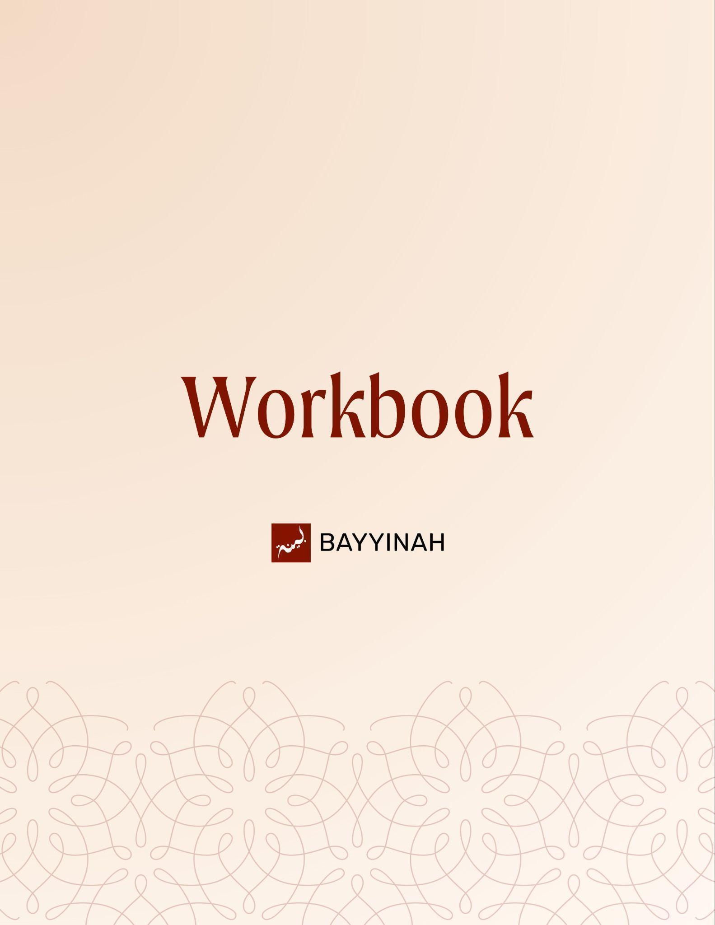
Divine Speech: We in Quran

Divine Speech: We in Quran

Contents
Introduction................................................................................................3
Section 1: Why Allah Speaks the Way He Does.........................................4
Section 2: Formality and Distance in Allah’s use of “He”….........................5
Section 3: Directness and Intensity in Allah’s use of “I”...............................6
Section 4: “We’’as Majesty, Kingdom and Divine Scale..............................7
Section 5: The Fragility of All False Objects of Pursuit...............................8
Section 6: The Seeker and the Sought are Both Weak……………............9
Section 7: True Strength Comes From Seeking Allah…………….....,,.....10
Quiz Questions.........................................................................................11
Reflection Questions...............................................................................12
Conclusion & Dua....................................................................................13

Introduction
Allah refers to Himself in the Quran using four pronouns I, We, He and You. All four appear clearly and repeatedly.The Quran raises some questions among readers and it linger quietly in the mind. Why does Allah speak as “I,” sometimes as “He,” and at times as “We”? The Quran does not announce an explanation. It expects the reader to observe.and it deserves a careful answer. It is not a theological puzzle first. It is a literary one. To understand it properly the Quran must be allowed to speak on its own terms.
This chapter is not about defending a belief. It is about understanding the language of revelation. The Quran teaches not only through what it says, but through how it says it. Pronouns shift. Tone changes. Distance and closeness alternate with precision. None of it is accidental.
By exploring this question methodically, we begin to see the Quran as a carefully constructed curriculum, shaping thought, reverence and relationship with Allah. What first appears as a grammatical curiosity unfolds into a deeper appreciation of divine wisdom, authority and mercy. This study is an invitation to read the Quran with greater attentiveness and echoed meanings that were always there.

Section 1: Why Allah Speaks the Way He Does
Many people have a common confusion/question about Allah speaking about Himself in the Quran using four pronouns. Each appears intentionally and never randomly. This is not a problem of belief but a matter of language. Allah’s speech is chosen carefully to teach, guide, and shape understanding. The way pronouns are used points to authority, emphasis, and guidance, while always affirming His absolute oneness.

Key takeaways:
- Allah uses I, We, He, and You in the Quran purposefully.
- First-person speech appears in both singular and plural forms.
- Plural usage is limited only to the first person.
- If the plural were literal, it would appear with other grammatical persons too.
- Its limitation shows that the plural is rhetorical, not numerical.
- Pronouns are tools to guide and teach, not descriptions of Allah Himself.
- The Quran focuses more on guiding us than on explaining itself.
- The choice of words shows how Allah wants us to understand Him.

“The Quran is not an autobiography of God. It is not Allah speaking for his own sake. It is. It is actually Allah speaking for our sake. In other words, Allah has given us a curriculum.”

Section 2: Formality and Distance in Allah’s Use of “He”
We do notice sometimes how Allah refers to Himself as He. This is not just a way of speaking, it has a purpose.Allah is not speaking to push us away, but to position us correctly. Before the heart is comforted, it must be oriented.Using He creates a respectful distance, helping us approach Allah with seriousness and proper understanding. It shapes how we think about Him and reminds us that learning about Allah is not only about knowledge, but also about attitude and reverence.
The distance in the language helps the message settle in the heart. It teaches before it comforts, guiding us toward the right mindset when speaking or thinking about Allah.

Key takeaways:
- Allah uses He to create respectful, instructional distance.
- This formality emphasizes seriousness rather than familiarity.
- The goal is guidance and correction, showing how we should understand Him.
- Distance gives the words weight and gravity.
- Instruction comes before comfort, shaping how believers approach Allah.
- Believers learn proper adab in speaking about and thinking of Allah.

“He (Allahﷻ ) facilitated the language in a way that when you remind someone else, they can actually get what you're saying. The language is structured in that way.’’

Section 3: Directness and Intensity in Allah’s Use of “I”
After establishing formality and distance, the Quran at times shifts its tone with striking force. Allah speaks using “I” This change is not incidental. It appears at moments where the message must land without distance. Allah uses “I” at moments where the heart must be fully present. These are moments of extremes. On one end is profound mercy,most notably in the language of tawbah. On the other end is severe warning. When Allah speaks with “I” in these contexts, accountability becomes unavoidable.Responsibility becomes immediate. The language closes the gap between what is being said and who it is meant for.

Key takeaways:
- Allah uses “I” only at specific moments of seriousness.
- This form of speech shows direct address without distance.
- When Allah speaks of accepting tawbah, He often uses “I.”
- When punishment or warning is mentioned, “I” is also used.
- The shift signals that the message should be taken immediately.
- The listener is placed face to face with responsibility.

‘’The use of I in Quran is either extreme love or extreme anger.’’

Section 4: ‘’We’’as Majesty, Kingdom and Divine Scale
The Quran also introduces a third mode of divine speech when Allah refers to Himself as “We”.This is the language of majesty. It appears when Allah speaks about actions that operate on an immense scale, such as revelation, creation and provision. It reflects authority and dominion.Every use of “We” is carefully anchored back to Allah’s oneness through singular references, leaving no room for confusion.

Key takeaways:
- We” is used only by Allah ﷻ when He speaks about His own actions
- This limited use shows the plural is rhetorical, not literal
- The form emphasizes authority and the vastness of His reach
- Acts of creation and sending revelation are often described using “We”
- When water and other related creations are mentioned, the Quran overwhelmingly uses “We” to describe Allah’s action
- Throughout, the Quran reminds us of Allah’s absolute oneness

‘’We is used when Allah describes something that is associated with Allah’s Kingdom’’

Section 5: The Fragility of All False Objects of Pursuit
Through this parable, the Quran shows the weakness of anything taken besides Allah ﷻ. Whatever people place above Him, whether idols, tyrants or personal goals, cannot carry real strength. Their inability is not hidden behind complexity or power. It is exposed through something small and ordinary, like a fly. The message is simple and direct. What cannot protect itself cannot be worthy of devotion.

Key takeaways:
- Anything taken as a god besides Allah ﷻ is shown to lack real power.
- Strength that is not rooted in Allah ﷻ does not last.
- Even something small can uncover what people falsely rely on.
- Truth is made clear without needing complexity.
- Human arrogance collapses when placed in the face of divine reality.
- Turning to creation instead of Allah ﷻ leads to weakness.

‘’They can’t even defend themselves against flies. Even if they all got together for it.’’

Section 6: The Seeker and the Sought are Both Weak
From the Quranic phrase, “ضَعُفَ ٱلطَّالِبُ وَٱلْمَطْلُوبُ” (Surah Al-Hajj 22:73), we are reminded that both the seeker and that which is sought carry weakness by their very nature. This weakness is not something added later; it is part of the essence of creation itself. Attachments, ambitions, and desires depend on what is fragile, and the seeker shares in that fragility. When the object collapses, the heart of the seeker is affected as well, showing how reliance on anything other than Allah ﷻ leaves one vulnerable.

Key takeaways:
- ضَعُفَ ٱلطَّالِبُ وَٱلْمَطْلُوبُ shows that both the seeker and the sought are inherently weak.
- Weakness is embedded in the natural order of creation.
- Dependence on creation leads to vulnerability.
- Attachment to worldly pursuits can drain inner strength.
- Loss of the object impacts the seeker’s heart as well.
- True strength is found only through reliance on Allah ﷻ.

‘The seeker and the sought, the one who is seeking and the thing that is being sought, are both inherently weak.’’

Section 7: True Strength Comes from Seeking Allah Alone
Our attention is drawn to what is familiar and easy to recognize in daily life. Crops grow strong, stand tall, then dry and turn yellow. Human life follows the same pattern, with interest, strength and ability rising for a time and then gradually declining. Allah ﷻ alone is not part of this cycle,What fades was never meant to be leaned on. Turning toward Him reorients the heart away from what is temporary and anchors it in what does not erode.

Key takeaways:
- The Quran describes how worldly things rise, mature, and then fade.
- Natural imagery, like crops turning yellow, helps the listener recognize the impermanence of life.
- Human strength and attachment follow the same pattern rising, peaking, then declining.
- Our hearts often lose interest once what we seek is in our hands.
- Attachment to temporary things makes the heart vulnerable to loss and change.
- Allah ﷻ alone is not subject to weakening or fading, and turning toward Him brings lasting stability.

“That powerful lesson is if you learn to seek Allah, you will become strong because everything other than Allah is weak, which will make you weak. So if you want to be strong, seek Allah.”

Quiz Questions

1. Why does Allah ﷻ use different pronouns for Himself in the Quran?
A) To reflect changes in time
B) To indicate multiple divine beings
C) To convey rhetorical purpose and teaching
D) To follow Arabic grammatical rules
E) To confuse the listener

2. When the Quran shifts from “He” to “We,” what does this change help the listener understand?
A) A change in historical narration
B) A legal ruling
C) The magnitude of Allah ﷻ’s actions, like creation and sending down water
D) Personal du‘aa of the Prophet ﷺ
E) An emotional appeal

3. What lesson does the parable of the fly convey about everything people pursue in the dunya?
A) They are complex and hard to understand
B) They are naturally weak and cannot provide true strength
C) They can protect themselves if humans intervene
D) They represent natural order
E) They are signs of divine artistic beauty

4. How does human attachment to worldly things affect the heart?
A) Strengthens patience and resilience
B) Leads to reliance and inner weakness
C) Makes one wiser over time
D) Protects against loss
E) Guarantees lasting happiness

5. According to the discussion, what is the source of true, lasting strength?
A) Financial security and social status
B) Intellectual superiority
C) Anchoring one’s purpose in seeking Allah ﷻ alone
D) Physical power and influence
E) Accumulation of knowledge

Reflection Questions
How does the Quran’s choice of pronouns change the way you listen to and reflect upon Allah’s words?

What worldly pursuits in your life might weaken you if they were suddenly lost, and how does this relate to the parable of the fly?

How would it be in your daily life to anchor your sense of strength in seeking Allah alone?

Thinking about the stages of humans growing interest, possession, loss, and decline how can recognizing this pattern guide your attachment and priorities?

Quiz Answers: 1.C, 2.D, 3.D, 4.C, 5.E

Conclusion
The question of why Allah uses “We” in the Quran is not a side issue of grammar. It is a doorway into understanding how divine speech educates the human heart.The Quran does not speak carelessly. Every pronoun is chosen with precision, emotional weight and pedagogical intent. Reflecting on the Quran shows how every word and pronoun is purposeful. Allah ﷻ uses “I,” “We,” “He,” and “You” to teach, guide, and signal His authority, while always affirming His oneness. . When Allah says “He”, distance and authority are established so the listener learns reverence. When Allah says “I”, the moment is charged with either overwhelming mercy or uncompromising warning. When Allah says “We”, the language of dominion unfolds, reminding the reader of a kingdom that governs creation, life, provision and revelation itself.
Crucially, the Quran never allows grandeur to be mistaken for plurality. Every “We” is anchored back to absolute oneness through immediate singular references. Confusion is anticipated and resolved within the text itself. More than answering a linguistic question, this study reshapes how we listen to Allah’s words.The Quran is teaching us the art to listen to the creator. And when the listener learns that skill, this Book no longer feels distant. It speaks directly, deliberately and powerfully to the soul.True strength comes from seeking Him alone, anchoring our purpose beyond loss and change.

Dua
O Allah make our hearts alive to Your guidance. Help us seek You above all else and find strength in Your permanence. Allow us to recognize the temporary nature of worldly pursuits, learn from Your signs in creation, and grow in sincerity, understanding, and steadfastness. Accept our efforts, forgive our shortcomings, and guide us toward what benefits us in this life and the next.

