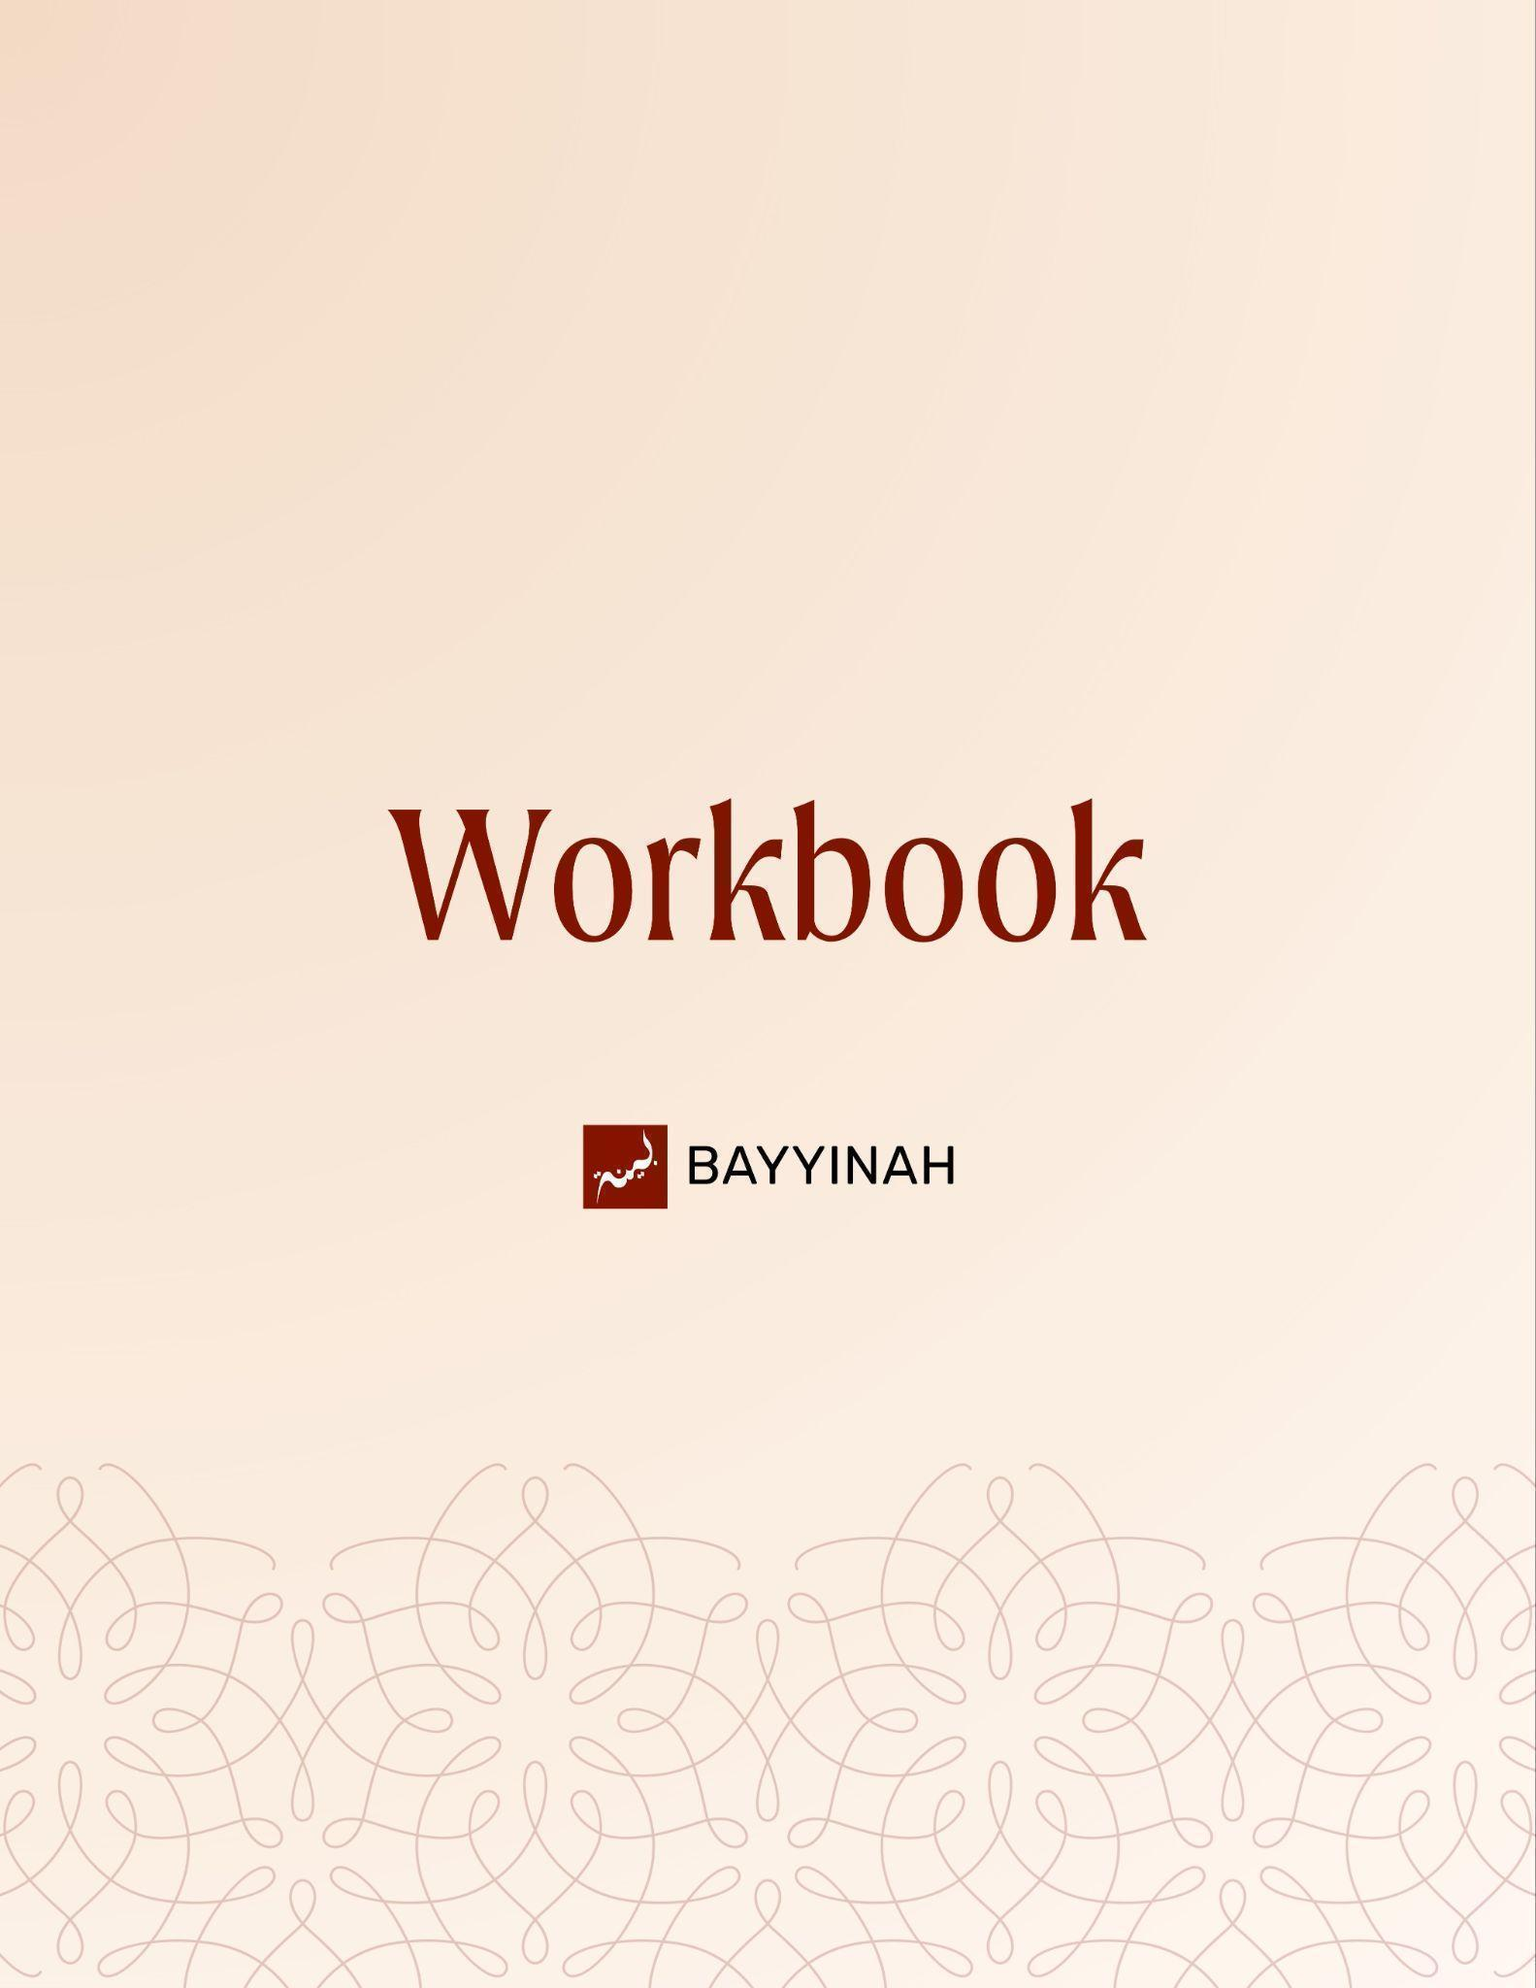
Divine Speech: Examples in the Quran

Divine Speech: Examples in the Quran

Contents
Introduction: Divine Translation.................................................................3
Section 1: Translation as a Sacred Responsibility and Prophetic Legacy..4
Section 2: How Mood Shapes Quranic Expression....................................5
Section 3: How Truth Prevails Through Time.............................................6
Section 4: Quranic Imagery and the Process of Divine Separation............7
Section 5: Jannah as the Primary Goal......................................................8
Section 6: The Forgotten Priority of Quranic Delivery.................................9
Quiz Questions.........................................................................................10
Reflection Questions...............................................................................11
Conclusion & Dua....................................................................................12

Introduction: Divine Translation
The Quran is revealed in Arabic, yet it speaks to people of every time and place. This is not ordinary translation, but divine communication in which meaning, emotion, and context are perfectly preserved. Revelation captures the complete reality of moments, showing that translation itself is part of the miracle and a responsibility inherited by the Ummah.

Key takeaways:
- The Quran renders earlier peoples’ words into Arabic by Allah’s will, making translation part of revelation.
- Allah’s translation preserves meaning, emotion, and context without loss, unlike human translation.
- Quranic wording reflects lived scenes and realities, not mere transcripts of speech.
- Conveying the Quran across languages is a sacred and continuous legacy.
- The Sahabah understood translation as an essential part of da‘wah

“A perfect translation means that not only are the words translated, but the emotions and the environment and the feeling.”

Section 1: Translation as a Sacred Responsibility and Prophetic Legacy
Because Allah translated revelation Himself, the Ummah inherits a duty to carry the Quran across languages with care and effort. Translation is not a modern compromise but a prophetic inheritance begun by the Sahabah. Neglecting this responsibility is a loss of perspective on the Prophet’s core mission.

Key takeaways:
- Conveying meaning across languages is part of da’wah.
- The Sahabah treated translation as service to revelation.
- Translation preserves access not dilution.
- Ignoring translation limits the Quran’s reach.
- The Prophet’s mission centered on delivery.

“ Allah himself left us the legacy of translation.”

Section 2: How Mood Shapes Quranic Expression
The Quran does not repeat events mechanically. When the same incident appears with different wording, the change reflects a different emotional and spiritual atmosphere. Day and night are not interchangeable. Revelation matches its language to mood, secrecy, vulnerability, and hope, showing that meaning is not only in facts, but in the state surrounding them.

Key takeaways:
- Similar events appear with different wording by design.
- Language reflects emotional and psychological context.
- Day imagery aligns with clarity and exposure.
- Night imagery aligns with secrecy and vulnerability.
- Surah tone influences word choice.
- Literary precision deepens reflection.

“ And the wording of the ayat is actually influenced by the mood of the passage.”

Section 3: How Truth Prevails Through Time
The Quran frames truth as something that settles and nourishes over time while falsehood rises briefly before disappearing. Through the imagery of rain and foam, Allah teaches that separation is gradual. History unfolds through filtration, not spectacle, demanding patience, clarity and trust in divine outcomes.

Key takeaways:
- Truth spreads like rain entering every valley
- Falsehood rises visibly but lacks substance
- Separation takes time, not sudden collapse
- What benefits people settles and remains
- Falsehood is noisy but temporary
- Truth is quiet but enduring

“As for the foam, it will dissipate, it will disappear, it will become nothing. And as for what benefits people, it will stay in the land.”

Section 4: Quranic Imagery and the Process of Divine Separation
Quranic parables do more than illustrate ideas; they compress history. The imagery of rain and fire mirrors the Makkan and Madinan phases of the Prophet’s mission. Open disbelief was washed away early, while hypocrisy required pressure to surface. The Seerah lives inside Allah’s metaphors.

Key takeaways:
- The Makkan phase resembled flooding rain.
- Open disbelief was separated quickly.
- The Madinan phase required fire and pressure.
- Hypocrisy surfaced only under trial.
- Battle refined the community like smelting metal.

“The next time the believer sees rain, he remembers the entire seerah. ”

Section 5: Jannah as the Primary Goal
The Quran reframes struggle by reordering value. Hardship and battle refine believers for what lasts, not what flashes and fades. Jannah is the true prize, like precious jewelry, while worldly victory is useful but secondary. Faith matures when priorities are clear.

Key takeaways:
- Jannah is the ultimate objective of struggle
- Trials refine believers like fire refines metal
- Battle is a means, not a destination
- Loss in this world does not equal failure
- True value lies in what endures

“We are working towards Jannah. If victory comes, that’s cool. If not, it’s not a big deal. We still got Jannah.”

Section 6: The Forgotten Priority of Quranic Delivery
The Prophet’s mission focused on conveying the Quran before any confrontation. Accountability came after clarity. Today, this order has been reversed: discussions about power and resistance appear while the message itself remains undelivered, even in Muslim homes. This reversal shows a loss of prophetic priorities and spiritual perspective.

Key takeaways:
- Da’wah precedes accountability in the Quranic model.
- The Prophet did not confront until the message was clear.
- Confrontation without delivery distorts Islam.
- Internal ignorance weakens the Ummah.
- The Quran must be taught before it is defended.

“Forget telling the non-Muslim world about the message of the Quran. We are living in the tragic times when the Muslims don’t know the word of Allah.”

Quiz Questions

1. Why does the Quran present non-Arab Prophets speaking Arabic?
A) Because Arabic was the global language
B) To preserve historical transcripts
C) Because Allah translated their words perfectly
D) To simplify memorization only
E) Because all Prophets were bilingual

2. What makes Allah’s translation fundamentally different from human translation?
A) It focuses only on literal meaning
B) It removes emotional context
C) It prioritizes brevity
D) It captures words, emotions and atmosphere
E) It avoids historical detail

3. Why does the Quran describe Zakariyya 's (AS) silence as “three days” in one Surah and “three nights” in another?
A) Angels corrected themselves
B) One account is metaphorical
C) The Quran contains contradictions
D) Each Surah reflects a different mood and atmosphere
E) One verse was revealed later

4. In the parable of rain and foam, what does the foam ultimately represent?
A) Strong believers
B) Divine punishment
C) Temporary falsehood without substance
D) The spread of Islam
E) Lasting benefit

5. According to the lecture, what is the most critical neglected priority today?
A) Political dominance
B) Military preparedness
C) Interfaith debate
D) Economic reform
E) Delivering the Quran’s message

Reflection Questions
How does understanding the Quran as a divine translation change the way you approach its language, meanings and emotional depth?

In what ways have you prioritized outcomes like recognition, success or victory over sincerity and Jannah in your own struggles?

Which parts of the Quran’s message have reached your household clearly and which parts remain undelivered or unexplored?

Quiz Answers: 1.C, 2.D, 3.D, 4.C, 5.E

Conclusion
The Quran does not merely inform us; it situates us. It places revelation within history, emotion and lived struggle so that guidance is not abstract but embodied. Through divine translation, Allah preserved not only meaning but memory. Through parables, He encoded the Seerah into images that return to us whenever rain falls or fire burns. Through patience, struggle and clarity of purpose, truth was allowed to settle while falsehood exposed itself and faded. This perspective restores balance. It reminds us that urgency without delivery is distortion and that victory without sincerity is hollow. The Prophet’s mission was not rushed. It was deliberate. The message reached hearts before hands were raised. Today, the crisis is not lack of strength but lack of transmission. Homes unfamiliar with the Quran cannot carry its weight into the world. This realization should humble us, slow us and reorient us. Our task is not to force outcomes but to restore pathways. When the Quran is allowed to enter every valley again, clarity will return. What benefits people will remain. What does not will disappear, as it always has.

Dua
May Allah make us people who understand His words with their hearts before carrying them on their tongues. May Allah anchor our efforts in sincerity, grant us patience in the process of truth and make Jannah our primary aim. May Allah revive the Quran in our homes, our conversations and our priorities and allow His guidance to settle firmly in our lives and remain.

