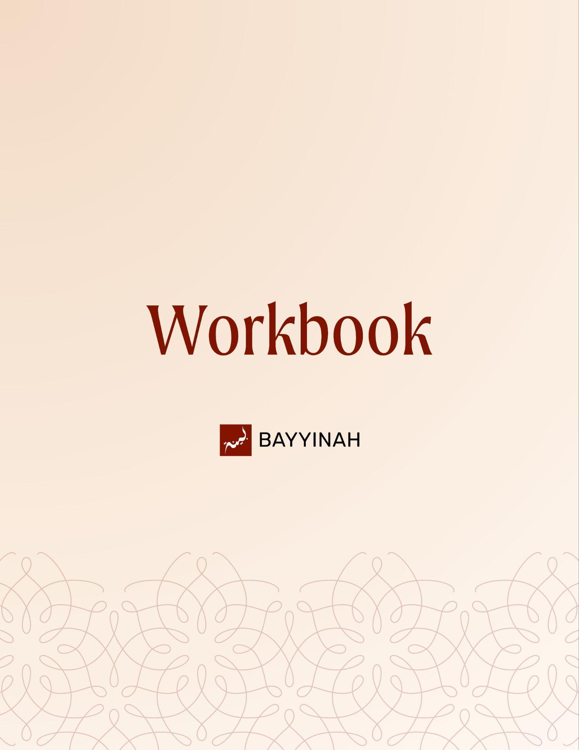
Divine Speech: Consistency in the Quran
Divine Speech: Consistency in the Quran

Contents
Introduction................................................................................................3
Section 1: Taking a Leap of Faith................................................................4
Section 2: Allah’s Absolute Reassurance and Control................................5
Section 3: Power Dynamics in Truth vs Tyranny…………….......................6
Section 4: Prophetic Intelligence and Rhetorical Precision.........................7
Section 5: Three Faces of Power in One Scene.........................................8
Ayat References...........................................................................................9
Quiz Questions...........................................................................................12
Reflection Questions..................................................................................13
Conclusion & Dua......................................................................................14

Introduction: Approaching Divine Dialogue in the Quran
The episode highlights two important lessons that one can apply whenever there is a dialogue presented in the Quran. First, reflecting on how Allah has chosen to capture the conversation. Second and more importantly, why has it been preserved for humanity to reflect on. The spiritual lessons that can be derived from Divine Speech and how those lessons are timeless throughout humanity. This episode showcases how Ustadh interprets the conversations of Allah, Musa (AS), Fir‘awn & the magicians through the lens of these two lessons. The Ayat can be referenced on Page 10 of this workbook.

Key takeaways:
- Quranic dialogue has wisdom not only in what is said but how Allah presents the points
- This dialogue demonstrates how Musa was instructed to engage with power, arrogance and fear - universal lessons that are relevant today.
- Musa (AS) is summoned while already vulnerable and exposed. Fear does not mean you are weak, it exposes where you can draw strength through faith and those around you.
- Allah’s call does not require one to be in an ideal circumstances and state of being.

“No doubt about it. Your Master, truly, He is the ultimate authority, and truly, He is always loving and caring.”

Section 1: Taking a Leap of Faith
Allah asks Musa (AS) to go to the corrupt nation of Fir’awn. Before confronting Fir‘awn, Musa (AS) confronts himself. He speaks honestly about fear, frustration, speech difficulty and a past sin. The Quran records this vulnerability to show that prophecy does not erase human weakness. It redirects it toward reliance on Allah.
Key takeaways:
- Allah calls Musa (AS) back to the very place he fled as a wanted man.
- Musa (AS) voices fear before taking action. Being honest with yourself gives you clarity on what to ask Allah for help in.
- Human limitation is acknowledged and given reassurance.
- Emotional regulation matters in delivering truth. Musa (AS) listed out all his fears. Calling out what is getting in your way of accomplishing anything hard you are set out to do to prepare for the task at hand.
- The focus of your life is always bigger than whatever hardship lies right in front of you. Musa's (AS) first concern is failing the mission, not losing his life. Don’t let hardships define you in that moment.

“My Master, I’m really afraid that they will call me a liar. My chest becomes tight and my tongue stops moving.”

Section 2: Allah’s Absolute Reassurance and Control
Allah’s response—كَلَّا—becomes a defining theme. One word from Allah removes every fear from the heart. The episode emphasizes that divine reassurance is all-encompassing and all-capable including Allah’s protection, support and even unasked miracles.

Key takeaways:
- Allah dismantles anxiety through trust. Allah teaches us not to argue with fear rather to re-direct that energy towards completely trusting the process.
- One divine word outweighs many human anxieties.
- The practice of having an inner dialogue with Allah about the hardships in your life is the source of tawakkal itself.
- Help arrives even before it is asked for. Allah’s help comes, in forms that we may not have even asked for.
- Divine support includes presence not just outcome.

“That’s all Allah says to him. No problem.”

Section 3: Power Dynamics in Truth vs Tyranny
After addressing and reassuring Musa (AS) Allah moves the dialogue to the next scene- Fir’awn’s palace. Allah gets straight to the point (a recurring theme in this section). As the dialogue unfolds, power quietly shifts. A lesson in communication skills and power dynamics. Allah showcases us the behaviors to observe and how to navigate situations where you need to communicate to power.

Key takeaways:
- Communication Skills 1 - Get straight to the point. When facing power or authority, be clear in your intent and messages. Musa (AS) introduces himself and Harun and explicitly mentions his objective.
- Communication Skill 2 - Be aware of your audience. Truth exposes insecurity in oppressive power. Tyranny weakens when challenged publicly. Musa (AS) gets straight to the point by addressing the major allegation - and utilising the audience to get back to his main points. Control of conversation signals real authority.
- Observational Skills - How do you recognise the behavior of Tyranny? Changing the subject is strategic not accidental. Those who may have power over you, are masters in manipulating the truth and using what they know about you, against you. Fir’awn brought up Musa’s (AS) past - Musa used it to regain control of the narrative.
- Oppression survives through narrative control. Fir’awn’s entire apparatus is set up to ensure his authority is unquestioned. Systems of oppression continue to use this tactic to manipulate us and our perceptions today.

“One man walked in from the desert with nothing and one man was sitting on a throne. And somewhere in the middle the tables turned.”

Section 4: Prophetic Intelligence and Rhetorical Precision
Musa (AS) never loses sight of why he came. Even when forced off topic he redirects the conversation back to Allah’s authority and the injustice against Bani Isra’eel. The episode highlights prophetic brilliance not just courage.

Key takeaways:
- Musa (AS) responds selectively not emotionally. Prophetic speech is strategic and calm.
- He answered what matters most.The mission stays central throughout.
- Never lose sight of the big picture. The main points you have come to address with the authority figure in your life.
- Truth is restated, not diluted.

“He didn’t get off topic. He used Fir‘awn’s tangent and turned it right back.”

Section 5: Three Faces of Power in One Scene

Fir’awn, Musa (AS) and the magicians reveal three opposing approaches to power. Fir’awn’s authority is noisy and insecure, sustained by fear, spectacle and elite approval. The moment attention shifts away from him, he resorts to accusations and threats. Musa (AS) does not compete for control or image. He presents truth plainly and leaves its defense to Allah. The magicians then begin yet expertise allows them to recognize truth instantly when it appears. Their sujood exposes the gap between human skill and divine reality. In one scene, false power is isolated, prophetic truth stands firm and former agents of oppression align themselves with Allah.
Key takeaways:
- Threats signal argumentative defeat.Tyrants rely on specialists to legitimize their rule; when those experts defect, the system cracks from the inside.
- The magicians represent manufactured authority—skilled, impressive but ultimately fragile before divine truth.
- Those most qualified to recognize falsehood are often the first to submit when truth appears clearly.
- Allah breaks oppressive systems by turning their strongest tools into evidence against them.

“They know magic and they know what is above magic. When their work disappeared in a split second, they were done. They fell straight into sujood.”

Ayat References

Surah Ash-Shu‘ara (26:9-33)
وَإِنَّ رَبَّكَ لَهُوَ الْعَزِيزُ الرَّحِيمُ
Your Lord is the Almighty, the Most Merciful.

وَإِذْ نَادَىٰ رَبُّكَ مُوسَىٰ أَنِ ٱئْتِ ٱلْقَوْمَ ٱلظَّٰلِمِينَ ۝ قَوْمَ فِرْعَوْنَ ۚ أَلَا يَتَّقُونَ
Your Lord called out to Moses: “Go to the wrongdoing people,
the people of Pharaoh. Will they not become mindful of God?”

قَالَ رَبِّ إِنِّيٓ أَخَافُ أَن يُكَذِّبُونِ ۝ وَيَضِيقُ صَدْرِي وَلَا يَنطَلِقُ لِسَانِي فَأَرْسِلْ إِلَىٰ هَٰرُونَ ۝
وَلَهُمْ عَلَيَّ ذَنبٌ فَأَخَافُ أَن يَقْتُلُونِ
Moses said, “My Lord, I fear that they will accuse me of lying,
that my heart will constrict and my tongue will not be fluent,
so send Aaron with me. They also have a charge against me and
I fear they will kill me.”

قَالَ كَلَّا ۖ فَٱذْهَبَا بِـَٔايَٰتِنَآ ۖ إِنَّا مَعَكُم مُّسْتَمِعُونَ
God said, “No indeed. Go with Our signs: We shall be with you, listening.”

فَأْتِيَا فِرْعَوْنَ فَقُولَآ إِنَّا رَسُولُ رَبِّ ٱلْعَٰلَمِينَ ۝ أَنْ أَرْسِلْ مَعَنَا بَنِيٓ إِسْرَٰٓءِيلَ
So go to Pharaoh and say, ‘We are messengers from the Lord of the worlds:
send the Children of Israel with us.’

قَالَ أَلَمْ نُرَبِّكَ فِينَا وَلِيدًا وَلَبِثْتَ فِينَا مِنْ عُمُرِكَ سِنِينَ ۝ وَفَعَلْتَ فَعْلَتَكَ ٱلَّتِي فَعَلْتَ وَأَنتَ مِنَ ٱلْكَٰفِرِينَ
Pharaoh said, “Did we not bring you up as a child among us?
Did you not stay with us for many years of your life?
And you committed the deed you committed, showing yourself to be ungrateful.”

قَالَ فَعَلْتُهَآ إِذًا وَأَنَا۠ مِنَ ٱلضَّآلِّينَ ۝ فَفَرَرْتُ مِنكُمْ لَمَّا خِفْتُكُمْ فَوَهَبَ لِي رَبِّي حُكْمًا وَجَعَلَنِي مِنَ ٱلْمُرْسَلِينَ
۝ وَتِلْكَ نِعْمَةٌ تَمُنُّهَا عَلَيَّ أَنْ عَبَّدتَّ بَنِيٓ إِسْرَٰٓءِيلَ
Moses replied, “I did it when I was misguided. I fled from you when I feared you,
but my Lord granted me wisdom and made me one of His messengers.
Is this the favor you reproach me with, that you enslaved the Children of Israel?”

قَالَ فِرْعَوْنُ وَمَا رَبُّ ٱلْعَٰلَمِينَ ۝ قَالَ رَبُّ ٱلسَّمَٰوَٰتِ وَٱلْأَرْضِ وَمَا بَيْنَهُمَآ ۖ إِن كُنتُم مُّوقِنِينَ
Pharaoh said, “And what is the Lord of the worlds?”
Moses said, “The Lord of the heavens and the earth and everything between them,
if you would be convinced.”

قَالَ لِمَنْ حَوْلَهُۥٓ أَلَا تَسْتَمِعُونَ ۝ قَالَ رَبُّكُمْ وَرَبُّ ءَابَآئِكُمُ ٱلْأَوَّلِينَ ۝
قَالَ إِنَّ رَسُولَكُمُ ٱلَّذِيٓ أُرْسِلَ إِلَيْكُمْ لَمَجْنُونٌ ۝ قَالَ رَبُّ ٱلْمَشْرِقِ وَٱلْمَغْرِبِ وَمَا بَيْنَهُمَآ ۖ إِن كُنتُمْ تَعْقِلُونَ ۝
قَالَ لَئِنِ ٱتَّخَذْتَ إِلَٰهًا غَيْرِي لَأَجْعَلَنَّكَ مِنَ ٱلْمَسْجُونِينَ
Pharaoh said to those around him, “Do you hear?”
Moses said, “Your Lord and the Lord of your forefathers.”
Pharaoh said, “This messenger sent to you is mad.”
Moses said, “The Lord of the east and the west and everything between them,
if you would use your reason.”
Pharaoh said, “If you take any god other than me, I will throw you into prison.”

قَالَ أَوَلَوْ جِئْتُكَ بِشَيْءٍ مُّبِينٍ ۝ قَالَ فَأْتِ بِهِۦٓ إِن كُنتَ مِنَ ٱلصَّٰدِقِينَ ۝ فَأَلْقَىٰ عَصَاهُ فَإِذَا هِيَ ثُعْبَانٌ مُّبِينٌ
Moses said, “Even if I bring you something clearly convincing?”
Pharaoh said, “Produce it, then, if you are telling the truth.”
So Moses threw his staff and suddenly it became a visible serpent.

وَنَزَعَ يَدَهُۥ فَإِذَا هِيَ بَيْضَآءُ لِلنَّٰظِرِينَ
Then he drew out his hand and it appeared white to those watching.

Quiz Questions
1. What does the Quran emphasize by recording Musa’s (AS) fears before his mission begins?
A) Prophets hesitate because of weak faith
B) Fear invalidates leadership
C) Human vulnerability can coexist with divine responsibility
D) Musa (AS) needed persuasion from Allah
E) Fir‘awn’s power justified fear

2. Why is Musa’s (AS) fear of being called a liar mentioned before his fear of being killed?
A) It reflects poor prioritization
B) It shows concern for reputation
C) It highlights social anxiety
D) It shows the mission mattered more than his life
E) It prepares Fir‘awn’s response

3. What is the significance of Allah responding to Musa (AS) with the single word كَلَّا?
A) Allah dismisses Musa’s emotions
B) Allah postpones the mission
C) Allah demands immediate obedience
D) Allah offers partial reassurance
E) Allah assumes complete control over the outcome

4. How does Fir‘awn attempt to avoid addressing Musa’s actual message?
A) By requesting proof immediately
B) By questioning Allah’s existence
C) By attacking Musa’s past and loyalty
D) By debating theology directly
E) By consulting his ministers

5. According to the episode, what does Fir‘awn’s threat of imprisonment indicate?
A) Strategic patience
B) Legal authority
C) Political wisdom
D) Moral certainty
E) Intellectual defeat

Reflection Questions
When you are called to do something right but difficult, which fears rise first: fear of failure, fear of people or fear of loss?

How does Musa’s (AS) honesty with Allah reshape the way you bring your own weaknesses into du’aa?

In what ways do modern systems of power still change the subject rather than address injustice directly?

What would it look like to trust Allah’s كَلا in a situation where answers have not yet arrived?

Quiz Answers: 1.C, 2.D, 3.E, 4.C, 5.E

Conclusion
The conversation between Musa (AS) and Fir’awn is not preserved as distant history. It is guidance meant to stay alive. It shows what truth looks like when fear is real and power feels overwhelming. Musa (AS) walks straight into the center of tyranny with no army, no leverage and no backup plan, only obedience and clear goal. Allah shifts the balance without weapons or crowds. Just words, placed exactly where they need to land. He produces courage through obedience. The Quran trains us to see that intimidation loses its grip when truth is spoken without theatrics, and that silence in the face of injustice only extends its life. This story leaves us responsible to speak with clarity, to resist distraction and to trust that no room ruled by arrogance is ever beyond Allah’s reach.

Dua
May Allah grant us the honesty of Musa (AS) when fear overwhelms us and the clarity to place His mission above our own comfort. May He steady our speech when truth must be spoken and expand our hearts when anxiety tightens them. May He make us trust His كَلَّا even when outcomes are unseen and make us among those who confront injustice with wisdom courage and unwavering faith.

