Computer-Based Version of “Kingdoms Game “
(Build-3)

Software Architecture Document

Version 3.00

Team F:
IU, Kelvin King Man
PENKOH JOUONANG, Babeth Kelly
SHARMA, Tarnum
ALOMARI, Zakaria

Overview

Build #3 is built on top of the full game logic implemented in build #2. In addition, changes were made to make Human player one of the strategy users can select when starting a new game and when a game is reloaded. Hence, the strategy of a player is always determined at runtime as opposed to restore from persistent data. Game logic have also been updated according to the posted requirements regarding the game play, end condition of a epoch/game, how a new epoch is setup, as well as the addition of natural disasters. Our program also had been re-architected to run in multi-threaded environment.

UML Class Diagram:

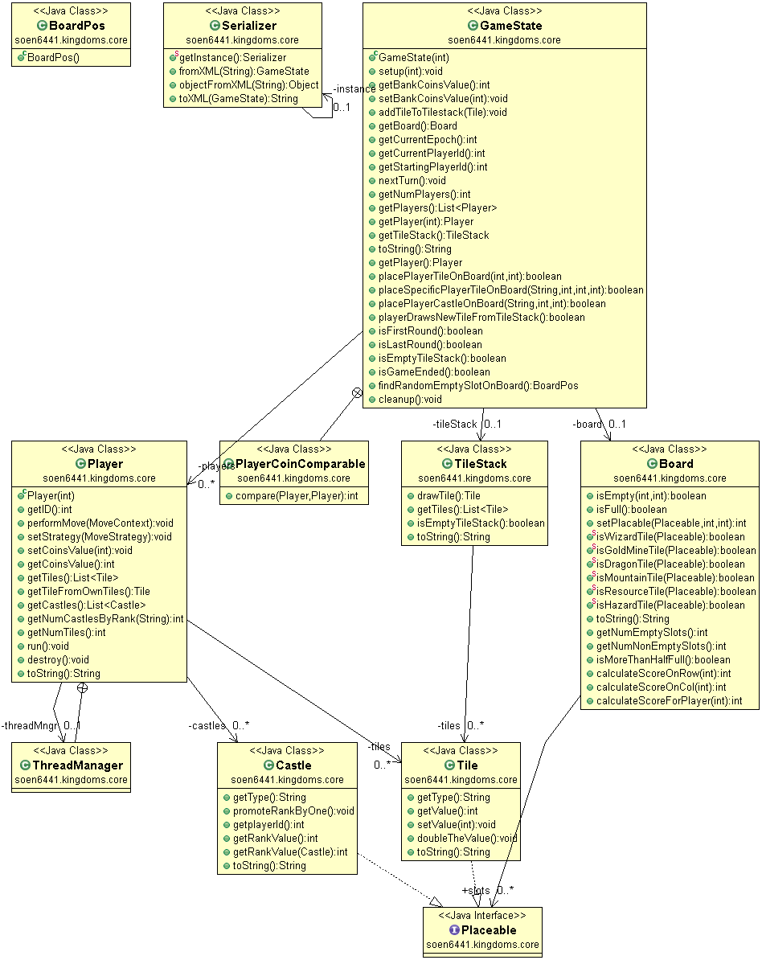

Strategy Related Classes
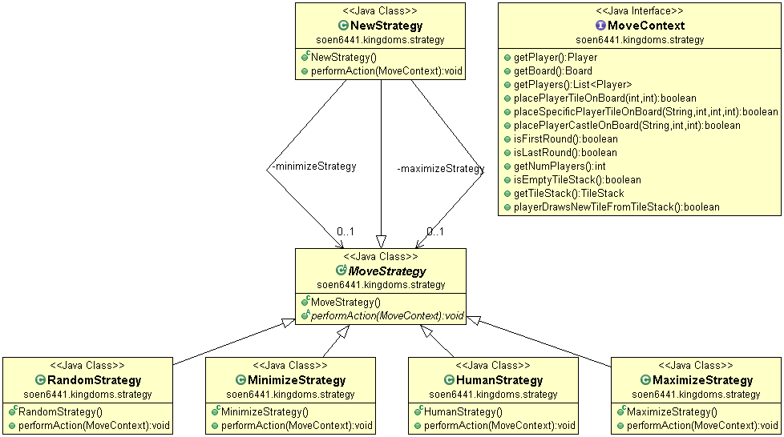

Changes in the Strategy pattern implementation:

Now each instance of Player class has a reference to an instance of MoveStrategy that is initialized when users select a strategy and this object will be used to perform the Player's turn.

A new MoveStrategy derived class HumanStrategy is introduced to implement the human player - obtain users input and perform selected actions.

Changes in game play and epoch initialization:

Initially at the start of the epochs there are three tiles i.e. Wizard, Dragon and Gold Mine tile which are randomly placed on the board at the beginning. From the remaining tiles in the tile stack three tiles are randomly given to each player. Since each tile is selected randomly this simulates the shuffling of the tiles in the tile stack.

In this Build3 on any turn, player now has two choices to be made instead of three choices as in build2 i.e.
1. Select a Castle among his castles.
2. Select a tile among his three tiles.

When a player places a tile on the board he draws a new tile to replace the one he just played.
At the end of each epoch all the castles are returned to the respective players and tiles are returned to the tile stack.

In the main game loop, we updated the method for evaluating if an epoch is finished to take into account if any player has accumulated score reaches 500 gold after each turn, in addition to checking if the board is full. The logic in another level of check whether a game is finished has also been updated to take into account the 500 gold limit as well as if the current epoch is the last one - 6 instead of 3.

Natural Disaster:

For this project we have implemented the earthquake disaster.
An earthquake removes all castles and tiles from a section of the board. The affected section is from 2-4 squares wide and from 2-4 squares high, including the width, height and location which are randomly chosen.
In the main class, the disaster time is randomly selected when the game begins and a variable representing the current time is initialized.
As each player takes his turn, that variable is incremented till it becomes equal to the randomly selected disaster time. When they become equal, the disaster has occurred and the actions to be taken are implemented in the disasterHasOccured() method which are:
1. A random slot(row and column) is selected.
2. A random width and a random height are selected.
For each Placeable(tile or castle) within the section obtained,if it is a castle, it is returned to the players. If it is a tile it is returned to the tile bank, which is then reshuffled, but the Wizard, the Dragon and the Gold Mine tiles are immune to earthquakes and are not removed from the board.

Player executed in separate thread:

The Player class implements the Runnable interface and its Run method contain a loop that will keep executing the performAction method for individual turn. The thread for player is created and started when users assign the strategy to a player.

Before player takes a turn, the thread is blocked until the main thread signal that the player can indeed start performs the turn. At this point the main thread is blocked and waits until the Player thread signal that it has completed the turn. The Player thread will be blocked again afterward. So at any point in time, only 1 thread is active, the others should be blocked.

When users exit the game or when users load a saved game, the GameState is responsible for destroying the Player threads by setting a flag in the Player to signal it to exit from the loop in its Run method.

Third Party Acknowledgements

Our application utilizes the following open-source library:
XStream for XML serialization

