Prashant Sah
THE BRITISH COLLEGE Thapathali Kathmandu
A COMPARATIVE ANALYSIS OF THE NOVEL AND MOVIE "FIGHT CLUB"

Table of Contents
Introduction...............................................................................................2
The Novel and the Film……….……………...........................................2
A Comparative Analysis of the Novel and Movie……………................3
A. Themes…………........................................................................3
i. Consumerism………………........................................................3
ii. Identity...……………..................................................................3
iii. Masculinity and Freedom…………….......................................4
B. Characters....................................................................................5
C. Structure, Dialogue, and Pacing…………..................................6
D. Cinematography.………….........................................................6
E. Which Version Works Better?.....................................................7
Conclusion................................................................................................8
References….............................................................................................9
Appendixes.............................................................................................10

Introduction
The adaptation of novels into films has always been interesting. Each medium tells a story in its way. Novels let readers know what characters think, feel and want. This is done through writing. On the hand films use visuals, acting, sound and camera work to tell the story. Comparing a novel to its film version helps readers see how directors understand books. It also shows how different storytelling methods affect how people experience the story. Fight Club, written by Chuck Palahniuk in 1996, is an influential modern book. It explores themes, like consumer culture, identity, masculinity and mental health. Three years later David Fincher made a movie based on the book. The film stars Edward Norton, Brad Pitt and Helena Bonham Carter. (Fincher, 1999)
The movie follows the events of the book. However, some scenes, conversations and even the ending were changed for the movie. This report. Contrasts the book and the movie. It looks at how both versions show their main themes develop character’s structure the story and engage people. The report also considers which version conveys the author’s message better. The book Fight Club and its movie version use techniques. The book uses writing. The movie uses visuals and sound. Both versions try to engage people in their way. The report evaluates how successful both versions are. (Palahniuk, 1996)
The Novel and the Film
Fight Club was first published in 1996 by American author Chuck Palahniuk. This novel is about a man who does not sleep well and gets tired of his job. He. Meets Tyler Durden, a soap salesman who thinks differently. Tyler Durden does not like that people care much about things they own. The man and Tyler Durden start Fight Club, a group where men fight to forget about their problems. As Fight Club grows into Project Mayhem the man learns something about Tyler Durden that changes everything he thought was real. (Palahniuk, 1996)
The movie version of Fight Club came out in 1999. Was directed by David Fincher. The person who wrote the movie Jim Uhls stayed true to the novel. Made some changes for the film. Edward Norton plays the man Brad Pitt plays Tyler Durden and Helena Bonham Carter plays Marla Singer. When the movie first came out people did not all like it. Now it is very popular, and many people think it is one of the best thrillers ever made. (Fincher, 1999)
The book and the movie tell the story but they are different in some ways. The book and the movie are different, in how they move what they look like and how the characters are shown. Fight Club, whether it is the book or the movie is still Fight Club. These differences are interesting because they show what books and movies can do well and what they cannot do well. (IMDb, n.d.)

A Comparative Analysis of the Novel and Movie
Themes
Consumerism
Consumerism is a theme in both novels and films. The unnamed narrator is stuck in a life where he buys a lot of stuff. Furniture, designer clothes and household products. He thinks that having all these things makes him successful and happy. Even with everything he wants he feels empty inside and can't sleep well. Tyler Durden shows up. The story starts to criticize how we live today saying people are controlled by big companies and ads instead of living real lives. The narrator thinks a lot about this. Describes how unhappy he is with his corporate job. This helps readers see how much consumerism affects who he is and how he feels. Chuck Palahniuk keeps saying that our society makes us think we're worth more if we have stuff not if we have values. The narrator starts to realize that buying things won't fix his loneliness or make him truly happy. (Palahniuk, 1996)
The film shows the thing, but it uses pictures and scenes to tell the story. David Fincher makes sets that are filled with things, rand name furniture and offices to show how empty consumer culture is. There's a scene where furniture shows up on screen like it’s from a catalog, which shows how obsessed the narrator is with stuff. The fast editing, colors and destruction of property all show that consumerism is not good without needing a lot of explanation. Both versions criticize consumer society. The novel goes deeper into the narrator’s thoughts while the film makes a bigger emotional impact, with its powerful pictures. The novel and the film both make us think about consumerism and how it affects us. Consumerism is a problem that we should all think about. (Fincher, 1999)

Identity
The idea of identity is really important in both the book and movie versions of Fight Club. The main character is trying to figure out who he really is. It is hard because the world wants him to be like everyone else and do the same things every day. He gets tired of his life and creates this other person, Tyler Durden, who is brave and confident and has all the qualities that the main character wishes he had. (Palahniuk, 1996)
When you read the book, you see all of this happening from the character’s point of view. You feel like you are there with him seeing how confused and upset he is and how much he starts to rely on Tyler Durden. The book slowly shows you that Tyler Durden is actually another part of the main character’s personality, which is a really surprising and believable twist. (Fincher, 1999)

The movie shows the thing, but it uses acting and camera tricks and symbols to get the point across. Edward Norton, who plays the character, is really nervous and unsure of himself while Brad Pitt, who plays Tyler Durden, is confident and charming. The director, David Fincher also puts in clues throughout the movie like showing Tyler Durden for a brief moment before he is officially introduced, which makes you want to watch the movie again to see if you can notice all the connections between the two characters. Both the book and movie do a job of exploring the idea of identity. However, the book helps you understand what is going on in the character’s mind a little better while the movie builds up suspense and makes the final twist really memorable. The book and movie are both good at showing how Fight Club and Tyler Durden are related to the characters search for identity. (Booker, 2007)
Masculinity and Freedom
Modern masculinity is another theme. The novel and the film talk about how many men feel disconnected from ideas of purpose and strength. Men do not feel independent in todays society. Fight Club becomes a place where men try to find these qualities through fighting and expressing their emotions. (Palahniuk, 1996)
The novel shows Tyler Durden as a leader who does not care about what society thinks. He tells men to stop caring about material things and to see pain as a way to be free. Tyler Durden gives speeches that make us question if our society has made people weak. We have replaced challenges that mean something with routines that're easy but do not mean anything. (Fincher, 1999)
The film shows this theme in a way with good performances and dialogue that people remember. Brad Pitts Tyler Durden is charming but dangerous to others. The fight scenes are filmed with a lot of energy. This makes the audience understand why the members of Fight Club care about it much. However, the film also shows how the search for freedom slowly turns into obedience with Project Mayhem. This shows the dangers of ideas. (Booker, 2007)
The novel and the film both explore masculinity. The films visuals make the emotions in Fight Club feel more real and stronger. Modern masculinity and the search for freedom are big parts of Fight Club. The search for freedom is a major theme, in both novels and the film.

Characters
The person telling the story in this book is really complicated. We get to see everything from his point of view which means we understand what he is afraid of, what makes him feel bad about himself and why he cannot sleep. He does not always tell the truth so we are not really sure what is real and what is not. This way of telling the story lets us see how bad his mental health is.
- Edward Norton does a job of playing the person telling the story. He uses his face and body to show how lonely and confused the person is. Even though the movie cannot show us everything the person is thinking Edward Norton is still able to show how the person is feeling. (Palahniuk, 1996)
- Tyler Durden is an important person in the story. He is like a friend to the person telling the story. He is also his enemy. Tyler Durden likes to talk about being free and not caring about what other people think. He wants people to think about what's really important in life.. As the story goes on Tyler Durden starts to say some pretty scary things. He thinks it is okay to do whatever you want even if it hurts people.
- Brad Pitt is really good at playing Tyler Durden. He makes Tyler Durden seem like a guy, but also a little scary. He shows us that Tyler Durden is what the person telling the story wishes he could be. This makes the end of the story really surprising.
- Marla Singer is another person in the story. She is a little messed up like the person telling the story. In the book we see how she and the person telling the story start to care about each other. Helena Bonham Carter does a job of playing Marla Singer in the movie. She is funny and sad at the time, which makes Marla Singer a really interesting person to watch.

Overall, the book tells us more about what the characters think and feel. The movie uses good acting to show us how the characters are feeling. The book and the movie are different. They are both really good at showing us what the characters are like. (Fincher, 1999)

Structure, Dialogue, and Pacing
The movie version of the story follows the plot of the book very closely including the narrators trouble sleeping his friendship with Tyler Durden, the creation of Fight Club, the growth of Project Mayhem and the big reveal about Tylers identity. Like a lot of books to movie adaptations the movie leaves out some smaller scenes and what the narrator is thinking so it can keep a good pace. This makes the story a little simpler. It still has the main ideas and is still exciting. (Fincher, 1999)
One of the things about the book is that it is told from the narrator’s point of view. Chuck Palahniuk lets you see everything that happens through the narrators’ eyes, which makes you wonder what is real and what is not. The way the story is told in pieces shows how unstable the narrators mind is and it builds up to a surprise. The book jumps around between memories of things the narrator sees and big thoughts, which makes you feel like you are really there.
The movie shows a lot of this to tell you, and it uses the narrator’s voice sometimes. Even so, Edward Norton says a lot of things like as the book David Fincher uses how the scenes are put together symbols and camera work to show what is going on in the narrator’s mind. The way the scenes jump around the quick shots and the weird camera movements all help you feel how confused the narrator is without having to explain it.
The things people say in the movie and the book are very similar. A lot of Tyler Durden’s quotes are in the movie, like when he talks about how bad consumer culture is and how messed up society is. These quotes are really memorable. Help the movie feel like the book. (Palahniuk, 1996)
The movie and the book go at speeds. The book takes its time to develop the ideas, so you have time to understand how the narrator is feeling and how he is changing. The movie goes faster because it has to. It still has a good rhythm because the scenes are put together well. Even though some things are left out the movie still tells a story that makes sense and is fun to watch.

Cinematography
While the book relies heavily on words and thoughts from the narrator the movie shows how powerful visual storytelling can be. David Fincher makes an industrial feel that matches how the narrator feels alone and unhappy with life today. The movies’ colors are not bright and the lighting is low. The settings are abandoned city areas, which highlight the themes of feeling disconnected and having inner conflicts. (Giroux, 2001)
Camera movement is very important in the movie. The dynamic shots that track the movement slow-motion scenes and creative visuals make the viewer feel like they are experiencing the narrator’s view of reality. Fincher also adds visual hints to suggest who Tyler Durden really is, long before it is finally revealed. These hidden details make people want to watch the movie and contribute to its lasting popularity. Another great technique used in the movie is images. Tyler often appears in places before he is formally introduced, suggesting that he exists in the narrator’s subconscious. (Booker, 2007)
The destruction of buildings, apartments, falling chaotic fight scenes represent rejecting consumerism and normal social structures. The sound design also makes the storytelling better. The music matches the movies’ feelings while quiet moments create tension in emotional scenes. Along with performances from Edward Norton, Brad Pitt and Helena Bonham Carter these techniques turn the philosophical book into a memorable visual experience.
Even though the book provides psychological insights, the movies visuals effectively share complex ideas through images rather than explanations showing the strengths of cinema as a way to tell stories. The film’s cinematography effectively communicates these ideas, making it a great example of storytelling. The movies use of visuals and sound design makes it an unforgettable experience.
Which Version Works Better?
The book and the movie Fight Club are good at getting the points across, but they do it in different ways. If you want to know what is going on in the narrator’s head and what he is thinking about life you might like the book better. The way Chuck Palahniuk writes lets you see what the narrator is thinking and feeling. You can really feel how crazy he is getting. (Fincher, 1999)
The movie is really good at making you feel things it has acting and the pictures are amazing, the way they put it together is really cool, and the music is stuck in your head. David Fincher did a job of turning the book into a thriller that keeps you on the edge of your seat without losing what Fight Club is really, about. (Palahniuk, 1996)
So, the book is better if you want to know all the details and think about it a lot and the movie is better if you want to feel like you're right there. The book and the movie do not replace each other, they just show you Fight Club in ways and that is what makes them both good.

Conclusion
The movie Fight Club shows us that books and movies can tell the story in different ways. Chuck Palahniuk’s book Fight Club is really good at looking at who we're what we buy what it means to be a man and the fights we have in our minds. We get to hear what the main guy is thinking. The movie version by David Fincher is also great because the actors are amazing, the pictures are full of hidden meanings. The way it is edited is really cool.
Some things changed when they made the book into a movie. The movie is still very true to what the book is about. Both the book and the movie make us think about the world we live in why we buy much stuff and who we really are. The book makes us think hard about these things. The movie is more about how it makes us feel and what we see.
The book Fight Club and the movie Fight Club are both good in ways. We cannot say that one is better than the other in every way. The book Fight Club tells us more about what's going on in people’s minds. The movie Fight Club shows us what movies can do that books cannot. Together the book Fight Club and the movie Fight Club are one of the examples of a book being made into a movie that people still talk about today. (Palahniuk, 1996; Fincher, 1999)

References (APA 7th Edition)
- Palahniuk, C. (1996). Fight Club. W. W. Norton & Company.
- Fight Club. (1999). Directed by David Fincher. Twentieth Century Fox.
- Giroux, H. A. (2001). Breaking into the Movies: Film and the Culture of Politics. Blackwell Publishers.
- Booker, M. K. (2007). Postmodern Hollywood: What's New in Film and Why It Makes Us Feel So Strange. Praeger.
- IMDb. (n.d.). Fight Club. https://www.imdb.com/title/tt0137523/
- Encyclopedia Britannica. (n.d.). Fight Club.
- Wikipedia contributors. Fight Club (novel).
- Wikipedia contributors. Fight Club (film).
- Fincher, D. (1999) Fight Club [Film]. Twentieth Century Fox.
- Palahniuk, C. (1996) Fight Club. New York: W.W. Norton & Company.

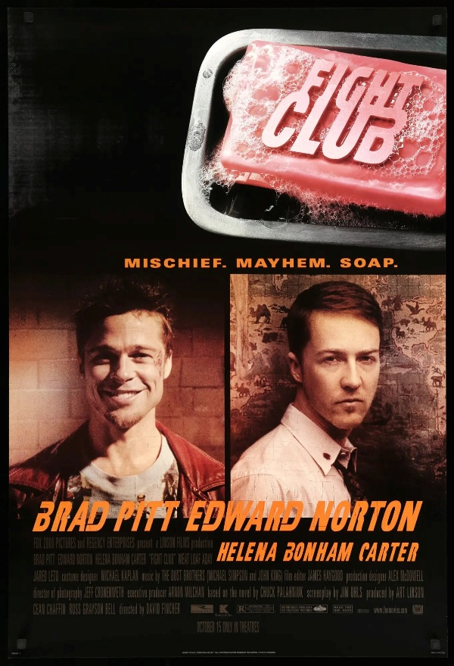
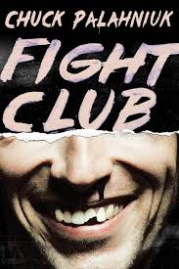
Appendixes

