16-06-2026

1) https://leetcode.com/problems/decode-ways/description/?envType=problem-list-v2&envId=dynamic-programming

Solution:
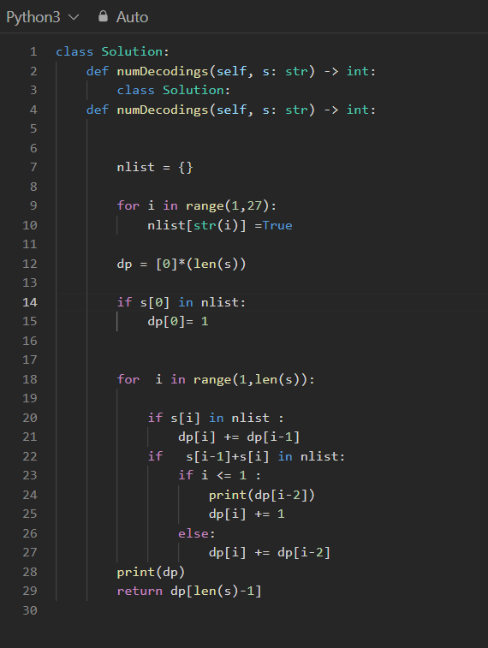

Output:
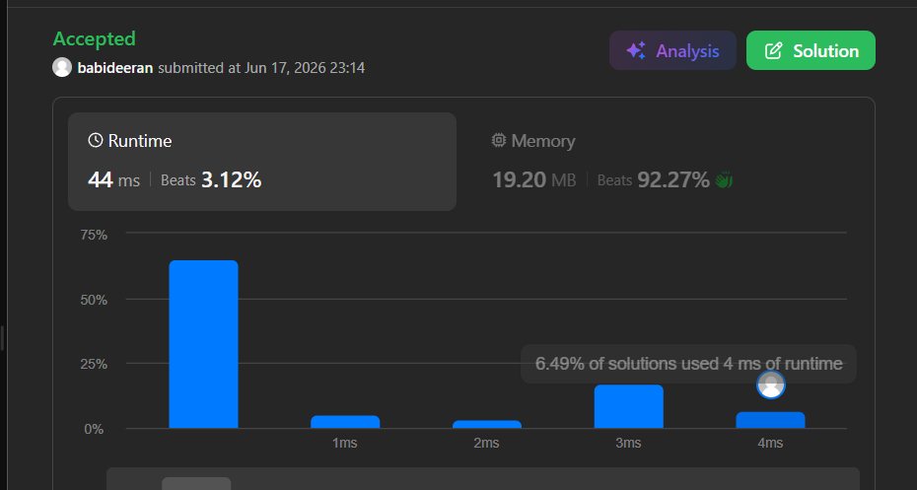

17-06-26
2) https://leetcode.com/problems/perfect-squares/?envType=problem-list-v2&envId=dynamic-programming

Solution
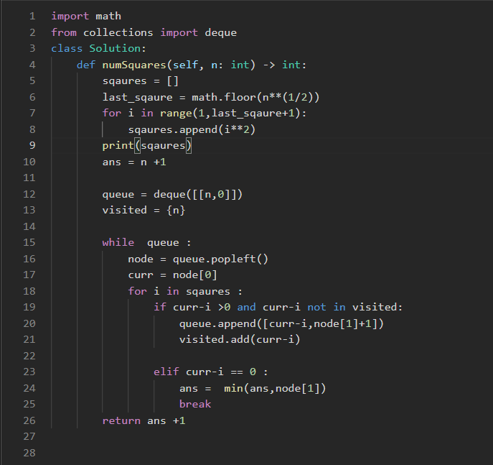

Output :

